**CS-255 System Analysis And Design**

**Module 5**

**Project One**

**Business Requirement Document**

**Submitted By:**

HAMNA KHALID

ID: 2902671

[hamna.khalid@snhu.edu](mailto:hamna.khalid@snhu.edu)

**Submitted To:**

PROFESSOR PARUL HIRPARA

p.hirpara@snhu.edu

Southern New Hampshire University

Thursday, October 02, 2025

**Business Requirements Document**

This document defines the requirements and design considerations for the DriverPass system. It captures the client’s needs, explains the purpose of the project, and organizes the functional and nonfunctional requirements into a structured plan. The document will guide both the design and future development phases of the system.

# **System Components and Design**

This section explains why the DriverPass system is needed, what problems it will solve, and the goals it must achieve. It also provides context for the project and identifies the major components that will make up the system.

## **Purpose**

The purpose of this project is to design and implement a training system for DriverPass that helps reduce DMV test failure rates. The system will combine online learning with on-the-road training and provide staff with tools to manage customers, reservations, and compliance.

* Provide students with online practice exams, courses, and progress tracking.
* Support reservations for driving lessons and training packages.
* Enable administrators, IT officers, and secretaries to manage accounts and scheduling.
* Deliver a secure, cloud-based system accessible from any device.

## **System Background**

DriverPass identified a problem where over 65% of DMV test applicants fail due to poor preparation. Current methods rely too much on memorizing old exams. DriverPass aims to solve this with a flexible system that blends online and in-person learning, ensuring students are fully prepared for their exams.

### **Problem To Solve**

DriverPass identified a critical issue in society: more than 65% of students fail their DMV driving tests due to inadequate preparation. Current approaches rely too heavily on memorizing past exams and lack structured practice. Without better training resources, students face low pass rates, causing frustration and delays in obtaining licenses.

### **Driverpass Solution**

DriverPass proposes a comprehensive training system that blends online and in-person learning. This solution ensures students gain both the theoretical knowledge and practical driving experience required to pass DMV tests. The system must:

* Provide access to online practice exams and DMV rules.
* Offer structured training packages with 6, 8, or 12 hours of on-the-road lessons.
* Support in-person instruction sessions.
* Track progress across tests, lessons, and packages.
* Ensure compliance with DMV policies and allow for easy updates.

### **Key System Components**

To deliver the solution, the system must include several integrated components:

* **User Scheduling & Lesson Tracking**

Students can make, modify, or cancel two-hour lessons, linked to a trainer, car, date, and time.

* **Registration & User Management**

Customers can register online or through the secretary; staff members manage accounts and reset passwords.

* **Security**

Role-based access with detailed logging of all user actions.

* **Progress Tracking**

Student tests show status (not taken, in progress, failed, passed).

* **DMV Compliance & Integration**

Automatic updates from DMV for new rules or policies.

* **Cloud-Based Infrastructure**

A web-accessible, mobile-friendly system with cloud security and minimal downtime.

### **Objectives and Goals**

This section defines what the DriverPass system must achieve once completed. Objectives describe the overall outcomes for the client, while goals break those outcomes into measurable, actionable tasks that ensure the system’s success. Together, they provide a roadmap for system design and development.

#### **Objectives**

* Deliver a secure, cloud-based training system accessible via web and mobile devices.
* Reduce DMV driving test failure rates by providing structured preparation tools.
* Support both customers and staff with role-specific features.
* Ensure ongoing compliance with DMV rules and updates.

#### **Goals**

* Provide students with online practice exams, interactive courses, and training packages.
* Enable customers to schedule, modify, and cancel driving lessons online or through staff.
* Track student progress, showing exam results and lesson completion statuses.
* Allow secretaries to enter customer data and manage appointments by phone or in person.
* Give IT officers the ability to reset passwords, manage accounts, and block access when needed.
* Provide managers with detailed reports and activity logs to monitor reservations and training activity.
* Connect with DMV systems to receive updates on new rules, policies, and test materials.

# **Requirements**

The requirements section defines everything the DriverPass system must achieve in order to meet the client’s needs. Requirements are divided into two categories: **nonfunctional requirements**, which describe the quality and constraints of the system, and **functional requirements**, which specify the actions the system must perform. Together, these requirements ensure DriverPass delivers a reliable, secure, and effective training solution.

## **Non-Functional Requirements**

This section outlines the qualities and constraints that the DriverPass system must meet to function effectively. Unlike functional requirements, which specify what the system should do, nonfunctional requirements describe how well the system should perform. These include ensuring reliability, security, and long-term adaptability. Non-functional requirements focus on performance attributes such as usability, scalability, and security.

### **Performance Requirements**

The DriverPass system must run smoothly across multiple environments and provide users with fast and reliable access.

* The system shall be web-based and cloud-hosted, ensuring access from any internet-enabled device (desktop, laptop, or mobile).
* The system shall load and respond within **2–3 seconds** for common operations such as login, test loading, and appointment booking.
* The system shall be available **99.9% of the time**, minimizing downtime for users.
* The system shall support regular updates, with major updates no more than once per quarter and minor fixes applied as needed.

### **Platform Constraints**

The DriverPass platform must operate consistently across different operating systems and integrate with the necessary backend tools.

* The system shall run on major platforms (Windows, macOS, Linux, iOS, and Android via browsers).
* The back end shall require a **cloud-based relational database** to support data storage and retrieval (e.g., MySQL, PostgreSQL, or equivalent).
* The platform shall be compatible with modern web browsers (Chrome, Firefox, Safari, Edge).

### **Accuracy and Precision**

Accuracy ensures the system correctly distinguishes between users and maintains data integrity.

* The system shall require unique usernames (or emails) for each customer and staff account.
* The system shall enforce case sensitivity where applicable (e.g., passwords).
* The system shall log all user activity, such as reservation creation, modification, and cancellation.
* The system shall immediately notify administrators of suspicious activity, system errors, or failed login attempts.

### **Adaptability**

The DriverPass system must be flexible enough to handle changes in business needs, technology, and users.

* The system shall allow IT administrators to add, remove, or modify user accounts without requiring code changes.
* The system shall support future DMV policy updates without major redesigns.
* The system shall be scalable, allowing additional packages, courses, or modules to be added in future updates.
* IT administrators shall have **full system access** to manage roles, permissions, and configurations.

### **Security**

Given the sensitivity of customer data and payment information, security is critical.

* The system shall require secure login credentials (username/email + strong password).
* All client-server communication shall use **encrypted HTTPS protocols (SSL/TLS)**.
* After **three failed login attempts**, accounts shall be temporarily locked to prevent brute-force attacks.
* The system shall include a secure password reset mechanism (e.g., email or SMS verification).
* Role-based access shall restrict users to only the features and data necessary for their role (e.g., IT officer, secretary, trainer, customer).
* Sensitive customer data, such as credit card details, shall not be stored directly; instead, the system shall integrate with a secure third-party payment processor.

## **Functional Requirements**

This section defines the essential actions the DriverPass system must perform to support the client’s needs. Each requirement is framed as “**The system shall**…” so that functionality is measurable, testable, and clear for developers.

* The system shall validate user credentials when logging in.
* The system shall allow customers to create, update, and manage accounts.
* The system shall allow students to schedule, modify, and cancel driving lesson reservations online.
* The system shall allow the secretary to create and manage lesson reservations for students by phone or in person.
* The system shall match students with an available car, trainer, date, and time for each reservation.
* The system shall provide training packages (6, 8, or 12 hours) with options for in-person DMV rule sessions and online course access.
* The system shall display student progress on online practice exams with statuses (not taken, in progress, failed, passed).
* The system shall maintain a history of all tests taken, including test name, time taken, score, and status.
* The system shall allow instructors to leave notes, lesson times, and comments for students.
* The system shall log all activity, including who created, modified, or canceled reservations.
* The system shall provide administrators with reports on system usage, reservations, and student progress.
* The system shall allow IT officers to reset passwords, manage accounts, and block access when necessary.
* The system shall connect with the DMV to update rules, policies, and test questions in real time.
* The system shall integrate with third-party vendors for secure payment processing.

### **User Interface**

The user interface is the layer through which each type of user interacts with the DriverPass system. It must be intuitive, accessible, and consistent across devices.

#### **Students**

* Access via web browser or mobile device.
* Register, log in, view available training packages, schedule lessons, access online courses, and track progress.
* Reset passwords automatically if forgotten.

#### **Secretary**

* Access via desktop browser.
* Create and manage customer profiles, schedule lessons, and update reservations made by phone or in person.

#### **Trainers**

* Log in to record lesson times, track attendance, and add notes or comments on student performance.

#### **IT Officer**

* Full access to manage user accounts, reset passwords, configure system settings, and block unauthorized access.

#### **Management (Owner)**

* Access high-level dashboards and activity reports, including reservations, customer progress, and compliance metrics.

#### **System Accessibility**

* The interface shall run smoothly on web browsers (Chrome, Firefox, Safari, Edge) and mobile platforms (iOS, Android).
* All users shall access the system through a secure, cloud-based platform.

### **Assumptions**

This section lists the assumptions made during the system design that were not explicitly covered in the interview. These ensure clarity and highlight expected conditions.

* It is assumed that all students have access to a computer or mobile device with internet connectivity.
* It is assumed that trainers and staff will have the necessary technical skills to operate the system.
* It is assumed that the DMV will provide timely updates about rule and policy changes in a usable digital format.
* It is assumed that DriverPass will provide cloud hosting and necessary security certifications.
* It is assumed that credit card processing will be handled by a trusted third-party vendor.
* It is assumed that DriverPass has the budget and resources to cover initial development, cloud hosting, and ongoing maintenance.

### **Limitations**

Every system has constraints, and identifying them early ensures realistic planning. These limitations apply to the DriverPass system.

* The system will not allow offline reservations or modifications; changes must occur online or through the secretary.
* Package customization (adding/removing modules) will not be included in the first release and may require future system updates.
* The system depends on stable internet connectivity; poor connections may affect performance for students or staff.
* The budget and timeline may restrict advanced features such as mobile app development or real-time GPS tracking of cars.
* DMV integration depends on the DMV’s willingness and ability to provide automated updates.
* The project timeline, as given, requires strict adherence to deadlines to avoid delays.

### **Gantt Chart**

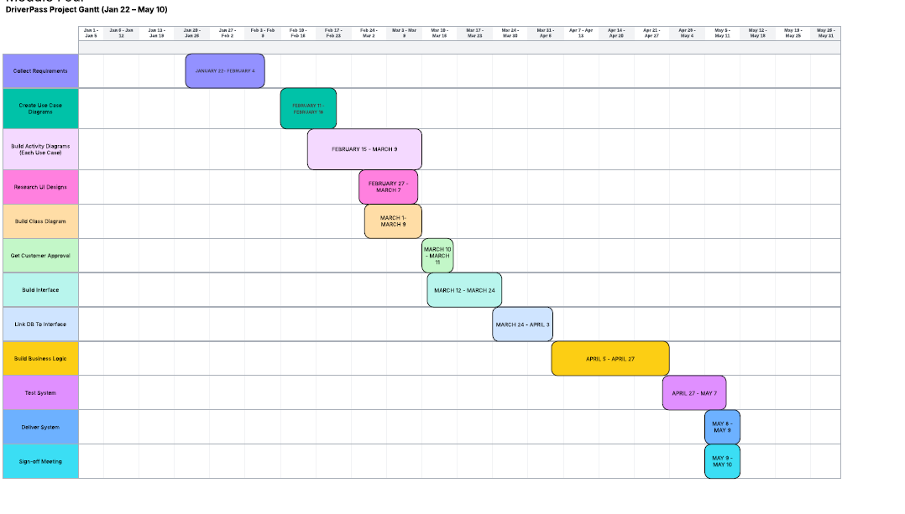

**Fig 1: Gantt Chart**

# **Acronyms and Full Forms**

This section explains the abbreviations used throughout the document to ensure clarity for all readers.

* **UML** – Unified Modeling Language
* **OOD** – Object-Oriented Design
* **DFD** – Data Flow Diagram
* **DB** – Database
* **DMV** – Department of Motor Vehicles
* **SNHU** – Southern New Hampshire University

# **References**

* Dennis, A., Wixom, B. H., & Tegarden, D. (2015). *Systems analysis and design with UML* (4th ed.). Wiley. [PDF]
* Fowler, M. (2003). *UML distilled: A brief guide to the standard object modeling language* (3rd ed.). Addison-Wesley. [PDF]
* Object Management Group (OMG). (2017). *Unified Modeling Language (UML) specification*. Object Management Group. [PDF]
* Valacich, J. S., & George, J. F. (2020). *Modern systems analysis and design* (9th ed.). Pearson. [PDF]
* Southern New Hampshire University. (2025). *CS-255 Systems Analysis and Design course materials*. [PDF]