**CS-255 System Analysis And Design**

**Module 3 Assignment**

**Hamp Crafts Process Model**

**Submitted By:**

HAMNA KHALID

ID: 2902671

[hamna.khalid@snhu.edu](mailto:hamna.khalid@snhu.edu)

**Submitted To:**

PROFESSOR PARUL HIRPARA

p.hirpara@snhu.edu

Southern New Hampshire University

Wednesday, September 17, 2025

**Hamp Crafts Process Model**

Process modeling is a crucial aspect of systems analysis and design because it enables analysts and business owners to visualize how different processes work together within a system. Instead of reading lengthy descriptions, a process model provides a clear picture of how data flows, where it is stored, and how tasks are performed. This type of diagram is especially helpful for businesses like Hamp Crafts, a family-owned craft store that currently operates solely through its brick-and-mortar shop. The owners want to expand by adding an online storefront, and to do so successfully, they first need to understand how their current purchasing and supply process functions. In this paper, I will describe Hamp Crafts’ existing process, outline the additional requirements for integrating an online storefront, and explain how these new elements could be incorporated into their current system.

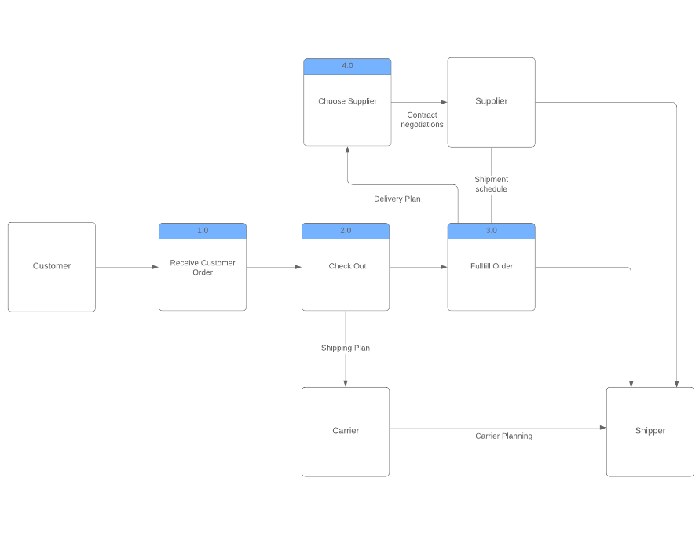

**Figure 1: Hamp Crafts’ Current Purchase and Supply Process**

# **Current Purchase and Supply Process**

The provided data flow diagram illustrates Hamp Crafts’ current purchase and supply process for its physical store. At the start of the process, a **customer places an order**, which is received by the store and recorded in the system. The next step is **checkout**, which is processed through a secure merchant account. All funds collected from purchases are transferred to Hamp Crafts’ primary business account within two business days.

Once the order is complete, the **fulfillment team prepares the order** and ensures the items are available. If supplies are low, the store interacts with a **supplier** through contract negotiations and shipment scheduling. The supplier sends the necessary inventory, which is then distributed through a **carrier and shipper** according to the shipping plan.

Currently, inventory monitoring and communication are handled manually. Employees check the **local database** for stock information and enter updates about order statuses and shipments. If there is an inventory shortage or delivery delay, the communication is not automated; instead, staff manually report the issue to ensure it is addressed.

## **Current Data Sources**

The main data sources in Hamp Crafts’ current process include:

* **Customer orders** (in-store purchases)
* **Supplier shipment schedules**
* **Carrier and shipper planning documents**
* **Local database** for tracking inventory and orders
* **Merchant account system** for payment processing

# **Additional Requirements for the Online Storefront**

To successfully expand into online sales, Hamp Crafts will need to integrate new processes, data sources, and potentially new databases.

## **New Processes Needed**

* **Online browsing and product selection:** Customers should be able to view products, descriptions, and stock levels directly on the website.
* **Online checkout and payment:** The system must securely process payments through credit cards, digital wallets, or PayPal.
* **Order confirmation and customer notifications:** Automated messages should confirm orders and provide tracking updates.
* **Administrative backend:** Employees need tools to manage product listings, update prices, adjust inventory, and provide technical support.
* **Customer service tools:** A support system such as live chat, a help desk, or a ticketing system for inquiries and complaints.

## **Additional Data Sources**

* **Customer accounts and profiles** (logins, addresses, payment preferences).
* **Online product catalog** that connects directly to inventory.
* **Order tracking information** shared with customers and staff.

## **Additional Databases**

* A **web-enabled inventory database** that syncs real-time stock between in-store and online sales.
* A **customer database** for storing accounts, purchase histories, and preferences.
* A **website content database** for product images, descriptions, and promotions.

# **Integrating the Online Storefront with the Current Process**

Rather than creating a separate system for the online storefront, it would be more efficient to integrate the new processes into Hamp Crafts’ current system. Keeping a single, unified process ensures that both in-store and online sales rely on the same inventory and payment structures. This prevents duplication of effort and avoids the risk of mismatched records between two different systems.

**For example**, when a product is purchased online, it should immediately update the same inventory database used by in-store employees. Similarly, payments from the online system should flow into the existing merchant account and business account, just like in-store sales. By integrating the online storefront into the current system, Hamp Crafts can reduce costs, streamline operations, and create a consistent customer experience across both sales channels.

# **Conclusion**

Hamp Crafts’ current purchase and supply process works well for its physical store but depends a lot on manual updates and lacks automation. Adding an online storefront can help the business reach more customers and boost sales, but it requires new processes like online browsing, secure payments, and customer support. More data sources and databases will also be necessary, including customer accounts, a product catalog, and a synchronized inventory system. The best solution is to integrate these new processes into the existing system so that inventory, payments, and order fulfillment stay connected. This integration will enable Hamp Crafts to modernize its operations while keeping efficiency and offering customers a seamless shopping experience both online and in-store.

# **Acronyms and Full Forms**

* **DFD** – Data Flow Diagram
* **DB** – Database
* **SNHU** – Southern New Hampshire University

# **References**

* Valacich, J. S., & George, J. F. (2020). *Modern systems analysis and design* (9th ed.). Pearson.
* Southern New Hampshire University (2025). *CS-255 Systems Analysis and Design course materials*.