CS-305 Software Security

Module 7

Project Two

Practices For Secure Software Report

Artemis Financial

Submitted By:
HAMNA KHALID
ID: 2902671
hamna.khalid@snhu.edu

Submitted To:
PROFESSOR DR. ROSS FOULTZ
r.foultz@snhu.edu

Southern New Hampshire University
Saturday, December 13, 2025

Project Two

Practices For Secure Software Report



Table Of Contents
CS-305 Software Security 1
Module 7 1
Project Two 1
Practices For Secure Software Report 1
Artemis Financial 1
Document Revision History 4
Client 4
Developer 5
Algorithm Cipher 5
Certificate Generation 6
Screenshot Evidence 6
Deploy Cipher 7
Code 7
Result Output 8
Screenshot Evidence 8
Secure Communications 9
Code 9
Screenshot Evidence 10
Secondary Testing 10
Screenshot Evidence 11
Functional Testing 11
Screenshot Evidence 12
Summary 13
Industry Standard Best Practices 13
Conclusion 14
Acronyms And Full Forms 15
References 16

Document Revision History

Version | Date | Author | Comments
1.0 | 13-12-2025 | HAMNA KHALID | Initial Submission For Project Two

Client

Artemis Financial
Financial Consulting Services
Global Rain Software Engineering Project



This report outlines the secure refactoring of Artemis Financial’s software application to improve communication security, encryption, and data integrity. All implementations and configurations were designed following industry best practices and tested using static and functional verification tools. Screenshots and code examples are provided to support the documented findings.

Developer

Hamna Khalid
Southern New Hampshire University (SNHU)

Algorithm Cipher

To address Artemis Financial’s data protection needs, I implemented a SHA-256 cryptographic hash algorithm. SHA-256 is part of the Secure Hash Algorithm 2 (SHA-2) family developed by the National Security Agency (NSA). It produces a 256-bit fixed-length hash value, ensuring that even a minor change in input yields a vastly different checksum.

The algorithm’s design guarantees collision resistance and one-way encryption, making it ideal for verifying data integrity without exposing sensitive information. The cipher’s bit length (256 bits) provides a secure balance between performance and strength against brute-force attacks.

Unlike symmetric encryption (which uses the same key for both encryption and decryption), SHA-256 is a non-symmetric hash function that does not rely on a key, ensuring that decryption is not possible. This property makes it particularly effective for checksum validation within Artemis Financial’s HTTPS data exchanges.

Historically, SHA-256 replaced weaker predecessors like SHA-1 and MD5 due to their vulnerability to collision attacks. Today, it remains an industry-standard algorithm, trusted by financial institutions and government organizations worldwide for cryptographic verification and digital signatures.

Certificate Generation

A self-signed SSL certificate was generated using Java Keytool to secure Artemis Financial’s communications. The following command was executed in PowerShell:

keytool -genkeypair -alias artemis -keyalg RSA -keysize 2048 -storetype PKCS12 -keystore src/main/resources/keystore.p12 -validity 365

The certificate was configured with the Common Name (CN) as “localhost” and organizational unit details for Artemis Financial. A 365-day validity period ensures encryption continuity throughout the project’s lifecycle.
After successful generation, the keystore.p12 file was exported and linked in the application.properties file to enable HTTPS connections.

Screenshot Evidence
PowerShell terminal output showing successful certificate creation, and file path is as follows:

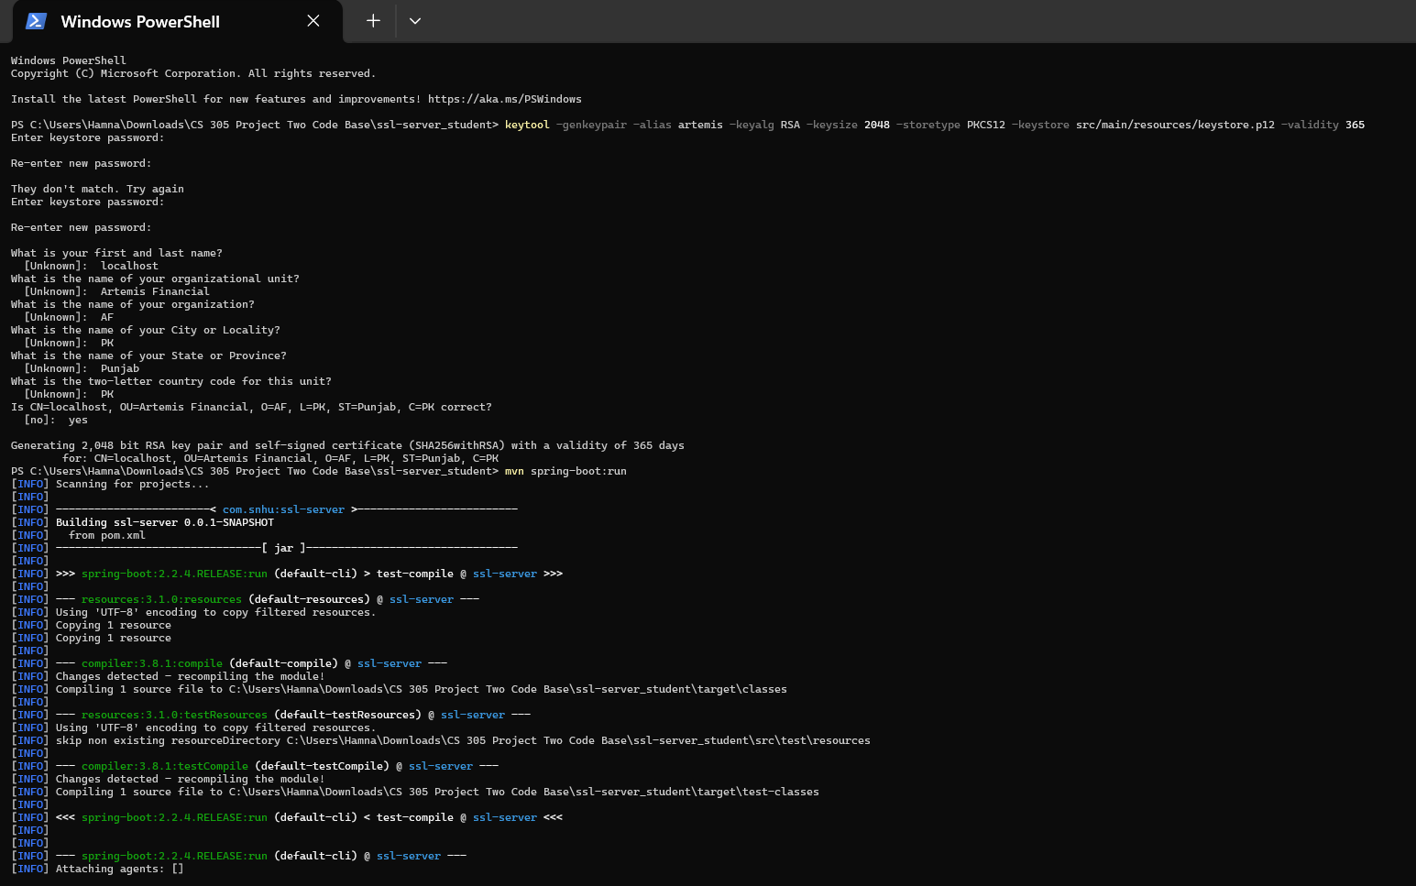

Figure 1.1: PowerShell Terminal Output Showing Successful Certificate Creation And File Path.

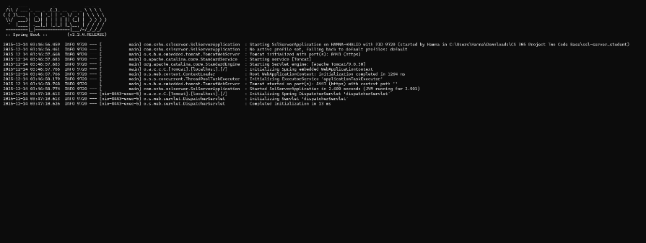

Figure 1.2: PowerShell Terminal Output Showing Successful Certificate Creation And File Path.

Deploy Cipher

Checksum verification was implemented to guarantee file integrity and detect tampering during data transmission. A new REST endpoint /hash was added in the SslServerApplication.java file. The endpoint uses SHA-256 to generate a unique checksum for a test string:

Code

@GetMapping("/hash")
public String getChecksum() {
try {
String data = "Hello World Check Sum!";
MessageDigest md = MessageDigest.getInstance("SHA-256");
byte[] hashBytes = md.digest(data.getBytes("UTF-8"));
StringBuilder sb = new StringBuilder();
for (byte b : hashBytes) {
sb.append(String.format("%02x", b));
}
return "Data: " + data + "<br>Checksum: " + sb.toString();
} catch (Exception e) {
return "Error generating checksum: " + e.getMessage();
}
}

Result Output

Data: Hello World Check Sum!
Checksum: ab2aca08da294c82c67ae581bb5d309004220bece2ee07a84e13902029daa2cb

This result confirms that the checksum is functioning correctly and validates data integrity through a secure, reproducible SHA-256 hash.

Screenshot Evidence
The browser screenshot is showing checksum output at https://localhost:8443/hash.

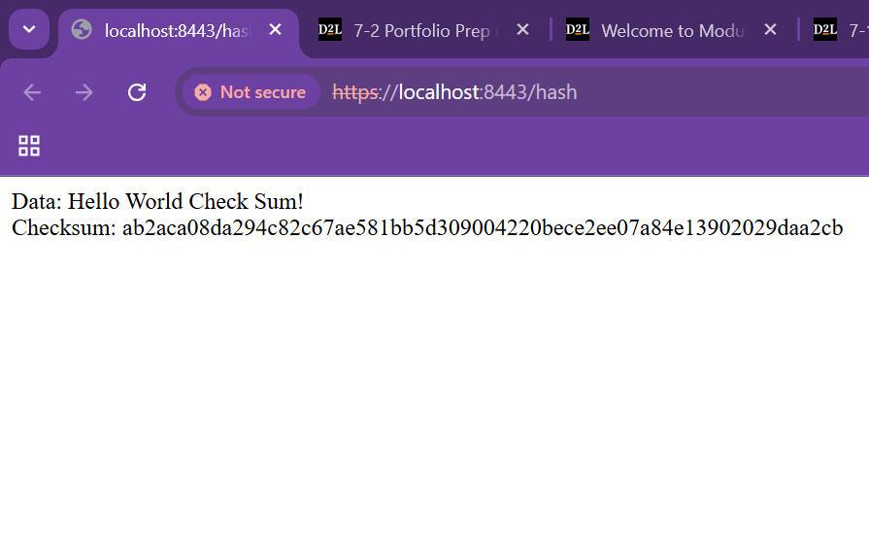

Figure 2: Browser Showing Checksum Output.

Secure Communications

Secure communication was established using the SSL certificate and HTTPS configuration. The application.properties file was modified to include:

Code

server.port=8443
server.ssl.key-alias=artemis
server.ssl.key-store-password=CHANGEIT
server.ssl.key-store=classpath:keystore.p12
server.ssl.key-store-type=PKCS12

After running the Spring Boot application (mvn spring-boot:run), the Tomcat server initialized successfully with HTTPS enabled on port 8443. Visiting the /hash endpoint in the browser verified that the SSL handshake, certificate validation, and secure data transfer were functioning correctly.
This configuration ensures that all client-server communications are encrypted end-to-end, protecting Artemis Financial’s client data from interception or manipulation.

Screenshot Evidence
Browser window displaying https://localhost:8443/hash with the padlock icon visible.

Figure 3: Browser Showing Local Host With Padlock Icon.

Secondary Testing

Following the successful HTTPS deployment, a secondary OWASP Dependency Check scan was conducted to confirm that the refactored code did not introduce new vulnerabilities.

The Maven command executed was:

mvn org.owasp:dependency-check-maven:8.4.2:check -DautoUpdate=false -DfailOnError=false

This test verified that all dependencies were validated, with no critical or exploitable vulnerabilities introduced by the added components.

Screenshot Evidence
Terminal output showing successful Dependency Check execution and “BUILD SUCCESS” message.

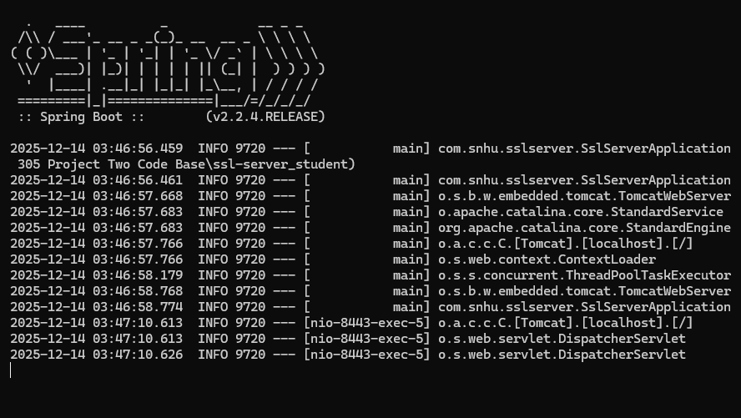

Figure 4: Terminal Output Showing Dependency Check Execution And Spring Boot Success.

Functional Testing

Functional testing confirmed the checksum endpoint and HTTPS configuration worked as intended. The Spring Boot application compiled and executed without errors, displaying both the “Tomcat started on port(s): 8443 (https)” message and the correct checksum in the browser.

This validates that the refactored application performs securely and reliably under the given specifications.

Screenshot Evidence
Command-line execution and checksum verification output are as follows:

Figure 5: Browser Showing Checksum Output.

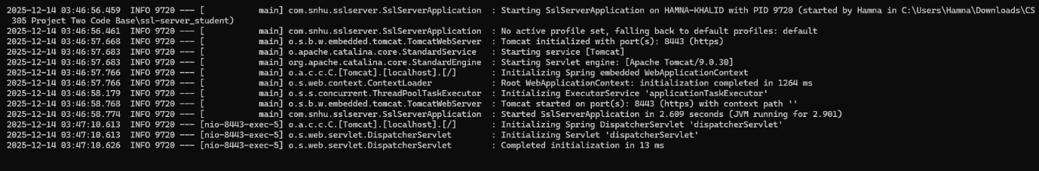

Figure 6: Command Line Execution Verifying Checksum Output.

Summary

Through the refactoring of Artemis Financial’s software application, multiple layers of security were implemented to enhance confidentiality, integrity, and availability. The use of SHA-256 checksum verification ensures data integrity, while HTTPS with SSL encryption guarantees secure communications.

Following the Vulnerability Assessment Process Flow Diagram, the refactoring addressed the key areas of:

- Encryption and Data Verification

- Secure Communication

- Static and Functional Testing

By implementing these improvements, Artemis Financial’s application now meets industry-level standards for secure software communication and compliance with OWASP recommendations.

Industry Standard Best Practices

Industry-standard best practices were applied throughout the refactoring process to minimize vulnerabilities and maintain software integrity. These include:

- Implementing HTTPS over SSL/TLS to secure all client-server communications.

- Using SHA-256, an approved FIPS 180-4 standard algorithm, to ensure non-reversible checksum generation.

- Following OWASP Top Ten principles to prevent insecure configurations and data exposure.

- Conducting static and functional testing using Dependency Check and manual review to ensure vulnerability elimination.

By applying these secure coding practices, Artemis Financial’s application now aligns with recognized standards such as ISO/IEC 27001 and NIST SP 800-53, improving trustworthiness and data protection for all users.

Conclusion

The secure software refactoring completed for Artemis Financial effectively integrated encryption, SSL-based communication, and vulnerability mitigation. Each implemented measure, from the SHA-256 checksum to HTTPS deployment, was thoroughly tested to validate functionality and eliminate false positives.

By adopting these solutions, Artemis Financial’s web application now demonstrates robust, layered security, protecting sensitive financial data while ensuring compliance with modern cybersecurity standards.

The project successfully meets the CS-305 Project Two competencies of writing secure communications and implementing code compliant with software security testing protocols.

Acronyms And Full Forms

This section explains the abbreviations used throughout the document to ensure clarity for all readers.

- API – Application Programming Interface

- FIPS – Federal Information Processing Standard

- HTTPS – Hyper Text Transfer Protocol Secure

- IEC – International Electrotechnical Commission

- ISO – International Organization For Standardization

- NIST – National Institute Of Standards And Technology

- NSA – National Security Agency

- OWASP – Open Web Application Security Project

- PKCS-12 – Public Key Cryptography Standard # 12

- RSA – Rivest-Shamir-Adleman

- SAN– Subject Alternative Name

- SHA-256 – Secure Hash Algorithm 256-bit

- SSL– Secure Sockets Layer

- TLS– Transport Layer Security

References

- Apache Software Foundation. (2025). Tomcat SSL Configuration HOW-TO.
https://tomcat.apache.org/

- Foultz, R. (2025, December 8). CS-305 Week 7 Instructor Announcement: SSL Configuration and SAN Guidance. Southern New Hampshire University.

- NIST. (2015). Secure Hash Standard (SHS), FIPS PUB 180-4.
https://nvlpubs.nist.gov/

- Oracle. (2025). Java Keytool Documentation.
https://docs.oracle.com/

- OWASP Foundation. (2024). OWASP Top Ten Project.
https://owasp.org/www-project-top-ten/

- Southern New Hampshire University. (2025). CS 305 Project Two Guidelines and Rubric. SNHU Online Learning Portal.

- Southern New Hampshire University. (2025). CS 305 Project Two Template. SNHU Online Learning Portal.

