CS-330 Computational Graphics And Visualization

Module 7

Final Project Work Proof

Execution Evidence For Evaluation

Submitted By:
HAMNA KHALID
ID: 2902671
hamna.khalid@snhu.edu

Submitted To:
PROFESSOR DR. BRIAN HOLBERT
b.holbert@snhu.edu

Southern New Hampshire University
Sunday, April 19, 2026

Module Seven

Execution Evidence For Evaluation Report

Section 1

7-1 Final Project Submission

Overview

In this final project, I combined all concepts from previous milestones, including geometry construction, texture mapping, and lighting, to create a complete 3D scene.

The scene includes a textured floor, a mug built from multiple primitive shapes, a notebook, and a monitor with a stand. The goal of this final stage was to refine the scene, correct previous issues, and improve realism through proper lighting and object placement.

This project builds directly on Milestone Five (texturing) and Milestone Six (lighting), where earlier issues with visibility, lighting interaction, and object positioning needed further refinement.

Initial Scene State

When I first transitioned from Milestone Six into the final project, the scene was functional but had several visible issues:

- The mug appeared too dark or completely black.

- Lighting had a strong green tint, making the scene look unnatural.

- Some objects, especially the mug, appeared floating above the floor.

- The monitor was either not visible or positioned incorrectly.

- Lighting from multiple sources did not appear clearly different.

This showed that while textures and geometry were working correctly, the integration of lighting and object positioning still needed improvement.

Challenges And Problem Solving

During final implementation, I encountered several technical challenges:

1. Mug Appearing Extremely Dark

The mug appeared almost black, with only the edges visible. This made it difficult to see its structure.

Causes

This was caused by how the lighting interacted with the surface normals and material properties. The diffuse lighting contribution was too low, causing the object to receive very little light.

Solution

- Increased ambient lighting contribution.

- Adjusted material properties for the mug.

- Ensured lighting was enabled correctly during rendering.

This allowed the mug to become clearly visible while still maintaining shading..

2. Green Tinted Lighting Across The Screen

The entire scene had a noticeable green tint, which made the lighting look unrealistic.

Causes

This was due to incorrect color balance in the secondary light source, where color intensity values were too high and unbalanced.

Solution

- Reduced intensity of colored lighting.

- Adjusted RGB values to create a more subtle blue-toned fill light.

- Balanced the primary white light with the secondary colored light.

This resulted in a more natural lighting appearance.

3. Mug Floating Above The Floor

The mug appeared to float slightly above the ground plane.

Causes

Incorrect Y-axis positioning during transformation caused the mug's base not to align with the floor.

Solution

- Adjusted Y-position values for the mug body and components.

- Ensured alignment with the ground plane.

This fixed the floating issue and improved realism.

4. Monitor Not Visible Or Blocking Objects

The monitor was either not visible or was incorrectly placed, sometimes blocking other objects such as the mug.

Causes

Improper positioning along the Z-axis and incorrect scaling caused visibility issues.

Solution

- Repositioned the monitor further back in the scene.

- Adjusted scale and placement for better balance.

- Ensured it did not overlap with foreground objects.

This made the monitor clearly visible without interfering with other objects.

5. No Visible Difference Between Light Sources

Although two lights were implemented, the scene appeared to use only one.

Causes

The intensity and color differences between the lights were too subtle, making their effects indistinguishable.

Solution

- Strengthened the primary white light for overall illumination.

- Added a distinct blue tint to the secondary light.

- Positioned lights at different angles

This created a visible contrast and improved depth perception.

6. Overexposed Or Flat Floor Texture

The floor texture sometimes appeared too bright or lacked depth.

Causes

Excessive diffuse lighting caused overexposure, while low contrast caused flat shading.

Solution

- Adjusted diffuse and ambient values.

- Balanced light intensity.

- Maintained UV scaling for texture clarity.

This improved the appearance of the floor and added realistic variation.

Final Outcome

After resolving the issues, the final scene includes:

- Properly grounded objects with no floating geometry.

- Balanced lighting with visible differences between light sources.

- A clearly visible monitor acting as a central object.

- A mug with improved visibility and shading.

- A textured floor that responds realistically to lighting.

The scene now maintains depth, clarity, and visual consistency.

Execution Evidence

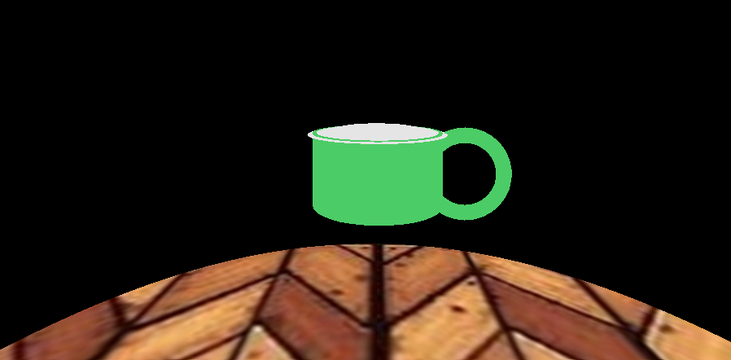

Figure 1: Initial Scene Before Final Implementation
This image shows the baseline state of the scene before applying final refinements. While the ground plane is textured and the mug structure is complete, the lighting is either not properly applied or lacks balance. As a result, the scene appears flat, with limited depth and poor visibility of certain objects.

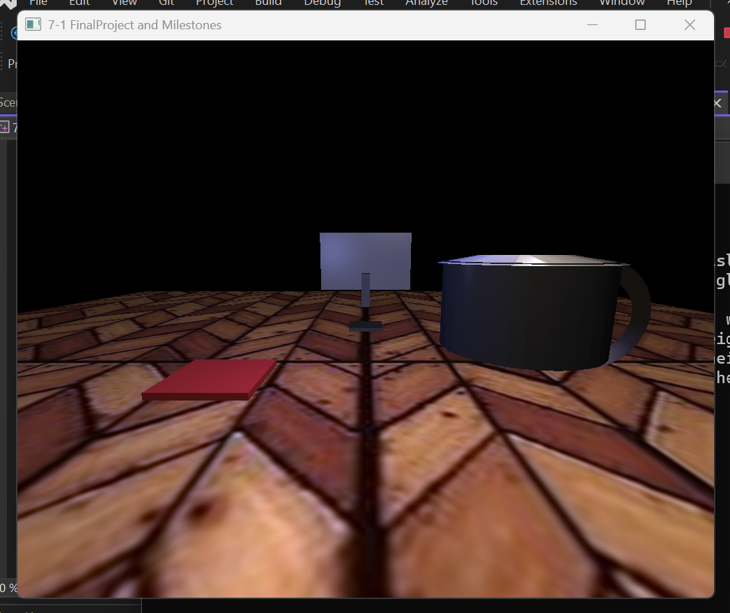

Figure 2: Final Scene With Applied Lighting And Complete Scene Composition
This image displays the completed scene after all final adjustments. Lighting is properly configured using multiple light sources, creating visible depth and improved object definition. The ground plane reflects light through the shader, and all objects, including the mug, monitor, and notebook, are clearly visible and correctly positioned, demonstrating a cohesive and realistic scene.

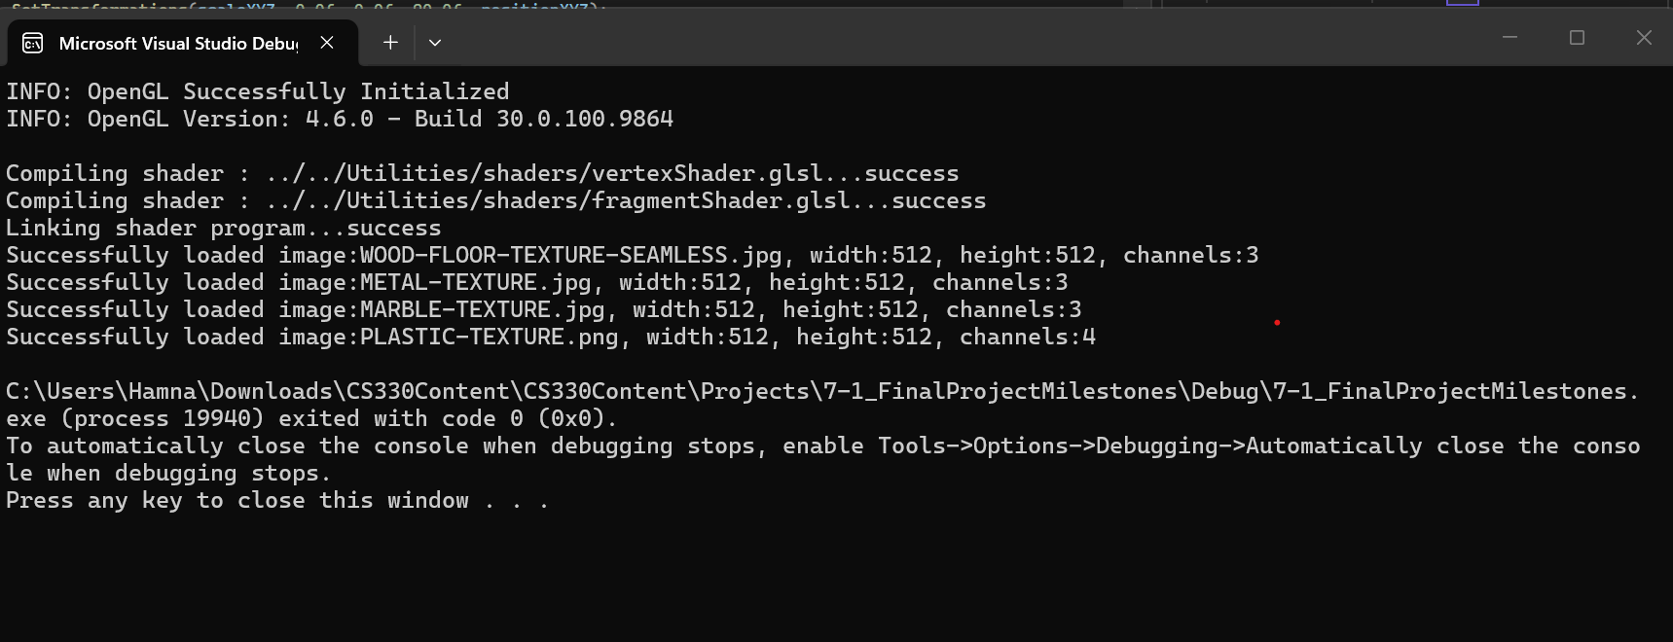

Figure 3: Console Output Showing Successful OpenGL Initialization And Shader Execution.
This output confirms that the OpenGL environment initialized successfully and that the shader programs responsible for lighting calculations were compiled and executed correctly.

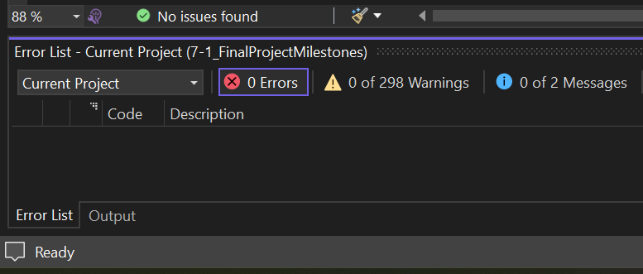

Figure 4: Visual Studio Build Output Indicating Successful Compilation With No Errors.
This image shows that the project compiled successfully without any errors or warnings. This confirms that all code modifications related to final touches were implemented correctly and did not introduce any syntax or build issues.

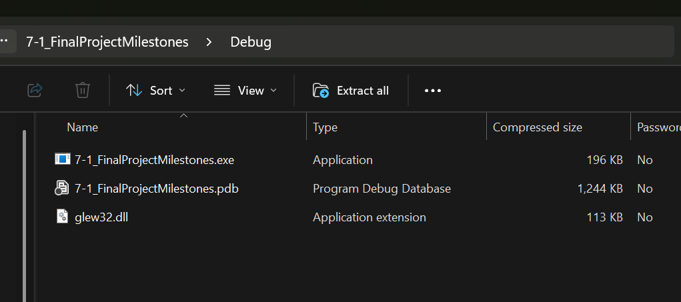

Figure 5: Generated Executable And Supporting Files After Successful Build.
This screenshot displays the compiled application files, including the executable (.exe), debug database (.pdb), and required OpenGL library (glew32.dll). These files confirm that the program is ready to run and that all dependencies are correctly included.

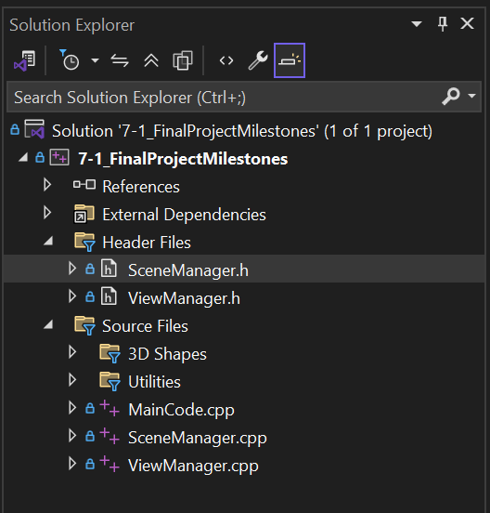

Figure 6: Solution Explorer View Showing Project Structure.
This image highlights the organization of the project within Visual Studio, including key source files such as SceneManager.cpp, ShaderManager.cpp, and ShapeMeshes.cpp. It demonstrates how scene rendering, lighting logic, and object construction are modularized and integrated within the project structure.

Conclusion

The final project demonstrates the successful integration of textures, lighting, and object composition into a complete 3D scene.

Through iterative debugging and refinement, issues related to lighting, color balance, and object positioning were resolved. The use of multiple light sources improved depth and realism, while adjustments to transformations ensured proper alignment of all objects.

This project highlights the importance of balancing lighting, geometry, and textures to achieve a visually coherent and functional 3D environment.

AI Usage Acknowledgment

I used OpenAI as a supplementary learning and development tool to assist with debugging, understanding OpenGL debugging lighting issues, refining object placement, and improving overall scene composition. All final implementations were tested and validated independently.

All code implementations, design decisions, and final modifications were independently reviewed, tested, and validated to ensure accuracy and functionality.

Acronyms And Full Forms

- API - Application Programming Interface

- GLSL - OpenGL Shading Language

- GPU - Graphics Processing Unit

- IDE - Integrated Development Environment

- OpenGL - Open Graphics Library

- UV - Texture Coordinate Mapping (U = horizontal, V = vertical)

References

- Khronos Group. (n.d.).
OpenGL Programming Guide.

- LearnOpenGL. (n.d.).
Lighting Models and Shaders

- LearnOpenGL. (n.d.).
Lighting.
https://learnopengl.com/Lighting

- OpenGL Documentation. (n.d.).
Lighting Models And Shaders.

- Southern New Hampshire University. (n.d.).
CS-330 Computational Graphics And Visualization Module Resource.

