CS-405 Secure Coding

Module 4

Milestone Two

Unit Testing

Submitted By:
HAMNA KHALID
ID: 2902671
hamna.khalid@snhu.edu

Submitted To:
PROFESSOR BEN BATTLE
b.battle2@snhu.edu

Southern New Hampshire University
Sunday, May 31, 2026

Module Four

Milestone Two

Unit Testing

Assignment Output

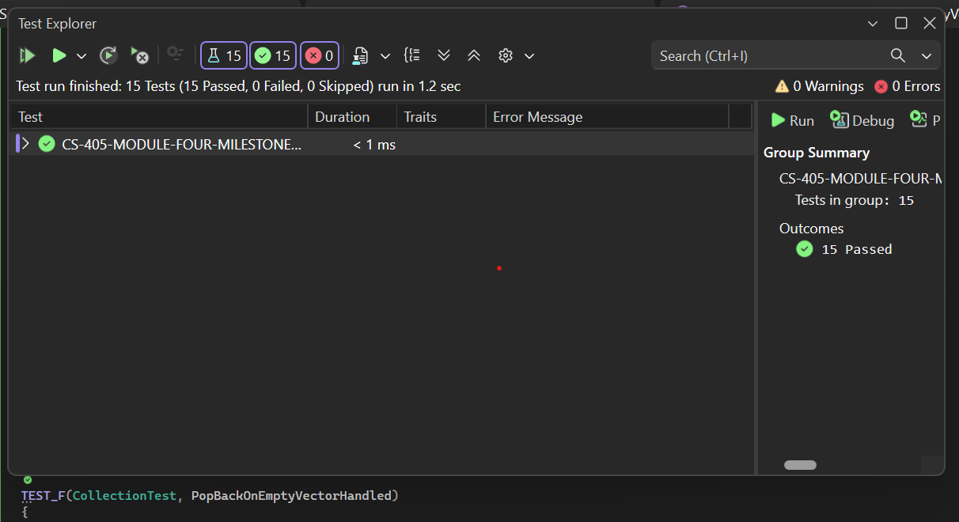

Process Summary

This activity focused on implementing unit testing using the Google Test framework to validate the behavior of a vector collection under various conditions. I completed all required tests and created two additional tests, including one positive and one negative test case.

The positive tests verified correct functionality such as adding elements, resizing the collection, and accessing values. The negative tests ensured that the program handled incorrect or invalid operations safely, such as accessing out-of-bounds elements using the at() function, which correctly threw a std::out_of_range exception.

One challenge was determining when to use ASSERT versus EXPECT macros. ASSERT was used for critical checks that should stop test execution if they fail, while EXPECT was used for validations that allow the test to continue even if a condition fails. This helped ensure thorough testing across multiple scenarios.

Another challenge involved handling edge cases such as empty collections. This was addressed by using conditional checks and safe operations to prevent runtime errors.

Overall, this activity demonstrates how unit testing supports shift-left security by identifying defects early in development. By validating both expected and unexpected behavior, unit testing improves code reliability, stability, and security.

