CS-405 Secure Coding

Module 2

Assignment

SQL Injection Coding

Submitted By:
HAMNA KHALID
ID: 2902671
hamna.khalid@snhu.edu

Submitted To:
PROFESSOR BEN BATTLE
b.battle2@snhu.edu

Southern New Hampshire University
Sunday, May 17, 2026

Module Two

Assignment

SQL Injection Coding

Introduction

This document provides evidence of implementing secure coding practices to detect and prevent SQL injection attacks in a C/C++ program. The objective of this activity was to modify the query execution function to identify malicious input patterns and prevent unauthorized access to database records.

In secure software development, improper handling of user input can lead to vulnerabilities such as SQL injection. This activity focused on identifying such risks and applying defensive coding techniques to ensure safe and reliable database operations.

Problem Identification

The original program executed SQL queries without validating their structure. This created a vulnerability where:

• A malicious user could modify queries using injected conditions.
• The database could return unintended results.
• Sensitive data, including user credentials, could be exposed.

One specific attack pattern identified was:

• SQL injection using OR value=value conditions.

This type of injection allows attackers to bypass filtering conditions and retrieve all records from the database.

Implementation Approach

To address this issue, I modified the run_query() function to validate SQL queries before execution.

Assumption

The detection logic assumes that SQL injection attempts follow a pattern involving OR-based equality conditions and does not account for more advanced or obfuscated injection techniques.

SQL Injection Detection

A helper function was implemented to detect injection patterns:

bool isSQLInjection(const std::string& query)

This function uses a regular expression to identify suspicious patterns in SQL queries, specifically:

• The presence of the keyword OR.
• A comparison of values such as value=value.

The regex pattern specifically detects logical conditions using the keyword "OR" followed by equality comparisons between values, which is a common SQL injection technique used to bypass query restrictions.

This ensures detection is not limited to a single case (such as 1=1) but works for multiple variations.

Pre Execution Validation

Before executing any SQL query, the program performs validation:

• If a potential SQL injection pattern is detected → execution is blocked.
• A message is displayed to notify the user.
• The function returns failure status to the calling function.

This ensures that malicious queries are never processed by the database.

Notification To The User

The program was updated to clearly display when a SQL injection attempt is detected:

SQL Injection Detected! Query Blocked.

Additionally:

• The function returns false to notify the calling function.
• This prevents further processing of unsafe data.

Defensive Coding Techniques Used

The following secure coding practices were applied:

- Input validation before query execution.
- Pattern-based detection using regular expressions.
- Fail-safe blocking of unsafe operations.
- Clear error notification to the user.
- Prevention of unsafe database access.

Challenges And Resolutions

Challenge 1:

Generalizing Detection

Detecting only 1=1 is not sufficient because attackers can use variations such as:

• 2=2
• 'hi'='hi'

Resolution:
A regex-based approach was implemented to detect the general pattern of OR value=value, ensuring broader coverage.

Challenge 2:

Maintaining Valid Functionality

Blocking all queries containing OR would break legitimate queries.

Resolution:
Detection logic was refined to target equality conditions rather than blocking all OR usage specifically.

Challenge 3:

Integration With Existing Code

The assignment required modifying the existing function without altering the overall structure.

Resolution:
Validation logic was inserted at the beginning of run_query() while keeping all existing functionality intact.

Results

After implementing the changes, the program successfully:

• Executed valid SQL queries correctly.
• Filtered queries based on conditions (e.g., selecting specific users).
• Detected multiple SQL injection attempts.
• Blocked malicious queries before execution.
• Displayed clear security messages.

The output confirms that the system prevents unauthorized data access while maintaining normal functionality.

Security And Best Practice Analysis

This implementation demonstrates key secure coding principles:

- Defense in Depth:
Validation occurs before database execution.

- Fail-Safe Defaults:
Unsafe queries are blocked by default.

- Input Validation:
All SQL input is validated before use.

- Least Privilege Concept:
Prevents unauthorized data retrieval.

These practices are essential in systems such as banking applications, where data security is critical.

Execution Evidence

The following figures provide evidence of successful implementation and testing:

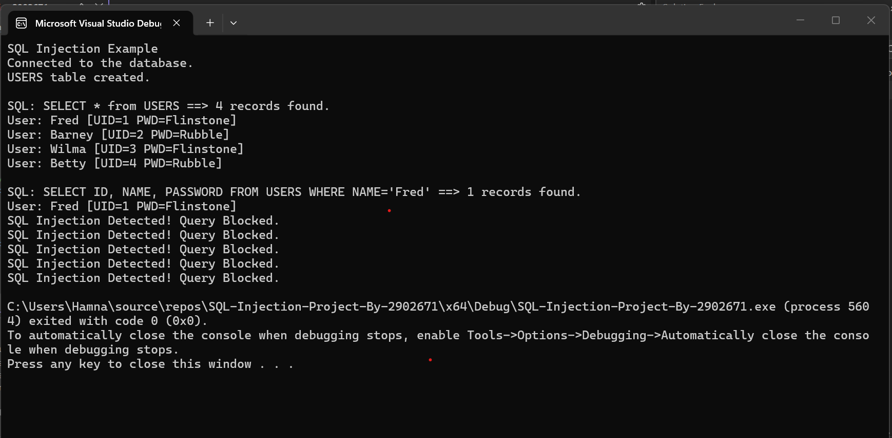

Figure 1: Console Output Demonstrating Successful Execution Of Valid SQL Queries, Detection Of SQL Injection Attempts, And Blocking Of Malicious Queries Using Pattern-Based Validation.

Reflection

Through this activity, I developed a deeper understanding of how SQL injection vulnerabilities arise and how to prevent them through proper input validation.

This activity reinforced the importance of:

• Validating all external input.
• Anticipating malicious behavior.
• Implementing defensive coding techniques early.

Conclusion

This activity demonstrated how SQL injection attacks can be effectively prevented using pattern-based detection and validation. By implementing a generalized detection mechanism and integrating it into the query execution process, the program now ensures secure and reliable database operations.

These techniques are critical in real-world applications where protecting sensitive data is essential.

AI Usage Acknowledgment

This assignment was completed with the assistance of the OpenAI tool to help with understanding SQL injection concepts, implementing detection logic, and structuring this summary. All code execution and validation were performed independently.

Acronyms And Full Forms

- API - Application Programming Interface

- DB - Database

- DiD - Defense In Depth

- IDE - Integrated Development Environment

- OWASP - Open Web Application Security Project

- SQL - Structured Query Language

References

- Acunetix. (n.d.).
SQL Injection Attacks.
https://www.acunetix.com/websitesecurity/sql-injection/

- Microsoft. (n.d.).
SQL Injection.
https://technet.microsoft.com/en-us/library/ms161953(v=sql.105).aspx

- Open Web Application Security Project (OWASP). (n.d.).
SQL Injection Prevention.
https://owasp.org/www-community/attacks/SQL_Injection

- Southern New Hampshire University. (2026).
CS-405 Module Two SQL Injection Activity Guidelines and Instructions.
Brightspace.

- Southern New Hampshire University. (2026).
Module Two Announcement: Defense in Depth.
Brightspace.

- W3Schools. (n.d.).
SQL Injection Tutorial.
https://www.w3schools.com/sql/sql_injection.asp

