CS-405 Secure Coding

Module 2

Assignment

Buffer Overflow Coding

Submitted By:
HAMNA KHALID
ID: 2902671
hamna.khalid@snhu.edu

Submitted To:
PROFESSOR BEN BATTLE
b.battle2@snhu.edu

Southern New Hampshire University
Sunday, May 17, 2026

Module Two

Assignment

Buffer Overflow Coding

Introduction

This document provides evidence of implementing secure coding practices to detect and prevent buffer overflow vulnerabilities in a C/C++ program. Buffer overflow is a critical issue in software systems where input exceeds allocated memory space, potentially overwriting adjacent memory and leading to unintended behavior or security risks.

This activity focuses on identifying such vulnerabilities and applying defensive coding techniques to ensure that user input does not corrupt sensitive data such as account numbers.

Problem Identification

The original program allowed user input to be stored in a fixed-size character array without validating its length. This created a vulnerability where:

- A user could input more than 20 characters.
- The extra input would overflow the buffer.
- The overflow could overwrite adjacent memory, including the account number.
- This could result in unauthorized modification of sensitive data.

This behavior demonstrates a classic buffer overflow vulnerability.

Implementation Approach

To address this issue, I modified the input handling process to validate the size of user input before copying it into the buffer.

Assumption

The detection logic assumes that buffer overflow occurs when the input length is greater than or equal to the allocated buffer size. This solution does not account for more advanced memory manipulation techniques or low-level exploits beyond input length validation.

Buffer Overflow Detection

A helper function was implemented to detect potential overflow conditions:

bool isOverflow(const std::string& input, size_t bufferSize)

This function compares the length of the user input against the size of the buffer.

If:

- Input length ≥ buffer size → overflow risk detected.

Pre Execution Validation

Before copying input into the buffer, the program performs validation:

- If overflow is detected → input is rejected.
- A message is displayed to the user.
- The function returns a failure status to the calling function.

This ensures that unsafe input is never written to memory.

Safe Input Handling

Instead of directly copying input into the buffer, a safe copy operation is used:

- Input is first stored in a std::string.

- The length is validated.

- Data is copied using a safe method (strncpy).

- Null termination is enforced.

This prevents memory corruption and ensures safe handling of user input.

Notification To The User

When a buffer overflow attempt is detected, the program displays:

Buffer Overflow Detected! Input Too Large.

Additionally:

- The function returns false to notify the calling function.

- The program stops further execution to prevent unsafe behavior.

Defensive Coding Techniques Used

The following secure coding practices were applied:

- Input length validation before memory operations.

- Boundary checking to prevent overflow.

- Safe copying using controlled functions.

- Fail-safe termination when unsafe input is detected.

- Clear user notification for security events.

Challenges And Resolutions

Challenge 1:

Detecting Overflow Before It Occurs

The original code accepted input directly into a fixed buffer without checks.

Resolution:
A validation function was implemented to compare the input size with the buffer capacity before copying.

Challenge 2:

Preventing Memory Overwrite

Unsafe functions could overwrite adjacent memory.

Resolution:
A safe copying approach was used with controlled buffer limits and enforced null termination.

Challenge 3:

Maintaining Program Functionality

Blocking all input would break normal operation.

Resolution:
Validation logic allows safe input while blocking only unsafe cases.

Results

After implementing the changes, the program successfully:

- Accepted valid input and displayed correct output.

- Detected input that exceeded buffer size.

- Prevented overflow before it occurred.

- Protected the account number from being modified.

- Displayed clear messages for unsafe input.

The results confirm that the program prevents unintended memory modification while maintaining normal functionality.

Security And Best Practice Analysis

This implementation demonstrates key secure coding principles:

- Defense in Depth:
Input validation is performed before memory operations.

- Fail-Safe Defaults:
Unsafe input is rejected by default.

- Input Validation:
All external input is validated before use.

- Memory Safety:
Prevents unintended memory overwrites.

These practices are essential in systems such as banking applications, where data security is critical.

Execution Evidence

The following figures provide evidence of successful implementation and testing:

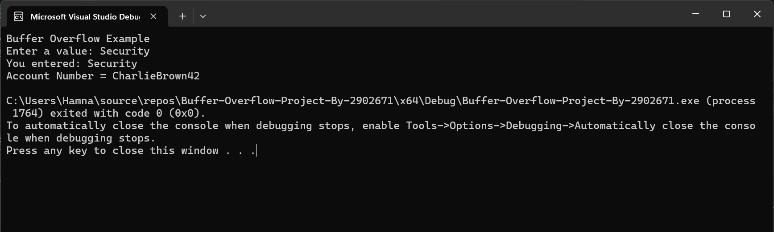

Figure 1: Normal Input Execution
The Program Successfully Accepts Valid Input And Displays The Correct Output Without Affecting The Account Number, Demonstrating Normal Program Functionality.

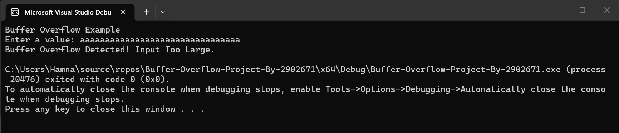
Figure 2: Buffer Overflow Detection
The Program Detects Input Exceeding The Buffer Size And Blocks Execution, Displaying A Warning Message And Preventing Modification Of The Account Number.

Reflection

Through this activity, I developed a deeper understanding of how buffer overflow vulnerabilities arise and how to prevent them through proper input validation and memory handling techniques.

This activity reinforced the importance of:

- Validating input before memory operations.

- Preventing unsafe data from entering the system.

- Implementing defensive coding techniques early.

Conclusion

This activity demonstrated how buffer overflow vulnerabilities can be effectively mitigated through boundary checking and safe input handling. By validating input size and preventing unsafe memory operations, the program ensures secure and reliable behavior.

These techniques are essential in real-world systems where protecting sensitive data is critical.

AI Usage Acknowledgment

This assignment was completed with the assistance of the OpenAI tool to support understanding of buffer overflow concepts, implementing detection logic, and structuring this summary. All code execution and validation were performed independently.

Acronyms And Full Forms

- API - Application Programming Interface

- DB - Database

- DiD - Defense In Depth

- IDE - Integrated Development Environment

- OWASP - Open Web Application Security Project

- SQL - Structured Query Language

References

- Acunetix. (n.d.).
Buffer Overflow Vulnerabilities.
https://www.acunetix.com/vulnerabilities/web/buffer-overflow/

- OWASP Foundation. (n.d.).
Buffer Overflow.
https://owasp.org/www-community/vulnerabilities/Buffer_Overflow

- Southern New Hampshire University. (2026).
CS-405 Module Two Buffer Overflow Activity Guidelines and Instructions.
Brightspace.

- Southern New Hampshire University. (2026).
Module Two Announcement: Defense in Depth.
Brightspace.

- W3Schools. (n.d.).
C++ Strings and Input Handling.
https://www.w3schools.com/cpp/cpp_strings.asp

