CS-405 Secure Coding

Module 2

Assignments Work Proof

Execution Evidence

Submitted By:
HAMNA KHALID
ID: 2902671
hamna.khalid@snhu.edu

Submitted To:
PROFESSOR BEN BATTLE
b.battle2@snhu.edu

Southern New Hampshire University
Sunday, May 17, 2026

Module Two

Execution Evidence

Section 1

2-2 Activity: SQL Injection Coding

Overview

This section provides execution evidence for the SQL Injection Coding activity. The objective of this task was to identify and prevent SQL injection vulnerabilities in a C/C++ application using an in-memory SQLite database.

Problem Identification

The original implementation executed SQL queries without validating user input. This created a vulnerability where malicious conditions, such as:

OR 1=1

could be appended to queries, allowing unauthorized access to all records in the database. This behavior demonstrated a SQL injection vulnerability where query logic could be manipulated by external input.

Implementation Approach

To address this issue, validation logic was introduced in the query execution process.

A helper function was implemented:

bool isSQLInjection(const std::string& query)

This function uses a regular expression to detect suspicious patterns in SQL queries. The detection focuses on identifying logical conditions using the keyword "OR" followed by equality comparisons between values, which is a common SQL injection technique used to bypass filtering conditions.

Security Logic Applied

The following defensive techniques were implemented:

- Input validation before query execution.

- Pattern-based detection using regular expressions.

- Blocking execution when suspicious patterns are detected.

- Returning failure status to the calling function.

- Displaying a clear warning message to the user.

Problem Solving And Debugging Summary

During implementation, several challenges were encountered:

- Ensuring that detection logic was not limited to a single case, such as 1=1.

- Designing a generalized approach to detect multiple injection variations.

- Maintaining normal query execution while preventing malicious input.

These challenges were resolved by implementing pattern-based validation and testing multiple injection scenarios to ensure reliable detection without affecting valid queries.

Execution Behavior After Fix

After implementing the solution:

- Valid queries executed successfully.

- Filtered queries returned correct results.

- Injected queries were detected and blocked.

- The system displayed the message:

"SQL Injection Detected! Query Blocked."

Final Outcome

The implementation successfully prevents SQL injection attacks by validating query input before execution. The detection logic identifies suspicious patterns involving logical conditions such as OR-based equality comparisons and blocks execution of malicious queries.

As a result:

- Valid SQL queries execute correctly and return expected results.

- Filtered queries maintain intended behavior.

- SQL injection attempts are consistently detected.

- Malicious queries are blocked before reaching the database.

- The system displays a clear warning message to the user.

- The calling function is properly notified through the return status.

This demonstrates that the system now enforces secure query handling and prevents unauthorized access to database records while preserving normal functionality.

Execution Evidence

Figure 1: SQL Injection Prevention Output
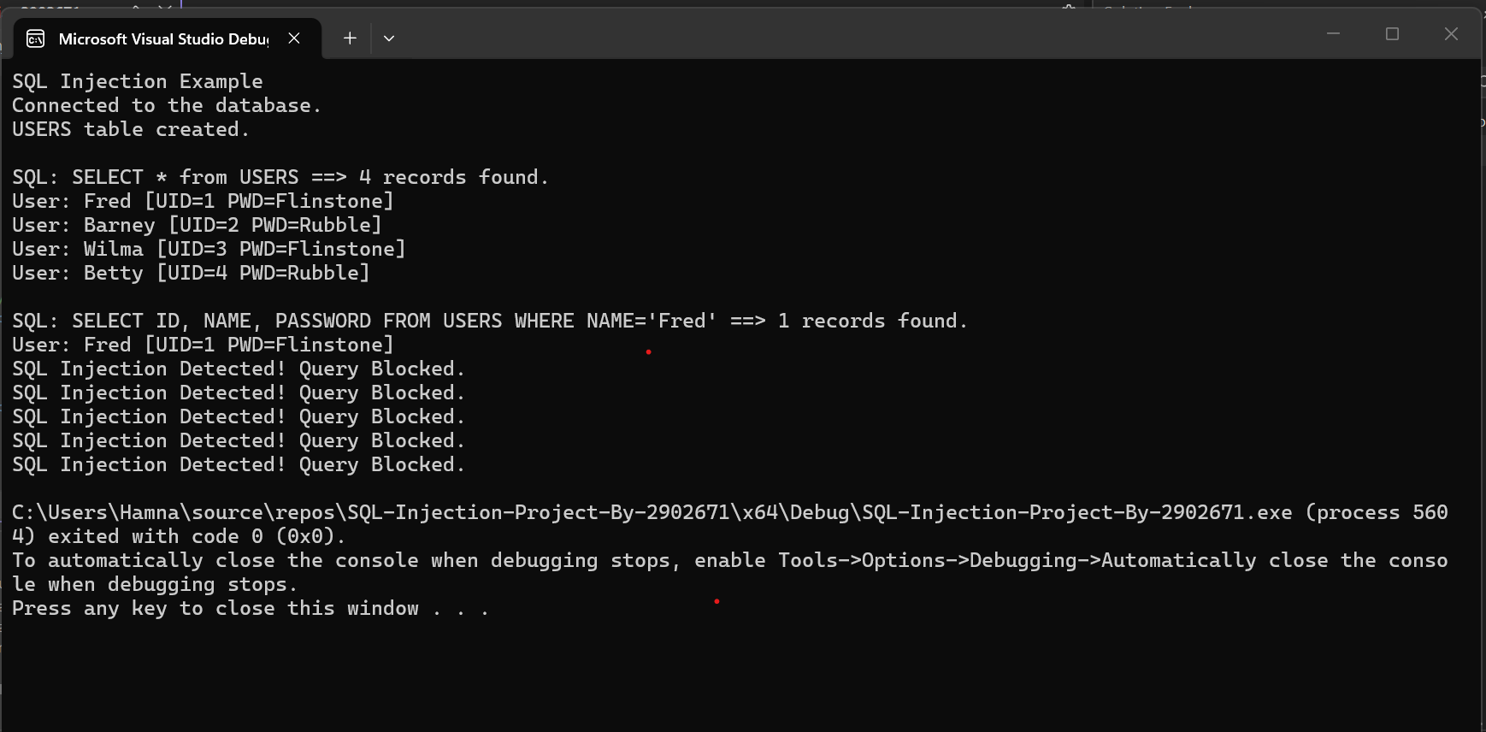

The console output demonstrates:

- Successful execution of valid SQL queries.

- Detection of injected queries.

- Blocking of malicious SQL statements.

Section 2

2-3 Activity: Buffer Overflow Coding

Overview
This section provides execution evidence for the Buffer Overflow Coding activity. The objective of this task was to detect and prevent buffer overflow vulnerabilities caused by unsafe input handling in a fixed-size character array.

Problem Identification

The original program accepted user input directly into a fixed-size buffer:

char user_input[20];

Without validation, input exceeding the buffer size could overwrite adjacent memory. This resulted in unintended modification of sensitive data, such as the account number.

Implementation Approach

To prevent buffer overflow, input validation was introduced before copying data into the buffer.

A helper function was implemented:

bool isOverflow(const std::string& input, size_t bufferSize)

This function compares the length of user input with the size of the buffer to determine if an overflow condition is likely to occur.

Assumption

The solution assumes that overflow occurs when the input length is greater than or equal to the buffer size. It focuses on preventing overflow through input length validation and does not account for more advanced low-level memory manipulation techniques.

Security Logic Applied

The following defensive coding techniques were used:

- Storing input in std::string before processing.

- Validating input length before memory operations.

- Preventing unsafe copying when overflow is detected.

- Using controlled copying (strncpy) for safe memory handling.

- Enforcing null termination.

- Returning failure status when overflow is detected.

Problem Solving And Debugging Summary

During development, the following challenges were encountered:

- Identifying where unsafe input handling caused memory to be overwritten.

- Ensuring detection occurs before copying into the buffer.

- Preserving normal program functionality while blocking unsafe input.

These challenges were resolved by introducing boundary checks and restructuring input handling to validate data before memory operations.

Execution Behavior After Fix

After implementing the solution:

- Valid input was accepted and processed correctly.

- Input exceeding the buffer size was detected.

- Overflow attempts were blocked before memory modification.

- The system displayed the message:
"Buffer Overflow Detected! Input Too Large."

- The account number remained unchanged.

Final Outcome

The implementation successfully prevents buffer overflow by validating user input size before copying data into the fixed buffer. The program ensures that input exceeding the buffer capacity is detected and blocked before any memory modification occurs.

As a result:

- Valid input is accepted and processed correctly.

- Input exceeding buffer size is consistently detected.

- Overflow attempts are blocked before memory overwrite.

- The program displays a clear warning message to the user.

- The calling function is notified through the return status.

- The account number remains unchanged and protected.

This confirms that the system now safely handles user input and prevents unintended memory corruption, ensuring reliable and secure program behavior.

Execution Evidence

Figure 2: Normal Input Execution

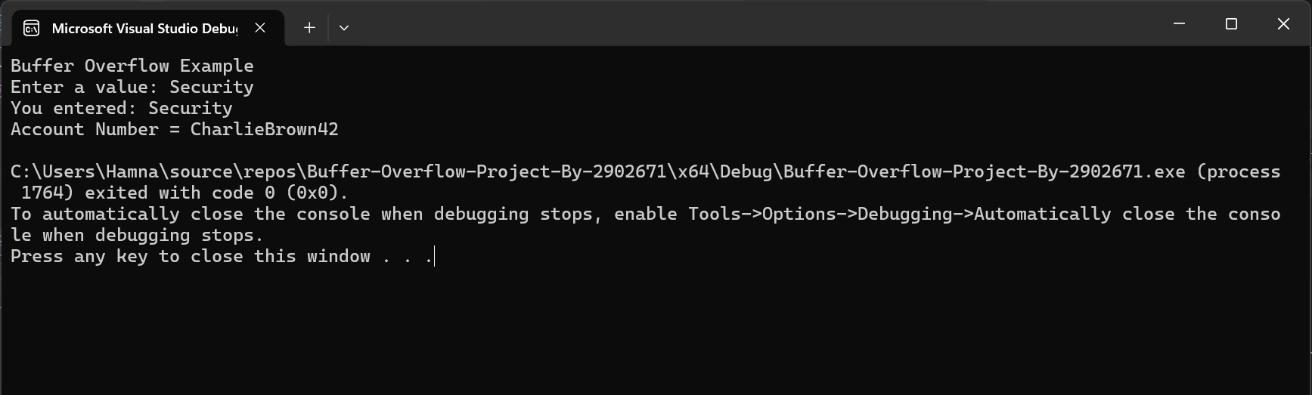

The console output demonstrates successful handling of valid input without affecting the account number.

Figure 3: Buffer Overflow Detection

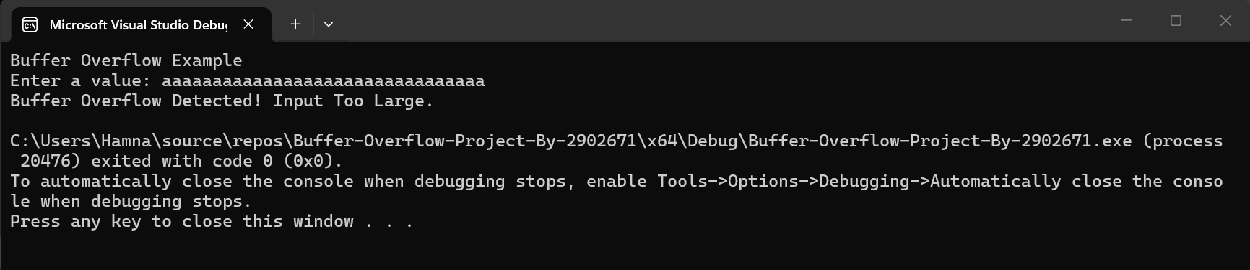

The console output demonstrates detection and blocking of input exceeding buffer limits, preventing modification of the account number.

Conclusion

Both SQL injection and buffer overflow vulnerabilities were successfully mitigated through structured input validation and defensive coding practices.

The execution evidence demonstrates that:

- Malicious input is detected and blocked.

- Safe input is processed correctly.

- Sensitive data remains protected.

These implementations reflect secure coding practices essential for developing reliable and secure software systems.

AI Usage Acknowledgment

I used OpenAI as a supplementary learning and development tool to assist with understanding secure coding concepts, debugging, and implementing solutions related to SQL injection and buffer overflow prevention. It was also used to help structure and refine the written documentation. All code implementations, design decisions, and final modifications were independently reviewed, tested, and validated to ensure accuracy and functionality.

Acronyms And Full Forms

- API - Application Programming Interface

- DB - Database

- DiD - Defense In Depth

- IDE - Integrated Development Environment

- OWASP - Open Web Application Security Project

- SQL - Structured Query Language

References

- Acunetix. (n.d.).
Buffer Overflow Vulnerabilities.
https://www.acunetix.com/vulnerabilities/web/buffer-overflow/

- Acunetix. (n.d.).
SQL Injection Attacks.
https://www.acunetix.com/websitesecurity/sql-injection/

- Microsoft. (n.d.).
SQL Injection.
https://technet.microsoft.com/en-us/library/ms161953(v=sql.105).aspx

- Open Web Application Security Project (OWASP). (n.d.).
Buffer Overflow.
https://owasp.org/www-community/vulnerabilities/Buffer_Overflow

- Open Web Application Security Project (OWASP). (n.d.).
SQL Injection Prevention.
https://owasp.org/www-community/attacks/SQL_Injection

- Southern New Hampshire University. (2026).
CS-405 Module Two SQL Injection Activity Guidelines and Instructions.
Brightspace.

- Southern New Hampshire University. (2026).
CS-405 Module Two Buffer Overflow Activity Guidelines and Instructions.
Brightspace.

- Southern New Hampshire University. (2026).
Module Two Announcement: Defense in Depth.
Brightspace.

- W3Schools. (n.d.).
C++ Strings and Input Handling.
https://www.w3schools.com/cpp/cpp_strings.asp

- W3Schools. (n.d.).
SQL Injection Tutorial.
https://www.w3schools.com/sql/sql_injection.asp

