CS-405 Secure Coding

Module 5

Assignments Work Proof

Execution Evidence

Submitted By:
HAMNA KHALID
ID: 2902671
hamna.khalid@snhu.edu

Submitted To:
PROFESSOR BEN BATTLE
b.battle2@snhu.edu

Southern New Hampshire University
Sunday, June 07, 2026

Module Five

Execution Evidence

Section 1

5-2 Activity: Encryption Coding

Overview

This section provides execution evidence for the Encryption Coding activity. The objective of this task was to implement XOR-based encryption in a C++ application, along with file input and output operations, to ensure secure transformation and storage of data.

Problem Identification

The original program could not encrypt sensitive data and did not implement proper file handling mechanisms. Additionally, it did not support loading input data from a file or saving processed data in a structured format. These limitations made the system insecure and unable to demonstrate data protection techniques.

Implementation Approach

To address these issues, XOR-based encryption was implemented using a repeating key. The encryption logic was applied character-by-character across the entire input string.

The following core components were developed:

- XOR encryption and decryption using modular key indexing.

- File reading using ifstream and stringstream.

- File writing using ofstream.

- Extraction of structured data (student name) from input file.

The same encryption function was used for both encryption and decryption, ensuring consistency and correctness.

Security Logic Applied

The following secure coding and defensive programming techniques were implemented:

- Use of XOR encryption to transform sensitive data.

- Application of modular arithmetic to handle variable key lengths.

- Input validation using assertions to prevent invalid processing.

- Structured file formatting to maintain data integrity.

- Separation of concerns through distinct functions for encryption, reading, and writing.

- Error handling for file operations to prevent silent failures.

Problem Solving And Debugging Summary

During development, several challenges were encountered:

- The program initially failed to read the input file due to incorrect working directory configuration.

- An assertion failure (source_length > 0) occurred when the file content was empty.

- Incorrect file path formatting caused compilation errors due to improper quotation marks and unescaped backslashes.

- A compiler warning related to the localtime function required resolution.

These issues were resolved by:

- Correctly placing the input file in the appropriate working directory.

- Using a relative file path instead of an improperly formatted absolute path.

- Applying _CRT_SECURE_NO_WARNINGS to resolve compiler warnings.

- Verifying file content before processing.

Execution Behavior After Fix

After implementing the solution:

- The program successfully read the input data file.

- Encryption was applied correctly across all characters.

- Encrypted data was saved in the specified file format.

- Decryption restored the original input data accurately.

- Output files were generated successfully without errors.

Final Outcome

The implementation successfully demonstrates secure data transformation using XOR encryption along with proper file handling techniques.

As a result:

- Data is securely encrypted and decrypted.

- File input and output operations function correctly.

- Program execution is stable and free of runtime errors.

- Structured output format is maintained.

- Secure coding practices are applied effectively.

Execution Evidence

Figure 1: Encryption And Decryption Output

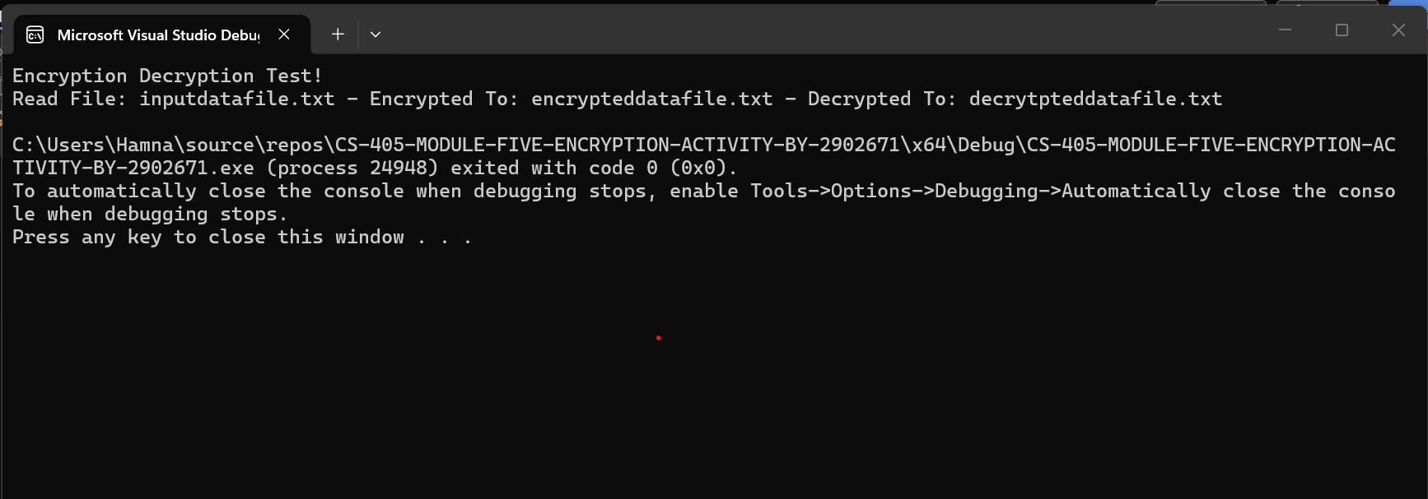

The output demonstrates:

- Successful reading of the input file.

- Proper encryption of data.

- Accurate decryption back to the original content.

- Correct generation of encrypted and decrypted files.

Evaluation

The implementation of XOR-based encryption in this activity was effective in demonstrating how data can be securely transformed and restored using a reversible encryption technique. By applying character-by-character encryption with a repeating key, the program ensured that both encryption and decryption processes remained consistent and reliable.

A key strength of this implementation was the correct handling of key length using modular arithmetic. This allowed the encryption logic to function correctly regardless of input size, ensuring that all characters were processed without errors and maintaining data integrity.

The file handling functionality significantly improved the robustness of the application. Successfully implementing file input and output operations in the required structured format demonstrated a strong understanding of data processing and organization. The ability to generate encrypted and decrypted files while preserving structure reflects practical, real-world application of secure data handling.

The debugging process further reinforced critical development practices. Resolving issues related to working directories, file paths, and assertion failures highlighted the importance of environment configuration and validation. Addressing compiler warnings and correcting string formatting errors improved both the stability and maintainability of the code.

Overall, the solution meets all assignment objectives by successfully implementing encryption logic, file processing, and structured output generation. The program demonstrates strong adherence to secure coding principles, including data protection, validation, and error prevention, and provides a practical foundation for applying encryption in real-world systems.

Section 2

5-3 Activity: Static Code Analysis

Overview

This section provides execution evidence for the Static Code Analysis activity. The objective of this task was to analyze a C++ source code file using both Visual Studio and Cppcheck to identify vulnerabilities, compare analysis results, and evaluate risks to improve code security and quality.

Problem Identification

Without proper static analysis, critical vulnerabilities in code may go undetected, leading to runtime failures, undefined behavior, or security risks.

Examples include:

- Buffer overflows caused by improper memory handling.

- Use of uninitialized variables.

- Pointer misuse leading to dangling references.

- Improper exception handling that can terminate execution.

Implementation Approach

Two static analysis tools were used to evaluate the source code:

- Visual Studio built-in analysis tool.

- Cppcheck static analysis tool.

The analysis process included:

- Running Visual Studio to identify warnings and basic issues.

- Running Cppcheck to generate an XML report of deeper vulnerabilities.

- Comparing outputs from both tools.

- Identifying overlapping and unique issues reported by each tool.

Security Logic Applied

The following analysis and validation strategies were applied:

  - Detection of memory safety issues such as buffer overflows.

  - Identification of uninitialized variables.

  - Detection of pointer misuse and unsafe memory handling.

  - Analysis of improper exception handling (noexcept violations).

  - Evaluation of iterator safety and container operations.

  - Comparison of multiple tools to ensure comprehensive vulnerability detection.

Problem Solving And Debugging Summary

During the analysis process, the following challenges were encountered:

- Interpreting warnings generated by Cppcheck, including informational messages.

- Differentiating between critical vulnerabilities and low-risk issues.

- Understanding differences in results between Visual Studio and Cppcheck.

These issues were resolved by:

- Focusing on security-relevant warnings.

- Reviewing the context of each issue.

- Comparing outputs from both tools to validate findings.

Execution Behavior After Implementation

After completing the static code analysis:

- Visual Studio identified issues such as buffer overrun and uninitialized variables.

- Cppcheck identified deeper issues, including pointer misuse and exception handling violations.

- Multiple vulnerabilities not visible during normal execution were detected.

- Code quality issues affecting maintainability were identified.

Final Outcome

The implementation successfully demonstrates the importance of static code analysis in identifying vulnerabilities and improving software security.

As a result:

  - Critical issues were identified early in development.

  - Differences between analysis tools were clearly understood.

  - Code quality and security awareness were improved.

  - Potential runtime failures and security risks were reduced.

The implementation successfully demonstrates the identification of vulnerabilities and evaluation of code quality through comprehensive static code analysis.

Execution Evidence

Figure 2: Static Code Analysis Results (Visual Studio Output)

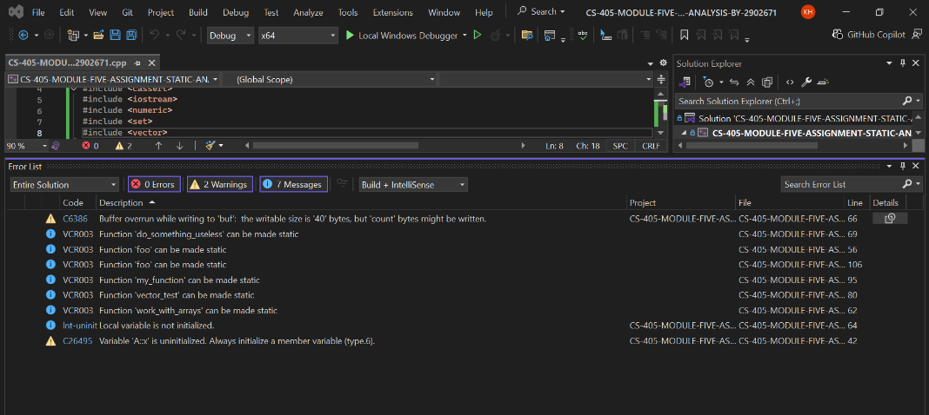

The output demonstrates:

  - Detection of memory-related issues such as buffer overruns.

  - Identification of logical and security vulnerabilities.

  - Differences between Visual Studio and Cppcheck analysis results.

  - Comprehensive validation of code quality and security risks.

Evaluation

The static code analysis activity demonstrated the effectiveness of using multiple tools to identify vulnerabilities and improve overall code quality. Visual Studio and Cppcheck each provided valuable insights, but their strengths differed in terms of depth and focus.

Visual Studio primarily identified basic issues such as buffer overruns and uninitialized variables, which are important for ensuring memory safety and preventing immediate runtime errors. These warnings are useful during development, as they provide quick feedback on common coding mistakes.

In contrast, Cppcheck identified more complex and deeper vulnerabilities, including pointer misuse, improper exception handling, and unsafe iterator usage. These issues are critical because they may not be visible during normal execution but can lead to undefined behavior, system crashes, or security risks in real-world applications.

A key observation from this activity is that relying on a single analysis tool is not sufficient for secure coding. Visual Studio focuses on runtime-related concerns, while Cppcheck provides a more comprehensive analysis of logical and security issues. By combining both tools, a more complete understanding of the codebase is achieved.

Additionally, the activity reinforced the importance of evaluating risks associated with each issue and applying appropriate mitigation strategies. Identifying vulnerabilities early in the development process helps prevent costly fixes later and improves overall software reliability.

Overall, this activity highlights the critical role of static code analysis in secure software development. It supports best practices by enabling developers to detect vulnerabilities early, improve code quality, and build more secure and maintainable systems.

Conclusion

Both encryption implementation and static code analysis were completed to improve data security, system reliability, and overall code quality.

The execution evidence demonstrates that:

  - Sensitive data is securely transformed using XOR-based encryption and accurately restored through decryption.

  - File handling operations are implemented correctly, ensuring structured input and output processing.

  - Code vulnerabilities are effectively identified using static analysis tools such as Visual Studio and Cppcheck.

  - Logical errors, memory safety issues, and security risks are detected and analyzed before runtime execution.

  - System stability, data protection, and code quality are significantly improved through secure coding practices.

These implementations reflect essential secure coding principles aligned with industry standards and support shift-left security practices by identifying and mitigating vulnerabilities early in the development lifecycle.

AI Usage Acknowledgment

I used OpenAI as a supplementary learning and development tool to assist with understanding encryption concepts, static code analysis, debugging, and structuring documentation. All code implementations, analysis results, and final outputs were independently tested and verified to ensure correctness and alignment with course requirements.

Acronyms And Full Forms

- IDE - Integrated Development Environment

- XML – Extensible Markup Language

- XOR – Exclusive OR

References

- Microsoft. (n.d.).
C++ File Handling and Input/Output Streams.
https://learn.microsoft.com/en-us/cpp/standard-library/input-output-streams

- Open Web Application Security Project (OWASP). (n.d.).
Secure Coding Practices.
https://owasp.org

- Southern New Hampshire University. (2026).
CS-405 Module Five Announcement: AAA Security and Defense in Depth.
Brightspace.

- Southern New Hampshire University. (2026).
CS-405 Module Five Encryption Activity Guidelines and Rubric.
Brightspace.

- Southern New Hampshire University. (2026).
CS-405 Module Five Learning Resources and Instructions.
Brightspace.

- Southern New Hampshire University. (2026).
CS-405 Module Five Static Code Analysis Activity Guidelines and Rubric.
Brightspace.

