First create a service 🡺 ng generate service services/StudentRepository

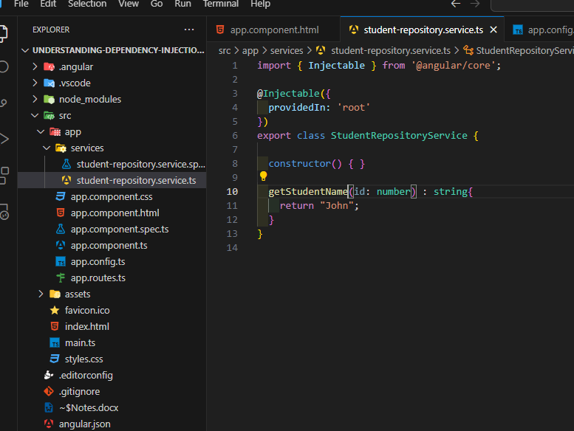

Now import “StudentRepositoryService” in app.config.ts file in order to use in every component.

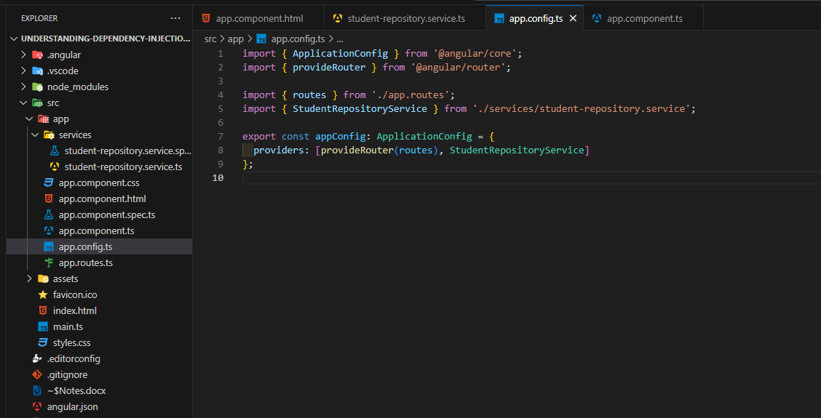

Now inject service in app component using constructor injection.

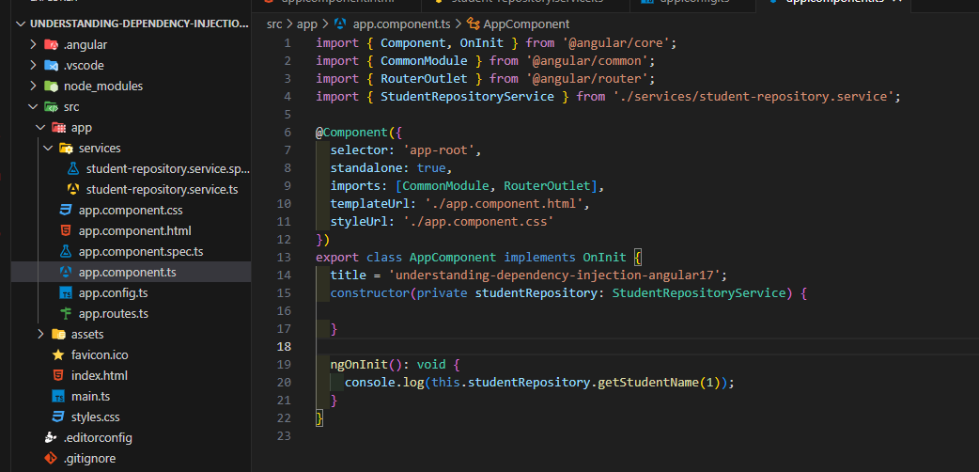

And here you will see the result on chrome console ☺

Now to check whether the service is available in all components, we have to create a new component.

Create a new component 🡺 ng generate component components/Login

Do same things for that component

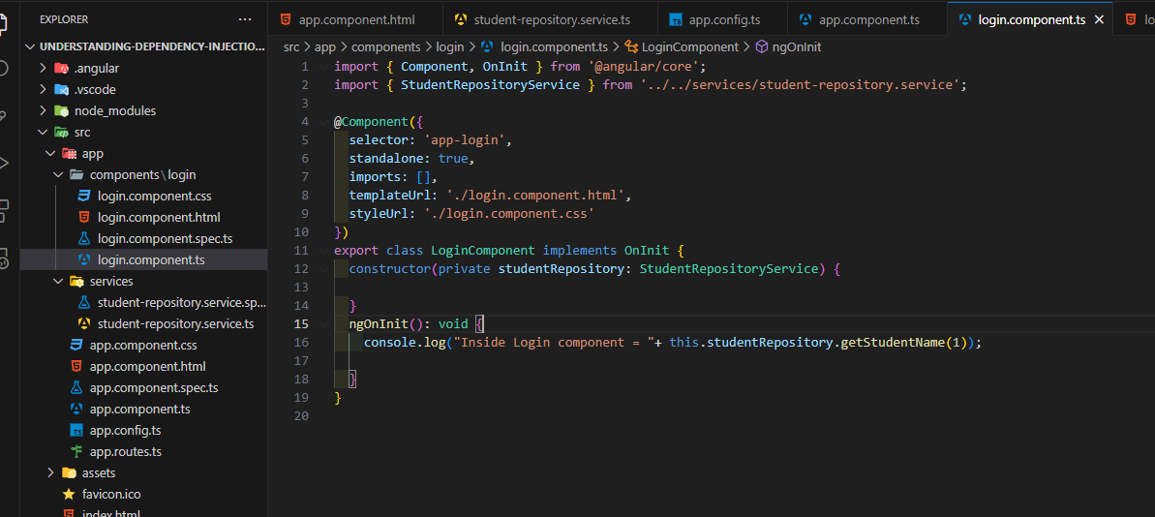

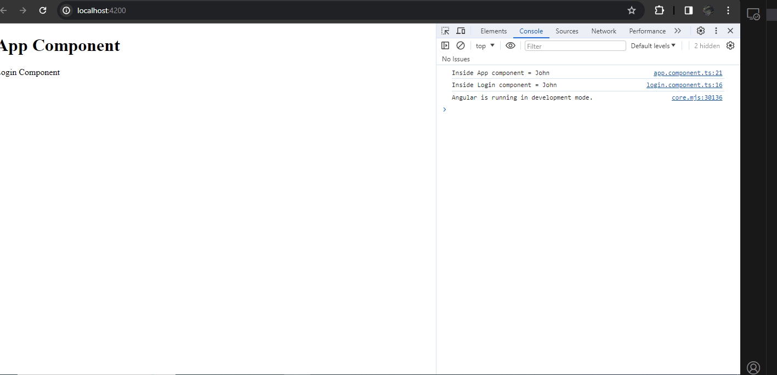

Now we are going to inject dependency in a specific component and not globally.

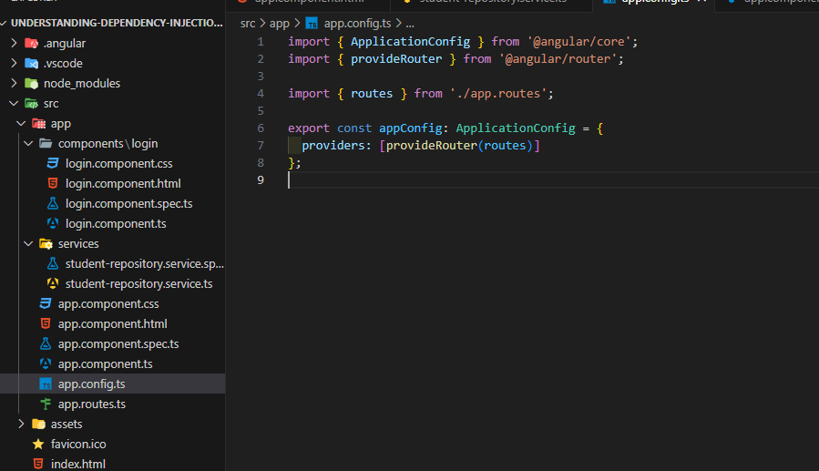

As you see, I removed StudentRepositoryService from providers array And still everything is working fine.

=====================================REPOSITORY PATTERN IN ANGULAR 17==============

Create following folder hierarchy.

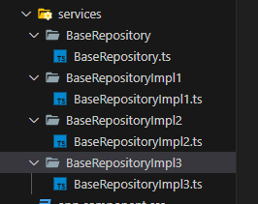

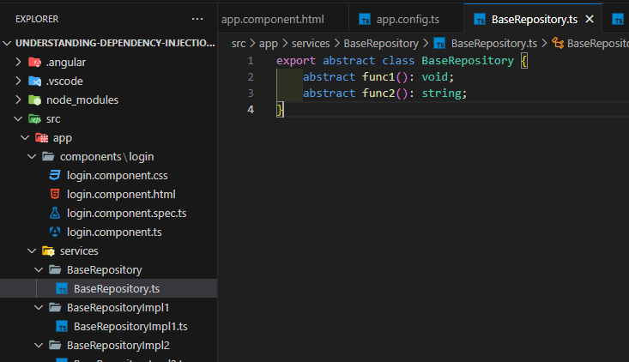

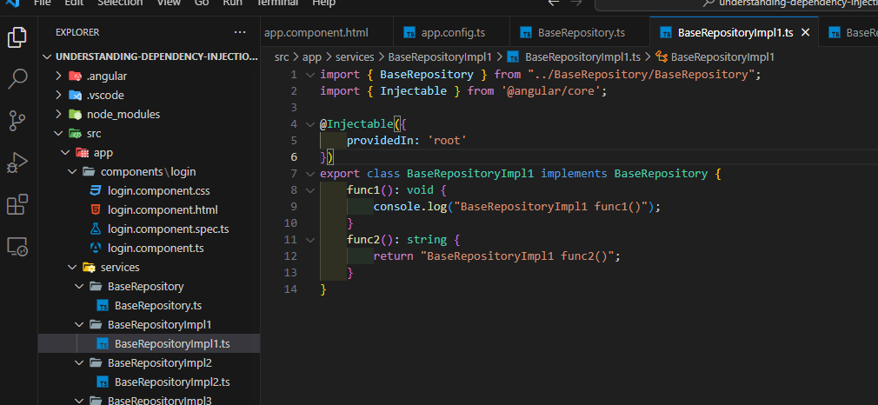

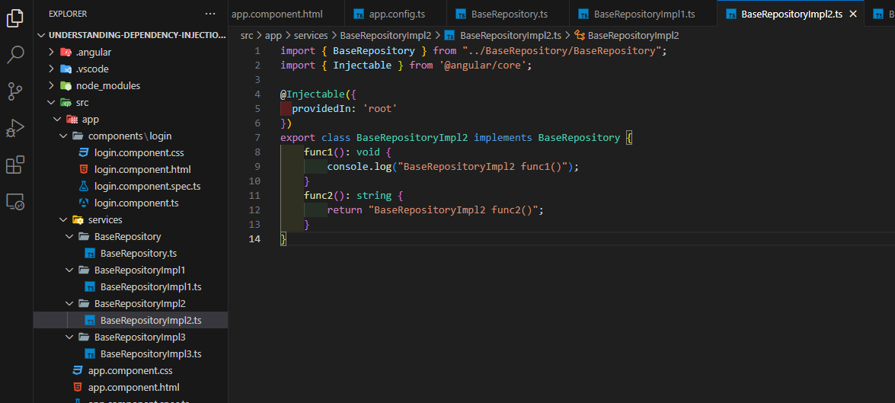

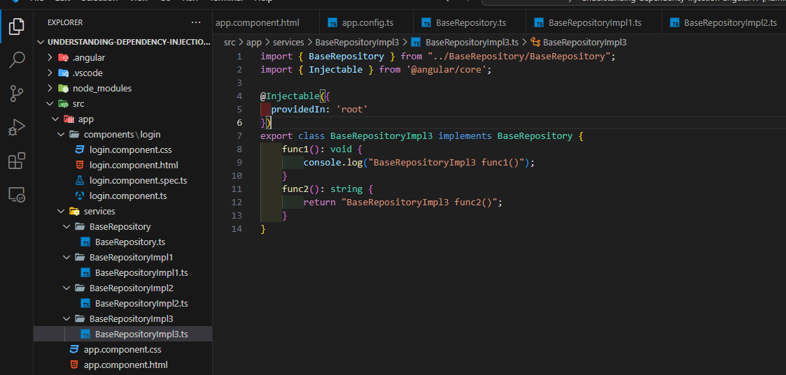

Suppose we want to use BaseRepositoryImpl3 implementation of BaseRepository. Also remove “student-repository-service” as we don’t need them anymore.

