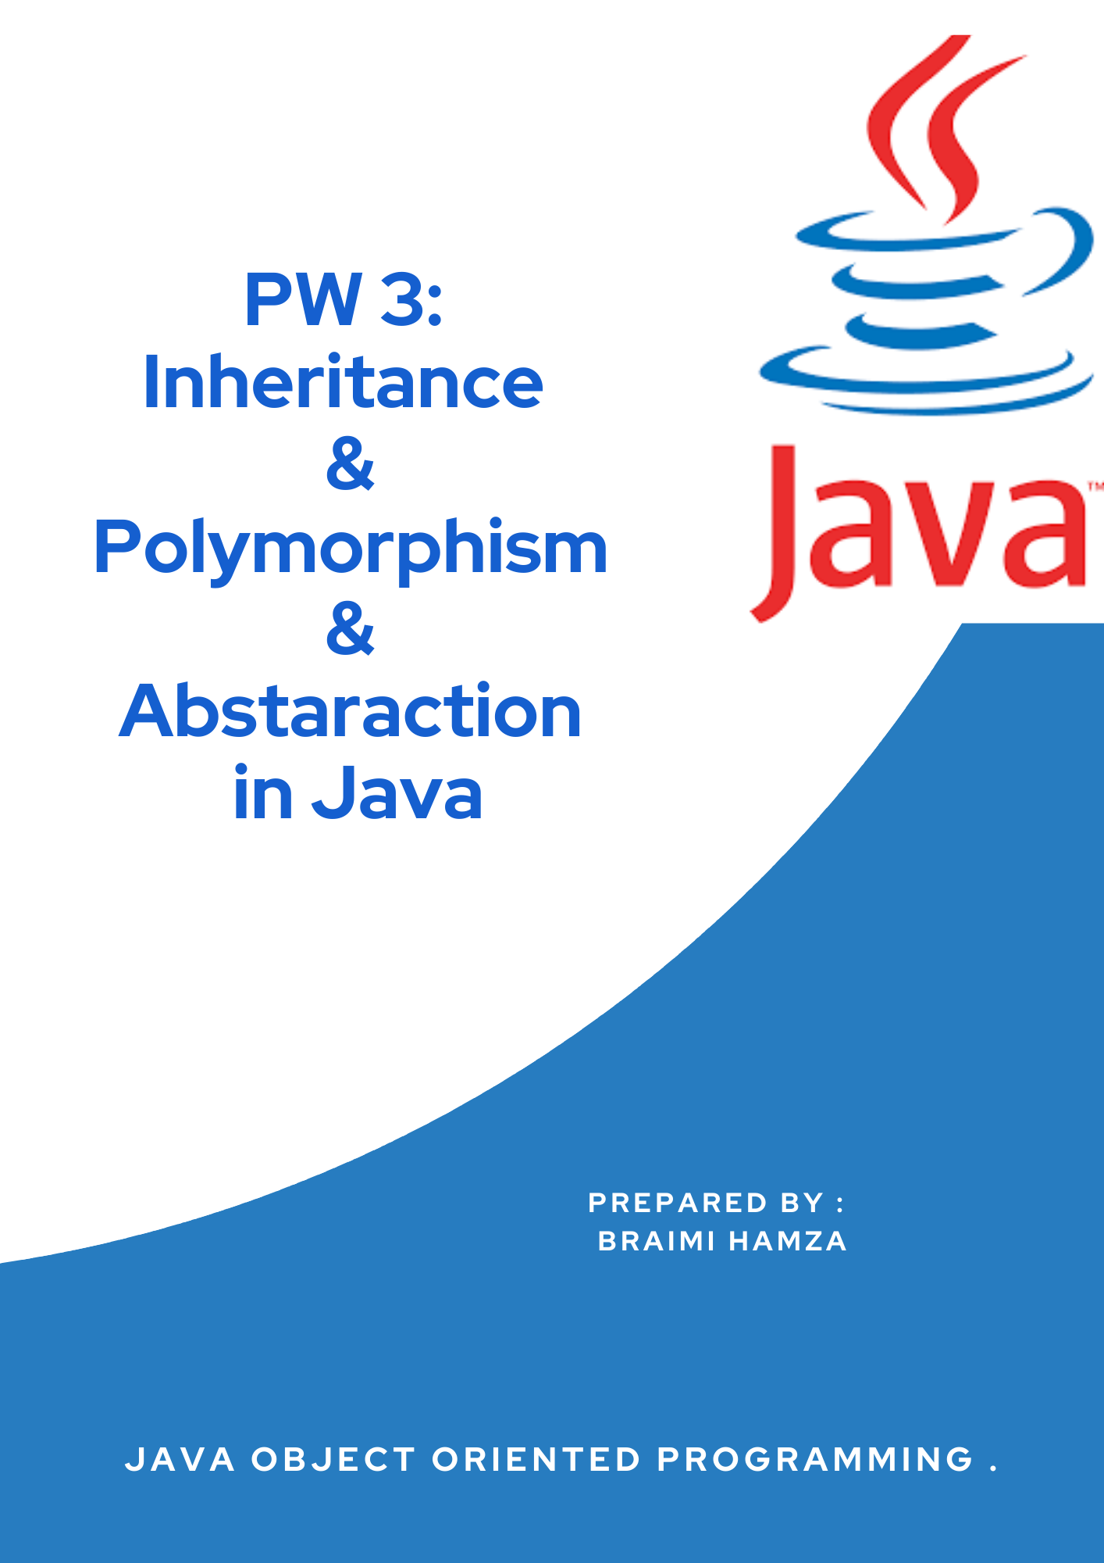

1

# What is Java?

Java Introduction

Java is a popular programming language, created in 1995.

It is owned by Oracle, and more than **3 billion** devices run Java. It is used for:

* Mobile applications (especially Android apps)
* Desktop applications
* Web applications
* Web servers and application servers
* Games
* Database connection
* And much, much more!

# Why Use Java?

Java works on different platforms (Windows, Mac, Linux, Raspberry Pi, etc.) It is one of the most popular programming languages in the world

It has a large demand in the current job market It is easy to learn and simple to use

It is open-source and free

It is secure, fast and powerful

It has a huge community support (tens of millions of developers)

Java is an object-oriented language which gives a clear structure to programs and allows code to be reused, lowering development costs

As Java is close to [C++](https://www.w3schools.com/cpp/default.asp) and [C#](https://www.w3schools.com/cs/default.asp), it makes it easy for programmers to switch to Java or vice versa

# Exercise 1:

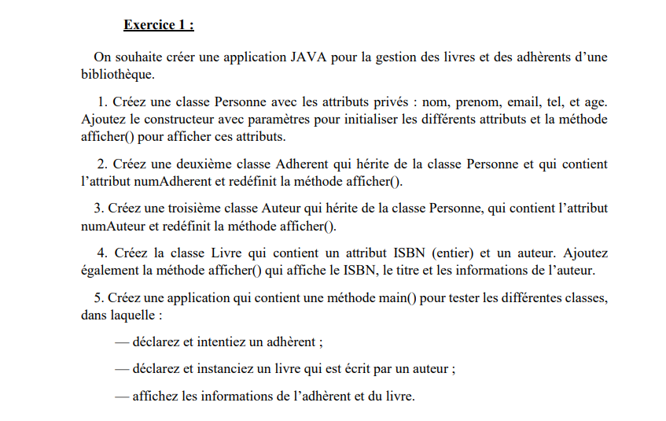

*Figure 1: Exercise 1*

* *In this exercise, we will develop a simple java application that manage books and authors*

*Of a library.*

***Step 1: Conception***

*The*[*UML*](https://en.wikipedia.org/wiki/Unified_Modeling_Language)*Class diagram is a graphical notation used to construct and visualize object-oriented systems. A class diagram in the Unified Modeling Language (UML) is a type of static structure diagram that describes*

*the structure of a system by showing the system's:*

* *classes,*
* *their attributes,*
* *operations (or methods),*
* *and the relationships among objects*

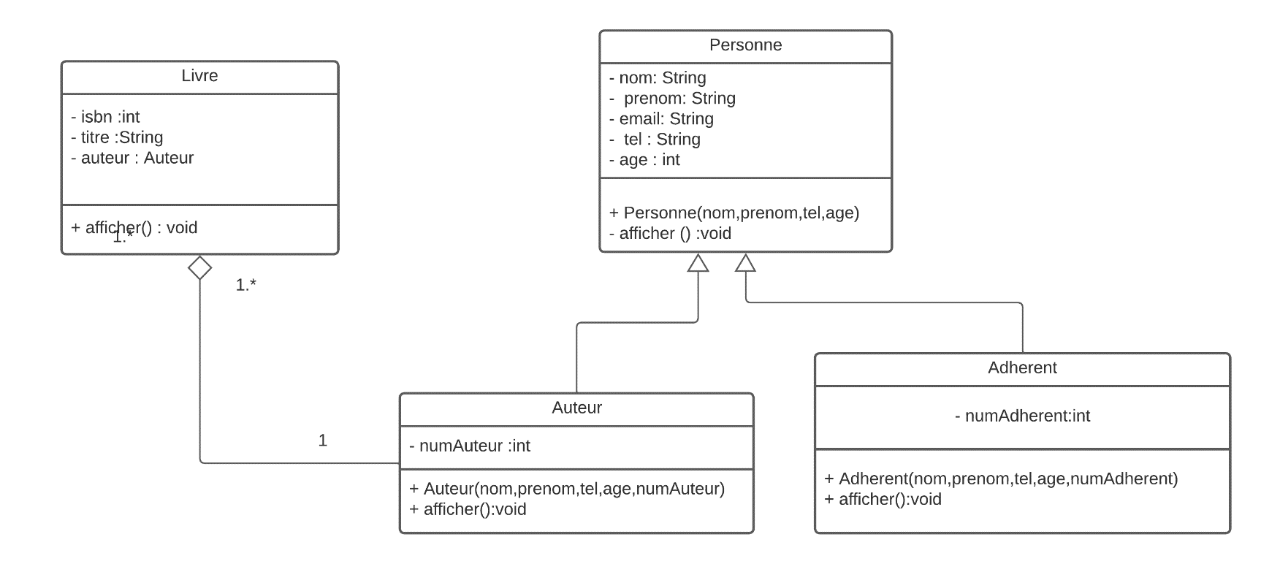

*Figure 2: UML Class Diagram*

*As Showed in the picture above there three classes. Person class is the parent of two class (Adherent – Author), So the connection between Person class and the other class we call this inheritance.*

*Author-----<> Livre: we call this association aggregation*

***Step 2: Development***

1. ***Response class:***

*In this class we automatically generate the following methods:*

***Constructors****: A constructor in Java is a****special method****that is used to initialize objects. The constructor is called when an object of a class is created. It can be used to set initial values for object attributes.*

***afficher() :*** *This method in Java that returns the value given to it in string format. Hence, any object that this method is applied on, will then be returned as a string object.*

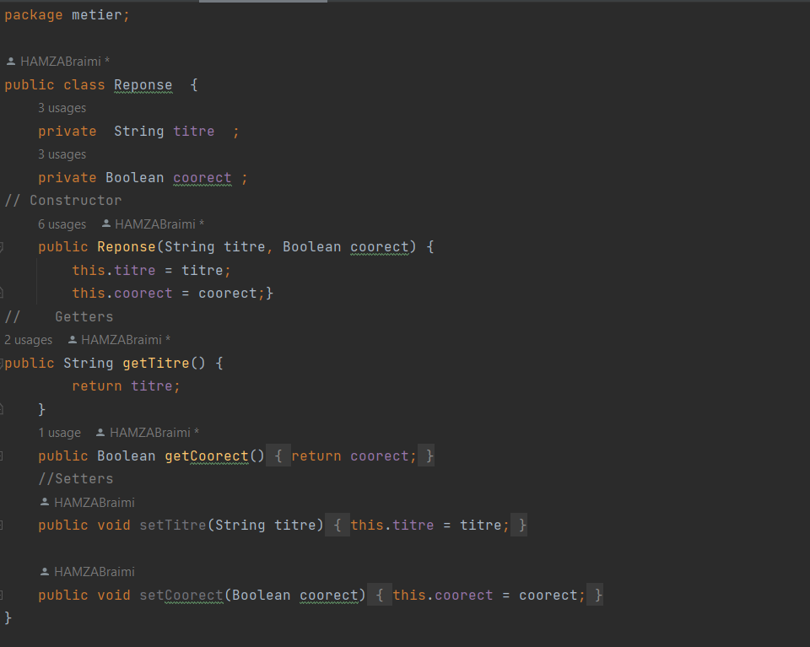

*Figure 3: Response Class*

1. ***Question class:***

*Figure 4: Question Class*

1. ***Questionnaire class:***

*Figure 5: Question Class*

* *StartExam is the main method that will display the questions + and calculate the score*

# Conclusion

*Everything in Java is associated with classes and objects, along with its attributes and methods. For example: in real life, a car is an object. The car has****attributes****, such as weight and color, and****methods****, such as drive and brake.*