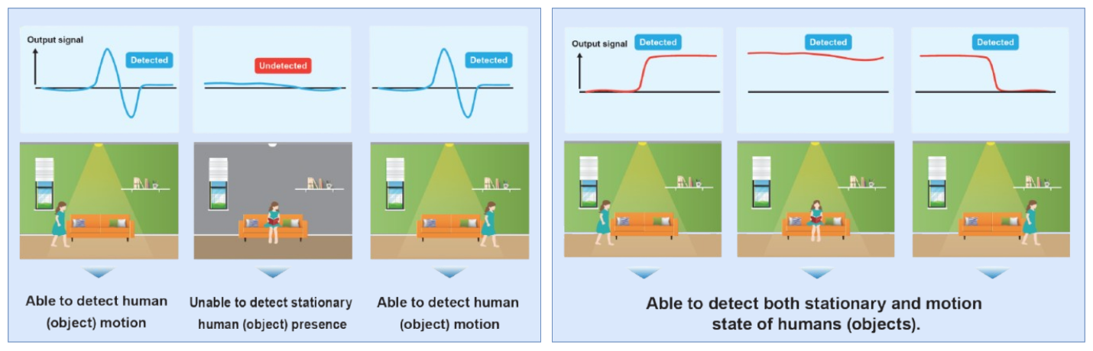

Figure 1: Visual comparison of PIR and thermal sensors for human presence detection [1]

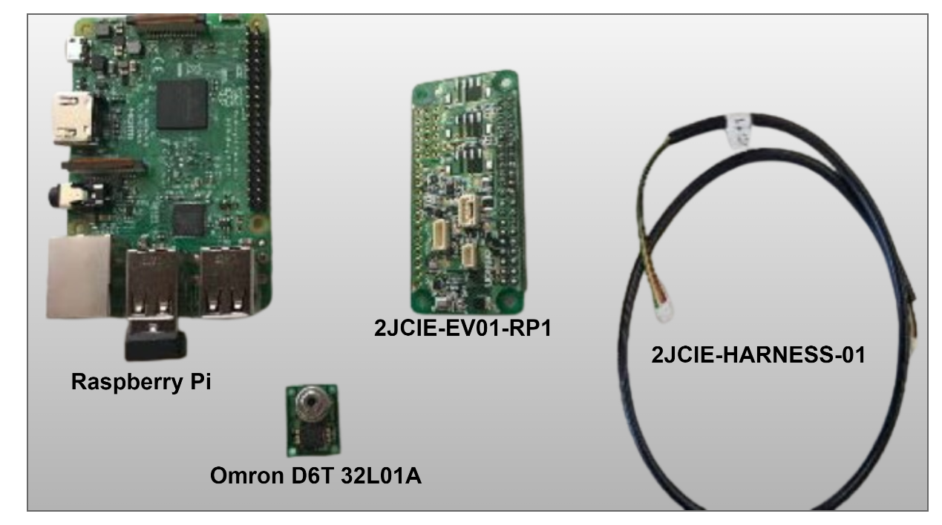

Figure 2: Key Hardware Components [2]

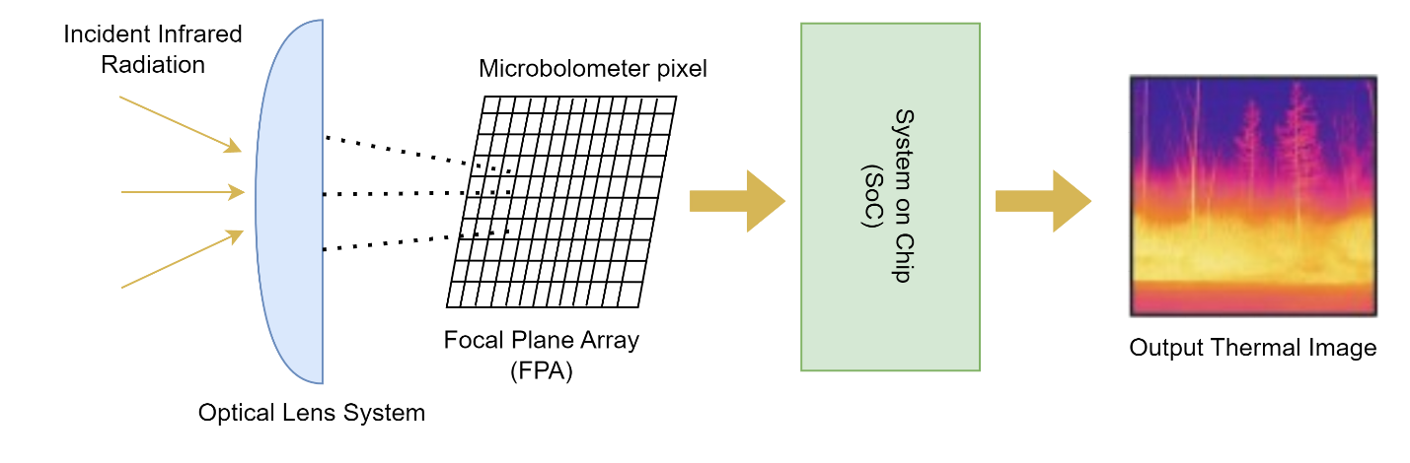

Figure 3: Working of Bolometer Based Thermal Sensor [3]

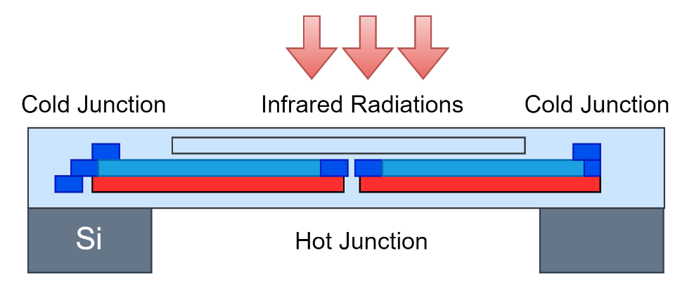

Figure 4: Thermopile sensor detection principle [1]

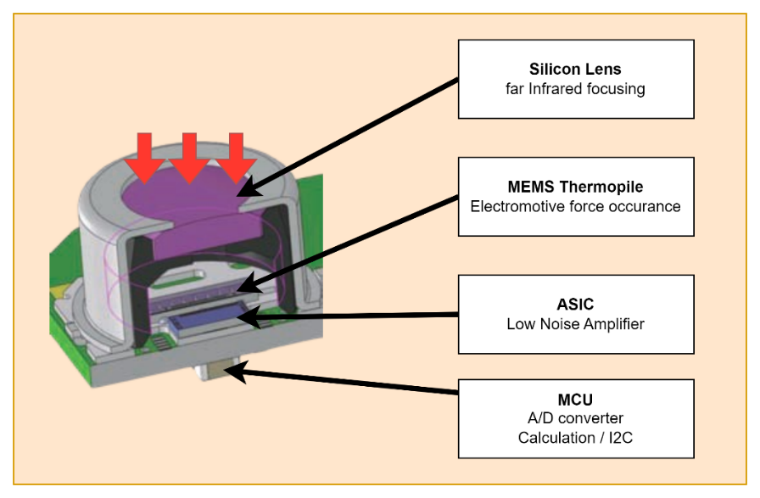

Figure 5: MEMS Thermopile Sensor [1]

References

1. <https://omronfs.omron.com/en_US/ecb/products/pdf/en_D6T_catalog.pdf>
2. <https://omronfs.omron.com/en_US/ecb/products/pdf/en_D6T_users_manual.pdf>
3. <https://ieeexplore.ieee.org/document/10014654>