**PROJECT REPORT**

Submitted by

**Hamzah Khan**

**RA1911031010087**

## NETWORK DESIGN PROPOSAL FOR A FICTIONAL

## UNIVERSITY

## SRM UNIVERSITY, KTR

**ABSTRACT**

This project is based on the “trending” field of Networking and Data Communications. People nowadays use the term for almost new technology that comes out and slowly fizzles out.

But Networking is the only “real” trending field, along with Data Structures and Algorithms, and Machine Learning. Both have existed almost since the advent of Computer Science. Both have the best of the best in CS working in the fields, huge wads of cash are thrown at the fields, and even bigger wads of cash are the result.

I found, from various forums and site around India and abroad (for example – MNIT, UCB, Stanford, Dartmouth, BITS, etc.) that use up huge amounts of green paper on extremely inefficient networks, that could have been diverted elsewhere, for example, on purchasing commercial licenses for software (such as Packet Tracer, AutoCAD, Windows, etc.), improving the infrastructure, PR/Marketing, and so on.

This project is a result of not inconsiderable toil. I have attempted to create a template that can be applied to *all* universities that do not have a very large size. I have given all the basic information necessary for setting up a network – the devices used, the network topology diagram, requirement analysis and so on.

I hope that I have convinced the reader that the field is interesting, as is the idea behind the project. The rest, I leave up to you.

**INTRODUCTION TO PROJECT**

**Introduction to Networking**

Each of the past three centuries was dominated by a single new technology. The highlight of the 18th century was the automation, bought about by the Industrial Revolution. The 19th century was the age of the steam engine, pioneered by James Watt 20th century, the key technology was gathering, processing, and distribution of information. Among other developments, we saw the installation of global telephone networks, the invention of both radio and TV, the birth and unforeseen (and exponential) growth of the Computer, the launching of communication satellites, and, of course, the Internet.

As a result of technological progresses, differences between collecting, transporting, storing, and processing information are quickly disappearing. Organizations with hundreds of offices spread over a wide geographical area can examine the current status of even their most remote outpost at the push of a button. The demand for ever more sophisticated information processing is growing even faster.

Although the computer industry is still young compared to other industries (e.g., automobiles and airline industry), computers have made amazing progress in a (relatively) short time-frame. During the first 20 years of their existence, computer systems were extremely centralized, usually within one large room. Not infrequently, this room had glass walls, through which visitors could gaze and marvel at the electronic wonder inside. A medium-sized company or university (for example, Dartmouth) *may* have had one or two computers, while very large institutions (for example, the Smithsonian Museum) had at *most* a few dozen. The idea that within less than 35 years, vastly more powerful computers smaller than the stamps used in postcards, would be mass produced by the *billions* was pure science fiction.

The merging of computers and communications has had a profound influence on the way computer systems are organized. The pre-dominant concept of the “computer center” as a single room with a large computer to which users brought their work, which an operator fed into the computer, is now obsolete. The old model of a single computer serving all of the organization’s needs has been replaced by one in which a large number of separate, but still interconnected computers, do the job.

These systems are called ***computer networks***. Two computers are said to be interconnected if they are able to exchange information. The connection need not be via a copper wire - fiber optics, microwaves, IR, and even satellites can be used (and are in use). They are usually connected together to make larger networks, with the Internet being the most well-known example of a network of networks.

**Introduction to Project**

Have you ever wondered *how* the networks you use daily – the ones supplied by BSNL, MTNL, Airtel, Cyberoam, Reliance, and so on – work the way they do?

Not the *software* part (HTML, CSS, MySQL, JS, PHP, etc.). The *hardware* part.

If the reader has read the introduction provided for a basic and brief understanding of networking, he may wonder about the *devices*, and the way the devices are *arranged* to form a network.

The networks used in almost all the universities around India are extremely inefficient (cost-bandwidth ratio is very high). So, keeping this in mind, the project is a basic design, a *template*, if you may, that is cost-efficient, while at the same time, supplies a decent bandwidth to the network.

It can be used both for designing a small to medium-sized network, and can even be used for upgrading a network. In case it is not obvious, the design is provided free-of-charge, with lifetime updates, under the GNU General Public License v3 – which means that if you want to supply the project under your own company, you can, but just include this report with the design.

Again, in case it is not obvious, the design is a PKT File – it can *only* be opened by Cisco Packet Tracer. You will need an account on <http://www.netacad.com/> , from where you can download

**MOTIVATION**

I got motivation for doing this project for various reasons some of the reasons were

* The things which me and my team were going to learn from this project

1. Professional
2. Broadened my horizons - learnt that there is more to life than studies.
3. Managed to set deadlines, and abide by them – so that there is no undue pressure near the end.
4. Technical
5. Learned the OSI and the TCP/IP model in great detail.
6. Learned about various protocols, and why they are (or not) in use.
7. Learned to build complex networks using Packet Tracer.
8. Learned in great detail about various components of a network – switches, routers, servers, connecting wires, etc.

* Project’s scope

1. The project is primarily intended for small organizations, which include startups & other organizations, and small to medium-sized universities.
2. The project has been made keeping in mind both cost and efficiency.
3. Lastly, the project can be used both as a blank slate, and for upgrading a pre-existing network.

* And last but not the least the utility of my project on which I spent my valuable time.

1. I firmly believe that the template provided by this design is applicable for *any* network – provided it is *not* large enough.

**DESIGN ARCHITECTURE**

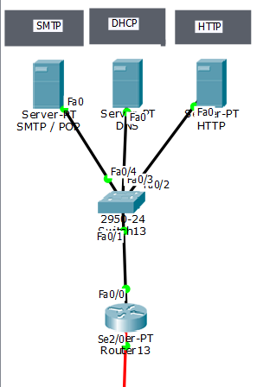

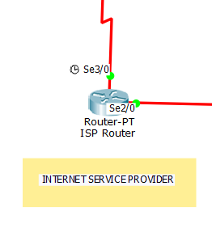

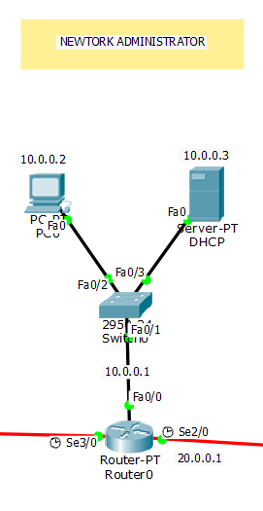

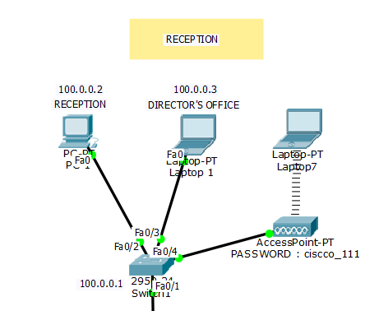

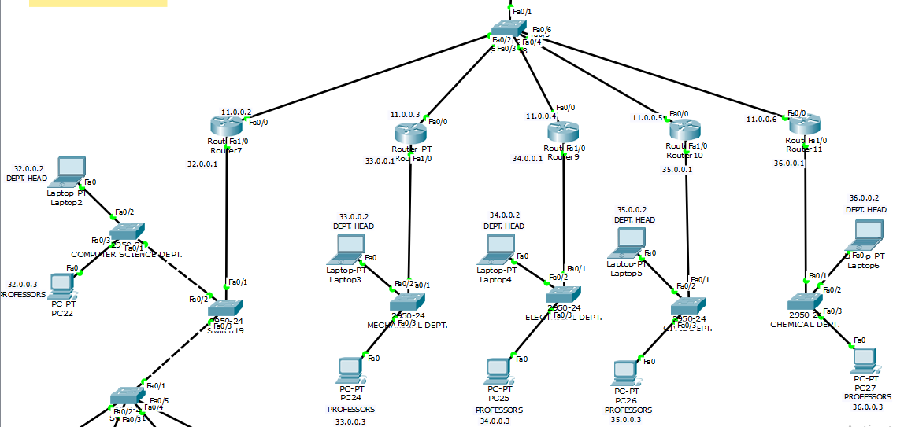

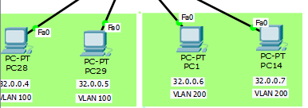





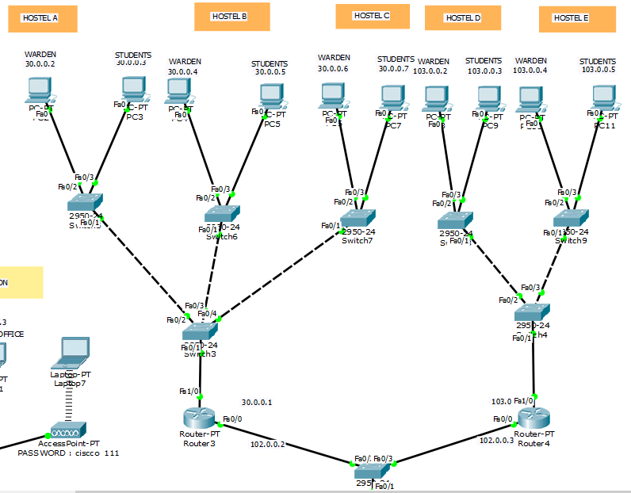

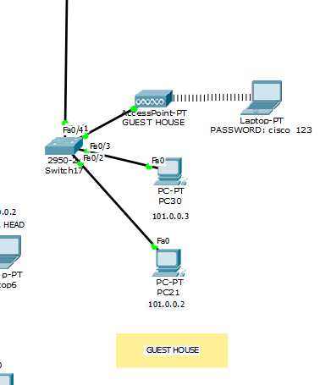

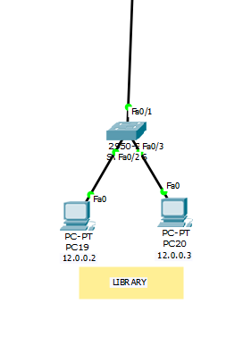

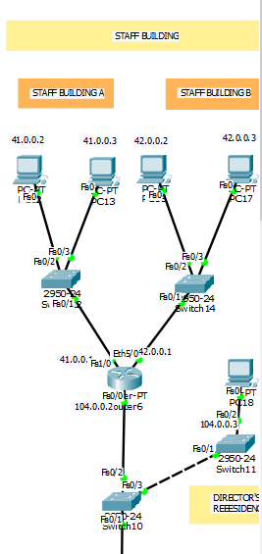

**CAMPUS DIAGRAM**

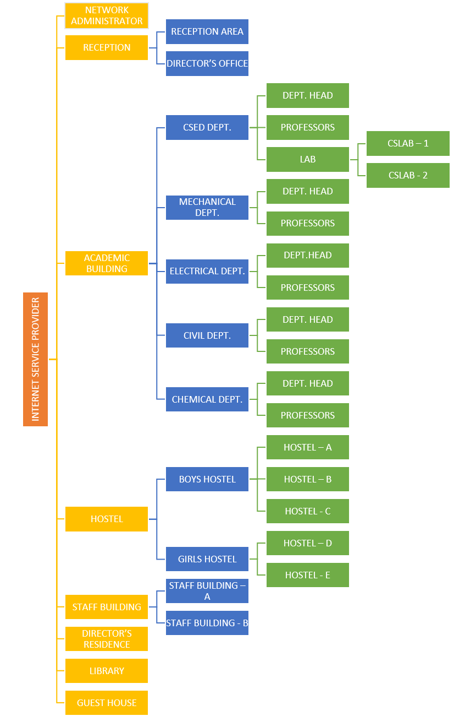

**NETWORK REQUIREMENT ANALYSIS**

The devices used in the design can be broadly divided into four categories:

1. Routers
2. Switches
3. Clients
4. Servers
5. Connecting wires

We’ll shortly elaborate more on the (slightly) unfamiliar terms of “router” and “switch”. First, we’ll get the simpler components out of the way.

* Clients – This may include the PCs connected to the network through LAN wires. This may also include smartphones connecting to the network wirelessly, although that particular facet of information will not be mentioned here.
* Connecting wires – This includes
* DCE/DTE wires – used to connect routers to each other.
* Copper Straight-Through Wires – one of the most versatile wires ever invented, and are used for connecting
* Router-to-Switch
* Switch-to-Clients
* Router-to-Clients
* Servers – Basically, a server is a specialized PC, with huge bandwidth, that hosts all the files for the network, and also enable Internet functionality, by maintaining a seamless connection to the World Wide Web (WWW) through the Internet Service Provider (ISP).

Now we’ll see more about the other devices we mentioned earlier –

* Routers – To be concise, a router is simply used for inter-connection of devices – for example, a PC to a PC. In our design, a router performs the job of inter-connecting a department to another department.
* Switches – A switch is used for handling selective data units, termed as packets. For example, suppose a client from the Human Resources Department (say PC1) wants to send some confidential data to a client in the R&D Department (say PC9) – this is accomplished through a switch, since a router would forward the packets everywhere without rhyme or reason – hence breaking the confidentiality of the data.

To put it more simply, a department will consist of a group of computers (the PCs) to a switch, which will be connected to other departments through routers. This is a simple and easy-to-understand design.

**NETWORK DIAGRAM**

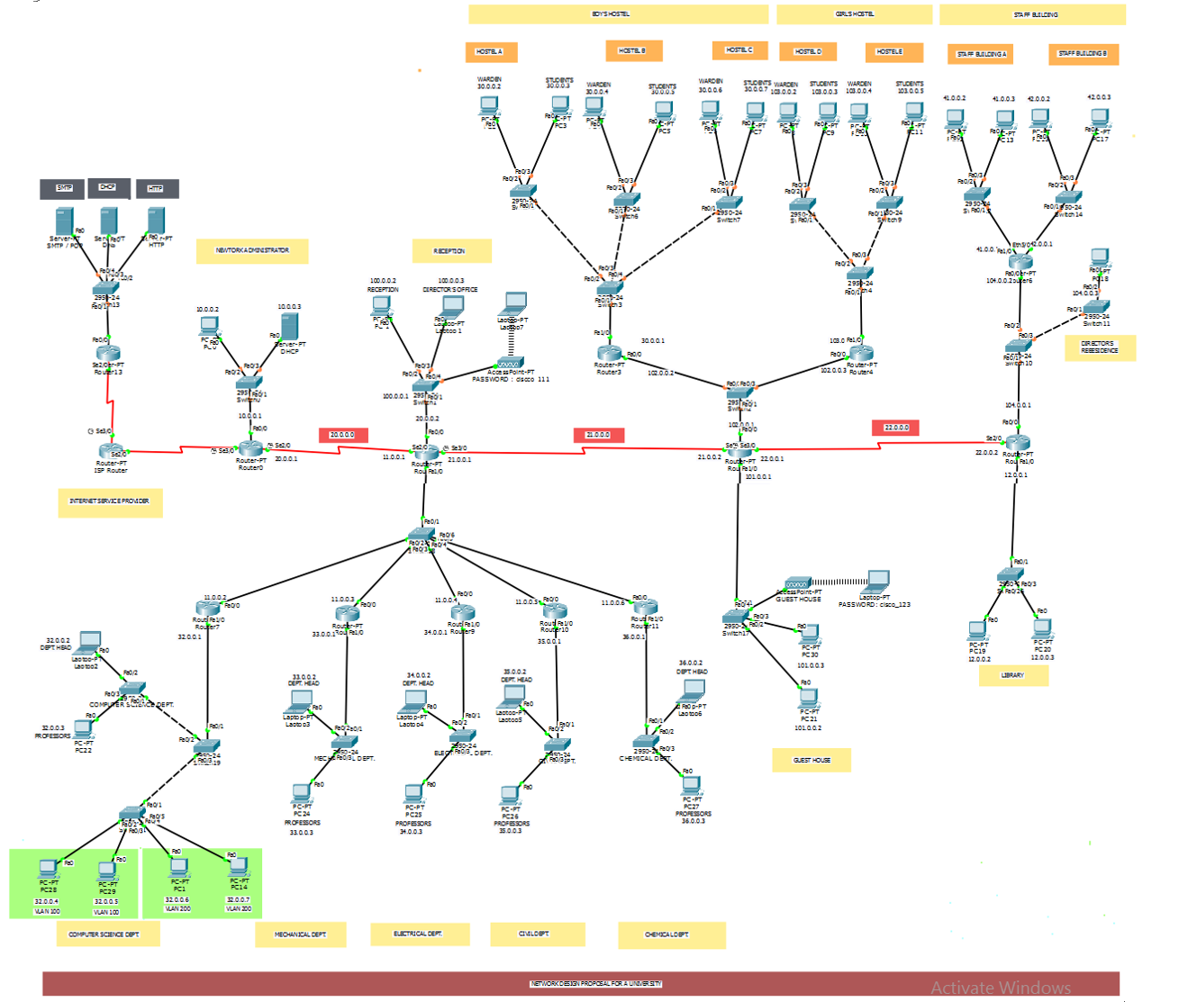

**NETWORK AND SYSTEM INTEGRATION METHODOLOGY**

The analysis for the requirements are as follows:

* Network access for the hostels – this is implemented through a separate switch being implemented for the boy’s hostel, and similarly for the girl’s hostel. A separate switch is implemented for each of the hostels (for example, 3 switches for three boys’ hostels) – to ensure that the students of one hostel cannot access the Internet services of another hostel. This reduces system traffic.
* Unlimited network access for the Director’s Office – a reasonable proposal. The Director’s Office will not have any sites blocked, but will be provided the same speed by the ISP even after fair usage limit. This proposal is extremely simple to implement – just erase the rules that restrict some sites being opened.
* Network access only for all the departments – For all departments other than CSE, one PC is shown as the “HOD PC” – the one specifically reserved for the Head of the Dept. All other PCs are collectively shown as “Other”. For CSE, due to the number of labs, multiple switches are created, each switch providing access to one lab where devices in each lab are connected to a vlan.
* Unlimited network access for the staff – we have implemented this by assuming that although the staff will not get their speeds reduced after the fair usage limit, there will be still some restricted sites (the same sites restricted for the students).
* Network access for the library – Simply attach a switch to one of the main routers to enable Internet access.
* Network access for the campus – As above, but Wi-Fi access needs to be provided instead of a wired connection, so a DSL modem is a must.
* Network access for the guest house – Simply attach a switch to one of the main routers to enable Internet access.

**IP NETWORK DESIGN GUIDELINES**

### DHCP

DHCP is a network server that dynamically assign default gateways, IP addresses and other parameters of network to client’s computers. This relies on the standard protocol also known as Dynamic Host Configuration Protocol or DHCP to respond to client broadcast queries. The DHCP server automatically sends the proper network parameters for clients to interact correctly on the network. Without DHCP the network administrator must manually set up any client that enters the network, which can be tedious, particularly in large networks.

### RIP

RIP is a standard transport layer protocol, intended to be used on a lesser scale. Networks, RIP was one of the first genuine network architectures for a distance vector, it is supported by a variety of systems. Each network which is 16 hops away or more is declared inaccessible by RIP, with a higher network length of 15 hops. A metric of 16 hops in RIP is known to be a poison route or an infinity metric. If several paths exist for a specified route, RIP can load that balancing among these paths (by default, up to 4) unless the metric (hop count) is equivalent (Gani *et al.*, 2011).

*Note*: *The Ip addresses of all the hardware is given in the network diagram.*

*Note: The NETWORK ADDRESS of all the hardware is given in the network diagram.*

*Note: The FIRST ADDRESS* *of all the hardware is given in the network diagram.*

*Note: The LAST ADDRESS* *of all the hardware is given in the network diagram.*

*Note: The BROADCAST ADDRESS* *of all the hardware is given in the network diagram.*

*Note: The SUBNET MASK* of *all the hardware is given in the network diagram*

**SERVICES AND FEATURES**

The various services provided by the network are detailed as follows:

* Instant network access –

We are not adding a portal for login – we felt it was too cumbersome. Instead, we are adding two Wi-Fi routers – one is for the guests (open access, 1/3rd the normal speed), and one for the students, staff, etc. (password protected WPA2/PSK, normal speed).

* Security –

We have also enabled a selective example to showcase the security measures we could possibly undertake in the future – for example, we have enabled a 256-bit password in the console for the router.

* The Internet Service Provider provides speed at a rate of 8 MB/s.
* There is also the provision for a Network Administrator added – the person(s) who can
  + Decrease, increase or otherwise modify the speeds of the network,
  + Shutdown or restart the entire network (only in cases of severe eventualities),
  + Add more sub-networks to the main networks (example – adding more users to a VLAN, in case a new department is established),
  + Sub-netting – although not done in our network due to complexity issues, it is possible for the network administrator(s) to establish sub-netting in case of lack of IP addresses.
  + It is also possible for the routers to get their firmware replaced, updated, etc. by the network administrator(s).

There may be other features added (or deleted) in the future which will be updated as necessary.

**BILL OF MATERIALS**

|  |  |  |  |
| --- | --- | --- | --- |
| BUDGET | PRICE PER UNIT | QUANTITY | TOTAL |
| Generic PC | 20,000 | 75 (can vary acc to needs) | Rs 1,500,000 |
| Cisco IP Phone 7960 | Rs 9,089 | 75 (can vary acc to needs) | Rs 681,675 |
| Cat 5E (8P8C Shielded Twisted Pair) | Rs 1,349 | 75 (can vary acc to needs) | Rs 101,175 |
| 2950-24 switch | Rs 1,699 | 10 (can vary acc to needs) | Rs 16,690 |
| Cable-moderm | Rs 2,098 | 1 (can vary acc to needs) | Rs 2,098 |
| 100ft coax cable | Rs 4,189 | 1 (can vary acc to needs) | Rs 4,189 |
| Dell poweredge R340  Server | Rs 97,902 | 3 (can vary acc to needs) | Rs 293,706 |
| 2811 router | Rs 44,209 | 4 (can vary acc to needs) | Rs 176, 836 |
| 5506-X ASA | Rs 42,569 | 1 (can vary acc to needs) | Rs 42,569 |
| 3560-24PS multilayer switch | Rs 64,659 | 1 (can vary acc to needs) | Rs 64,659 |
| Serial DCE | Rs 236 | 3 (can vary acc to needs) | Rs 708 |
|  |  |  | **TOTAL** |
|  |  |  | **Rs 2,884,305 (est)** |

**CONCLUSION**

Although it is difficult to say anything conclusive at this point of time, we can definitely say that we have much to improve upon in the future. They were not implemented in the final design. These suggestions may be taken at face value, depending upon the reader’s own discretion:

* Sub-netting – always a useful feature, although may increase congestion on a particular group of IPs – *not necessary/optional.*
* Sub-interfacing – again, a very useful feature, but will increase congestion on a particular group of interfaces (fast Ethernet, serial, etc.) – *not necessary/optional.*
* More PCs added to each VLAN/Switch – the network topology is for representation purposes only, as the PCs connected to each switch are only two in number, which is obviously not feasible for *any* institute – *strongly recommended (to the point of necessity).*

Other suggestions may be updated as necessary.

We are of the firm opinion that the template provided by this is applicable for *any* network – provided it is *not* large enough.

The network is fully featured with ISP, network administration, interconnection of various departments, VLANs for connection of Department Heads and wardens, network access for library, guesthouse, and an open Wi-Fi too.

This is the template that universities look for when building their first network. We hope you will too.