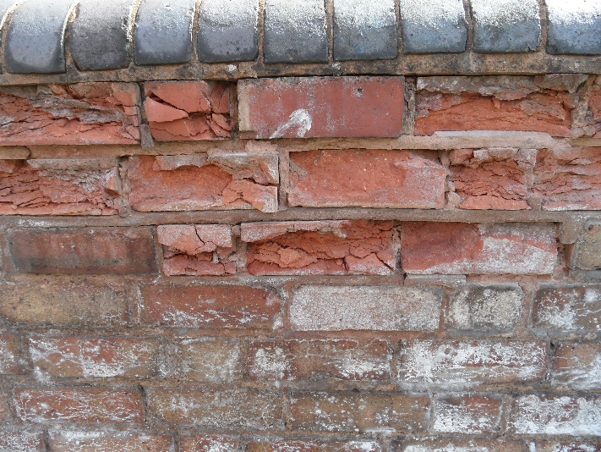When a brick material is exposed to both liquid moisture and freezing temperatures, the risk of cracks occurring in the material could increase significantly. In such situations, a range of criteria can be employed to assess the potential damages. In a minimum approach, the threshold levels from literature are applied. One approach considers Fagerlund’s critical moisture volume, which assumes a 91% moisture volume, accounting for a 9% volume expansion during the phase change from liquid water to ice (Fagerlund G., 1975). Alternatively, in the case of a masonry façade, Mensinga’s measured value can be adopted. The lowest critical ice volume for Canadian bricks was determined to be 25% (Mensinga P. et al, 2010). In a superior approach, a more accurate criterion is needed. This involves conducting laboratory tests on brick samples to obtain the critical ice content which entails damage by subjecting the bricks to cycles of freezing and thawing.

|  |  |  |
| --- | --- | --- |
| *Superior* | *Advanced* | *Minimum* |
| *Material specific critical ice contents or moisture saturation degree.* | *Percentage of the ice volume should not exceed 25%.* | *Moisture saturation degree should not exceed 90%.* |