# APRS Reception Quick Start Guide

# Microsoft Windows version 1.0

## May 2014

Software and documentation can be obtained from the Downloads section of <http://home.comcast.net/~wb2osz/site/>

## Step 1: Install Dire Wolf

Put the Dire Wolf distribution file, direwolf-0.9-win.zip (or similar name depending on version), in some convenient location such as your user directory. In this example, we will use C:\Users\John

In Windows Explorer, right click on this file and pick “Extract All…” Click on the Extract button.

You should end up with a new folder containing:

* direwolf.exe -- The application.
* decode_aprs.exe -- APRS raw data decoder.
* Quick-Start-Guide-Windows.pdf -- This document.
* User-Guide.pdf -- More complete information.
* and a few others …

In Windows Explorer, right click on **direwolf.exe** and pick **Send To > Desktop** (create shortcut).

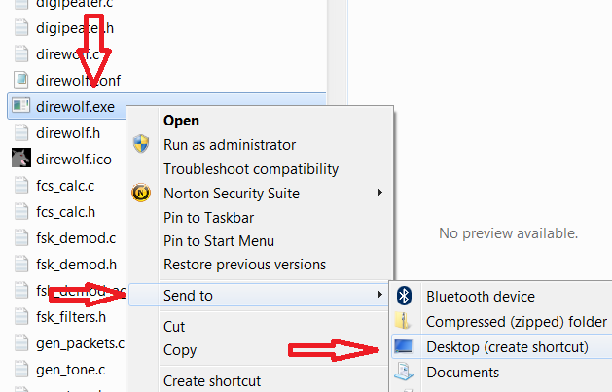

Look for the new direwolf.exe icon on your desktop.

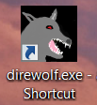

## Step 2: Connect audio and test

For receiving all you need to do is connect your receiver speaker to the “Line In” or “Mic” jack on your computer.

If you are using a laptop, with a built-in microphone, you could probably just set it near your radio’s speaker in a quiet setting.

Double click on the desktop icon:  and you should get a new window similar to this:

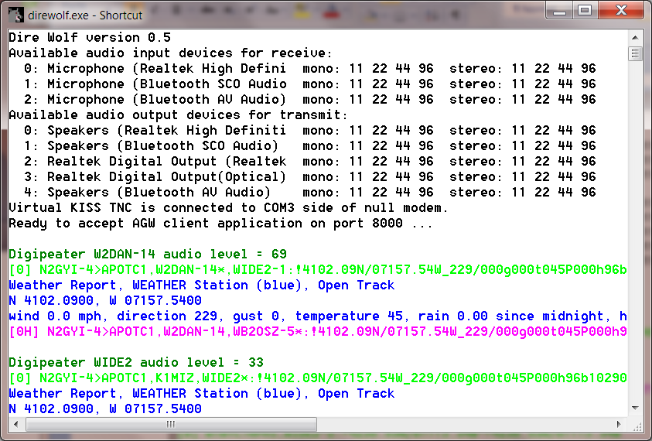

Different types of information are color coded for easy recognition.

It starts with some informational messages in black.

A group of several lines is displayed for each packet received.

The first line of each group, in dark green, contains the audio level of the station heard. It might be the original station or it might be a digipeater that was heard.

The raw data is displayed in green and deciphered information is in blue.

Transmitted packets are in magenta. In the example above, we see that Dire Wolf is being used as a digipeater.

Sometimes you will see error messages in red when invalid data is received.

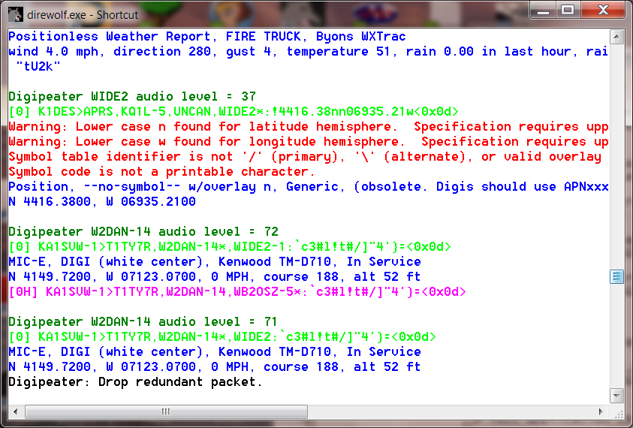

You might need to change the font for best results.

Right-click on the title bar and pick Properties from the pop-up menu.

Use one of the fonts other than “Raster Fonts.”

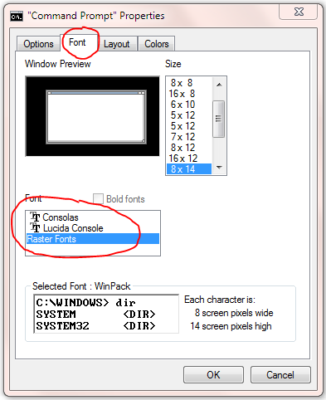

## Alternate Audio Device Selection

If you have multiple audio interfaces, you might want to pick one other than the default. In this example, I plugged in a SignaLink USB, it now appears at the top of the list, and it became the default.

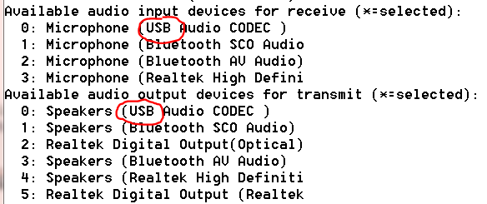

This is probably not a good thing because the operating system sounds will go out over the radio. Go to the Control Panel 🡪 Sound and notice how the USB device became the default.

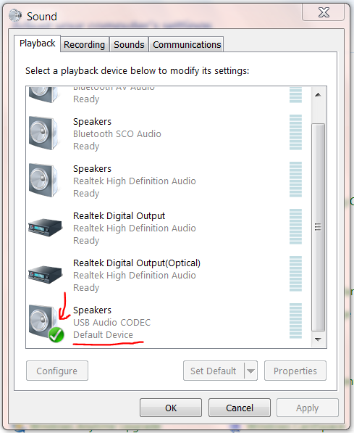

You will probably want to select the Speakers, corresponding to the built-in audio interface, as the default so operating system sounds will come out here.

Edit the direwolf.conf file and look for a line that contains ADEVICE. Add a line like this:

ADEVICE USB

Stop Dire Wolf by pressing Control-C and then restart it. This time you should see the USB sound device explicitly selected with “*” next to it.

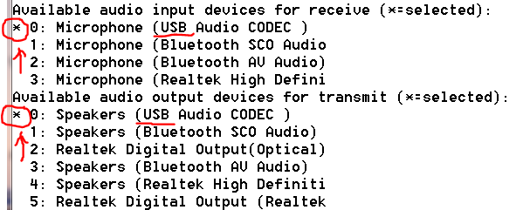

You should now be receiving APRS packets! It’s more interesting to see symbols on a map instead of text. Here is how to install one popular application…

## Step 3: Install APRSIS32

Download the APRSIS32 zip file from <http://aprsisce.wikidot.com/downloads>

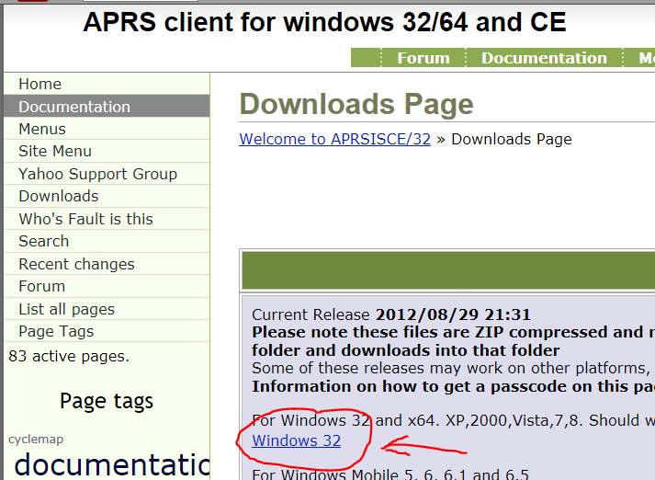

Save it in some convenient place such as C:\Users\John*,* where Dire Wolf was saved.

In Windows Explorer, right click on this file and pick “Extract All…”

Right click on the resulting aprsis32.exe file then pick Send to > Desktop (create shortcut).

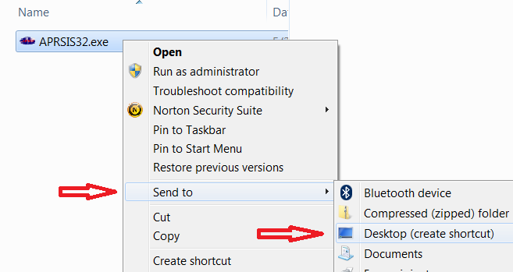

You should end up with a desktop shortcut like this: 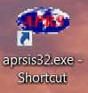

## Step 4: Configure APRSIS32

1. If not already running, start up Dire Wolf by double clicking the  desktop shortcut created earlier.
2. Run APRSIS32 by double clicking the  desktop shortcut.
3. Fill in your ham call and click Accept.

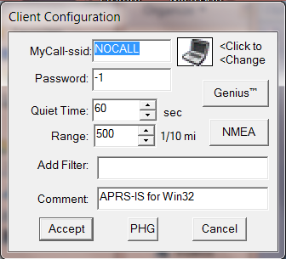

1. From the “Configure” menu, pick “ports” then “new port…”
2. Select type “AGW” from the list. Enter “Dire Wolf” as the name. Click “Create” button.

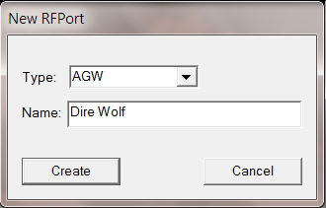

1. When it asks, “Configure as TCP/IP Port?” answer Yes.
2. Enter “localhost” for the address and port 8000. Then OK.

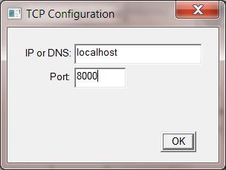

1. Finally click on “Accept.”.
2. You might want to go to the “Enables” menu and uncheck the “APRS-IS enabled” item so you will only display local information received over the radio.
3. If all goes well, you should see received messages, similar to these in the Dire Wolf window:

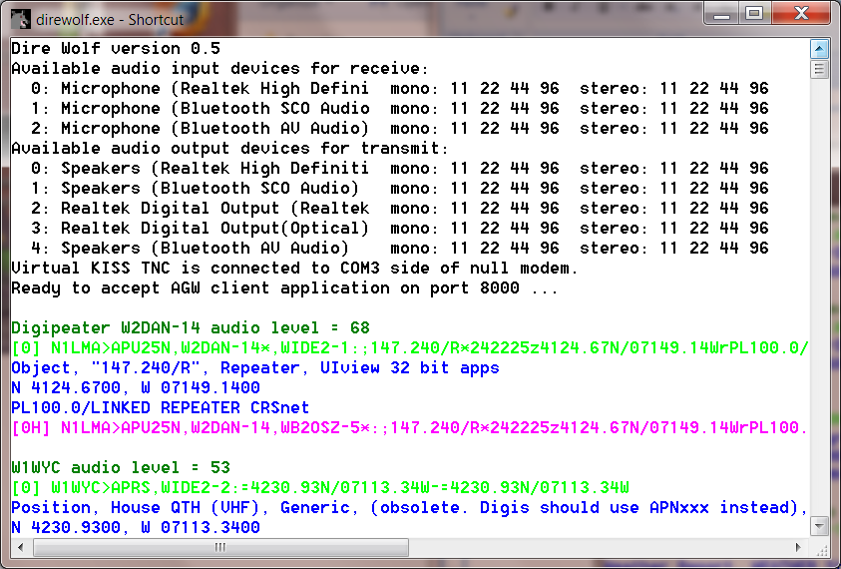

and the same stations should appear along the left side of APRSIS32.

1. Click on a station from the list then pick “Center” from the pop up menu. Zoom in by clicking the “+” on the left side of the map or by moving the mouse scroll wheel away from you. Scroll the map by holding the left mouse button down and dragging.

## Step 5: Learn about the other features

Refer to the more complete **User Guide** for details on other features such as:

* Wiring for transmitting.
* Dual radio operation.
* Selecting other audio devices.
* Beacons.
* Digipeating.
* Internet Gateway.
* AGW network application interface.
* KISS application interface – network or serial port emulation.
* Changing audio tones and data rate.
* decode_aprs.exe – Raw packet decoder.