1. Problem Statement:
The banking and financial services sector faces ongoing challenges in managing credit risk and minimizing losses during the lending process. Approving loans to clients who are unlikely to repay leads to significant financial exposure and instability for the institution.
The FINVAULT dashboard was built to develop a data-driven understanding of risk analytics in banking, allowing decision-makers to evaluate each client's financial profile and determine the likelihood of loan repayment before approval.
Key objectives:
- Monitor total loan exposure, deposits, and fees across 3,000 clients
- Identify high-risk and high-value client segments
- Enable time-based analysis through an interactive period slicer
- Provide breakdowns by nationality, income band, banking relationship, and gender
- Support executive-level decision-making through a clean summary dashboard
2. About Dataset:

The dataset contains financial and personal information for 3,000 banking clients. It was originally provided as a CSV file and loaded into a PostgreSQL database for structured querying before Python analysis.

3. Data Pipeline:
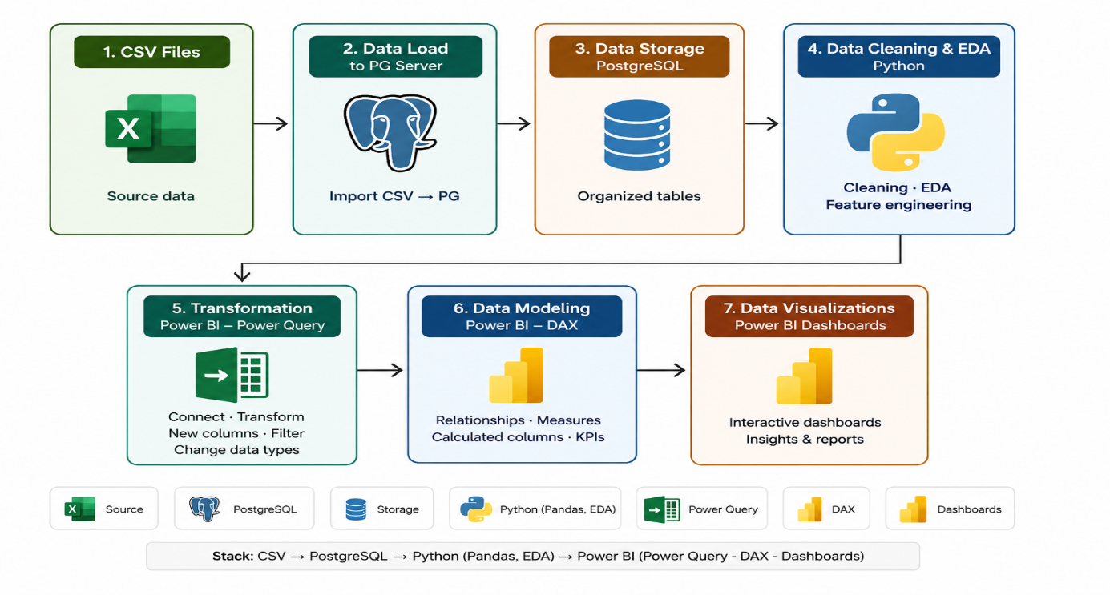
This pipeline covers the full data workflow — from raw CSV files to interactive Power BI dashboards, passing through PostgreSQL storage, Python analysis, and DAX modeling.
4. Data Cleaning & Exploratory Data Analysis:
The EDA was performed in Python using Pandas, Matplotlib, and Seaborn. The notebook was connected directly to the PostgreSQL database using SQLAlchemy.

4.1 Feature Engineering in Python:
The engineered features were created during EDA:
New Column | Method | Values
Income_band | pd.cut on Estimated Income | Low (< 100K) / Mid (< 300K) / High (300K+)

4.2 Mapping Operations (Power Query)
Several numeric ID columns were converted to readable labels using Power Query mapping transformations in Power BI:

Original Column | Transformation | Example Output
GenderId | Mapped to gender label | 1 → Male / 2 → Female
BRId | Mapped to banking relationship name | 1 → Private Bank / 2 → Retail / ...
IAId | Mapped to investment advisor name | Readable advisor names

4.3 Correlation Analysis
A correlation heatmap was produced on all numerical columns to identify key financial relationships between client accounts.
Key findings from the heatmap:
- Bank Deposits ↔ Checking Accounts (0.84): strongest correlation, indicating a high-liquidity client segment
- Bank Deposits ↔ Saving Accounts (0.75): clear saver profile, ideal target for wealth management products
- Bank Loans ↔ Business Lending (0.42): suggests an SME/entrepreneur segment
- Bank Loans ↔ Credit Card Balance (0.37): debt-layering pattern, potential credit risk signal
- Superannuation is independent of all variables: driven by employer contributions, not active banking behavior

4.4 Bivariate Analysis:
Regression plots (regplot) were used to visualize 7 key variable pairs, confirming trends identified in the heatmap. Notably:
- Bank Deposits Vs Saving Accounts: strong positive linear trend confirming the saver segment
- Age Vs Superannuation: nearly flat regression line; age does not predict retirement savings
- Business Lending Vs Bank Loans: consistent upward trend confirming the SME borrowing pattern.
5. Calculated Column:

5.1 Processing Fees
A calculated column was created to assign a processing fee rate based on the client's Fee Structure category.
Processing Fees =
SWITCH(
'public customer'[Fee Structure],
"High", 0.05,
"Mid", 0.03,
"Low", 0.01,
0 )

5.2 Engagement Days
Calculates how many days each client has been with the bank since joining.
Engagement Days =
DATEDIFF('public customer'[Joined Bank], TODAY(), DAY)

5.3 Engagement Timeframe
Categorizes clients by their banking relationship duration for segmentation analysis.
Engagement Timeframe =
SWITCH(
TRUE(),
'public customer'[Engagement Days] < 365, "< 1 Year",
'public customer'[Engagement Days] < 1095, "1-3 Years",
'public customer'[Engagement Days] < 1825, "3-5 Years",
"5+ Years")
DATEDIFF('public customer'[Joined Bank], TODAY(), DAY)

5.3 Income Band (DAX)
Bins clients into income segments for income-based filtering in the dashboard.
Income Band =
SWITCH(
TRUE(),
'public customer'[Estimated Income] < 100000, "Low",
'public customer'[Estimated Income] < 300000, "Mid",
"High"
)

5.3 Joining Year
Extracts the year a client joined the bank, enabling year-based filtering and trend analysis in the dashboard.
Year Of Joining = YEAR('public customer'[Joined Bank])

6. DAX Measures:
All KPI values displayed on the dashboard are powered by DAX measures. Using measures instead of simple column sums ensures dynamic recalculation based on slicer selections and filter context.
Measure | DAX Formula | Result (All Time)
Total Clients | DISTINCTCOUNT([Client ID]) | 3,000
Total Loans | [Bank Loan] + [Business Lending] + [Credit Cards Balance] | $4.38bn
Bank Loan | SUM([Bank Loans]) | $1.77bn
Business Lending | SUM([Business Lending]) | $2.6bn
Credit Cards Balance | SUM([Credit Card Balance]) | $9.53M
Total Deposit | [Bank Deposit] + [Savings Acc] + [Checking Acc] + [Foreign Currency] | $3.77bn
Bank Deposit | SUM([Bank Deposits]) | $2.01bn
Saving Account Amount | SUM([Saving Accounts]) | $698.73M
Checking Account Amount | SUM([Checking Accounts]) | $963.28M
Foreign Currency Amount | SUM([Foreign Currency Account]) | $89.65M
Total Fees | SUMX(customer, [Total Loans] * [Processing Fees]) | $158.19M
Total CC Amount | SUM([Amount of Credit Cards]) | $9.53M
Average Engagement Years | DIVIDE(AVERAGE([Engagement Days]), 365) | 15.76 years

6.1 Key Measure Explanations
Why SUMX for Total Fees?
SUMX iterates row by row — for each client it multiplies their Total Loans by their Processing Fee rate, then sums the results. A simple SUM cannot perform this row-level multiplication.
Total Fees = SUMX(
'public customer',
[Total Loans] * 'public customer'[Processing Fees]
)

-- Example:
-- Client A: $500K loans × 5% = $25K
-- Client B: $300K loans × 3% = $9K
-- Client C: $100K loans × 1% = $1K
-- Total Fees = $35K

Why DISTINCTCOUNT for Total Clients?
DISTINCTCOUNT counts unique Client IDs, ensuring no client is counted twice even if they appear in multiple rows.
7.Date &Time Intelligence:

7.1 Date Table Creation
A dedicated calendar table was created to support time intelligence calculations and connect the Period Slicer to all dashboard visuals.
DateTable =
CALENDAR(
MIN('public customer'[Joined Bank]),
TODAY()
)

A relationship was then established in Model View:
DateTable[Date] → 'public customer'[Joined Bank] (Many-to-One, Single direction)

7.2 Period Filter Slicer
A custom Chiclet Slicer (tile-style) was implemented using a dedicated Period Filter table to enable time-based filtering across all dashboard visuals.
Tile | Filter Applied
All Time | No date filter — shows all data
Last 30 D | Last 30 days from today
Last 90 D | Last 90 days from today
Last 3 M | Last 3 months
Last 6 M | Last 6 months
Last 12 M | Last 12 months
Last 24 M | Last 24 months
CM | Current Month
CQ | Current Quarter
CY | Current Year
8.Dashboard Pages & Visualizations:
The FINVAULT dashboard consists of 4 main pages. All pages share a consistent dark navy theme, the FINVAULT logo, and the interactive Period Slicer:

8.1 Home Page

The landing page featuring the FINVAULT logo, navigation buttons, Gender slicer (tile), and Joining Year slicer. Displays the 6 most important KPI cards at a glance.

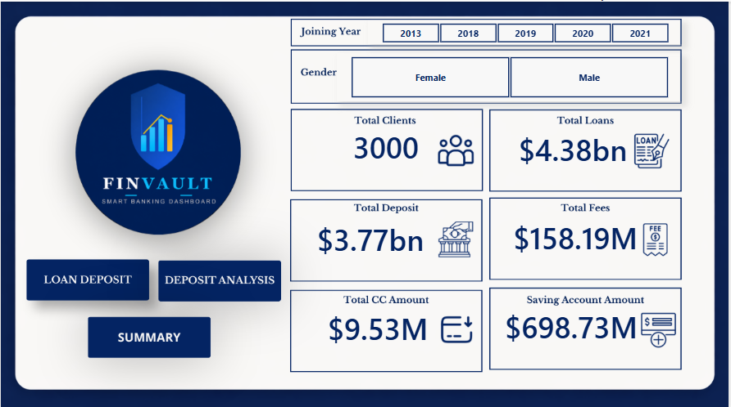
Figure 1:Home

8.2 Loan Analysis Page
Deep-dive into loan distribution across multiple dimensions.
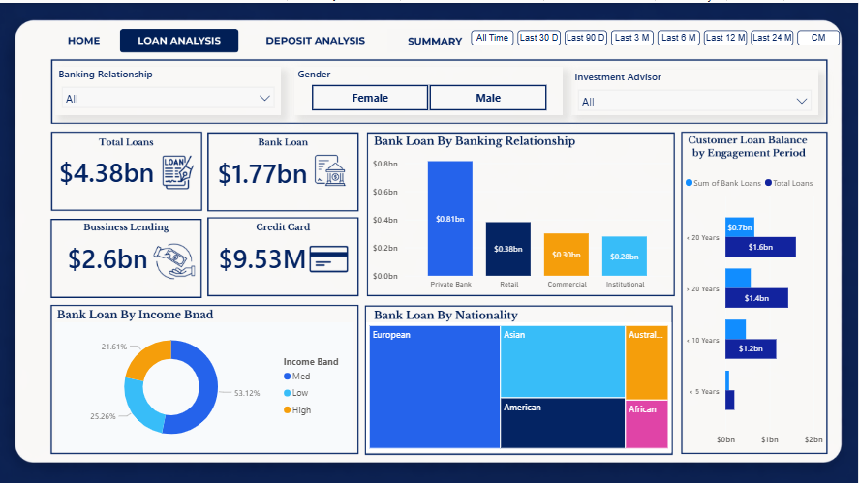
Figure 2:Loan Analysis

8.3 Deposit Analysis Page
Analysis of client deposit behavior across account types and demographics.
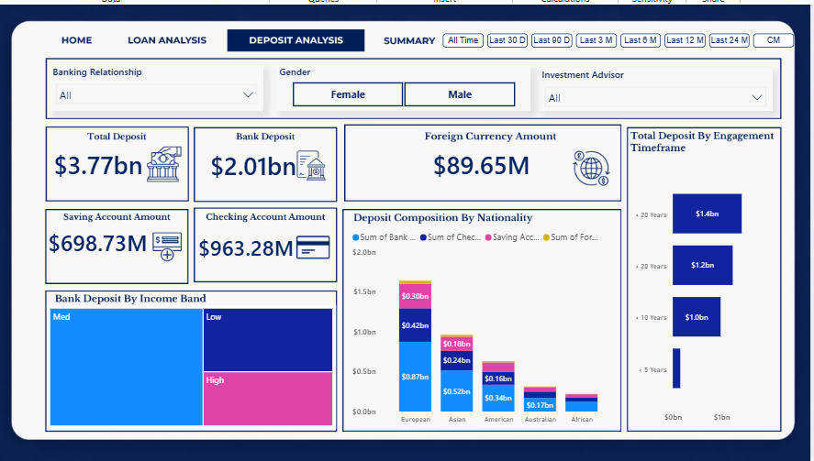
Figure 3:Deposit Analysis

8.4 Summary Page
Executive-level overview showing all KPIs in a single view. Includes Banking Relationship, Gender, and Investment Advisor slicers for cross-filtering analysis.
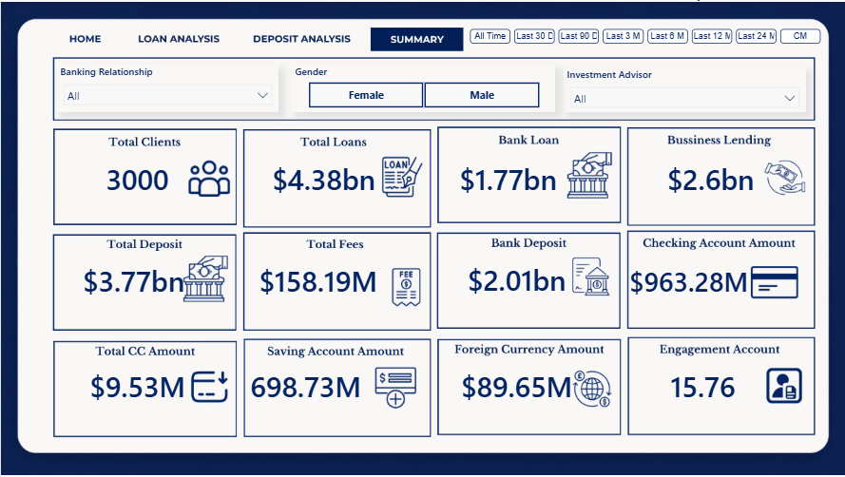
Figure 4:Summary
9. Key Insights

9.1 Loan Insights
- Total Loans ($4.38bn) exceed Total Deposits ($3.77bn), placing the bank in a net lending position with a funding gap of approximately $610M — meaning the bank relies on external funding sources beyond client deposits to finance its lending activity. This generates interest revenue but introduces credit risk that requires active monitoring.
- Business Lending ($2.6bn) is the dominant loan category, surpassing Bank Loans ($1.77bn), which reflects a strong SME and corporate client base.
- Private Bank clients carry the highest individual loan balances ($0.81bn), followed by Retail ($0.38bn), Commercial ($0.30bn), and Institutional ($0.28bn), indicating that premium relationship clients represent the largest credit exposure.
- Clients with more than 20 years of engagement hold the largest loan balances, confirming that long-term clients are the bank's most significant borrowers.
- The Mid income band accounts for 53.12% of total loans, making it the core credit segment. The Low income band represents 25.26%, a non-negligible exposure that warrants ongoing risk monitoring.
- European clients represent the largest nationality segment by loan volume, followed by Asian and American clients. Australian and African clients represent smaller but present segments.
- Clients in the 5–10 year engagement range already hold $1.2bn in loans, suggesting that mid-tenure clients are an actively growing borrower segment.

9.2 Deposit Insights
- Total Deposits amount to $3.77bn, with Bank Deposits ($2.01bn) as the primary channel, followed by Checking Accounts ($963.28M) and Saving Accounts ($698.73M).
- European clients are the largest depositors across all account types. Asian clients rank second with $0.52bn in bank deposits, followed by American, Australian, and African clients.
- The Mid income band contributes the largest share of total deposits, consistent with its dominance in the loan portfolio.
- Clients with more than 20 years of engagement hold $1.4bn in deposits, demonstrating that client loyalty directly correlates with deposit volume.
- Checking Accounts ($963.28M) represent a large liquid asset pool and a potential cross-sell opportunity for investment and wealth management products.
- Foreign Currency Accounts ($89.65M) represent a small but internationally active client segment, introducing limited FX exposure.
- Clients with fewer than 5 years of engagement hold comparatively low deposit balances, indicating that newer clients are not yet fully integrated into the bank's product ecosystem.
- The gap between Total Loans ($4.38bn) and Total Deposits ($3.77bn) represents a funding gap of approximately $610M, meaning the bank relies on external funding sources beyond client deposits to finance its lending activity.

9.3 Risk Observations
- The correlation between Bank Loans and Credit Card Balance (0.37) signals a debt-layering pattern in a subset of clients, representing an elevated credit risk profile worth flagging for the risk team.
- The concentration of loan balances among Private Bank clients ($0.81bn) creates revenue concentration risk — a deterioration in this segment would have an outsized impact on the loan portfolio.
- High income clients represent 21.61% of total loans. Although a smaller segment by count, they are high-value accounts that justify dedicated relationship management.
- The Low income band (25.26% of loans) presents a segment that requires careful credit monitoring, particularly in economic downturns.
- Superannuation savings show no correlation with any banking variable, confirming they are driven by employer contributions rather than banking behavior. Retirement products should therefore be marketed independently of standard banking offers.
- Foreign Currency exposure ($89.65M), while limited in scale, introduces FX risk that should be tracked alongside interest rate sensitivity.
- Total Fees of $158.19M are generated through processing fee rates applied to total loan balances. High fee structure clients (5% rate) contribute the most per loan, making them the most profitable segment on a fee basis.

9. Conclusion:

The FINVAULT Banking Dashboard demonstrates a complete, production-grade data analytics pipeline — from raw CSV data through PostgreSQL storage, Python exploratory analysis, and a fully interactive Power BI dashboard.
The project delivers actionable insights into client loan exposure, deposit behavior, fee revenue, and engagement patterns. The interactive Period Slicer and multi-dimensional filters allow business users to slice data dynamically without writing a single query.
The dashboard proves that:
- Total Loans ($4.38bn) exceed Total Deposits ($3.77bn) — the bank is generating revenue through active lending
- Long-term clients (> 20 years) are the most valuable — highest loans and highest deposits
- Mid income band represents the core client base — 53% of loans and the largest deposit share
- European clients dominate both loan volumes and deposit balances

Future Improvements
- Connect Power BI directly to PostgreSQL for real-time data refresh
- Build a loan default prediction model using Python (scikit-learn / XGBoost)
- Add a Drill Through page for individual client-level analysis
- Implement Row-Level Security (RLS) in Power BI for role-based access
- Expand the dataset with transaction history for time-series forecasting

