This paragraph appears BEFORE the embedded image. The quick brown fox jumps over the lazy dog.
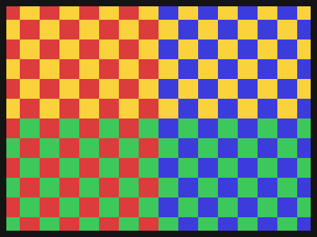
This paragraph appears AFTER the embedded image. Sphinx of black quartz, judge my vow.

