Write a simulation code for simulate mixed traffic multi server queuing system using mat lab or any language you prefer

Description

We want to find the blocking probabilities of a given **mixed traffic** multi server system which consists of three different arrival rates and with three different distributions. Three distributions are Poisson distribution, normal distribution, Pareto distribution. We have to find blocking probability of each distribution after they mixed in the queue. Packets arrive in to the queue with three arrival rates.(can take any value for the arrival rates).

A - Pareto distribution (packets with three different arrival rates $(λ_{1}$, $λ_{2}$, $λ_{3}$)

B - Normal distribution (packets with three different arrival rates ($λ_{1}$, $λ_{2}$, $λ_{3}$)

C- Poisson distribution (packets with three different arrival rates ($λ_{1}$, $λ_{2}$, $λ_{3}$)

The task is to write a Matlab simulation(if not any other language prefer) code to find blocking probability of A,B,C for each arrival rates when it **mixed in the queue** and draw a graph for blocking probability versus traffic intensity. ( there should be 9 curves in the graph)

Example

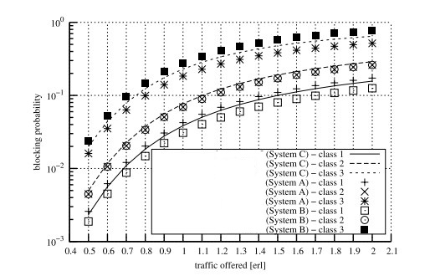

**note :-**

**(class 1 ,class 2, class 3 = $λ_{1}$, $λ_{2}$, $λ_{3}$)**

**Consider this as mixed traffic do not consider distributions separately**

**Clear and simple comments should be include in the simulation code**