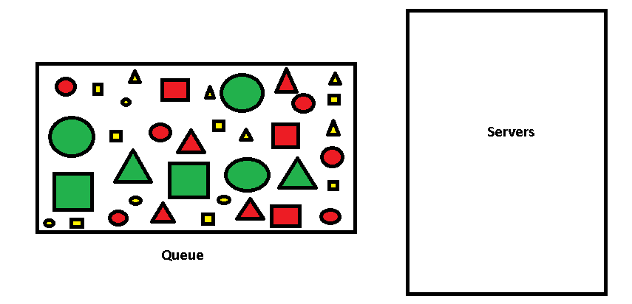

**Red -Pareto distribution**

**Green - Normal Distribution**

**Yellow - Poisson Distribution**

$λ_{1}$**=**

$λ_{2}$**=**

$λ_{3}$**=**

* **Number of servers should be limited**

**According to the above given figure packets arrive in to the queue .There is a mixed traffic in the queue. When you draw the graph you can take any range of value to draw the X- axis(0-20 Erl).**

**For the following results you have to draw the graph**

**- blocking probability of Pareto distribution of packets arrive at $λ_{1}$**

**- blocking probability of Pareto distribution of packets arrive at $λ_{2}$ Three curve**

**- blocking probability of Pareto distribution of packets arrive at $λ_{3}$**

**- blocking probability of normal distribution of packets arrive at $λ_{1}$**

**- blocking probability of normal distribution of packets arrive at $λ_{2}$ Three curve**

**- blocking probability of normal distribution of packets arrive at $λ_{3}$**

**- blocking probability of Poisson distribution of packets arrive at $λ_{1}$**

**- blocking probability of Poisson distribution of packets arrive at $λ_{2}$ Three curve**

**- blocking probability of Poisson distribution of packets arrive at $λ_{3}$**

**You will get nine curves in a single plot. ( a plot as given in the previous document).**

***note: when you consider the queue you cannot take each distributions separately because this is a mixed traffic .***