10-01-2018

1.Architecture:
Physicalnet: A Generic Framework for Managing and Programming Across Pervasive Computing Networks
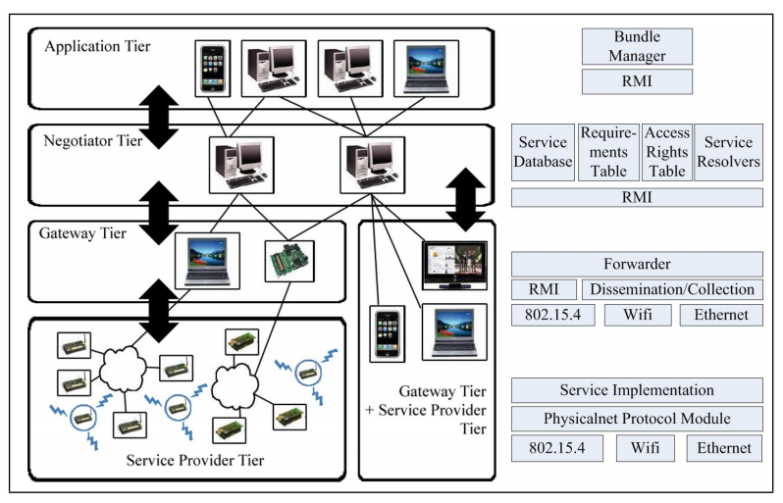

What should be decided:
- protocol
-packet format
27-01-2018 Notes from Papers
A Generic IoT Architecture for Smart Cities

- The IoT platforms could be divided into four types:
- eGovernment-related platforms -- which we could use for public area
- enterprise-based platforms
- company-based platforms
- pure business-oriented platforms.-- which we could use in the building

- design element: 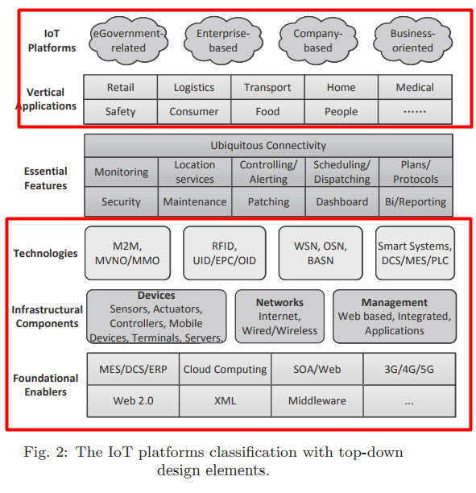
- eGovernment-related platforms
-Security: The eGovernment IoT platform needs information relevance to prevent the ‘information island’ effect and ensure network- and information security.

- Business-oriented IoT platforms
An IoT integrated information centre is envisaged as an important part of the generic IoT platform to unify the organization, implementation, and planning of the integrated IoT application market for the attraction of commercial capital investments. The information centre is operated by an IoT service provider, which may quickly become another major player in addition to the existing service-provider types.
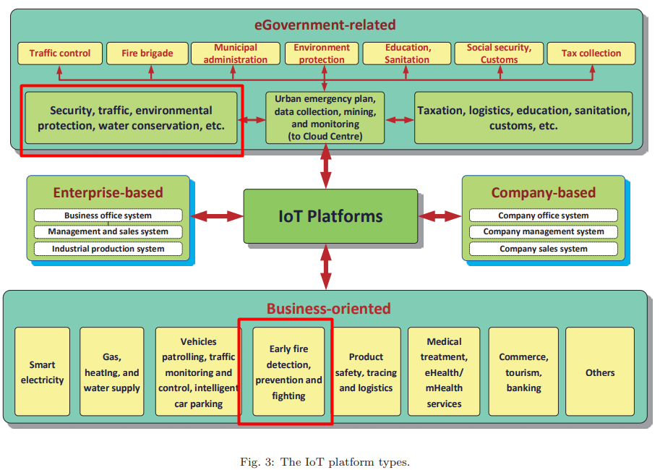
Internet of Things for Smart Cities
- An architecture in detail:
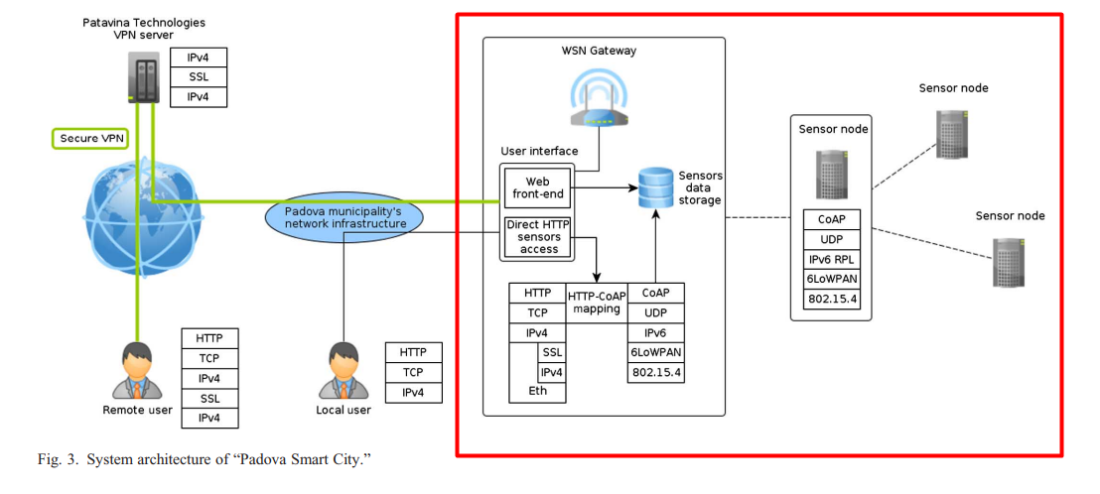
Enlightened by figure, I think we could use this structure partly(for public area):
1-2-2018 notes of papers
Work summary:
- Structure: figure
- Protocols: 6LowPan/Bluetooth
Internet of Things for Smart Cities

Noise Monitoring: Noise can be seen as a form of acoustic pollution as much as carbon oxide (CO) is for air. In that sense, the city authorities have already issued specific laws to reduce the amount of noise in the city centre at specific hours. An urban IoT can offer a noise monitoring service to measure the amount of noise produced at any given hour in the places that adopt the service [14]. Besides building a space-time map of the noise pollution in the area, such a service can also be used to enforce public security, by means of sound detection algorithms that can recognize, for instance, the noise of glass crashes or brawls. This service can hence improve both the quiet of the nights in the city and the confidence of public establishment owners, although the installation of sound detectors or environmental microphones is quite controversial, because of the obvious privacy concerns for this type of monitoring.
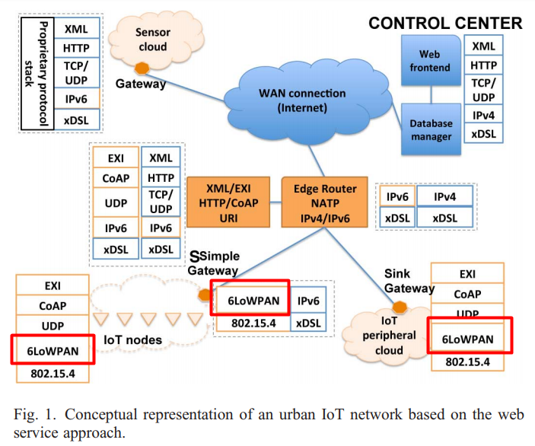

Problem: WSNs details
