EECS 3311 - B : First Software Project – Display Shapes

Happy Patel | Student ID : 216829038 | TA: Naeiji Alireza

**PART 1 – INTRODUCTION**

**ABOUT**

This Software Project is designed to display 6 random shapes (includes Circle, Rectangle, Square) every time when the user clicks on “Load Shapes”. Also, when user clicks on “Sort Shapes” it displays the random 6 shapes in Ascending order.

The Goal for this project is to learn how to use JFrame, JPanel, Graphics to Display Shapes using OOD Principles and using Sorting Algorithm to Sort Shapes in order.

**PROBLEMS**

First, JFrame and JPanel were difficult to understand at first, I had to play around with paintComponent(Graphics g) method at first to understand how to display random Shapes with random dimensions. Then the next most difficult thing was to get Bubble sort working on the random shapes list.

**CONCEPTS**

OOD stands for Object-oriented design.

It is the process of implementing Object Oriented concept for any application or programs.

I have used Abstraction and Inheritance OOD Principle for this software project. Further explained in Part 2.

**DESIGN PATTERNS**

I have used Factory Pattern and Singleton Pattern in this Project.

In Factory pattern, we make object without uncovering the creation rationale to the customer and allude to a recently made item utilizing a typical interface.

Singleton pattern includes a solitary class which is capable to make an article while ensuring that main single item gets made. This class gives a way of getting to its main article which can be gotten to straightforwardly without need to start up the object of the class.

**PART 2 – DESIGN OF THE SOLUTION**

**MY UML DESIGN**

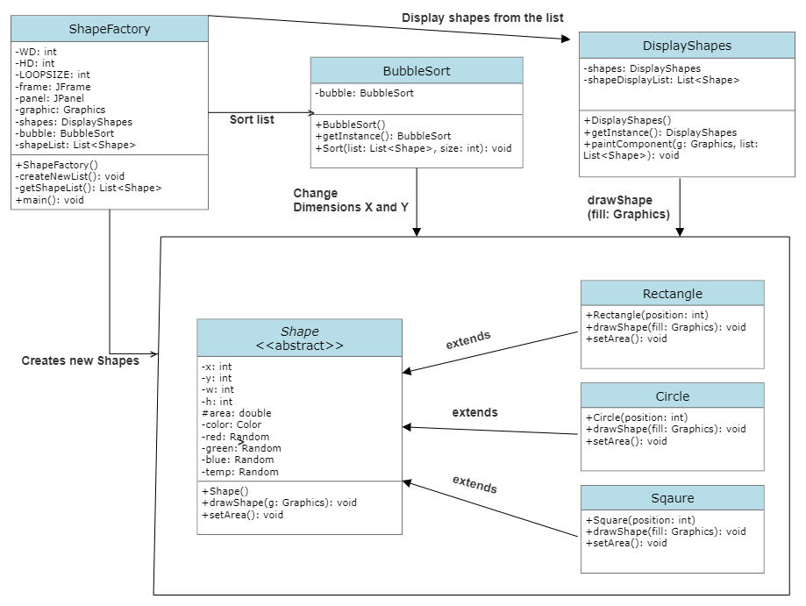

In my design, I have created an Abstract class named Shape and class Rectangle, Square, Circle extends abstract class Shape.

Shape factory class creates new list with random shapes as values in the list. It also contains PSVM method to run the entire program.

In Bubble sort, I have used Singleton Pattern that is in form of instance and sorts the list into ascending order.

In Class Display Shapes, I have used Singleton Pattern that is in form of instance, and it takes a list which with help of the for-loop calls draw Shape method from each Shape to draw that shape.

**OOD PRINCIPLES USED IN THIS PROJECT**

1. Inheritance: The properties of a class that are inherited or extended by other classes. Child classes can reuse the parent class methods without changing them.

2. Abstraction: It shows necessary details of the class to other classes. I have created abstract class Shape as parent class and Square, Circle and Rectangle class extends this Shape class for the variables and methods from Shape class.

**PART 3 – IMPLEMENTATION OF THE SOLUTION**

**BUBBLE SORT**

In this algorithm, we just repeatedly compare and swap till we have a descending or ascending order we require. In this project we are using Ascending order.

Pseudo Code:

bubbleSort(list, size)

for i <- 1 to size-1

if leftElement > rightElement

swap leftElement and rightElement

end bubbleSort

**IMPLEMENTAION**

Abstract class Shape: It is the base of each class that extends Shape class that is Circle, Rectangle and Square. It contains unique setters for random width, height, and color.

Class Rectangle, Square and Circle: All of them extends Shape class, have unique set area method according to the shape. Also, they have draw Shape method which is later used by Display Shapes class to draw shapes on the panel.

Class ShapeFactory: First of all, it has create new list method which creates new list of 6 random shapes, there dimensions are set from 75 to 525 with a distance of 75 between each shape’s center point. Secondly, Jframe, JPanel and JButton is used with the help of Action Listeners to create desired GUI and either print new shapes or sort the displayed shapes. Lastly, PSVM to run entire project.

Class BubbleSort: It has a Sort method which takes a list of type List<Shape> and size of the list in integer and return sorted list in ascending order.

Class DisplayShapes: It has a paint Component method which takes a list with other necessary parameters (i.e., Graphics g, int WD, int HD) to call draw Shape method from that particular shape’s class for each Shape in the list.

**CODE EXECUTION**

Initial State

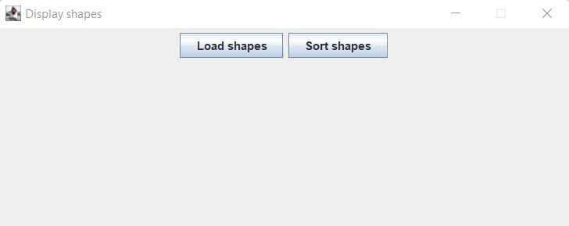

ON CLICK “Load shapes” ON CLICK “Sort shapes”

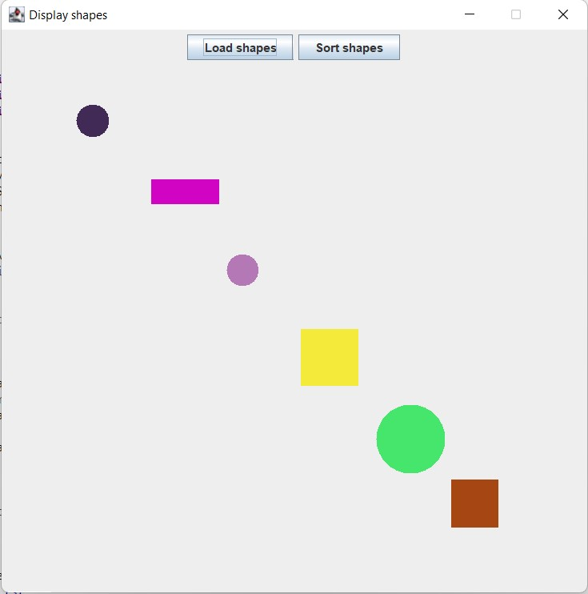

**TOOLS USED**

Eclipse IDE for Java Developers - 2021-09 for Programming.

GitHub for uploading my project (private repo).

Smart Draw for creating UML Diagrams.

Zoom screen recorder for recording video.

YouTube for uploading an unlisted video.

**PART 4 – CONCLUSION**

**ABOUT MY PROJECT DIFFICULTIES**

Everything went well in the start, after testing out Jframe and JPanel for sometime I was able understand it easily. While creating a list and getting random shapes to display was done perfectly in first attempt. Also I didn’t had any errors while using Singleton Pattern in Display Shapes class and Bubble Sort class.

I had issues after setting up my BubbleSort class. My list was sorting but the shapes were still not sorted on the Panel. I thought it was an error while displaying the shapes but after some test with System.out.println I was able to find that while sorting the shapes I didn’t change X and Y dimensions that will display shapes according to the sorted list.

In the END everything is working.

**LEARNING OUTCOME**

* Using and implementing OOD Principles.
* Java GUI
  + Jframe
  + JPanel
  + JButton
  + Paint Component
* Bubble Sort
* Singleton Pattern – Design Pattern

**RECOMMENDATIONS**

* Using abstract class instead of interface class
* Using setting a list of random colors and select a color from that list.
* Create a separate paint or draw method to display all the shapes.