CONFIGURATIONS
1 SW2- Access Switch.
Creating the VLANs department, assigns access ports, and configures its half of the EtherChannel bundle up to SW1.
enable
configure terminal
hostname SW2

Create VLANs
vlan 10
name Administration
vlan 20
name Production
vlan 30
name Warehouse
vlan 40
name Servers_Future
vlan 99
name Management
exit
Access ports
interface FastEthernet0/1
switchport mode access
switchport access vlan 10
spanning-tree portfast
no shutdown
exit

interface range FastEthernet0/2, FastEthernet0/6
switchport mode access
switchport access vlan 20
spanning-tree portfast
no shutdown
exit

interface FastEthernet0/3
switchport mode access
switchport access vlan 30
spanning-tree portfast
no shutdown
exit

EtherChannel (LACP active/active) to SW1
interface range GigabitEthernet0/1-2
channel-group 1 mode active
no shutdown
exit

interface Port-channel1
switchport mode trunk
switchport trunk allowed vlan 10,20,30,40,99
exit

Management SVI (for remote switch management via VLAN 99)
interface vlan 99
ip address 172.30.18.226 255.255.255.224
no shutdown
exit
ip default-gateway 172.30.18.225

Harden unused ports
interface range FastEthernet0/4, FastEthernet0/5, FastEthernet0/7-24
shutdown
exit

end

2 SW 1- Central Hub
enable
configure terminal
hostname SW1

vlan 10
name Administration
vlan 20
name Production
vlan 30
name Warehouse
vlan 40
name Servers_Future
vlan 99
name Management
exit

EtherChannel (LACP active/active) to SW2
interface range GigabitEthernet0/1-2
channel-group 1 mode active
no shutdown
exit

interface Port-channel1
switchport mode trunk
switchport trunk allowed vlan 10,20,30,40,99
exit

Trunk to R1 (adjust interface number to match topology)
interface GigabitEthernet0/3
switchport mode trunk
switchport trunk allowed vlan 10,20,30,40,99
no shutdown
exit

Management SVI
interface vlan 99
ip address 172.30.18.227 255.255.255.224
no shutdown
exit
ip default-gateway 172.30.18.225

end
R1- EDGE ROUTER
enable
configure terminal
hostname R1

Physical interface stays up, no IP itself
interface GigabitEthernet0/0
no shutdown
exit

Sub-interfaces (router-on-a-stick)
interface GigabitEthernet0/0.10
encapsulation dot1Q 10
ip address 172.30.18.1 255.255.255.192
exit

interface GigabitEthernet0/0.20
encapsulation dot1Q 20
ip address 172.30.18.65 255.255.255.192
exit

interface GigabitEthernet0/0.30
encapsulation dot1Q 30
ip address 172.30.18.129 255.255.255.192
exit

interface GigabitEthernet0/0.40
encapsulation dot1Q 40
ip address 172.30.18.193 255.255.255.224
exit

interface GigabitEthernet0/0.99
encapsulation dot1Q 99
ip address 172.30.18.225 255.255.255.224
exit

WAN interface to ISP
interface GigabitEthernet0/1
ip address 172.30.19.1 255.255.255.252
no shutdown
exit

Default route out to ISP
ip route 0.0.0.0 0.0.0.0 172.30.19.2

end
configure terminal
Enable SSH version 2 only
ip ssh version 2
ip ssh time-out 60
ip ssh authentication-retries 3

VTY lines: SSH only, no Telnet
line vty 0 4
transport input ssh
login local
exec-timeout 5 0
exit

restrict SSH source to management VLAN via ACL
access-list 10 permit 172.30.18.224 0.0.0.31
line vty 0 4
access-class 10 in
exit

end

Checking for results
On SW1 / SW2
show etherchannel summary - Po1 should show (P) on both Gi0/1 and Gi0/2, protocol LACP
show vlan brief -confirms access port-to-VLAN mapping
On R1:
show ip interface brief -all sub-interfaces up/up with correct IPs
show ip route - connected routes for all 5 subnets + default route
show ip ssh - confirms SSH v2 enabled

SW1
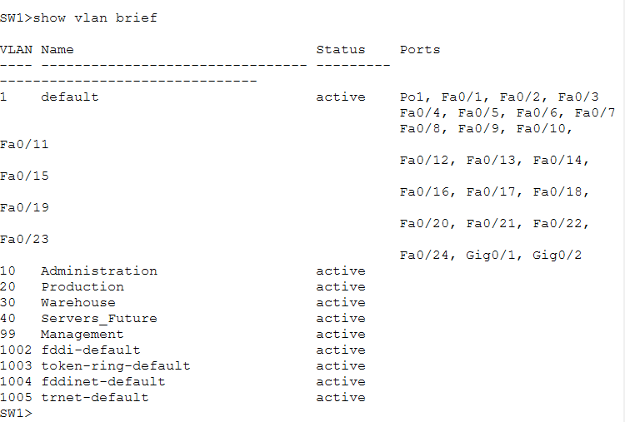
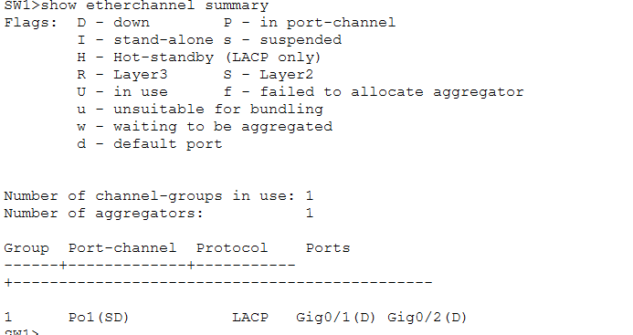
SW2
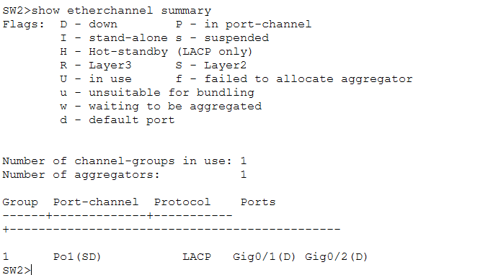
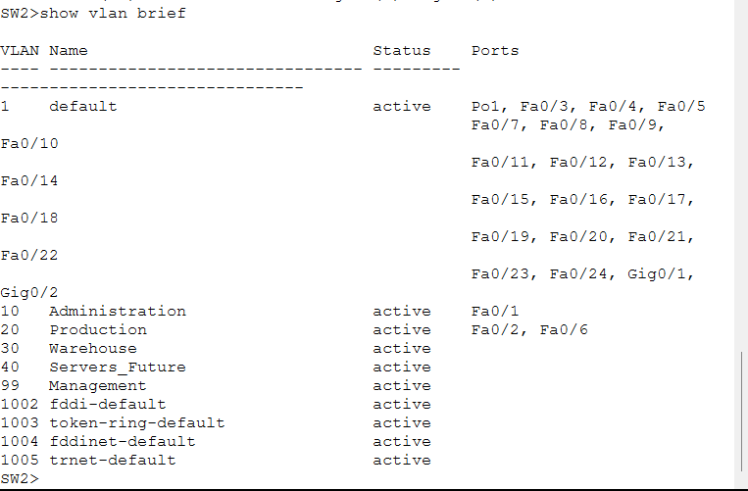

R1
