Group Project Documentation   
Advanced Cross-Platform Application Programming with .NET

Blood Donor

|  |  |
| --- | --- |
| **Group Happy 3 Friends** | |
| **Lecture** | Ms Vo Thi Thanh Van |
| **Group members** | Nguyen Dao Duc Quan – SE151008 Huynh Le Thuy Tien – SE151104 Nguyen Lam Thuy Phuong – SE150999 |

**Ho Chi Minh City, 2022**

**Table of Contents**

1. Project Introduction 4

1.1 Product Perspective 4

1.2 User Classes and Characteristics 5

**1.2.1 Business Rule** 5

**1.2.2 User Requirement Specification** 7

2. Database Design 9

2.1 Conceptual Entity Relationship Diagram 9

2.2 Logical Entity Relationship Diagram 10

2.3 Physical Design Diagram 12

3. System Architecture 14

4. Implementation 14

4.1. Deployment Considerations 14

4.2. Screenshots and explanations 14

*5.* References 14

**List of Tables**

Table 1 Conceptual Entity Relationship Diagram Data Dictionary 9

Table 2 Logical Entity Relationship Diagram Data Dictionary 10

Table 3 Logical Entity Relationship Diagram Attribute Data Dictionary 11

Table 4 Physical Design Diagram Attribute Data Dictionary 14

**List of Figures**

Figure 1 The actions of actors in a blood donation 5

Figure 2 Notification process - receive rewards 6

Figure 3 The process of creating a new event 6

Figure 4 The process of managing a completed event 7

Figure 5 Conceptual Entity Relationship Diagram 9

Figure 6 Logical Entity Relationship Diagram 10

Figure 7 Physical Design Diagram 12

**Revision History**

|  |  |  |  |
| --- | --- | --- | --- |
| **Name** | **Date** | **Reason For Changes** | **Version** |
| *Quan Nguyen* | *28 September 2022* | *Initial version* | *1.0* |
|  |  |  |  |
|  |  |  |  |
|  |  |  |  |
|  |  |  |  |

# Project Introduction

## Product Perspective

Voluntary blood donation is always a noble gesture to the community. Thousands of patients are treated promptly every year with blood and blood products. It is estimated that in 2021, more than 1.3 million blood units have been donated and this number is still expected to increase in the coming years.

With those expectations and needs, the Blood Donor website was born to better manage and propagate blood donation campaigns to volunteers, helping voluntary blood donation be more popular in society.

It is expected that the Blood Donor website will be part of the blood storage and management system in locations across the country. BloodDonor will perform the main functions such as:

* Create voluntary blood donation projects, divided into 2 types: campaigns (with certain deadlines and regulations) and freedom blood donations (not included in the campaign).
* Management of voluntary blood donation projects: Number of participants, the total amount of blood collected.
* Manage the process to get rewards for volunteers with great contributions.

## User Classes and Characteristics

### **1.2.1 Business Rule**

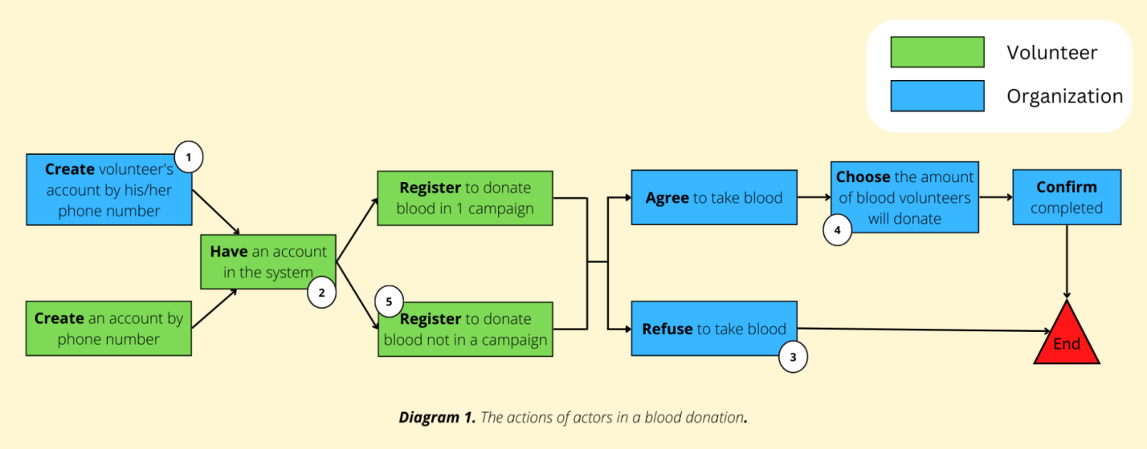

**Figure 1 The actions of actors in a blood donation**

1. The created accounts will have the default password is the login name (phone number) of the volunteer. The volunteer can change it later.
2. Volunteers are required to have an account to participate in blood donation. Volunteers can create an account at home or go to a blood donation place to ask staff to help create an account with the organization's account.
3. After the health check, in case the volunteer is not eligible to participate in blood donation, the organization calling for blood donation will refuse to receive blood from the volunteer.
4. If the volunteer is healthy enough to donate blood, the organization's staff will ask how much blood the volunteer wants to donate. The staff will then select the option corresponding to that amount of blood on the system. There are 3 levels of blood donation: 250ml, 350ml, 450ml.
5. The interval between 2 blood donations is 12 weeks. Volunteers cannot register to donate blood in 2 events at the same time. To register to donate blood at another event, volunteers need to cancel the registration form of the previous event.

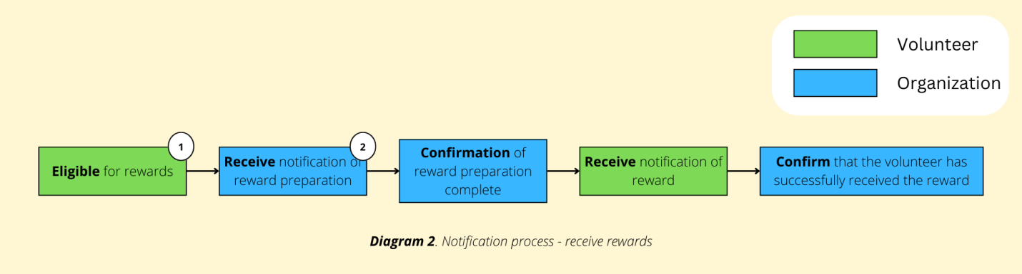

***Figure 2 Notification process - receive rewards***

1. Volunteers will be rewarded for each blood donation right after donating blood. This process is used to describe the receipt of a reward when a volunteer donates blood a sufficient number of times. Rewards can include gifts, cash, certificates of merit prepared by the awarding organization. Reward milestones: 5 times, 10 times, 20 times, 30 times, 40 times, 50 times.
2. The organization that prepares the reward does not have to be a place where volunteers donate blood. Volunteers can donate blood in many places and receive rewards in another, classified by registered address.

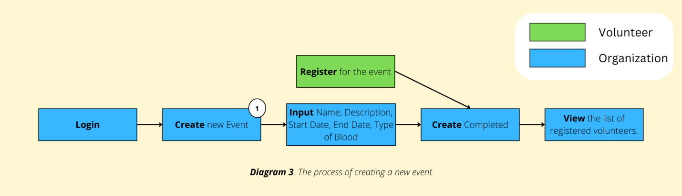

**Figure 3 The process of creating a new event**

1. An event is a blood donation activity, can be a campaign or a free blood donation day:
   1. A campaign consisting of name, description, start date, end date, blood type, created by an employee of the organization.
   2. A free blood donation day also includes name, description, start and end dates are defaulted on the same day, receive all types of blood, are automatically generated every day in the system.

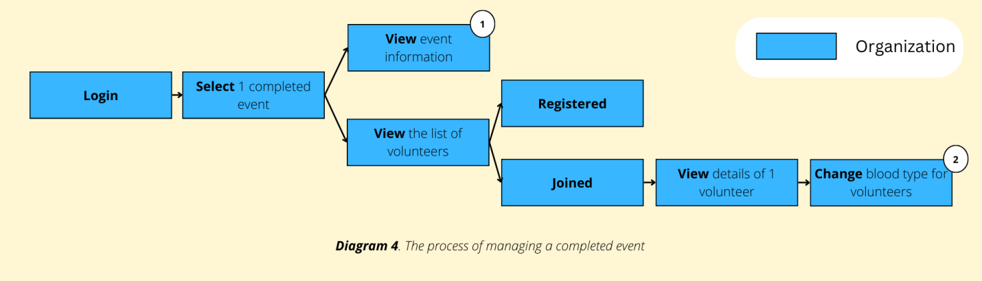

**Figure 4 The process of managing a completed event**

1. Event information includes basic information: Start - end date, name, description, ... and total blood and total amount of blood each type received.
2. Volunteers who do not know their blood type will be assigned to the unspecified blood group. The organization's staff will add blood group information for volunteers after the first blood donation.

### **1.2.2 User Requirement Specification**

**The system is divided into 4 basic User Roles as follows:**

* **Guest:** User who only view information on the web.
* **Volunteer:** The person who donates blood.
* **Organization:** An employee of the organization entrusted with the management of blood donations.
* **Admin:** The general manager of the organization.

**Each role will have different functions and operations on the system, specifically as follows:**

* **Guest:**
* View information about blood donation.
* View blood donation campaigns.
* **Volunteers must login to do these actions:**
* Login/log out.
* Create an account by phone number.
* View - edit account information (cannot adjust blood type).
* View blood donation history.
* View reward history.
* Find a suitable campaign.
* Register to participate in the campaign.
* Register to donate blood freely.
* Receive campaign alerts.
* Receive notifications about receiving rewards.
* **Hospital/Red Cross must login to do these actions:**
* Close/open 1 campaign.
* Manage the status of volunteers participating in a campaign: registered, participate (volunteers are free to come and participate without pre-registration, the hospital/red cross will register to help).
* Close/open free blood donation day (not included in any campaign).
* Manage the status of free volunteers (free blood donation, not in a campaign): registered, engaged.
* Manage blood volume (ml) of 1 volunteer in each blood donation.
* Manage campaign list, free blood donation date (search, view, history, volunteers who participated, amount of blood (ml) donated, amount of blood (ml) of each type).
* To be informed about the volunteers who meet the criteria to receive the reward (ex: after 5 blood donations, after 10 blood donations) (only the city Red Cross will receive this notice).
* CRUD accounts for volunteers (View, search, adjust blood type, reward history).
* **Admin must login to do these actions:**
* Manage the Hospital/Red Cross information list (search, view).
* CRUD Hospital/Red Cross account.

# Database Design

## 2.1 Conceptual Entity Relationship Diagram

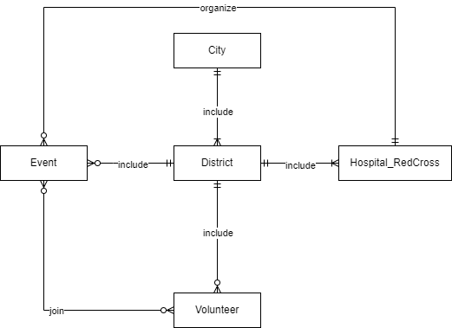

**Figure 5 Conceptual Entity Relationship Diagram**

|  |  |
| --- | --- |
| **Entity Data dictionary: describe content of all entities** | |
| **Entity Name** | **Description** |
| City | Describe all cities in the system. |
| District | Describe all districts in the system. |
| Hospital_RedCross | Describe all organizations (including hospital or Red Cross society) in the system. |
| Event | Describe all events (including campaign or freedom donated blood day) in the system. |
| Volunteer | Describe all blood donated volunteers in the system. |

**Table 1 Conceptual Entity Relationship Diagram Data Dictionary**

## 2.2 Logical Entity Relationship Diagram

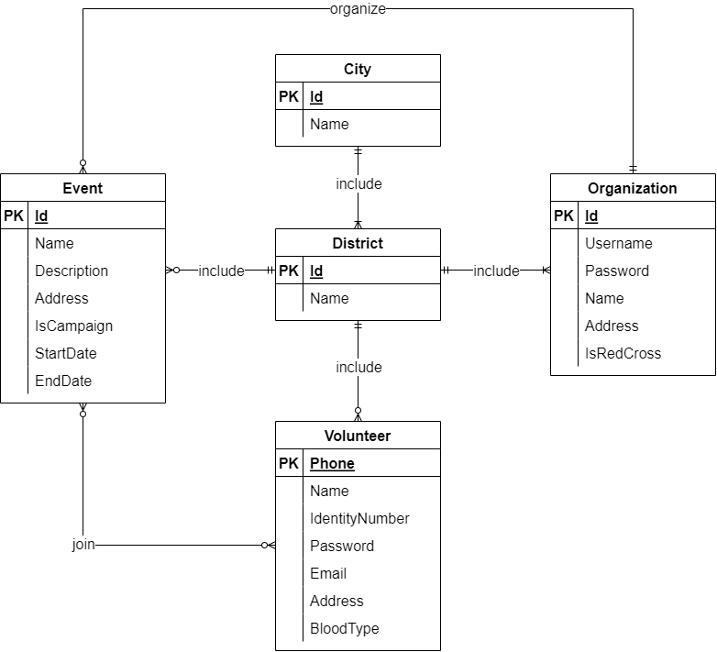

**Figure 6 Logical Entity Relationship Diagram**

|  |  |
| --- | --- |
| **Entity Data dictionary: describe content of all entities** | |
| **Entity Name** | **Description** |
| City | Describe all cities in the system. |
| District | Describe all districts in the system. |
| Organization | Describe all organizations (including hospital or Red Cross society) in the system. |
| Event | Describe all events (including campaign or freedom donated blood day) in the system. |
| Volunteer | Describe all blood donated volunteers in the system. |

**Table 2 Logical Entity Relationship Diagram Data Dictionary**

|  |  |  |  |  |
| --- | --- | --- | --- | --- |
| **Entity name** | **Attribute** | **Description** | **Domain** | **Null** |
| City | Id {PK} | Unique identity of each city. | INT | No |
| Name | Name of city. | NVARCHAR(50) | No |
| District | Id {PK} | Unique identity of each district. | INT | No |
| Name | Name of district. | NVARCHAR(50) | No |
| Organization | Id {PK} | Unique identity of each organization. | INT | No |
| Username | Unique username of each organization. | VARCHAR(20) | No |
| Password | Password belong to username of each organization for login. | VARCHAR(16) | No |
| Name | Name of each organization. | NVARCHAR(100) | No |
| Description | Description of each organization. | NTEXT | Yes |
| Address | Address details of each organization. | NVARCHAR(100) | Yes |
| IsRedCross | Check if organization is Red Cross society or hospital. | BIT | No |
| Event | Id {PK} | Unique identity of each event. | INT | No |
| Name | Name of each event. | NVARCHAR(100) | No |
| Description | Description of each event. | NTEXT | Yes |
| Address | Address details of each event. | NVARCHAR(100) | Yes |
| IsCampaign | Check if event is campaign or freedom donated blood day. | BIT | No |
| StartDate | Start date of each event. | DATETIME | No |
| EndDate | End date of each event. | DATETIME | No |
| Volunteer | Phone {PK} | Unique phone of each volunteer for login. | CHAR(10) | No |
| Name | Name of each volunteer. | NVARCHAR(100) | No |
| IdentityNumber | Identity number of each volunteer. | CHAR(12) | No |
| Password | Password belong to phone of each volunteer for login. | VARCHAR(16) | No |
| Email | Email of each volunteer. | VARCHAR(50) | Yes |
| Address | Address details of each volunteer. | NVARCHAR(100) | Yes |
| BloodType | Blood type of each volunteer. | CHAR(3) | Yes |

**Table 3 Logical Entity Relationship Diagram Attribute Data Dictionary**

## 2.3 Physical Design Diagram

**Figure 7 Physical Design Diagram**

|  |  |  |  |  |
| --- | --- | --- | --- | --- |
| **Entity name** | **Attribute** | **Description** | **Domain** | **Null** |
| City | Id {PK} | Unique identity of each city. | INT | No |
| Name | Name of city. | NVARCHAR(50) | No |
| District | Id {PK} | Unique identity of each district. | INT | No |
| Name | Name of district. | NVARCHAR(50) | No |
| CityId {FK} | ID of city where district is located in. | INT | No |
| Organization | Id {PK} | Unique identity of each organization. | INT | No |
| Username | Unique username of each organization. | VARCHAR(20) | No |
| Password | Password belong to username of each organization for login. | VARCHAR(16) | No |
| Name | Name of each organization. | NVARCHAR(100) | No |
| Description | Description of each organization. | NTEXT | Yes |
| Address | Address details of each organization. | NVARCHAR(100) | Yes |
| IsRedCross | Check if organization is Red Cross society or hospital. | BIT | No |
| DistrictId {FK} | ID of district where organization is located in. | INT | No |
| Event | Id {PK} | Unique identity of each event. | INT | No |
| Name | Name of each event. | NVARCHAR(100) | No |
| Description | Description of each event. | NTEXT | Yes |
| Address | Address details of each event. | NVARCHAR(100) | Yes |
| IsCampaign | Check if event is campaign or freedom donated blood day. | BIT | No |
| StartDate | Start date of each event. | DATETIME | No |
| EndDate | End date of each event. | DATETIME | No |
| DistrictId {FK} | ID of district where event is located in. | INT | No |
| OrganizationId {FK} | ID of organization which organize event. | INT | No |
| Volunteer | Phone {PK} | Unique phone of each volunteer for login. | CHAR(10) | No |
| Name | Name of each volunteer. | NVARCHAR(100) | No |
| IdentityNumber | Identity number of each volunteer. | CHAR(12) | No |
| Password | Password belong to phone of each volunteer for login. | VARCHAR(16) | No |
| Email | Email of each volunteer. | VARCHAR(50) | Yes |
| Address | Address details of each volunteer. | NVARCHAR(100) | Yes |
| LastDonationDate | The last date of blood donation of each volunteer. | DATE | Yes |
| DistrictId {FK} | ID of district where volunteer live in. | INT | No |
| BloodId {FK} | Blood Id of each volunteer. | CHAR(3) | Yes |
| Blood | Id {PK} | Unique identity of each blood. | INT | No |
| Type | Type of each blood. | CHAR(3) | No |
| VolunteerInEvent | Id {PK} | Unique identity of each relationship of volunteer in event. | INT | No |
| VolunteerId {FK} | Phone of volunteer who join in event. | CHAR(10) | No |
| EventId {FK} | ID of event which organize for volunteer to join for blood donation activity. | INT | No |
| BloodAmount | Blood amount of volunteer’s blood donation. | INT | Yes |
| RegistrationDate | The day when volunteers register to donate blood. | DATETIME | No |
|  | ScheduleStateId {FK} | ID of volunteer schedule status with registered dates and events. | INT | No |
| RequiredBloodInEvent | Id {PK} | Unique identity of each relationship of blood in event. | INT | No |
| EventId {FK} | ID of event which organize for volunteer to join for blood donation activity. | INT | No |
| BloodId {FK} | Blood Id which require in event. | CHAR(3) | No |
| ScheduleState | Id {PK} | Unique identity of each schedule status. | INT | No |
| Name | Name of volunteer schedule status with registered dates and events. | NVARCHAR(30) | No |
| ReceivedAwardHistory | Id {PK} | Unique identity of each received award history. | INT | No |
| OrganizationId {FK} | ID of Red Cross soceity which give the award to volunteer. | INT | No |
| VolunteerId {FK} | Phone of volunteer who receive award. | CHAR(10) | No |
| ReceivedDate | Date when volunteer receive award. | DATETIME | No |
| Description | Description of award. | NTEXT | Yes |
| State | The status of volunteer has come to receive the award or not. | NVARCHAR(50) | No |

**Table 4 Physical Design Diagram Attribute Data Dictionary**

# System Architecture

# Implementation

## Deployment Considerations

## Screenshots and explanations

# References