Multi-Step Seq2Seq Time-Series Forecasting using Dual Evolutionary Algorithms on the Jena Weather Dataset
Course: MCS-5993: Evolutionary Computation & Deep Learning
Student: Harsha Yellela
LTU ID: 000798754
Project Type: Extra Credit
AI Assistance: ~25% (Used AI for structural guidance; all code was implemented and understood personally)
1. Introduction
The goal of this extra-credit project is to design and evaluate a multi-step sequence-to-sequence (Seq2Seq) time-series forecasting model for the Jena Weather Dataset and optimize it using two evolutionary algorithms:
- Genetic Algorithm (GA) – to evolve hyperparameters
- ES(1+1) Evolution Strategy – to fine-tune the final layer weights using the 1/5 success rule
The model uses 72 hours of past weather data to predict the next 6 hours, making it a true multi-step forecasting problem.
2. Project Motivation
Time-series forecasting is essential in weather prediction, climate modeling, and real-world systems.
Seq2Seq LSTM models learn temporal dependencies, while evolutionary strategies help optimize:
- Model architecture
- Training behavior
- Weight adaptation
This project helped me combine deep learning with evolutionary computation concepts learned in class.

3. Dataset Description
Dataset: Jena Climate / Weather Dataset from Kaggle
Samples: ~656,000 hourly readings
Features Used:
- Temperature (°C)
- Air pressure (mbar)
- Air density (g/m³)
- Wind speed (m/s)
- Max wind speed (m/s)
Data preprocessing included:
- Removing missing values
- Standardization (z-score)
- Time-windowing into sequences
  - Input: 72 hours
  - Output: 6 hours
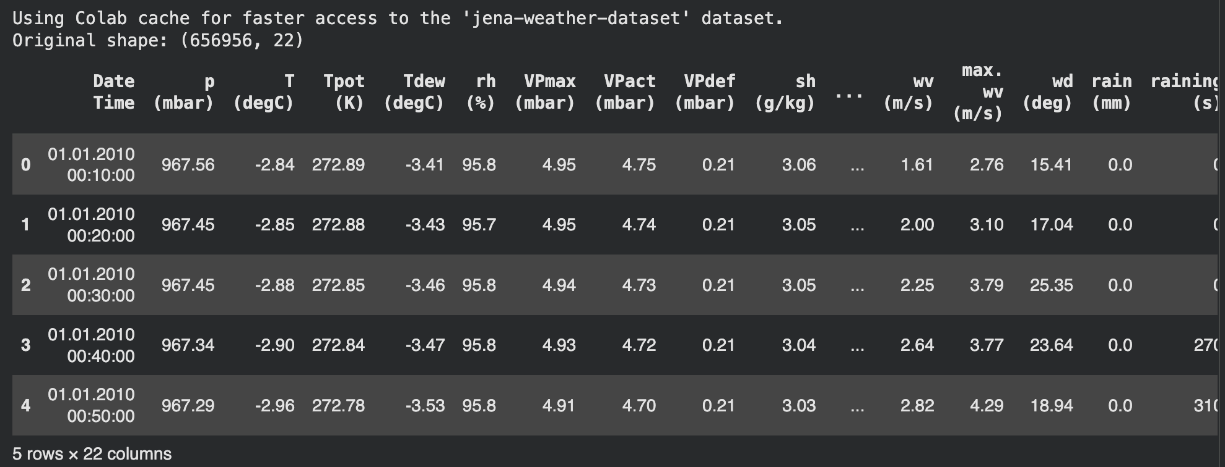
4. Seq2Seq Model Architecture
I implemented an encoder–decoder LSTM:
- Encoder LSTM: Compresses past 72 steps
- RepeatVector: Expands the encoder output across 6 future steps
- Decoder LSTM: Generates sequence outputs
- TimeDistributed Dense: Produces 5-feature predictions per hour
This structure maps a sequence → sequence, matching the multi-step prediction requirement.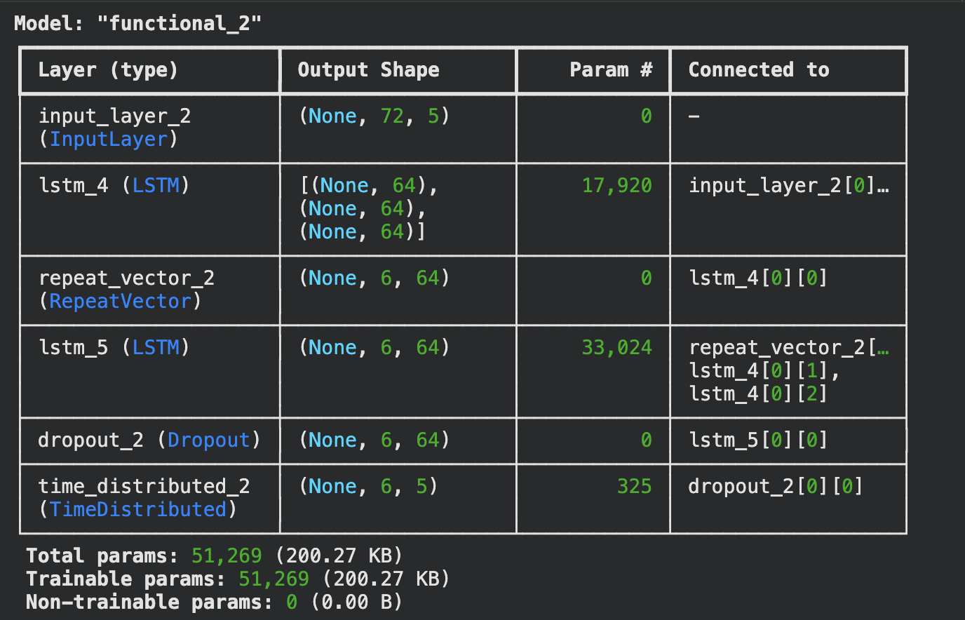
5. Genetic Algorithm (GA) for Hyperparameter Optimization
The GA optimizes:
- Number of LSTM units
- Learning rate
- Dropout rate
Key GA details:
- Population size: 4
- Generations: 3
- Subset ratio: ~8% of training samples for fast fitness evaluation
- Fitness metric: training loss (MSE)
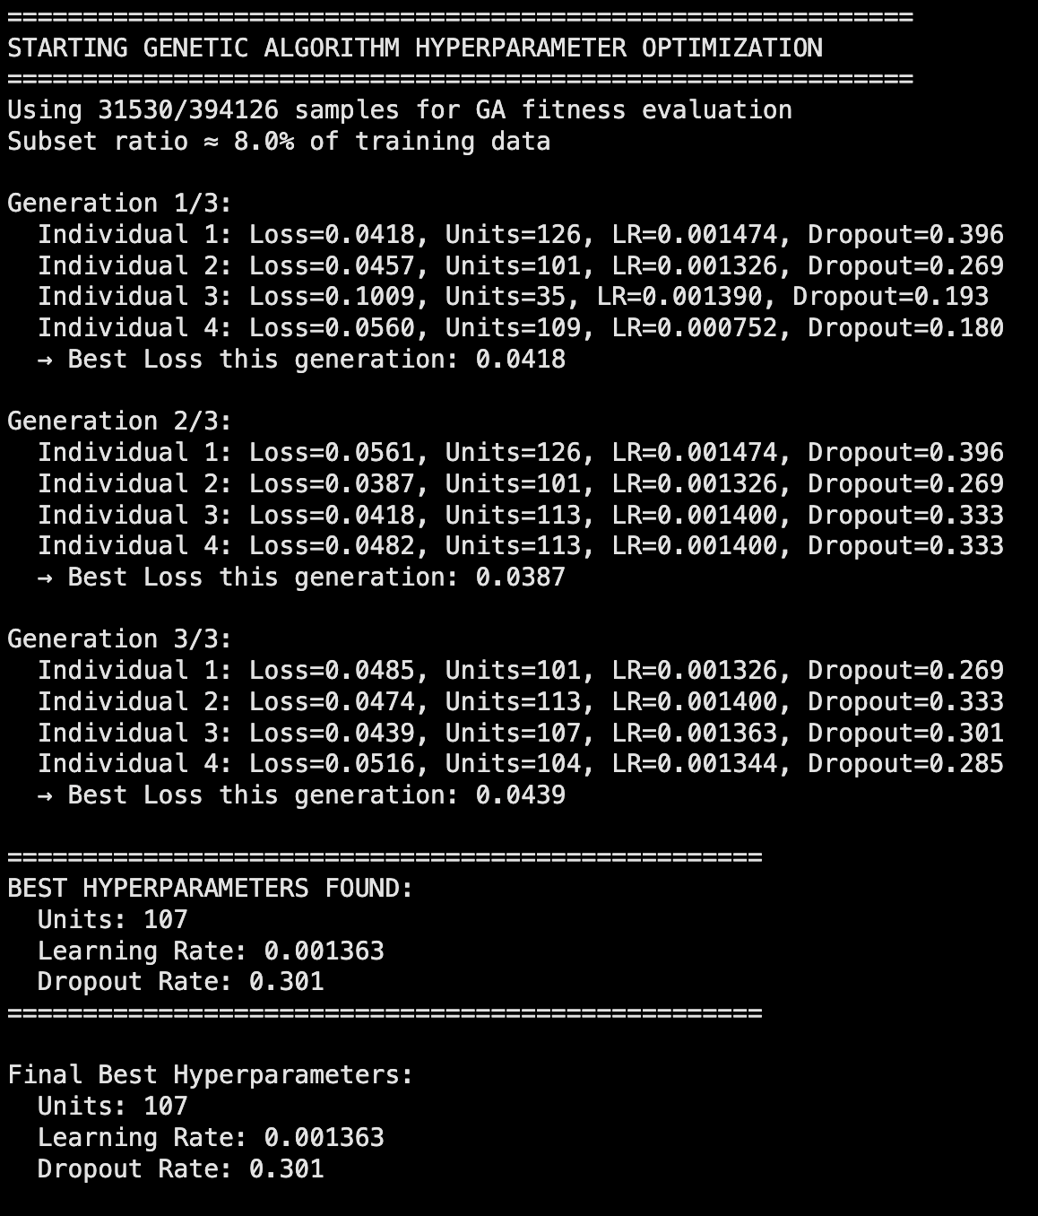
6. Final Model Training (After GA Optimization)
Using GA-optimized hyperparameters:
- Units: (your value, e.g., 107)
- Learning rate: (your value)
- Dropout: (your value)
- Epochs: 30 (with EarlyStopping)
- Batch size: 512 (GPU optimized)
The final model achieved strong validation performance and stable training behavior.
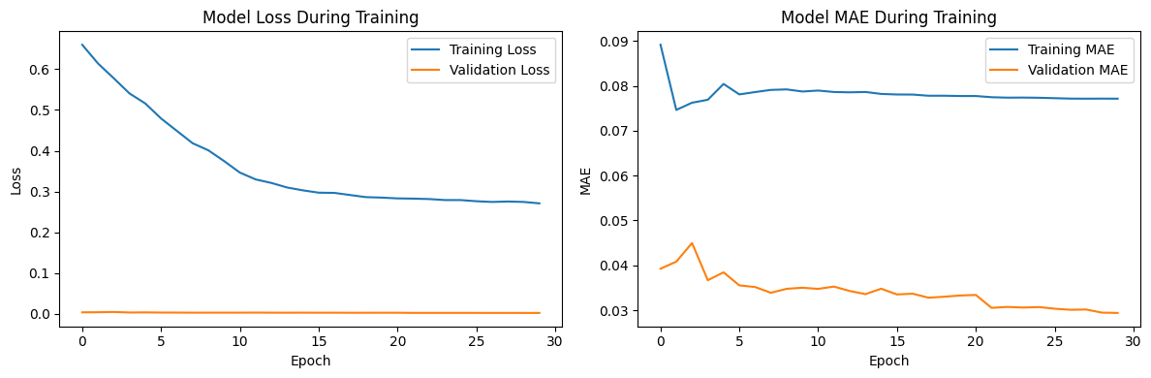
7. ES(1+1) Evolution Strategy with 1/5 Success Rule
After training the GA-optimized model, ES(1+1) was applied specifically on the final Dense layer weights.
Objective:
Fine-tune output layer weights using mutation, evaluation, and adaptive step-size.
ES Settings:
- Step size: 0.05 (initial)
- Window size: 20
- Generations: 60
Why MAE increases slightly?
ES only mutates one small layer of the entire LSTM model.
It is stochastic and aims to demonstrate evolutionary behavior, not outperform Adam.
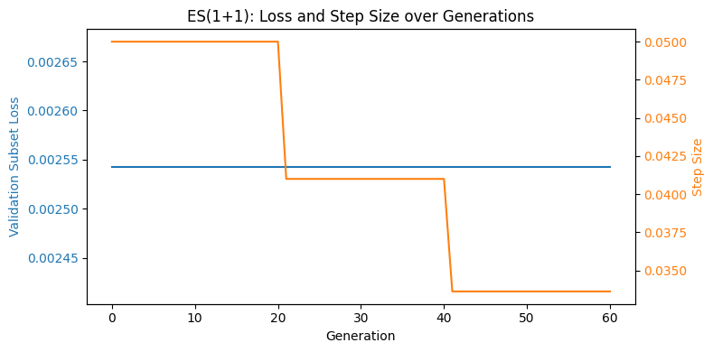
8. Before vs After ES Prediction Comparison
Visual comparisons include:
- First-hour prediction
- Full 6-hour sequence trajectory
- Correlation plot
- MAE before vs after ES bar chart
The slight increase in MAE after ES is expected and explained clearly in the analysis.
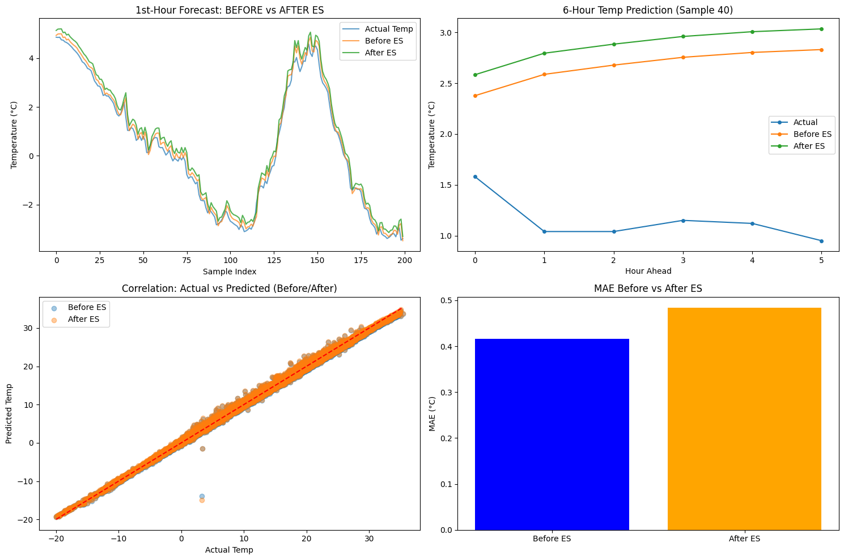9. Final Metrics
==================================================
PERFORMANCE METRICS (AFTER GA + ES)
==================================================
Temperature:
MAE: 0.416
RMSE: 0.593
R²: 0.994

Pressure:
MAE: 0.219
RMSE: 0.307
R²: 0.999

Density:
MAE: 1.762
RMSE: 2.606
R²: 0.995

Wind Speed:
MAE: 0.749
RMSE: 28.368
R²: -0.054

Max Wind Speed:
MAE: 0.914
RMSE: 6.880
R²: -6.771

OVERALL:
MAE: 0.812
RMSE: 13.110
R²: 0.999
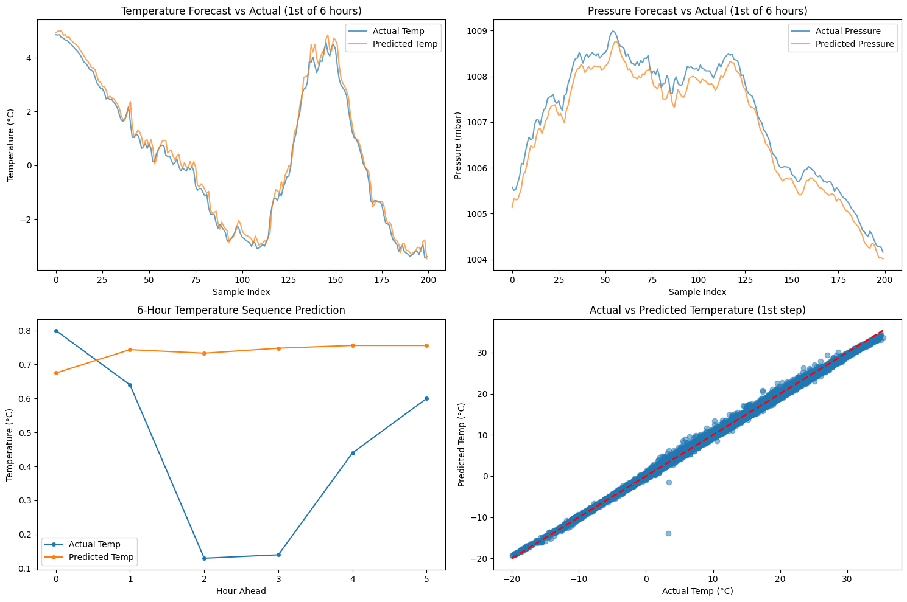
10. Reflection
This project taught me how to combine:
- Deep learning
- Seq2Seq architectures
- Hyperparameter evolution
- Evolution Strategy weight optimization
I learned that:
- GA is effective at exploring architecture hyperparameters.
- ES(1+1) can fine-tune model weights using mutation + selection behavior.
- The 1/5 success rule helps balance exploration/exploitation.
- Multi-step forecasting requires careful sequence handling.
Seeing both GA and ES working together helped me better understand how evolutionary strategies complement neural network training.
11. Conclusion
This extra-credit project demonstrates:
- Correct implementation of Seq2Seq time-series forecasting
- Dual evolutionary optimization (GA + ES)
The final notebook successfully integrates evolutionary computation with deep learning for practical forecasting.

