
Dear {{ name }},

{{ date }}

A Global Entity of VDart Inc
{{ reg_no }}

{{ major }}
{{ college }}

Congratulations!
We are pleased to offer you an opportunity to undergo On-The-Job Training (OJT) at VDart Academy. This training program is designed to provide you with practical exposure and hands-on experience, enhancing your skills and preparing you for future career opportunities.
Please find below the details of the same

Enrollment: | Academic Internship | Enrollment ID:
Technology: | {{ role }} | Domain: | Information Systems
Organization: | VDart Academy | Location: | GCE – Mannapuram
Start Date: | {{ start_date }} | End Date: | {{ end_date }}
Stipend: | Not Applicable | Reporting SME: | Anubharathi P
Shift Time: | 9:00 AM to 1:00 PM IST | Shift Days: | Monday - Friday
SME Email: | anubharathi.p@vdartinc.com | SME Mobile: | +91 99445 48333

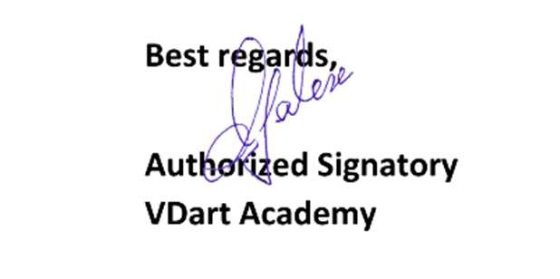

We believe this opportunity will contribute to your professional development, and we look forward to your active participation. Kindly confirm your acceptance by signing a copy of this letter by {{ n_date }}.
Should you have any questions, feel free to contact us.

