Dear {{ name }},



{{ date }}

A Global Entity of VDart Inc

{{ reg_no }}

{{ major }}

{{ college }}

Congratulations!

We are pleased to offer you an opportunity to undergo On-The-Job Training (OJT) at VDart Academy. This training program is designed to provide you with practical exposure and hands-on experience, enhancing your skills and preparing you for future career opportunities.

Please find below the details of the same

|  |  |  |  |
| --- | --- | --- | --- |
| **Enrollment:** | Academic Internship | **Enrollment ID:** |  |
| **Technology:** | {{ role }} | **Domain:** | Information Systems |
| **Organization:** | VDart Academy | **Location:** | GCE – Mannapuram |
| **Start Date:** | {{ start_date }} | **End Date:** | {{ end_date }} |
| **Stipend:** | Not Applicable | **Reporting SME:** | Anubharathi P |
| **Shift Time:** | 9:00 AM to 1:00 PM IST | **Shift Days:** | Monday - Friday |
| **SME Email:** | anubharathi.p@vdartinc.com | **SME Mobile:** | +91 99445 48333 |

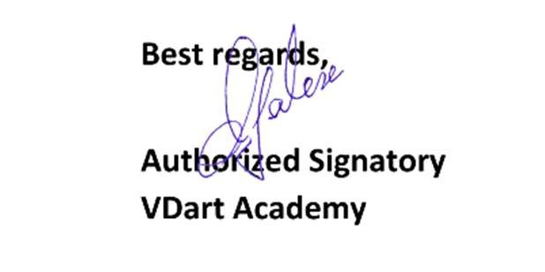

We believe this opportunity will contribute to your professional development, and we look forward to your active participation. Kindly confirm your acceptance by signing a copy of this letter by {{ n_date }}.

Should you have any questions, feel free to contact us.