**EXAMLY ROUND 3 – PROJECT**

**DIFFICULTY OF THE QUESTION**

**PROBLEM STATEMENT**

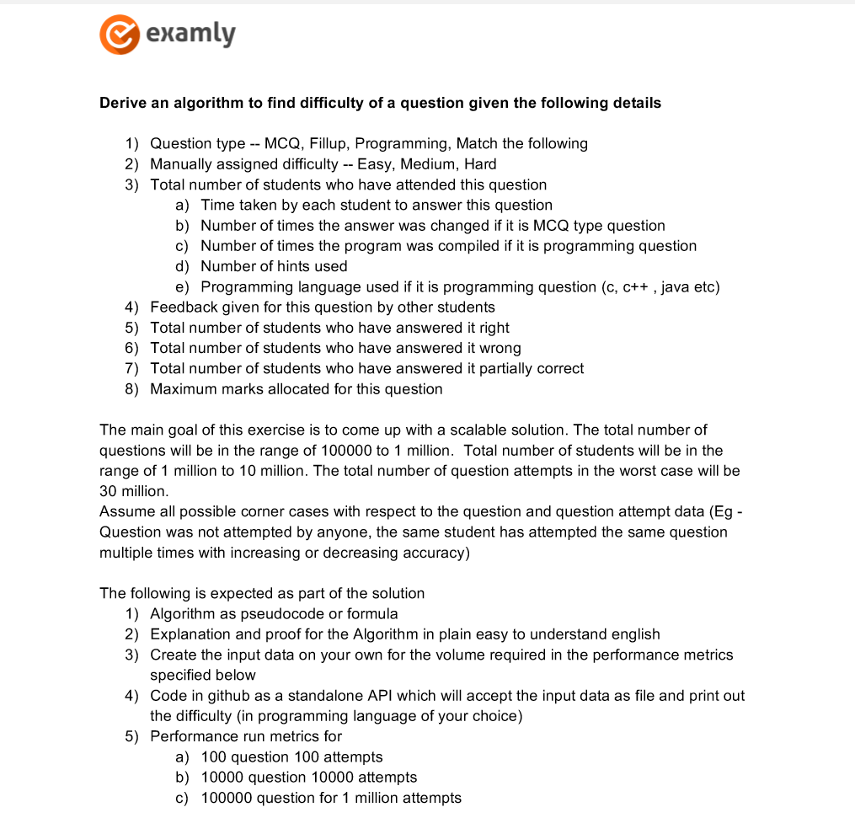

This project is to find the difficulty level of the question for various question types considering the factor like total number of student attended, average time taken of all students, the number of times answer was changes, the number of times compiled in case of program, number of hints used, question answered right, wrong, partially correct in case of program, marks allocated.

**PREREQUISITES**

To run this project the system should be installed with Flask (for API), latest version of Python (for ML).

**PROJECT STRUCTURE**

The project has four main parts:

i) Difficulty_Calculator.py

ii) app.py

iii) templates

iv) Dataset for training the model

Difficulty_Calculator.py – To Calculate the difficulty as easy, medium, hard for the given dataset and output the training set for the model.

app.py – To train the model by taking the training set outputted by Difficulty_Calculator.py. It also predicts the difficulty of the dataset file submitted from API using KNN algorithm trained model and outputs the result.

templates - This folder contains the HTML template to allow user to upload csv file for which difficulty is to be predicted.

Dataset – An excel file and csv file containing 4096 rows and 11 colums generated as per the conditions and details provided in the problem statement.

DATASET

To train the model data set is required, the data set is generated for four types of questions including 11 fields as mentioned in the problem statement and for each question type 1024 rows of data are used satisfying the performance metric conditions and to make the model well trained to work efficiently.

ALGORITHM OF Difficulty_Calculator.py

The Difficulty_Calculator file is inputted with the dataset csv file and using csv.reader() its stores as a list of list.

The csv file stored in a list of list is in the form of strings so its type casted to float and stored.

To store the Difficulty along with fields specified in an excel sheet xlsxwriter is imported and a new worksheet is created in a new workbook.

The code traverses through the list of list which contains the values of csv file inputted in the form of float, along with three variables easy, medium and hard.

In case of the time taken to answer for MCSs, Fill ups and match, if the average time taken is below 60seconds easy variable is incremented, if time taken is between 60 and 90 seconds medium is incremented else hard is incremented. For programs same happens in terms of minutes.

The number of times options changed and number of times compiled for MCQs and Programs respectively also carries the same way as if option is changed less than 2 times and program is compiled less than 2 times then the question is easy, if the options is changed or program is compiled between 2 to 6 times question is medium and else the question is hard (variable increments).

The number of hints used is also taken into consideration in case of programming and the based on the certain condition the hard, medium and east variables are incremented.

Regarding the programming language the C is easy, C++ is medium and Java is taken as hard.

Further based on the student attended and student correct count the variables are incremented, if ratio of correct answer and student attended is > 66% then easy, if less than 33% then hard else medium.

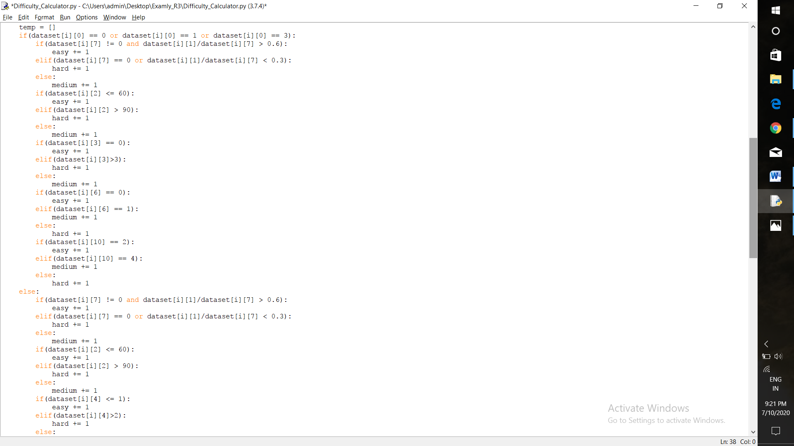

Based on the above mentioned criteria the variable having the maximum count is the difficulty level of the question for the dataset inputted.

The difficulty levels for training datasets are appended as a last field and the excel file is outputted.

The above mentioned process can be even carried out to predict the difficulty since the dataset to train the model is not available and it is not that much efficient it is considered only for calculating the difficulty level for the dataset.

ALGORITHM OF app.py

The inputted training set csv file is converted into list of list.

The list of list values are converted to float values excluding the last value since it acts as a label to classify the data by calling function str_column_to_float.

The last value of list of list is passed to an another function named str_column_to_int and the labels for classification is found.

0 means Easy, 1 means Hard and 2 means Medium.

The inputted csv file via web api is reverted to this python page and the file is converted to list of list and stored in form of float.

The k (number of nearest neighbors) value is given as 10.

The predict_classification function is called with the actual parameters as training dataset, predict dataset and k.

The get_neighbours function is called from the predict_classification function and the naerest k neighbours are found by calculating the Euclidean distance between the datasets and sorting them.

The get_neighbors function returns the k neighbor dataset values to the predict_classification function and the predict_classification function returns the max label(Hard, Medium , Easy) value.

The above three steps are carried out for all the rows in a dataset inputted via web-api.

The label values predicted is appended along with the csv file imported and converted into excel and then stored in device in the name Result.xlsx via an import xlsx reader.

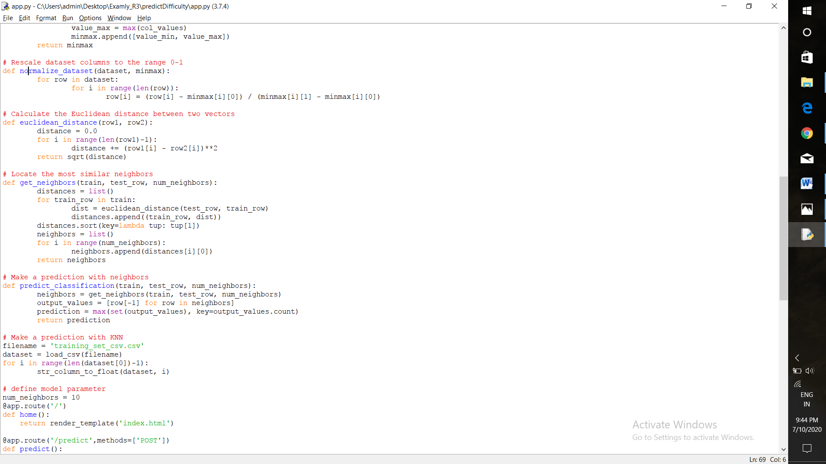

ALGORITHM OF TEMPLATES

The templates folder contain two files html and css which acts as a web-api through which the csv file to predict difficulty is uploaded.

The work is carried out in Anaconda and Spyder and Anaconda prompt is used to execute the flask commands to set up the flask environment and to run the python files.

**RUNNING THE PROJECT**

In the Anaconda Promptensure that you are in a project home directory to create and install the flask environment type conda create –n flask pip flask.

Activate the flask environment using conda activate flaskEnv.

Run the app.py in the flask environment.

By default flask will run on port:5000, Navigate to URL [http://localhost:5000](http://localhost:5000/).

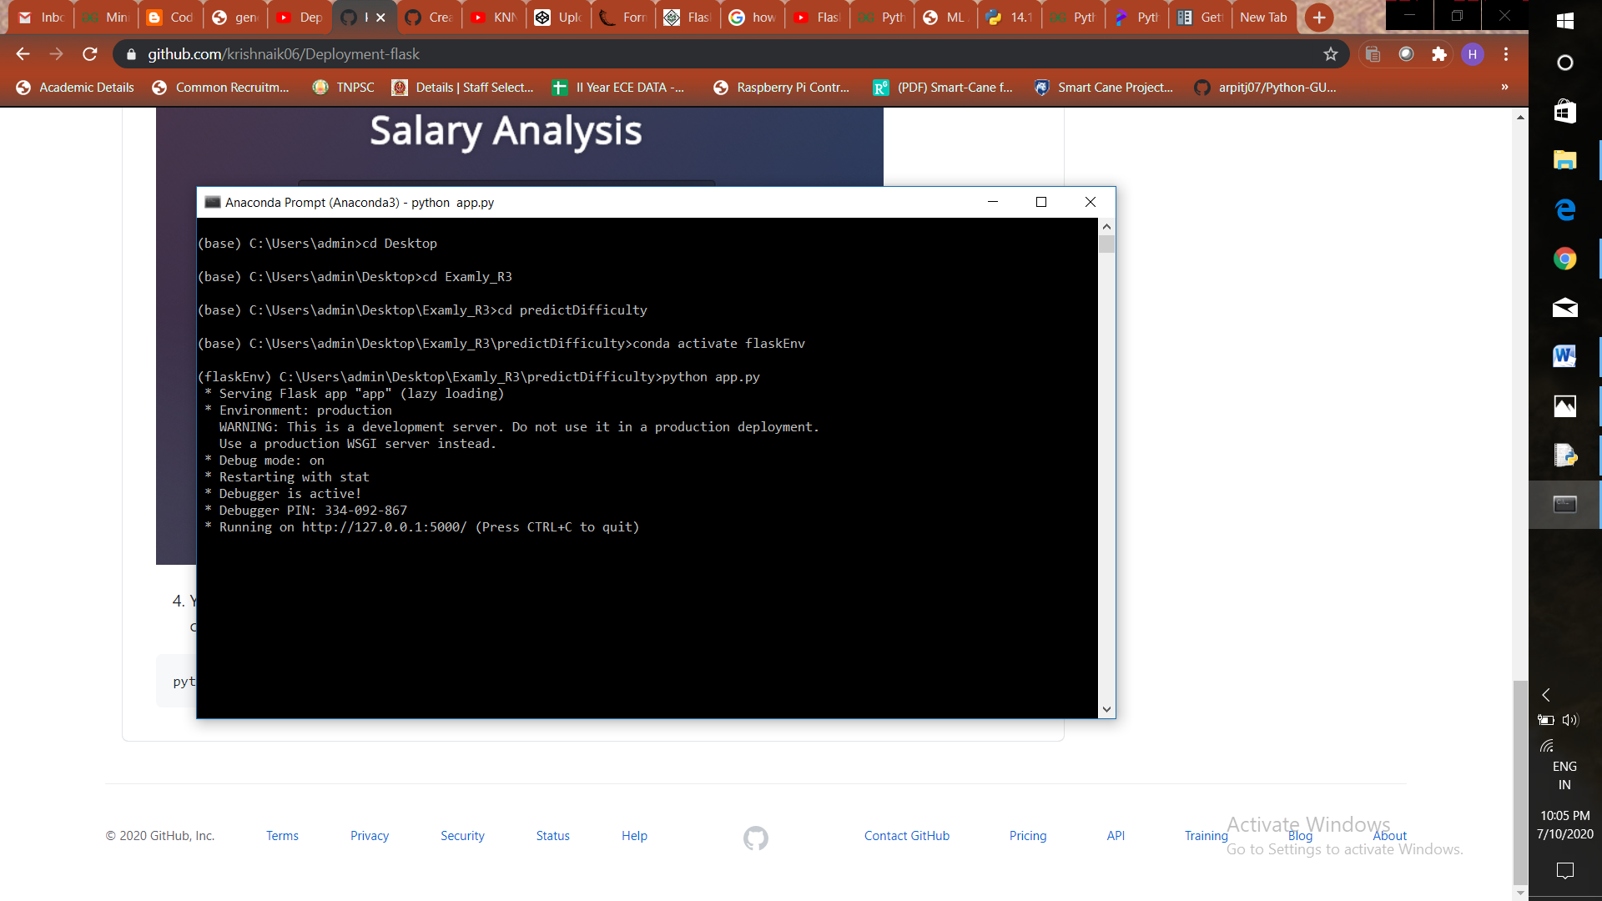

The web-api will be visible as:

