

**<Insert image on the background>**

**Click Image Area -> Format Tab -> Shape Fill -> Picture**

DriCalc4 configuration details

Author:

Designation

Place

Contents

Jenkins configuration details 3

Installed plugins details 3

List of available jobs 4

**DRICALC4 DevOps configuration and JOBS Details**

Server IP: 192.168.22.106

URL: http://192.168.22.106:8080/

Jenkins Version: 1.577

Jenkins configuration details

Manage Jenkins🡪Configure system

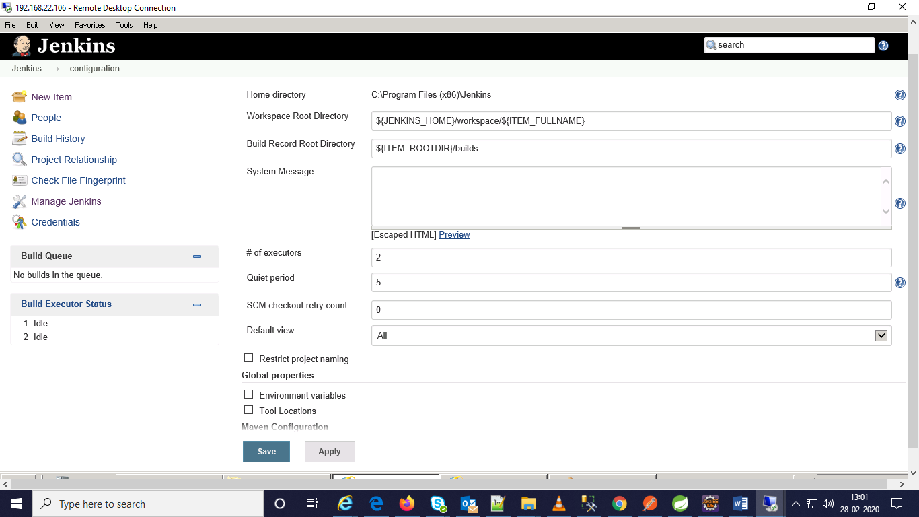

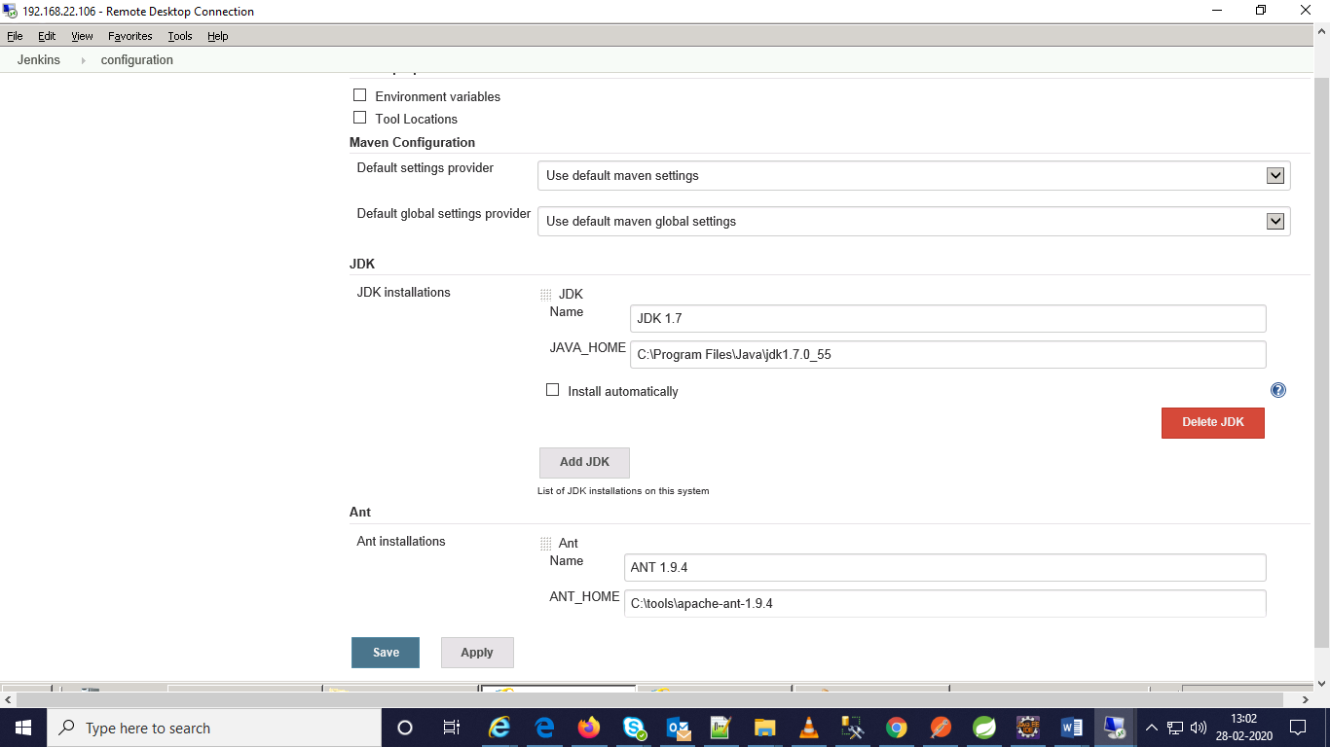

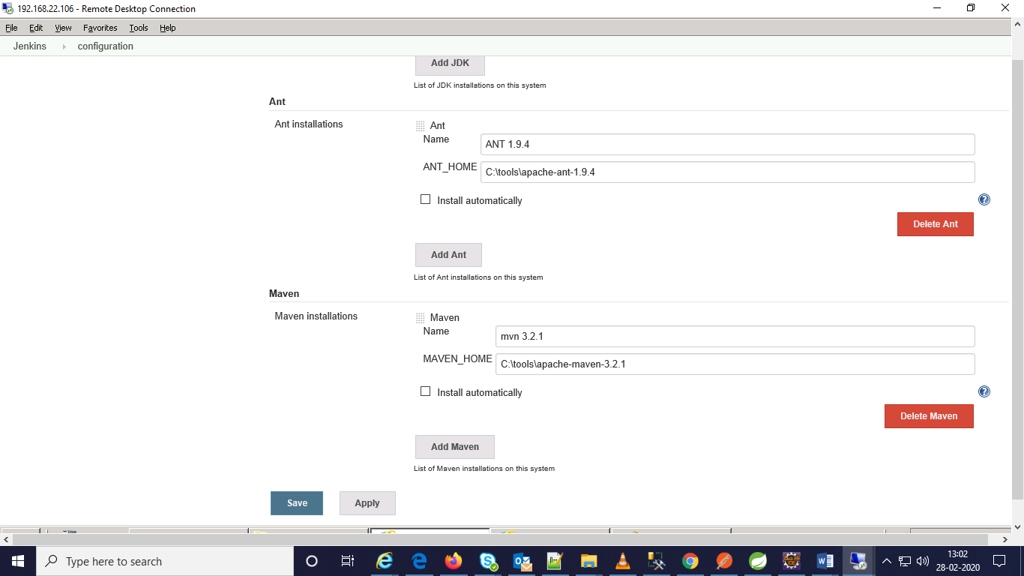

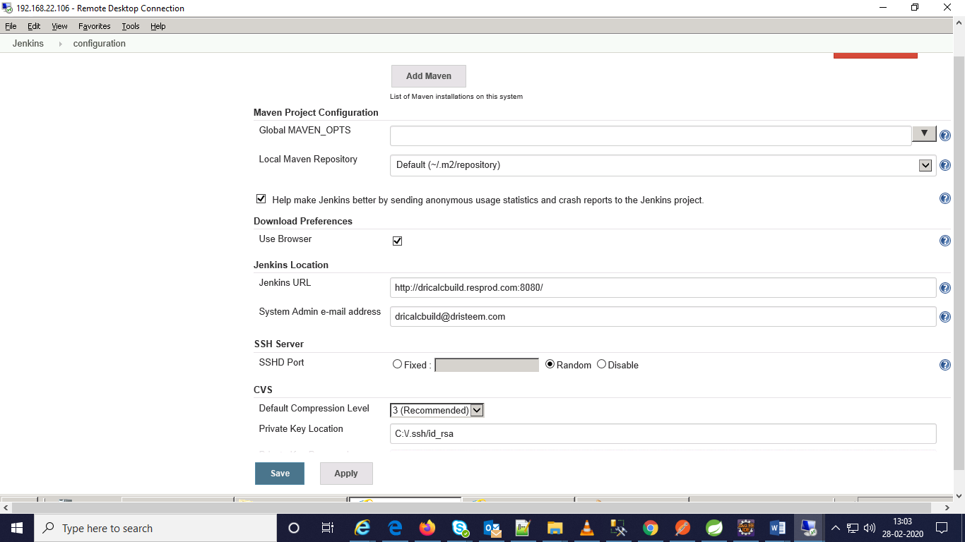

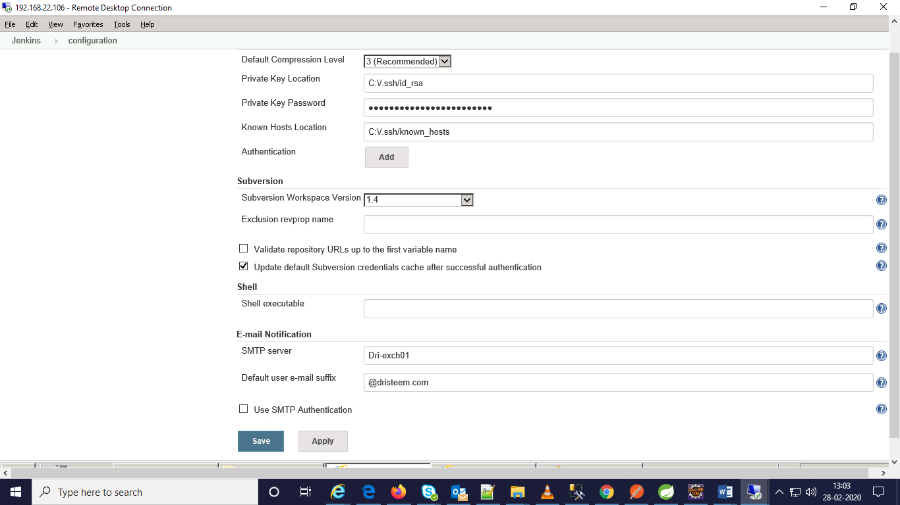

Save and apply.

Installed plugins details:

* Ant
* Credentials
* CVS
* JaCoCo
* JavaDoc
* Junit
* LDAP
* Mailer
* Matrix project
* Maven integration
* SSH build gents
* Ssh credentials
* Subversion
* WMI windows agents

Store credentials in this path

Manage Jenkins-🡪manage credentials

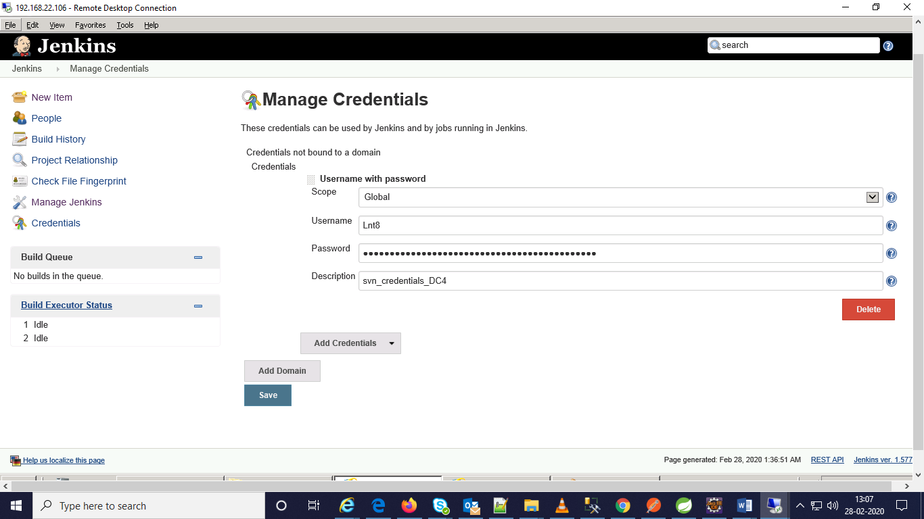

Available jobs:

1. DriCalc 4 Dev Build
2. DriClac DEV Deploy
3. DriCalc Production Deploy
4. DriCalc4_Sys_Build
5. DriCalc4_Sys_Deploy
6. Configuration details of DriCalc 4 Dev Build:

Step 1:

Select Maven project and name it.



Step 2:

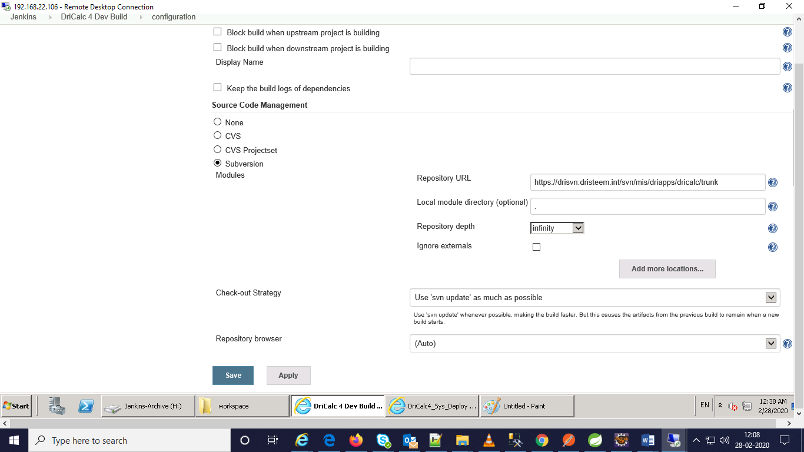

Step 3:

In the advanced tab options

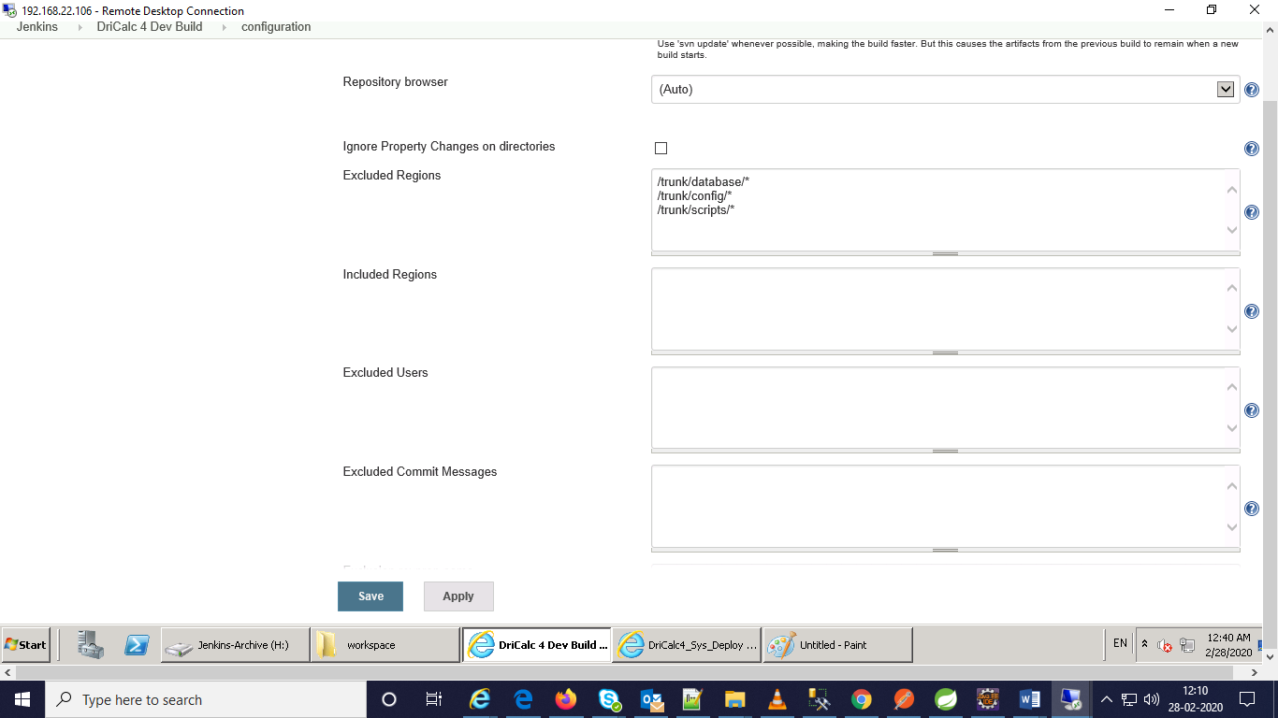

Step 4:

Build triggers:

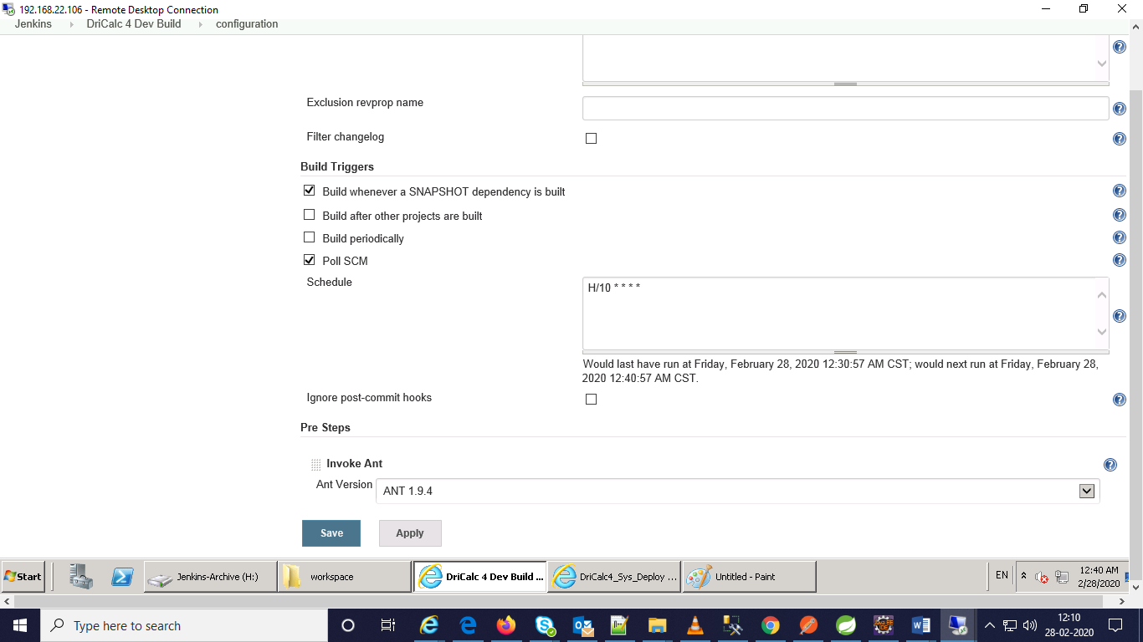

Step 5:

Presteps:

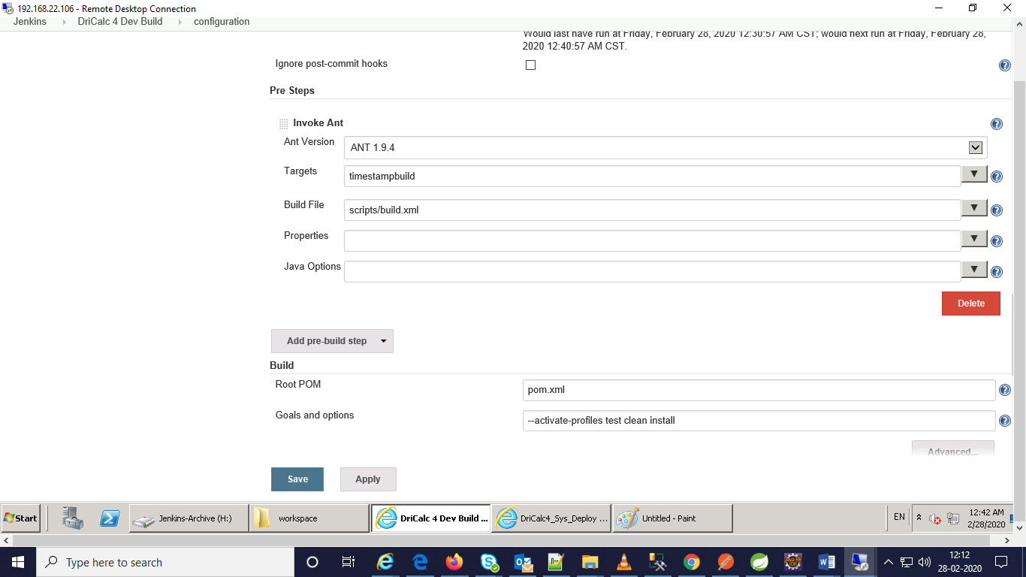

Step 6:

Build:

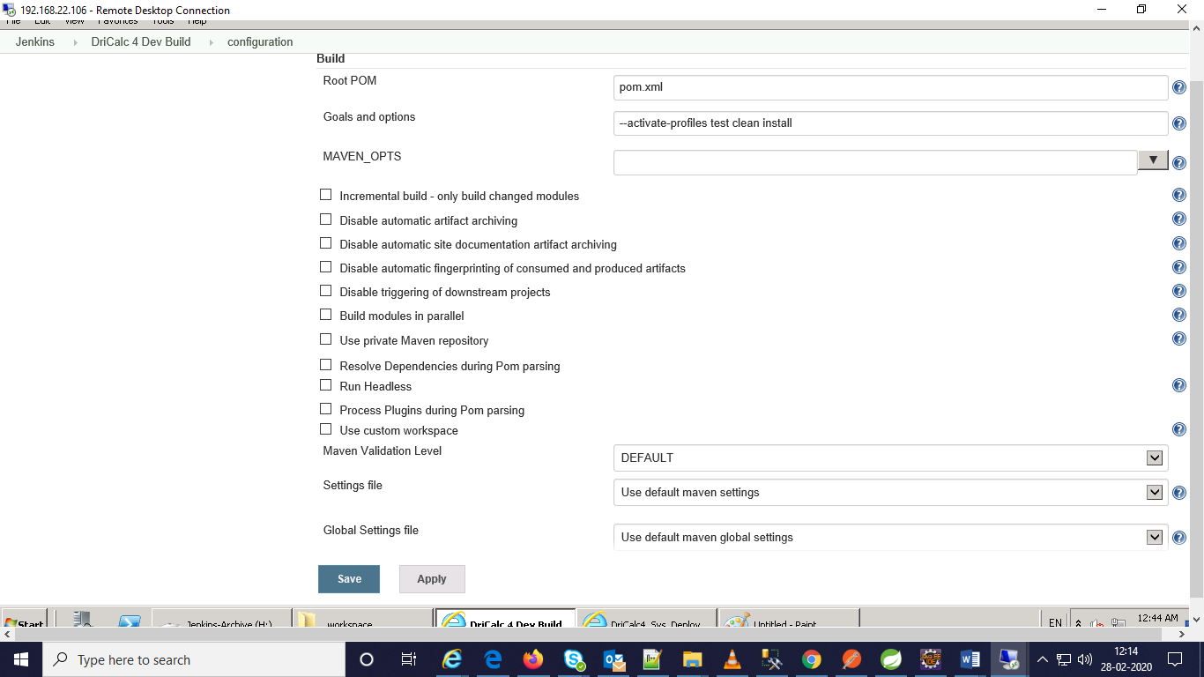

Step 7:

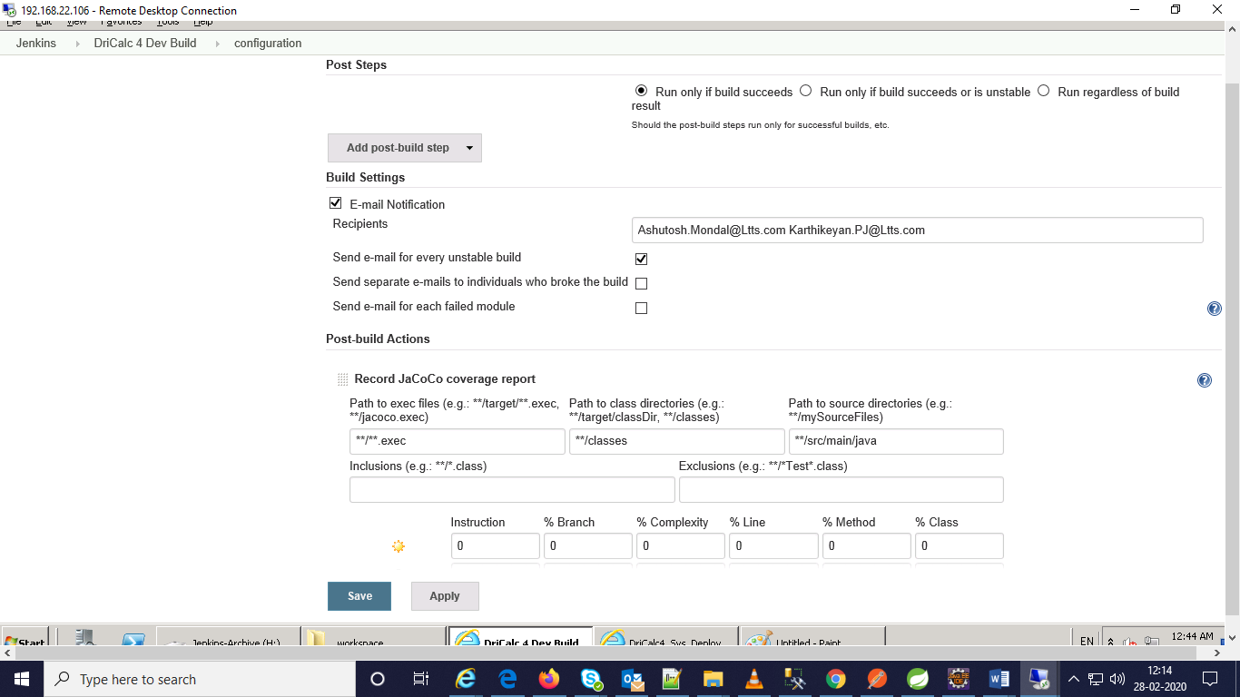

Step 8:

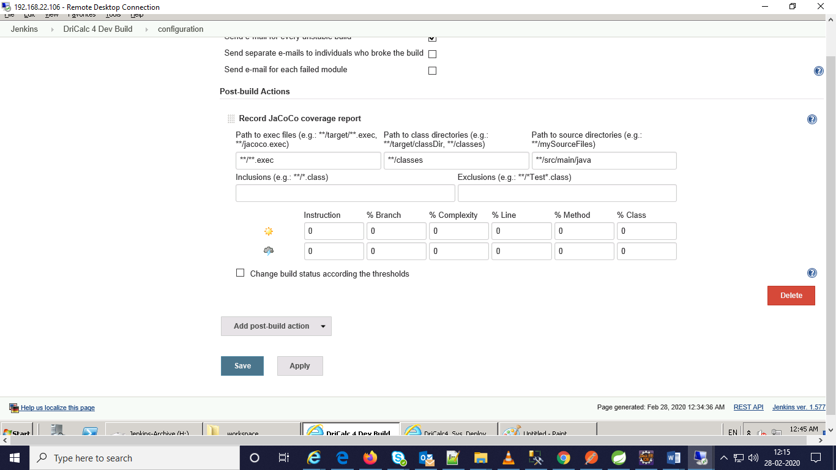

Step 9:

Save and apply

1. Configuration details of DriCalc DEV Deploy

Step 1:

Choose free style project and name the project.

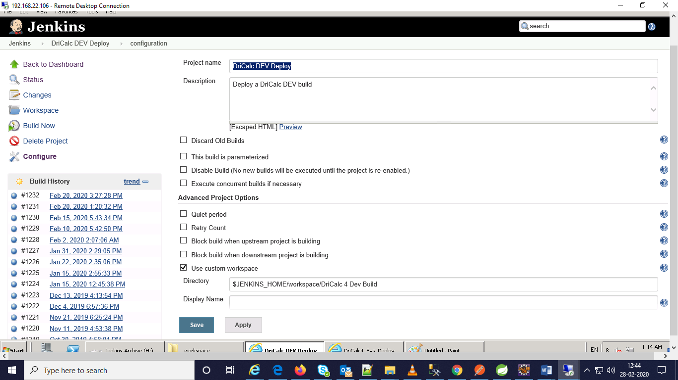

Step 2:

Select source code management as None.

Step 3:

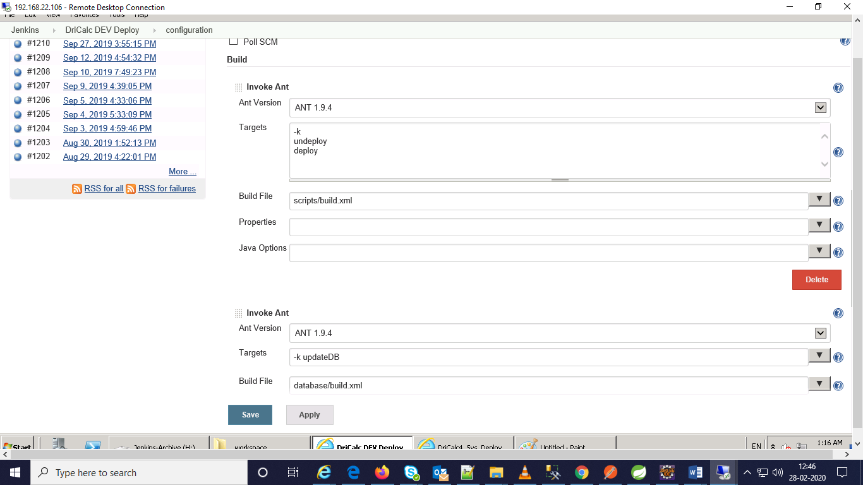

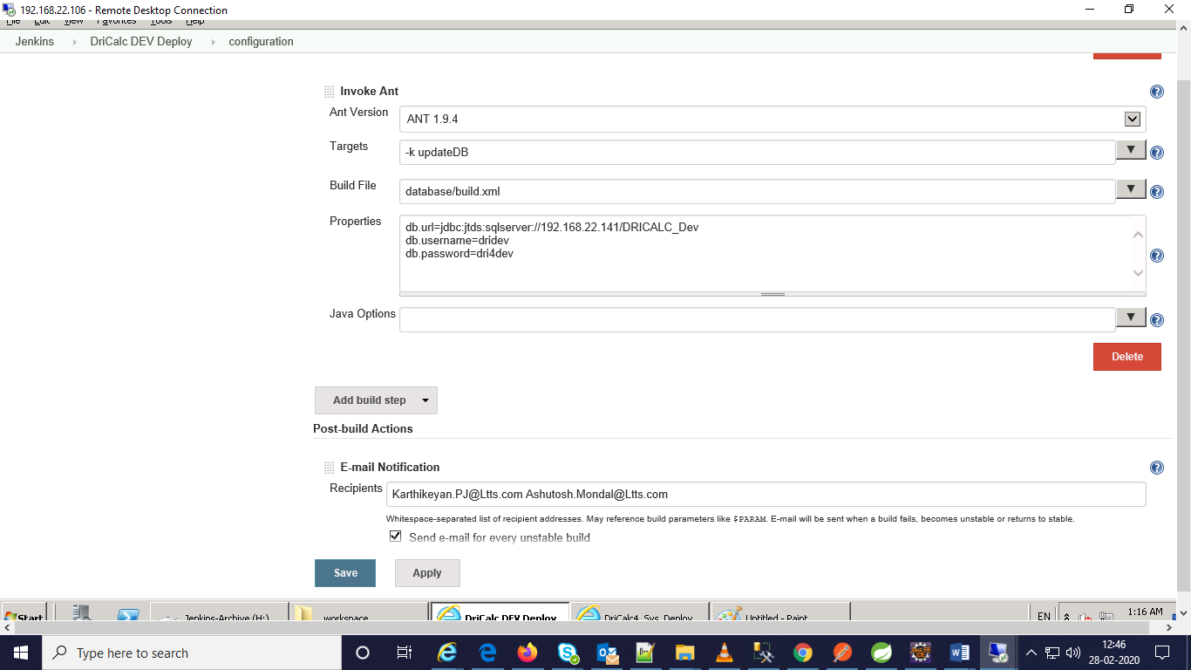

Step 4:

Post build actions:

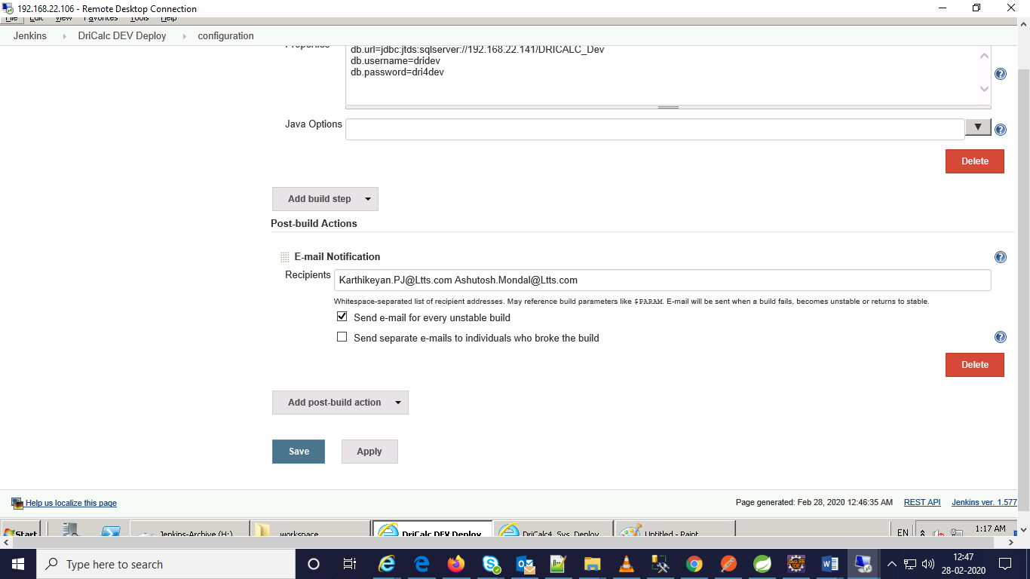

Step 5:

Save and apply

1. Configuration details of DriCalc4 Production Deploy:

Step 1:

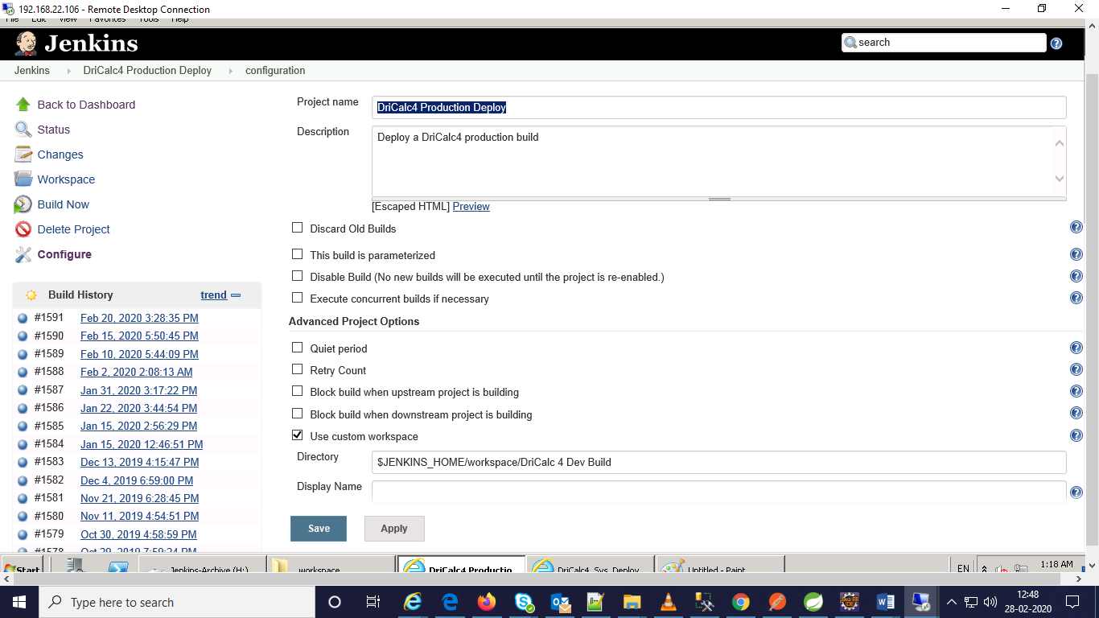

Step 2:

Select source code management as None.

Step 3:

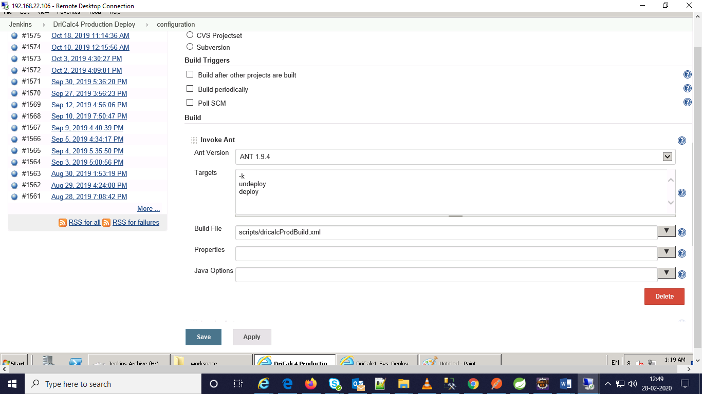

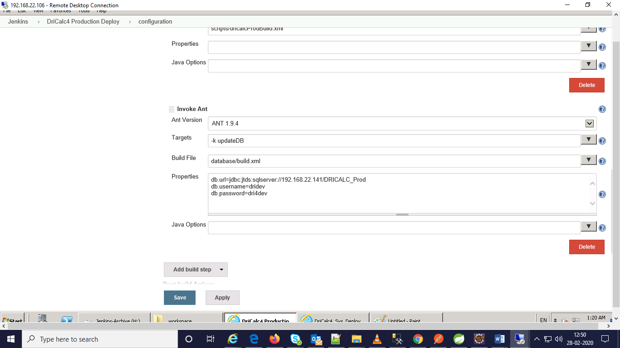

Step 4:

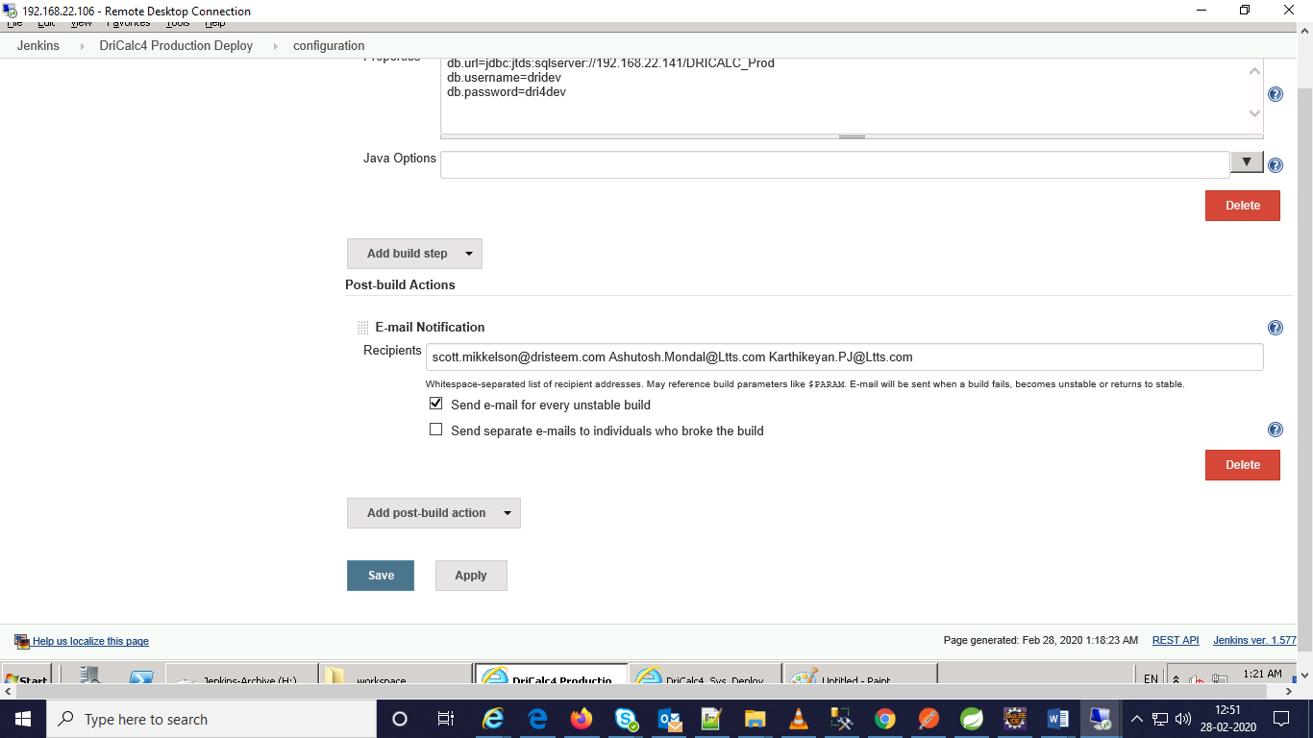

Step 5:

Save and apply

1. Configuration Details of DriCalc4_Sys_Build:

Step 1:

Select maven project and name it as DriCalc4_Sys_Build.

Step 2:

Source code management:

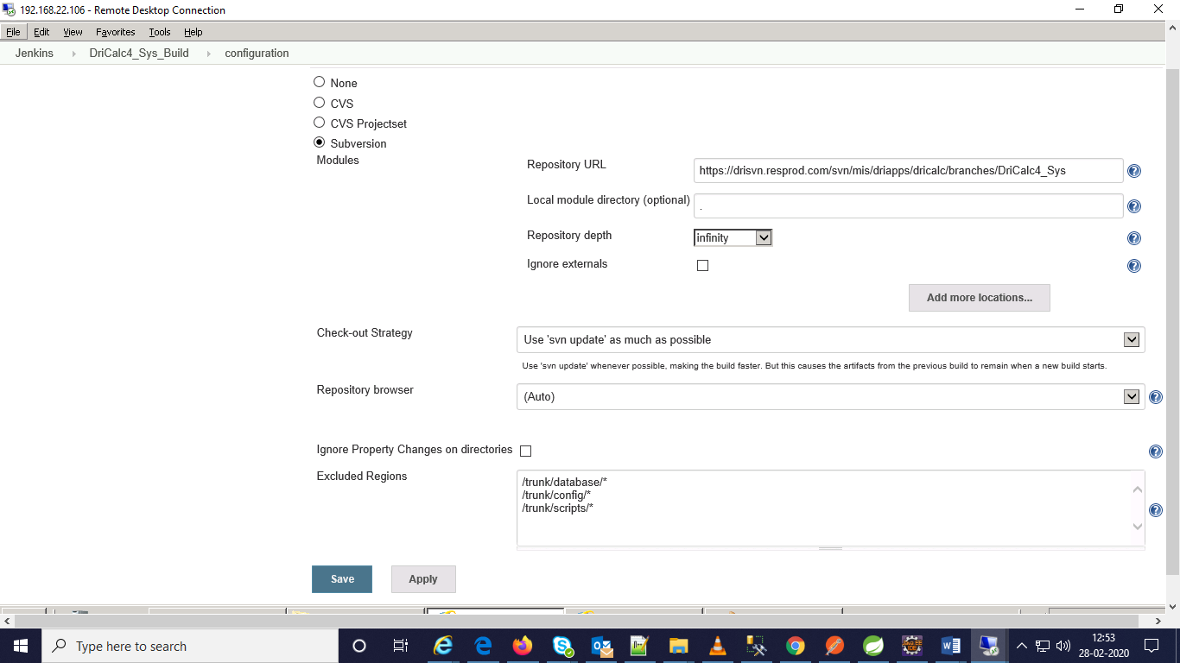

Step 3:

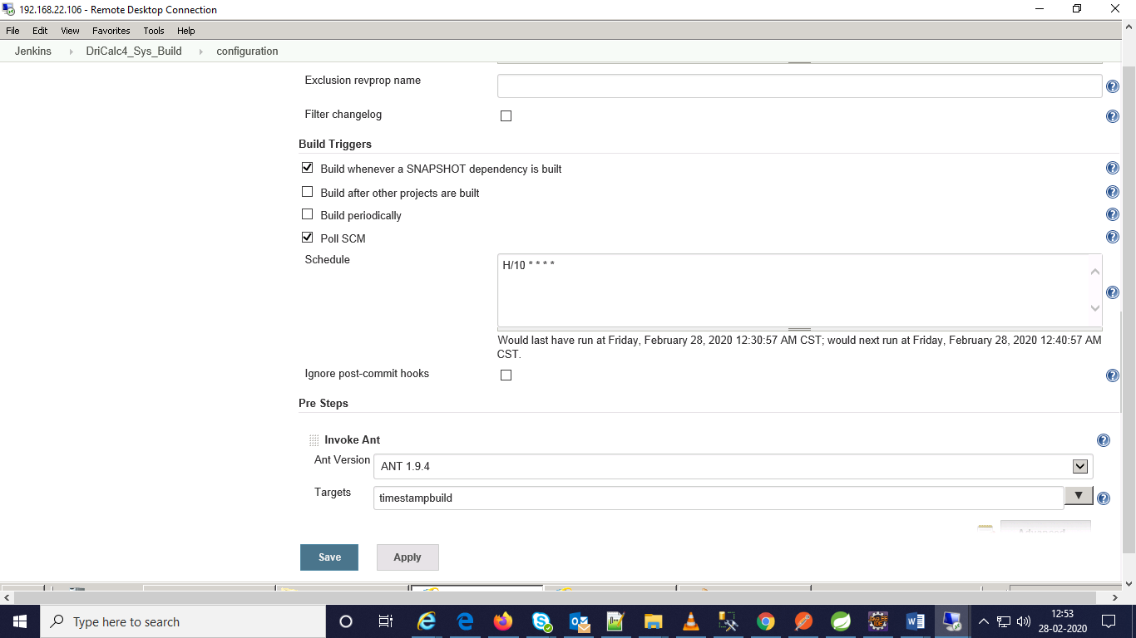

Step 4:

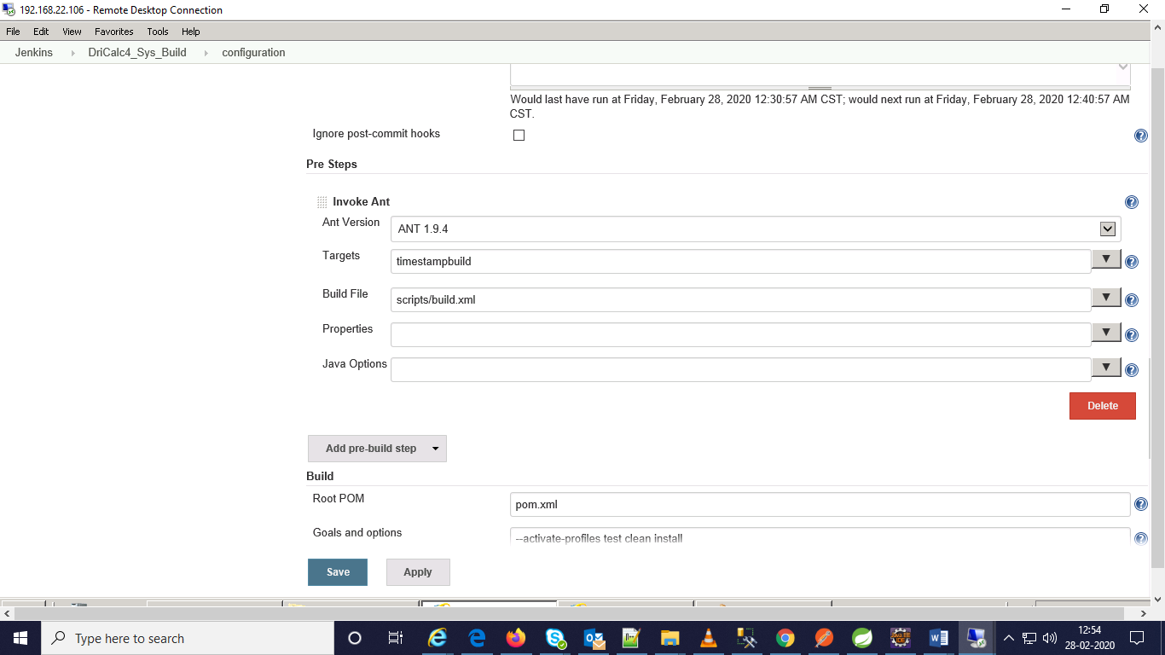

Step 5:

Build:

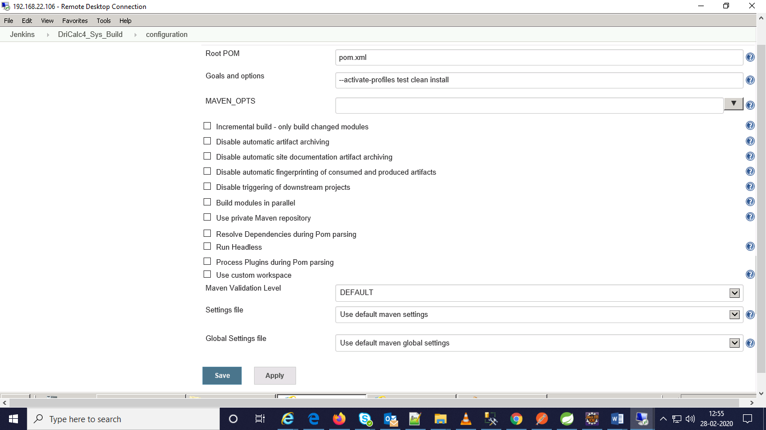

Step 6:

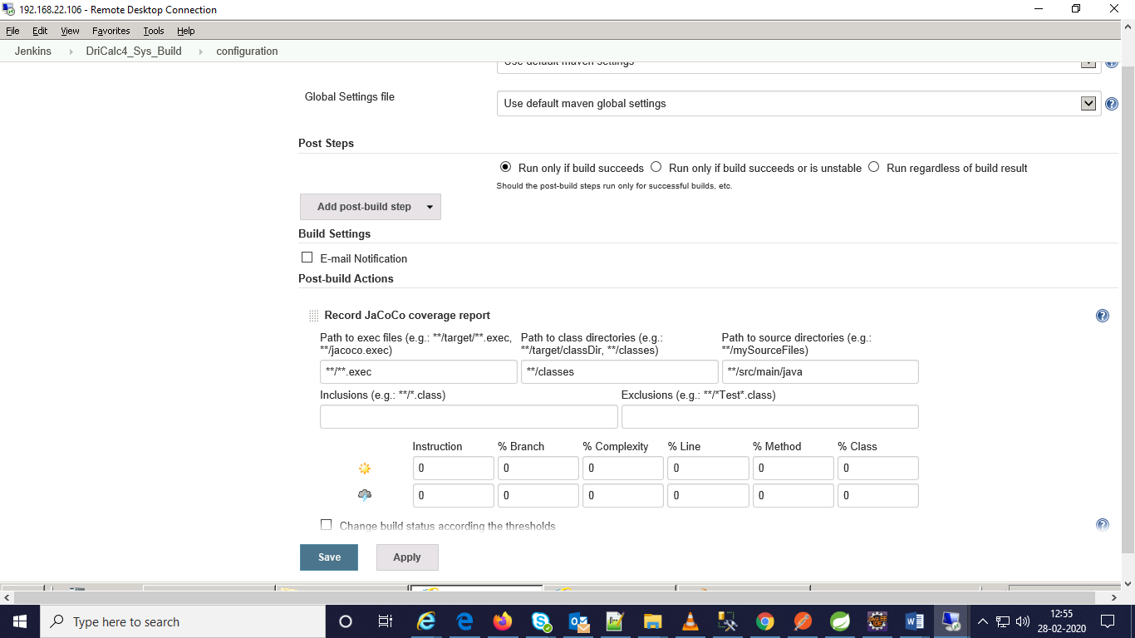

Step 7:

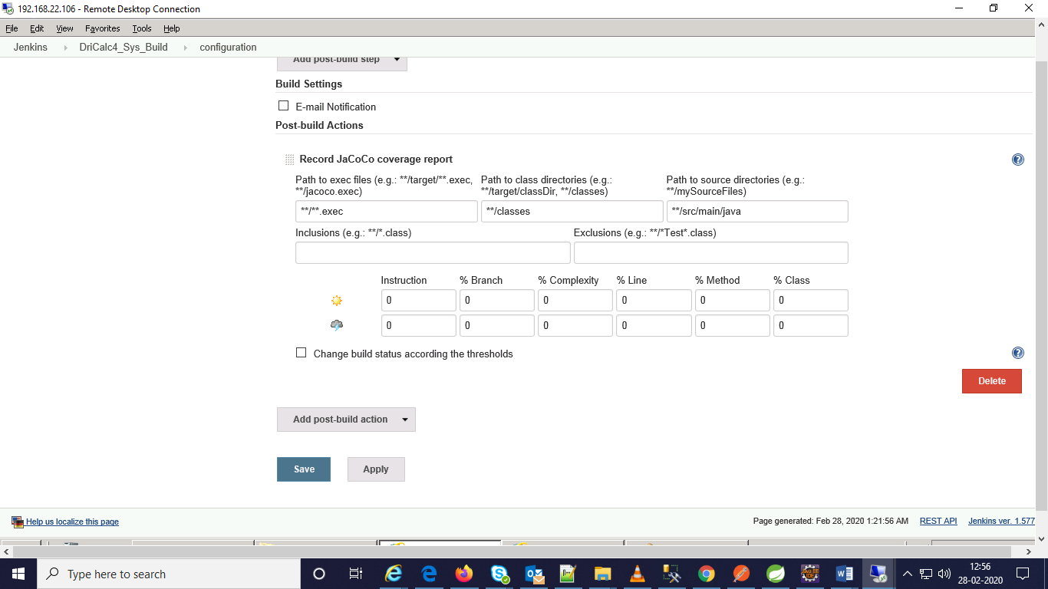

Step 8:

Save and apply

1. Configuration details of DriCalc4_Sys_Deploy job:

Step 1:

Select a free style project and name it as DriCalc4_Sys_Deploy.

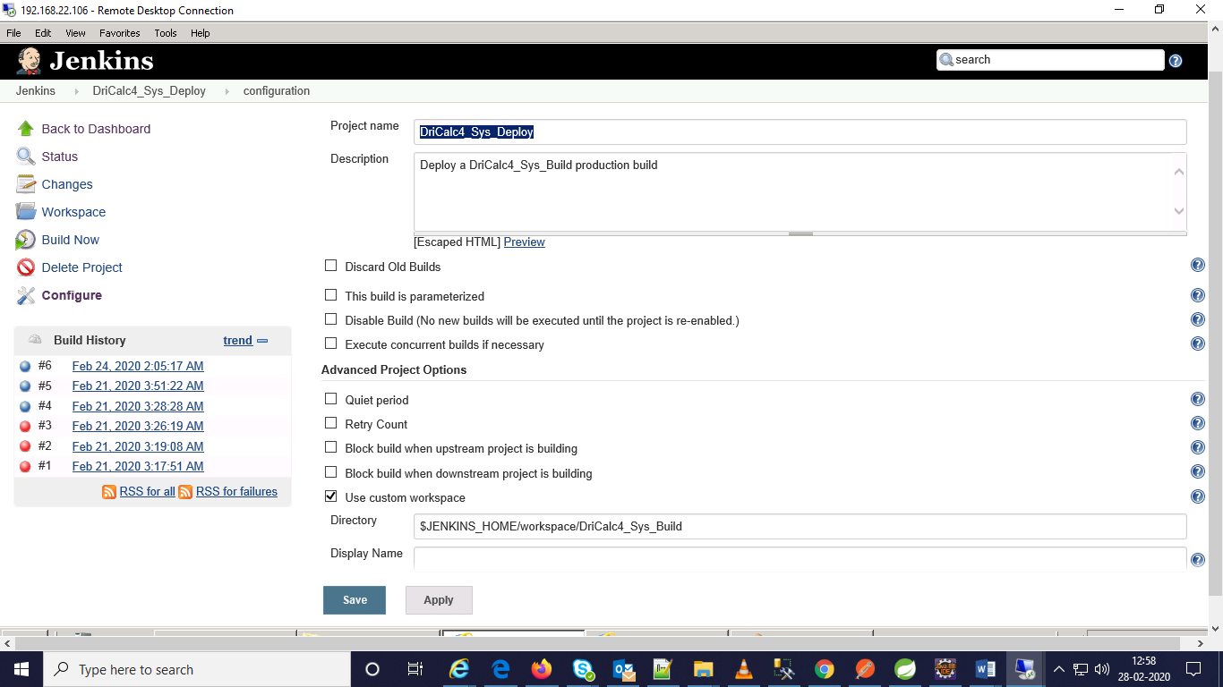

Step 2:

Select source code management as None.

Step 3:

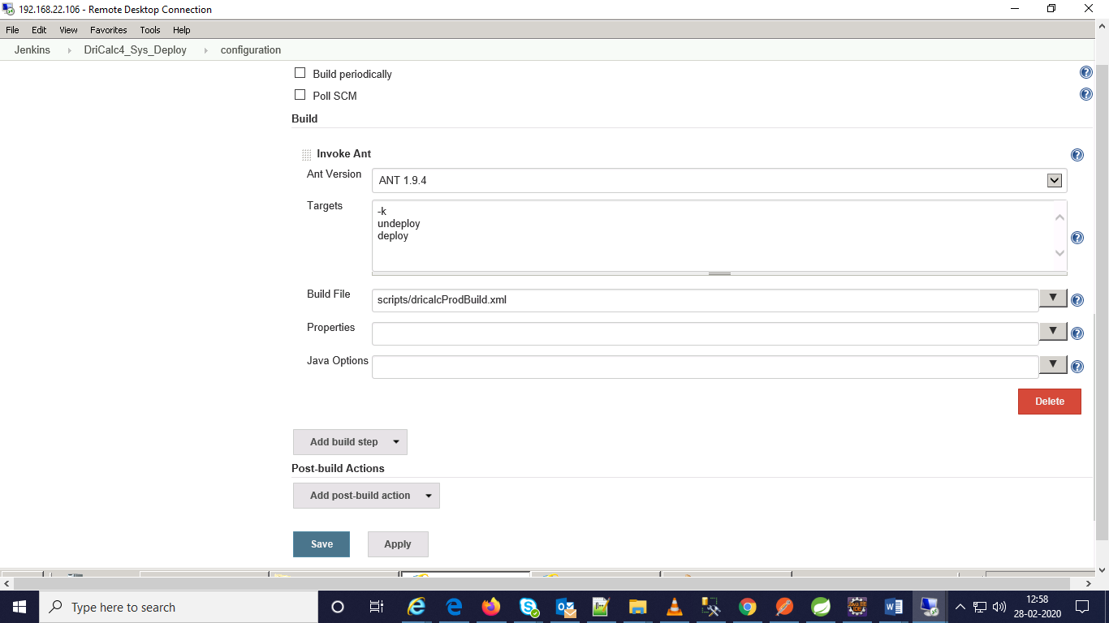

Step 4:

Save and apply

DriCalc4 PROD SERVER DETAILS:

IP: 192.168.19.14

Tomcat server path: C:\apache\webapps

War file: DriCalc4.war

Tomcat-user.xml file configuration Details:

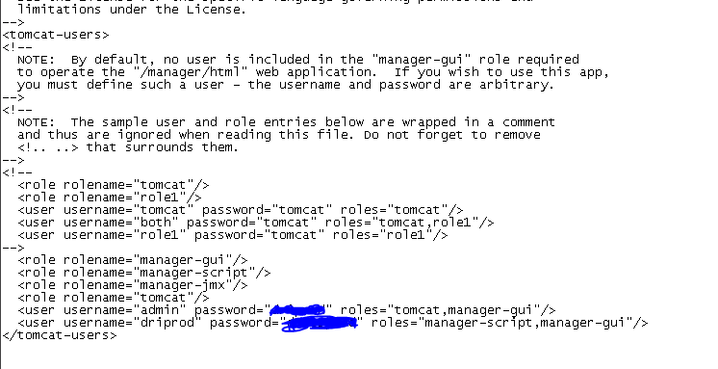

Server.xml File configuration details:

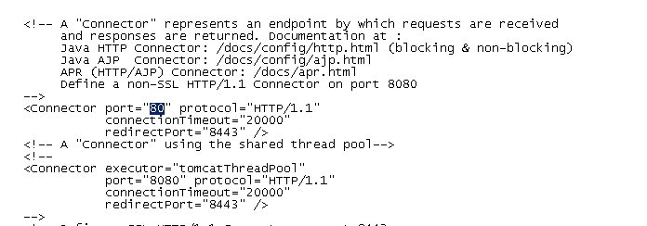

DriCalc4-Sys Server Details:

Server IP: 192.68.19.11

Tomcat Path Details:

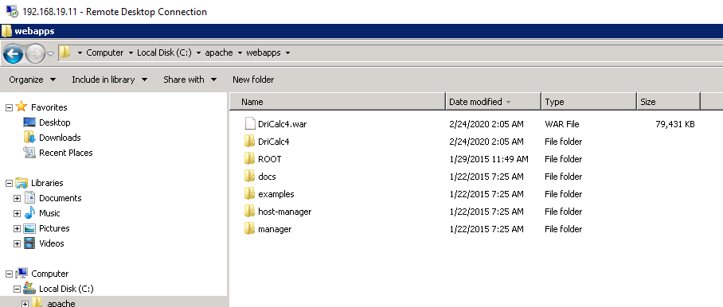

Server.xml file configuration details:



Tomcat-user.xml file configuration details:

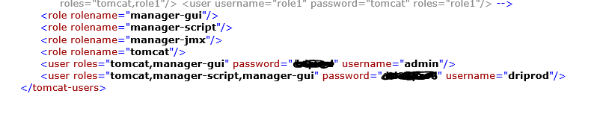

Other Details:

|  |  |
| --- | --- |
| **System Properties** |  |
| [Name  ↓](http://192.168.22.106:8080/systemInfo) | [Value](http://192.168.22.106:8080/systemInfo) |
| awt.toolkit | sun.awt.windows.WToolkit |
| executable-war | C:\Program Files (x86)\Jenkins\jenkins.war |
| file.encoding | Cp1252 |
| file.encoding.pkg | sun.io |
| file.separator | \ |
| guice.disable.misplaced.annotation.check | TRUE |
| hudson.diyChunking | TRUE |
| hudson.lifecycle | hudson.lifecycle.WindowsServiceLifecycle |
| java.awt.graphicsenv | sun.awt.Win32GraphicsEnvironment |
| java.awt.headless | TRUE |
| java.awt.printerjob | sun.awt.windows.WPrinterJob |
| java.class.path | C:\Program Files (x86)\Jenkins\jenkins.war |
| java.class.version | 51 |
| java.endorsed.dirs | C:\Program Files (x86)\Jenkins\jre\lib\endorsed |
| java.ext.dirs | C:\Program Files (x86)\Jenkins\jre\lib\ext;C:\Windows\Sun\Java\lib\ext |
| java.home | C:\Program Files (x86)\Jenkins\jre |
| java.io.tmpdir | C:\Windows\TEMP\ |
| java.library.path | C:\Program Files (x86)\Jenkins\jre\bin;C:\Windows\Sun\Java\bin;C:\Windows\system32;C:\Windows;C:\Windows\system32;C:\Windows;C:\Windows\System32\Wbem;C:\Windows\System32\WindowsPowerShell\v1.0\;C:\Program Files\TortoiseSVN\bin;;. |
| java.runtime.name | Java(TM) SE Runtime Environment |
| java.runtime.version | 1.7.0_25-b17 |
| java.specification.name | Java Platform API Specification |
| java.specification.vendor | Oracle Corporation |
| java.specification.version | 1.7 |
| java.vendor | Oracle Corporation |
| java.vendor.url | http://java.oracle.com/ |
| java.vendor.url.bug | http://bugreport.sun.com/bugreport/ |
| java.version | 1.7.0_25 |
| java.vm.info | mixed mode |
| java.vm.name | Java HotSpot(TM) Client VM |
| java.vm.specification.name | Java Virtual Machine Specification |
| java.vm.specification.vendor | Oracle Corporation |
| java.vm.specification.version | 1.7 |
| java.vm.vendor | Oracle Corporation |
| java.vm.version | 23.25-b01 |
| line.separator |  |
| mail.smtp.sendpartial | TRUE |
| mail.smtps.sendpartial | TRUE |
| os.arch | x86 |
| os.name | Windows Server 2008 R2 |
| os.version | 6.1 |
| path.separator | ; |
| sun.arch.data.model | 32 |
| sun.awt.enableExtraMouseButtons | TRUE |
| sun.boot.class.path | C:\Program Files (x86)\Jenkins\jre\lib\resources.jar;C:\Program Files (x86)\Jenkins\jre\lib\rt.jar;C:\Program Files (x86)\Jenkins\jre\lib\sunrsasign.jar;C:\Program Files (x86)\Jenkins\jre\lib\jsse.jar;C:\Program Files (x86)\Jenkins\jre\lib\jce.jar;C:\Program Files (x86)\Jenkins\jre\lib\charsets.jar;C:\Program Files (x86)\Jenkins\jre\lib\jfr.jar;C:\Program Files (x86)\Jenkins\jre\classes |
| sun.boot.library.path | C:\Program Files (x86)\Jenkins\jre\bin |
| sun.cpu.endian | little |
| sun.cpu.isalist | pentium_pro+mmx pentium_pro pentium+mmx pentium i486 i386 i86 |
| sun.desktop | windows |
| sun.io.unicode.encoding | UnicodeLittle |
| sun.java.command | C:\Program Files (x86)\Jenkins\jenkins.war --httpPort=8080 |
| sun.java.launcher | SUN_STANDARD |
| sun.jnu.encoding | Cp1252 |
| sun.management.compiler | HotSpot Client Compiler |
| sun.os.patch.level | Service Pack 1 |
| svnkit.http.methods | Digest,Basic,NTLM,Negotiate |
| svnkit.ssh2.persistent | FALSE |
| user.country | US |
| user.dir | C:\Program Files (x86)\Jenkins |
| user.home | C:\ |
| user.language | en |
| user.name | DRICALCBUILD$ |
| user.script |  |
| user.timezone | America/Chicago |
| user.variant |  |

|  |  |
| --- | --- |
| **Environment Variables** |  |
| [Name  ↓](http://192.168.22.106:8080/systemInfo) | [Value](http://192.168.22.106:8080/systemInfo) |
| ALLUSERSPROFILE | C:\ProgramData |
| APPDATA | C:\Windows\system32\config\systemprofile\AppData\Roaming |
| BASE | C:\Program Files (x86)\Jenkins |
| CommonProgramFiles | C:\Program Files (x86)\Common Files |
| CommonProgramFiles(x86) | C:\Program Files (x86)\Common Files |
| CommonProgramW6432 | C:\Program Files\Common Files |
| COMPUTERNAME | DRICALCBUILD |
| ComSpec | C:\Windows\system32\cmd.exe |
| FP_NO_HOST_CHECK | NO |
| JENKINS_HOME | C:\Program Files (x86)\Jenkins |
| LOCALAPPDATA | C:\Windows\system32\config\systemprofile\AppData\Local |
| NUMBER_OF_PROCESSORS | 2 |
| OS | Windows_NT |
| Path | C:\Windows\system32;C:\Windows;C:\Windows\System32\Wbem;C:\Windows\System32\WindowsPowerShell\v1.0\;C:\Program Files\TortoiseSVN\bin; |
| PATHEXT | .COM;.EXE;.BAT;.CMD;.VBS;.VBE;.JS;.JSE;.WSF;.WSH;.MSC |
| PROCESSOR_ARCHITECTURE | x86 |
| PROCESSOR_ARCHITEW6432 | AMD64 |
| PROCESSOR_IDENTIFIER | Intel64 Family 6 Model 37 Stepping 1, GenuineIntel |
| PROCESSOR_LEVEL | 6 |
| PROCESSOR_REVISION | 2501 |
| ProgramData | C:\ProgramData |
| ProgramFiles | C:\Program Files (x86) |
| ProgramFiles(x86) | C:\Program Files (x86) |
| ProgramW6432 | C:\Program Files |
| PSModulePath | C:\Windows\system32\WindowsPowerShell\v1.0\Modules\ |
| PUBLIC | C:\Users\Public |
| SERVICE_ID | jenkins |
| SystemDrive | C: |
| SystemRoot | C:\Windows |
| TEMP | C:\Windows\TEMP |
| TMP | C:\Windows\TEMP |
| USERDOMAIN | RESPROD |
| USERNAME | DRICALCBUILD$ |
| USERPROFILE | C:\Windows\system32\config\systemprofile |
| windir | C:\Windows |
| windows_tracing_flags | 3 |
| windows_tracing_logfile | C:\BVTBin\Tests\installpackage\csilogfile.log |
| WINSW_EXECUTABLE | C:\Program Files (x86)\Jenkins\jenkins.exe |

|  |  |  |  |
| --- | --- | --- | --- |
| **Plugins** |  |  |  |
| [Name  ↓](http://192.168.22.106:8080/systemInfo) | [Version](http://192.168.22.106:8080/systemInfo) | [Enabled](http://192.168.22.106:8080/systemInfo) | [Pinned](http://192.168.22.106:8080/systemInfo) |
| ant | 1.2 | TRUE | FALSE |
| antisamy-markup-formatter | 1.1 | TRUE | FALSE |
| credentials | 1.9.4 | TRUE | FALSE |
| cvs | 2.11 | TRUE | FALSE |
| external-monitor-job | 1.2 | TRUE | FALSE |
| jacoco | 1.0.14 | TRUE | FALSE |
| javadoc | 1.1 | TRUE | FALSE |
| junit | 1 | TRUE | FALSE |
| ldap | 1.6 | TRUE | FALSE |
| mailer | 1.1 | TRUE | FALSE |
| matrix-auth | 1.1 | TRUE | FALSE |
| matrix-project | 1.3 | TRUE | FALSE |
| maven-plugin | 2.5 | TRUE | FALSE |
| pam-auth | 1.1 | TRUE | FALSE |
| ssh-credentials | 1.6 | TRUE | FALSE |
| ssh-slaves | 1.5 | TRUE | FALSE |
| subversion | 1.54 | TRUE | FALSE |
| translation | 1.1 | TRUE | FALSE |
| windows-slaves | 1 | TRUE | FALSE |

www.LTTS.com info@LTTS.com Copyright © L&T Technology Services

