

**<Insert image on the background>**

**Click Image Area -> Format Tab -> Shape Fill -> Picture**

DriCalc5 configuration details

Author:

1. Designation

1. Place

Contents

Details of the project tools 3

Plugins required in Jenkins server  3

DriCalc Build configuration details 4

DriCalc Deploy configuration details 4

**DRICALC5 Jenkins configuration and Job Details**

Jenkins server IP: 192.168.22.65

Jenkins URL: <http://192.168.22.65:8080/>

Username: admin

Password: will share in separate mail.

Below are the details of the project tools.

* SVN as source code management
* Jenkins for both CI and CD
* Maven as build tool
* JaCoCo for coverage report

Jenkins server is running with version 2.204 and currently we have 2 Jobs are running on the server.

1. DriCalc Build
2. DriCalc Deploy

Plugins required in Jenkins server:

* JaCoCo plugin
* Maven integration plugin
* Publish over SSH
* Subversion
* Workspace cleanup plugin
* Copy Artifact plugin
* Artifactory plugin
* Test results analyser plugin
* Subversion workspace Cleaner
* Timestamper
* Powershell plugin
* Orcle java SE Development Kit installer plugin
* Maven release plug-in
* Junit plugin
* Junit Realtime test reporter plugin
* Javadoc plugin
* Email extension plugin
* CVS
* Credentials Binding
* Credentials plugin
* Build Timeout

Source code Management: subversion

Repository URL: <http://drisvn.dristeem.int/svn/mis/webdll/tags/Karthik/Dricalc-4.2>

Build tools: Maven

Set JDK installation path in Manage Jenkins-🡪Global Tool Configuration like below.

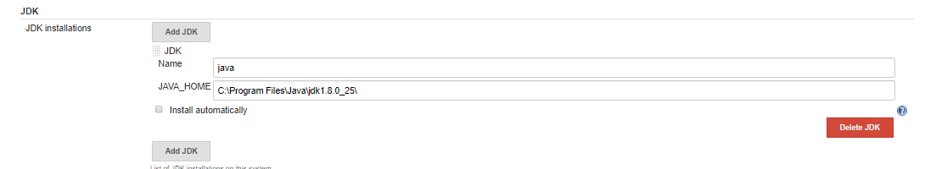

Set maven installation path in Manage Jenkins🡪Global tool configuration like below.

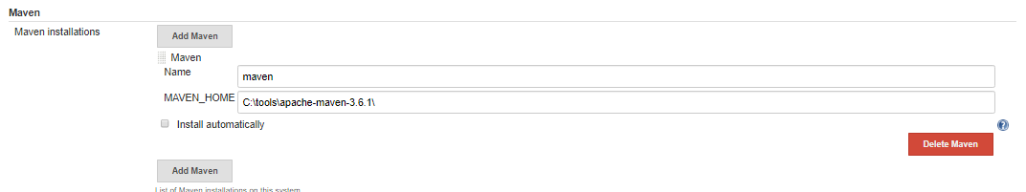

coverage reports:

JaCoCo

**DriCalc Build configuration details:**

Step 1:

Choose Maven project and name the project.

Step 2:

Source Code Management:

Select subversion

Repository url : <http://drisvn.dristeem.int/svn/mis/webdll/tags/Karthik/Dricalc-4.2>

Credentials: give the credentials of that SVN repository by adding them in the Jenkins home 🡪Credentials

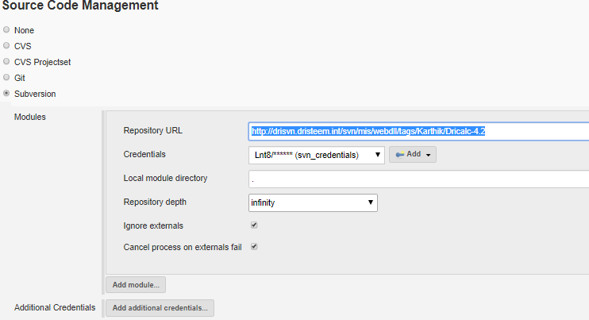

Step 3:

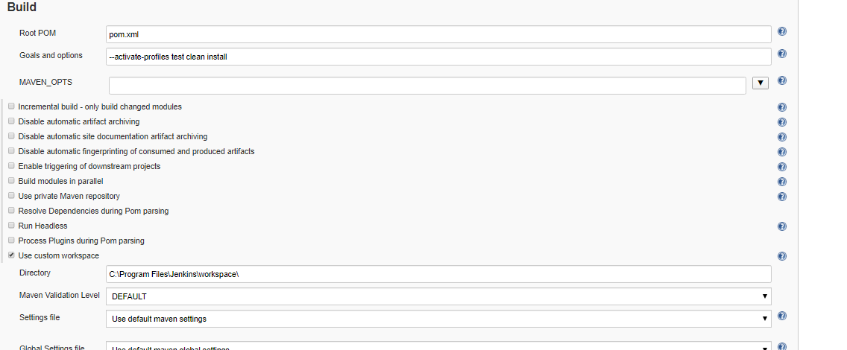

Step 4:

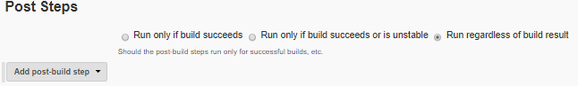

Step 5:

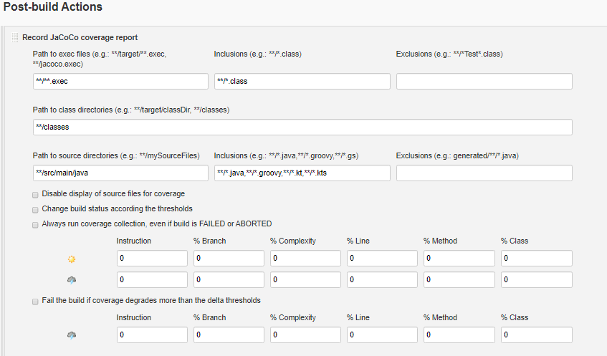

**DriCalc Deploy configuration details:**

Step 1:

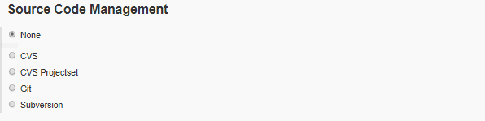

Step 2:

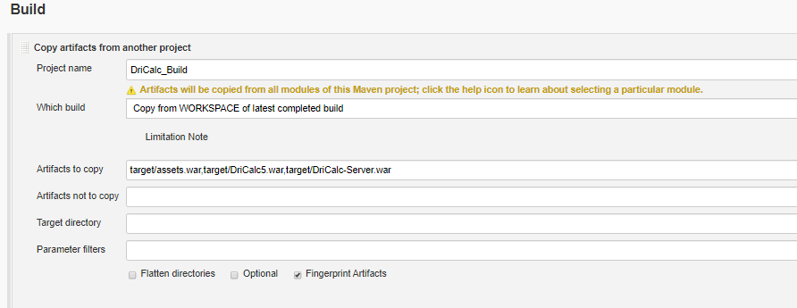

Step 3:

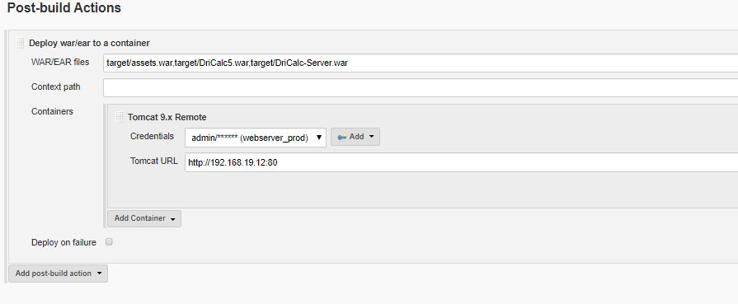

Save and Apply

Save credentials of the deployment server and subversion repository in credentials tab of Jenkins.

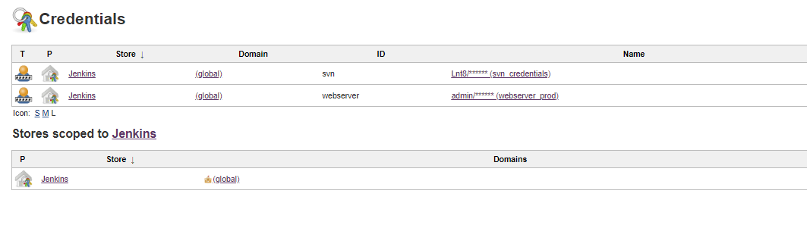

Global tool configuration



PROD SERVER DETAILS:

PROD SERVER IP: 192.168.19.12

Tomcat server path:

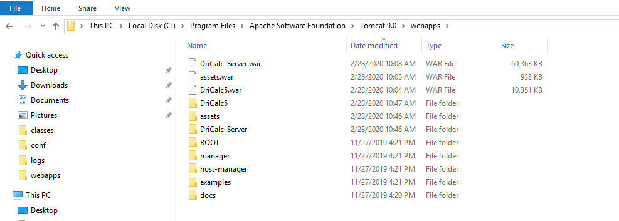

Tomcat-users.xml file configuration details:

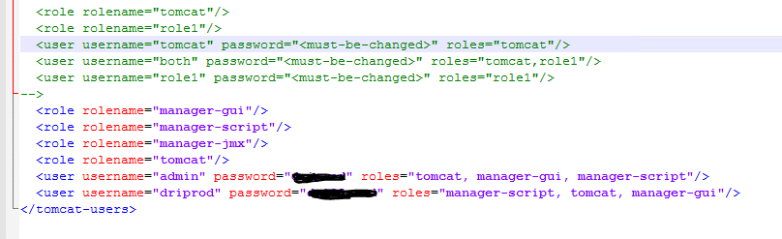

Server.xml file configuration details:

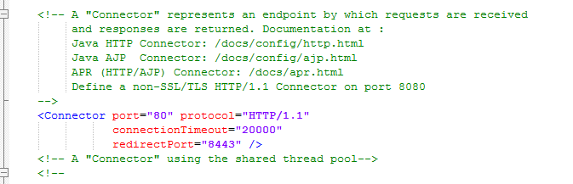

Other Details:

|  |  |  |
| --- | --- | --- |
| **Plugins** |  |  |
| [Name  ↓](http://192.168.22.65:8080/systemInfo) | [Version](http://192.168.22.65:8080/systemInfo) | [Enabled](http://192.168.22.65:8080/systemInfo) |
| ace-editor | 1.1 | TRUE |
| ant | 1.11 | TRUE |
| ant-in-workspace | 1.1.0 | TRUE |
| antexec | 1.11 | TRUE |
| antisamy-markup-formatter | 1.8 | TRUE |
| apache-httpcomponents-client-4-api | 4.5.10-2.0 | TRUE |
| artifactory | 3.5.0 | TRUE |
| authentication-tokens | 1.3 | TRUE |
| bouncycastle-api | 2.18 | TRUE |
| branch-api | 2.5.5 | TRUE |
| build-timeout | 1.19 | TRUE |
| cloudbees-folder | 6.11.1 | TRUE |
| command-launcher | 1.4 | TRUE |
| config-file-provider | 3.6.3 | TRUE |
| copyartifact | 1.43 | TRUE |
| credentials | 2.3.1 | TRUE |
| credentials-binding | 1.2 | TRUE |
| cvs | 2.11 | TRUE |
| deploy | 1.15 | TRUE |
| display-url-api | 2.3.2 | TRUE |
| docker-commons | 1.16 | TRUE |
| docker-workflow | 1.21 | TRUE |
| durable-task | 1.33 | TRUE |
| email-ext | 2.68 | TRUE |
| external-monitor-job | 1.7 | TRUE |
| git | 4.1.1 | TRUE |
| git-client | 3.1.1 | TRUE |
| git-server | 1.9 | TRUE |
| github | 1.29.5 | TRUE |
| github-api | 1.106 | TRUE |
| github-branch-source | 2.6.0 | TRUE |
| gradle | 1.36 | TRUE |
| handlebars | 1.1.1 | TRUE |
| ivy | 2.1 | TRUE |
| jackson2-api | 2.10.2 | TRUE |
| jacoco | 3.0.5 | TRUE |
| javadoc | 1.5 | TRUE |
| jdk-tool | 1.4 | TRUE |
| jquery-detached | 1.2.1 | TRUE |
| jsch | 0.1.55.2 | TRUE |
| junit | 1.28 | TRUE |
| junit-realtime-test-reporter | 0.6 | TRUE |
| ldap | 1.21 | TRUE |
| lockable-resources | 2.7 | TRUE |
| m2release | 0.16.2 | TRUE |
| mailer | 1.3 | TRUE |
| mapdb-api | 1.0.9.0 | TRUE |
| matrix-auth | 2.5 | TRUE |
| matrix-project | 1.14 | TRUE |
| maven-plugin | 3.4 | TRUE |
| momentjs | 1.1.1 | TRUE |
| nant | 1.4.3 | TRUE |
| pam-auth | 1.6 | TRUE |
| pipeline-build-step | 2.11 | TRUE |
| pipeline-github-lib | 1 | TRUE |
| pipeline-graph-analysis | 1.1 | TRUE |
| pipeline-input-step | 2.11 | TRUE |
| pipeline-milestone-step | 1.3.1 | TRUE |
| pipeline-model-api | 1.5.1 | TRUE |
| pipeline-model-declarative-agent | 1.1.1 | TRUE |
| pipeline-model-definition | 1.5.1 | TRUE |
| pipeline-model-extensions | 1.5.1 | TRUE |
| pipeline-rest-api | 2.13 | TRUE |
| pipeline-stage-step | 2.3 | TRUE |
| pipeline-stage-tags-metadata | 1.5.1 | TRUE |
| pipeline-stage-view | 2.13 | TRUE |
| plain-credentials | 1.7 | TRUE |
| powershell | 1.4 | TRUE |
| publish-over | 0.22 | TRUE |
| publish-over-ssh | 1.20.1 | TRUE |
| resource-disposer | 0.14 | TRUE |
| scm-api | 2.6.3 | TRUE |
| scp | 1.8 | TRUE |
| script-security | 1.69 | TRUE |
| ssh | 2.6.1 | TRUE |
| ssh-agent | 1.19 | TRUE |
| ssh-credentials | 1.18.1 | TRUE |
| ssh-slaves | 1.31.1 | TRUE |
| ssh-steps | 2.0.0 | TRUE |
| ssh2easy | 1.4 | TRUE |
| structs | 1.2 | TRUE |
| subversion | 2.13.0 | TRUE |
| svn-workspace-cleaner | 1.1 | TRUE |
| test-results-analyzer | 0.3.5 | TRUE |
| timestamper | 1.1 | TRUE |
| token-macro | 2.1 | TRUE |
| trilead-api | 1.0.5 | TRUE |
| windows-slaves | 1.6 | TRUE |
| workflow-aggregator | 2.6 | TRUE |
| workflow-api | 2.39 | TRUE |
| workflow-basic-steps | 2.19 | TRUE |
| workflow-cps | 2.78 | TRUE |
| workflow-cps-global-lib | 2.15 | TRUE |
| workflow-durable-task-step | 2.35 | TRUE |
| workflow-job | 2.36 | TRUE |
| workflow-multibranch | 2.21 | TRUE |
| workflow-scm-step | 2.1 | TRUE |
| workflow-step-api | 2.22 | TRUE |
| workflow-support | 3.4 | TRUE |
| ws-cleanup | 0.38 | TRUE |

|  |  |
| --- | --- |
| **Environment Variables** |  |
| [Name  ↓](http://192.168.22.65:8080/systemInfo) | [Value](http://192.168.22.65:8080/systemInfo) |
| ALLUSERSPROFILE | C:\ProgramData |
| ANT_HOME | C:\tools\apache-ant-1.9.14 |
| APPDATA | C:\Windows\system32\config\systemprofile\AppData\Roaming |
| BASE | C:\Program Files (x86)\Jenkins |
| ChocolateyInstall | C:\ProgramData\chocolatey |
| CommonProgramFiles | C:\Program Files (x86)\Common Files |
| CommonProgramFiles(x86) | C:\Program Files (x86)\Common Files |
| CommonProgramW6432 | C:\Program Files\Common Files |
| COMPUTERNAME | DRICALCBUILD2 |
| ComSpec | C:\Windows\system32\cmd.exe |
| JAVA_HOME | C:\Program Files\Java\jdk1.8.0_25 |
| JENKINS_HOME | C:\Program Files (x86)\Jenkins |
| JRE_HOME | C:\Program Files\Java\jdk1.8.0_25\jre |
| LOCALAPPDATA | C:\Windows\system32\config\systemprofile\AppData\Local |
| MAVEN_HOME | C:\tools\apache-maven-3.6.1 |
| NUMBER_OF_PROCESSORS | 4 |
| OS | Windows_NT |
| Path | C:\Python27\;C:\Python27\Scripts;C:\Program Files (x86)\Common Files\Oracle\Java\javapath;C:\ProgramData\Oracle\Java\javapath;C:\Windows\system32;C:\Windows;C:\Windows\System32\Wbem;C:\Windows\System32\WindowsPowerShell\v1.0\;C:\tools\apache-ant-1.9.14\bin;C:\tools\apache-maven-3.6.1\bin;C:\Program Files\Java\jdk1.8.0_25\bin;C:\Program Files\Java\jdk1.8.0_25\jre\bin;C:\ProgramData\chocolatey\bin;"C:\Program Files\OpenSSH-Win64";C:\Windows\system32\config\systemprofile\AppData\Local\Microsoft\WindowsApps |
| PATHEXT | .COM;.EXE;.BAT;.CMD;.VBS;.VBE;.JS;.JSE;.WSF;.WSH;.MSC |
| PROCESSOR_ARCHITECTURE | x86 |
| PROCESSOR_ARCHITEW6432 | AMD64 |
| PROCESSOR_IDENTIFIER | Intel64 Family 6 Model 37 Stepping 1, GenuineIntel |
| PROCESSOR_LEVEL | 6 |
| PROCESSOR_REVISION | 2501 |
| ProgramData | C:\ProgramData |
| ProgramFiles | C:\Program Files (x86) |
| ProgramFiles(x86) | C:\Program Files (x86) |
| ProgramW6432 | C:\Program Files |
| PSModulePath | C:\Program Files\WindowsPowerShell\Modules;C:\Windows\system32\WindowsPowerShell\v1.0\Modules |
| PUBLIC | C:\Users\Public |
| SERVICE_ID | Jenkins |
| SystemDrive | C: |
| SystemRoot | C:\Windows |
| TEMP | C:\Windows\TEMP |
| TMP | C:\Windows\TEMP |
| USERDOMAIN | RESPROD |
| USERNAME | DRICALCBUILD2$ |
| USERPROFILE | C:\Windows\system32\config\systemprofile |
| windir | C:\Windows |
| WINSW_EXECUTABLE | C:\Program Files (x86)\Jenkins\jenkins.exe |
| WINSW_SERVICE_ID | Jenkins |

|  |  |
| --- | --- |
| **System Properties** |  |
| [Name  ↓](http://192.168.22.65:8080/systemInfo) | [Value](http://192.168.22.65:8080/systemInfo) |
| awt.toolkit | sun.awt.windows.WToolkit |
| executable-war | C:\Program Files (x86)\Jenkins\jenkins.war |
| file.encoding | Cp1252 |
| file.encoding.pkg | sun.io |
| file.separator | \ |
| guice.disable.misplaced.annotation.check | TRUE |
| hudson.lifecycle | hudson.lifecycle.WindowsServiceLifecycle |
| java.awt.graphicsenv | sun.awt.Win32GraphicsEnvironment |
| java.awt.headless | TRUE |
| java.awt.printerjob | sun.awt.windows.WPrinterJob |
| java.class.path | C:\Program Files (x86)\Jenkins\jenkins.war |
| java.class.version | 52 |
| java.endorsed.dirs | C:\Program Files (x86)\Jenkins\jre\lib\endorsed |
| java.ext.dirs | C:\Program Files (x86)\Jenkins\jre\lib\ext;C:\Windows\Sun\Java\lib\ext |
| java.home | C:\Program Files (x86)\Jenkins\jre |
| java.io.tmpdir | C:\Windows\TEMP\ |
| java.library.path | C:\Program Files (x86)\Jenkins\jre\bin;C:\Windows\Sun\Java\bin;C:\Windows\system32;C:\Windows;C:\Python27\;C:\Python27\Scripts;C:\Program Files (x86)\Common Files\Oracle\Java\javapath;C:\ProgramData\Oracle\Java\javapath;C:\Windows\system32;C:\Windows;C:\Windows\System32\Wbem;C:\Windows\System32\WindowsPowerShell\v1.0\;C:\tools\apache-ant-1.9.14\bin;C:\tools\apache-maven-3.6.1\bin;C:\Program Files\Java\jdk1.8.0_25\bin;C:\Program Files\Java\jdk1.8.0_25\jre\bin;C:\ProgramData\chocolatey\bin;"C:\Program Files\OpenSSH-Win64";C:\Windows\system32\config\systemprofile\AppData\Local\Microsoft\WindowsApps;. |
| java.runtime.name | Java(TM) SE Runtime Environment |
| java.runtime.version | 1.8.0_144-b01 |
| java.specification.name | Java Platform API Specification |
| java.specification.vendor | Oracle Corporation |
| java.specification.version | 1.8 |
| java.vendor | Oracle Corporation |
| java.vendor.url | http://java.oracle.com/ |
| java.vendor.url.bug | http://bugreport.sun.com/bugreport/ |
| java.version | 1.8.0_144 |
| java.vm.info | mixed mode |
| java.vm.name | Java HotSpot(TM) Client VM |
| java.vm.specification.name | Java Virtual Machine Specification |
| java.vm.specification.vendor | Oracle Corporation |
| java.vm.specification.version | 1.8 |
| java.vm.vendor | Oracle Corporation |
| java.vm.version | 25.144-b01 |
| jetty.git.hash | e1bc35120a6617ee3df052294e433f3a25ce7097 |
| jna.loaded | TRUE |
| jnidispatch.path | C:\Windows\TEMP\jna-31029424\jna1438506829770489355.dll |
| line.separator |  |
| mail.smtp.sendpartial | TRUE |
| mail.smtps.sendpartial | TRUE |
| os.arch | x86 |
| os.name | Windows Server 2016 |
| os.version | 10 |
| path.separator | ; |
| sun.arch.data.model | 32 |
| sun.awt.enableExtraMouseButtons | TRUE |
| sun.boot.class.path | C:\Program Files (x86)\Jenkins\jre\lib\resources.jar;C:\Program Files (x86)\Jenkins\jre\lib\rt.jar;C:\Program Files (x86)\Jenkins\jre\lib\sunrsasign.jar;C:\Program Files (x86)\Jenkins\jre\lib\jsse.jar;C:\Program Files (x86)\Jenkins\jre\lib\jce.jar;C:\Program Files (x86)\Jenkins\jre\lib\charsets.jar;C:\Program Files (x86)\Jenkins\jre\lib\jfr.jar;C:\Program Files (x86)\Jenkins\jre\classes |
| sun.boot.library.path | C:\Program Files (x86)\Jenkins\jre\bin |
| sun.cpu.endian | little |
| sun.cpu.isalist | pentium_pro+mmx pentium_pro pentium+mmx pentium i486 i386 i86 |
| sun.desktop | windows |
| sun.io.unicode.encoding | UnicodeLittle |
| sun.java.command | C:\Program Files (x86)\Jenkins\jenkins.war --httpPort=8080 --webroot=C:\Program Files (x86)\Jenkins\war |
| sun.java.launcher | SUN_STANDARD |
| sun.jnu.encoding | Cp1252 |
| sun.management.compiler | HotSpot Client Compiler |
| sun.os.patch.level |  |
| svnkit.http.methods | Digest,Basic,NTLM,Negotiate |
| svnkit.ssh2.persistent | FALSE |
| user.country | US |
| user.dir | C:\Program Files (x86)\Jenkins |
| user.home | C:\Windows\system32\config\systemprofile |
| user.language | en |
| user.name | DRICALCBUILD2$ |
| user.script |  |
| user.timezone | America/Chicago |
| user.variant |  |