**Kubernetes.**

**Why:** Kubernetes is a portable, extensible, open-source platform for managing containerized workloads and services, that facilitates both declarative configuration and automation.

Containers: it is runs on any platform with minimum size.

**JBOSS:** More power full application server.it is only for java application.

**Microservices**: it is loosely coupled services means they are coupled but not tightly.

Kubernetes called **BORG.**

**Points:**

* Kubernetes is a containers orchestration platform.
* It is managing the containers in such a ways:

1. Containers talk
2. Containers security.
3. Containers scalable and available.
4. Containers Types:

Docker

Contained d

RKT

**Architecture**

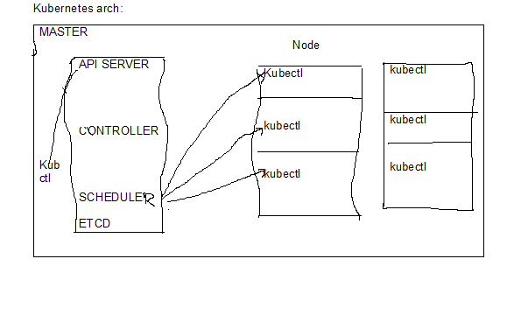

Arch explanation done by sunil. Please refer online material as well for understanding the above diagram.

**PODS:** One or more no of containers.

**Example:**

Local host

|  |  |
| --- | --- |
| CI | C2 |

Above figure is an example of Jenkins and SonarQube communicating with each other.

**Kubectl** :- it is command line tool which takes intrustions from users.

**POD CIDR**(This is a communication media through kubernetes .

10.0.0.0/16

10.0.1.0/24

10.0.2.0/24

**Kubeadm:-**it is atool to used to create kubernetes cluster.

**Command:**

Kubeadm init –apiserver -advertise -adress(hostname -i).

Also some demos on creating pods and clusters and basic kubernetes commands hands on.