NIP Project — Submission Template
Pega Platform project · This document is your complete submission
Read this before you start:
1. Fill in Section 1 completely. The Pega application name must follow the format NIP-[Project]-[YourName].
2. Create a new Operator in Pega with your full name and log in as that operator before taking any screenshot.
3. When you create your test case, enter YOUR FULL NAME in the Issue Description (Vehicle) or Movie Name (Movie) field.
4. Complete only the section for your chosen project. Delete the other project section.
5. Paste one screenshot per user story (10 total). Follow the screenshot rules in your selected project section.
6. Answer every question in Sections 3 and 4 in your own words.
7. Save the file using this format: ProjectName_FirstName_LastName.docx. Use VehicleService or MovieTicket as the ProjectName. Examples: VehicleService_Ravi_Kumar.docx or MovieTicket_Ravi_Kumar.docx.

Section 1 — Your Details
Full Name | Hariharan P
Email ID (registered on NIP) | hariharan2pvsh@gmail.com
Phone Number | 6382065727
College Name | V.S.B Engineering College, Karur
Course (e.g. IT, CS) | B.Tech Information Technology
State | Tamil Nadu
Project Chosen (Vehicle Service OR Movie Ticket Booking) | Movie Ticket Booking
Pega Application Name (e.g. NIP-VehicleService-YourName) | NIP-MovieTicket-Hariharan
Case Type Name (exact) | MovieTicketBooking
Pega Instance URL | https://1nab48he.pegaacademy.net/prweb/app/nip--movie-ticket--hariharan-1/9s5UaqMnbUJVha0uH6A0u1OCMjwg_tSN*/!STANDARD?pzuiactionzzz=CXtycX1jNzRiNGY4ZDQ2MzNkZGE3MGE0ZWU3Mzg2Njc5N2I2NWMxYzJjYTY1MGEzNjFhYjRlNDU3ZDQ2MjUyOGM1YjkxNWE2NmQ4Mjc5NTc0NDFhNzMwZjhmNzhjNDc3ZGUxM2M=*
Operator Name (created in Pega with your full name) | Hariharan P

Section 2 — Movie Ticket Booking Management Application
Complete this section only if you selected this project. Delete the other project section before submitting.

Screenshot rules — IMPORTANT before you start:
1. Name your Pega application as: NIP-VehicleService-YourName OR NIP-MovieTicket-YourName
2. Create a new Operator in Pega with your full name (Security → Operators) and log in as that operator.
3. When you create your test case, enter YOUR FULL NAME in the Issue Description (Vehicle) or Movie Name (Movie) field.
4. The logged-in operator name must be visible in every screenshot wherever the Pega interface displays it.
5. The student's full name must be visible in all running-case screenshots.
6. Configuration screenshots must clearly show the relevant application or rule name.
Screenshots that do not show these will not be accepted.

US-001 — Submit Movie Ticket Request
What is expected:
Case created, customer submits Movie Name, Show Date, Show Time, Number of Tickets. Validation applied.
Screenshot — paste your screenshot below this line:
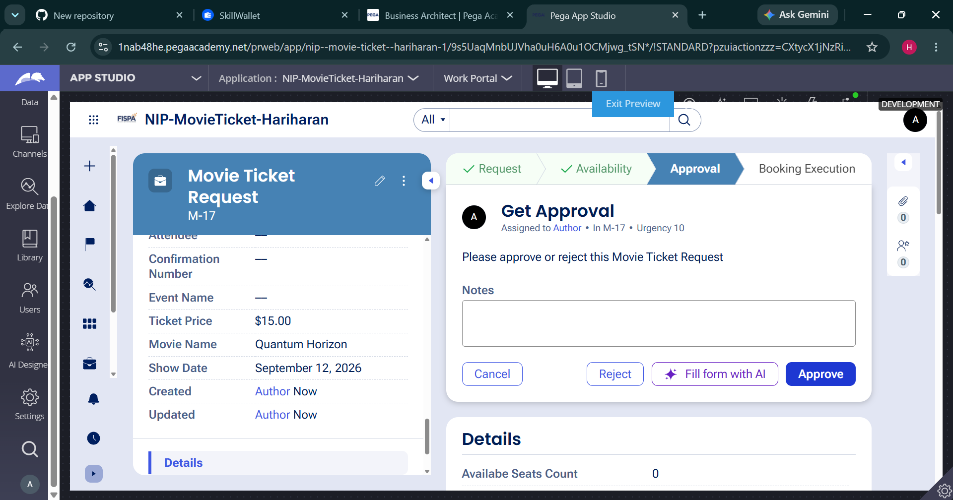

What I built for this (1–2 lines in your own words):
Created the Movie Ticket Request case with Movie Name, Show Date, Show Time, and Number of Tickets, with validation for the required details.

US-002 — Check Show Availability
What is expected:
Availability stage. Seat Availability Status and Available Seats Count captured. Booking proceeds only if available.
Screenshot — paste your screenshot below this line:


What I built for this (1–2 lines in your own words):
Added the Availability stage to capture Seat Availability Status and Available Seats Count and allow the booking flow to continue only when seats are available.

US-003 — Calculate Booking Cost
What is expected:
Total Cost calculated automatically from Ticket Price and Number of Tickets using a business rule.
Screenshot — paste your screenshot below this line:


What I built for this (1–2 lines in your own words):
Configured Total Cost to be calculated automatically from Ticket Price and Number of Tickets.

US-004 — Confirm Booking Request
What is expected:
Approval stage assigned to Customer. Booking Status captured. Flow branches on confirm/cancel.
Screenshot — paste your screenshot below this line:


What I built for this (1–2 lines in your own words):
Added the Approval stage for customer confirmation and configured the flow to continue after confirmation or cancellation.

US-005 — Maintain Movie and Show Data
What is expected:
Reusable Movie and Show data objects created with Movie Name, Genre, Show Date, Show Time, Seat Capacity — linked to case.
Screenshot — paste your screenshot below this line:


What I built for this (1–2 lines in your own words):
Created reusable Movie and Show data with movie, genre, show date, show time, ticket price, and seat capacity details and linked the data to the case.

US-006 — Review Booking Details
What is expected:
Confirmation screen shows Movie Name, Show Timing, Number of Tickets and Total Cost clearly.
Screenshot — paste your screenshot below this line:


What I built for this (1–2 lines in your own words):
Added a review screen so the customer can clearly see Movie Name, Show Timing, Number of Tickets, and Total Cost.

US-007 — Process Ticket Booking
What is expected:
Booking Execution stage. Seat Numbers, Ticket ID and Booking Confirmation Status maintained.
Screenshot — paste your screenshot below this line:


What I built for this (1–2 lines in your own words):
Added the Booking Execution stage to maintain Seat Numbers, Ticket ID, and Booking Confirmation Status.

US-008 — Notify Booking Confirmation
What is expected:
Correspondence rule triggered on case resolution. Email includes movie, show, seat and cost details.
Screenshot — paste your screenshot below this line:


What I built for this (1–2 lines in your own words):
Configured booking confirmation correspondence to be triggered when the case is resolved, including the movie, show, seat, and cost details.

US-009 — Define Booking SLA
What is expected:
SLA configured on the case type. Goal: 1 day. Deadline: 2 days. Priority increases on breach.
Screenshot — paste your screenshot below this line:


What I built for this (1–2 lines in your own words):
Configured the booking SLA with a 1-day goal and 2-day deadline, with priority increasing after breach.

US-010 — Route by Show Type
What is expected:
Routing rule or Decision Table routes to PremiumShowQueue or StandardShowQueue based on Show Type property.
Screenshot — paste your screenshot below this line:


What I built for this (1–2 lines in your own words):
Configured routing by Show Type using PremiumShowQueue for premium shows and StandardShowQueue for standard shows.

Section 3 — About Your Application
These answers are checked against your screenshots. Write exactly what is in your application.

Q1. List your stages in the order they appear in your case lifecycle.
Stage names in order, separated by commas.
Request, Availability, Approval, Booking Execution

Q2. Name the data object(s) you created and the properties inside them.
Data object name and its properties.
Movie and Show data objects. Movie: Movie Name, Genre, Show Date, Show Time, Seat Capacity. Show: Show Date, Show Time, Show Type, Ticket Price, Seat Capacity, Available Seats.

Q3. What is the exact name and type of the rule you used to calculate Total Cost?
Provide:
• Rule Name
• Rule Type
• Properties used in the calculation
• Formula used
Rule Name: CalculateTotalCost
Rule Type: Declare Expression
Properties used: Ticket Price, Number of Tickets
Formula: Total Cost = Ticket Price × Number of Tickets

Section 4 — Your Understanding
Short, honest and specific answers score well.

Q4. What did Blueprint generate for you, and what did you add or change yourself afterwards?
Be specific about what was already there and what you built or modified on top.
Blueprint provided the initial case structure, stages, fields, and flow. I then configured the movie/show details, availability handling, cost calculation, approval, booking execution, routing, correspondence, and SLA according to the project requirements.

Q5. Was there anything Blueprint created that you had to correct or configure further? Describe one example.
A real example from your own work.
One example was the Total Cost calculation. It needed to be configured so that Ticket Price and Number of Tickets are used to calculate the Total Cost automatically.

Q6. Explain your case flow from creation to resolution, in order.
What happens first, who does what, when the case closes.
The case starts with the Request stage. The customer enters the movie and show details. The case then checks Availability. If seats are available, it proceeds to Approval. After confirmation, it moves to Booking Execution, where ticket and seat details are maintained. The case is then completed and the booking confirmation is sent.

Q7. Pick two design choices you made in your application and explain why you made them.
For each design choice, provide:
• What you implemented
• Why you chose that approach
• What benefit it provides to the application
1. I used a separate Availability stage so that seat availability is checked before the booking is confirmed. This prevents unavailable bookings from continuing.
2. I used routing based on Show Type so premium and standard bookings can be handled by their respective work queues. This keeps work organized.

Q8. What was the hardest part, and how exactly did you fix it?
Specific and honest. A real challenge scores much better than a generic answer.
The hardest part was making the stages and calculations work in the correct order. I tested the case flow stage by stage and checked the required fields and calculation so the case could proceed correctly.

Q9. If the approval step was only needed when Total Cost is above a certain amount, what would you change in your application?
Explain what you would change and where. You do not need to build this.
I would add a decision condition before the Approval stage that checks Total Cost against the selected threshold. If the cost is above the threshold, the case would go to Customer Approval; otherwise, it would skip Approval and continue to Booking Execution.

Q10. List three exact rule names from your application that you personally created or modified.
Include the rule name and rule type for each one (for example: CalculateTotalCost - Declare Expression).
CalculateTotalCost — Declare Expression
RouteByShowType — Decision Table
BookingConfirmation — Correspondence
Q11. List all personas used in your application.
List the persona names exactly as they appear in your application.
Customer
Q12. List all work queues used in your application and explain when each one is used.
For each work queue, provide its exact name and the condition or type of work routed to it.
PremiumShowQueue — used for Premium Show bookings.
StandardShowQueue — used for Standard Show bookings.
Before You Submit — Check These
Read through once before uploading.
1. Section 1 filled in. Application named as NIP-[Project]-[YourName]. Names match the actual application.
2. New Operator created in Pega with my full name. I logged in as that operator for all screenshots.
3. Only my chosen project section remains — the other project section is deleted.
4. All 10 user story screenshots are pasted and follow the operator, running-case, application, and rule-name evidence requirements.
5. Every question in Sections 3 and 4, including Q10, Q11, and Q12, is answered in my own words.
6. This file is named using the required format: ProjectName_FirstName_LastName.docx (for example, VehicleService_Ravi_Kumar.docx or MovieTicket_Ravi_Kumar.docx) and uploaded as required.

