**1. Component Structure in CRXDE**

The **Author Component** is created under the following path:

* **apps/myTraining/components/author**

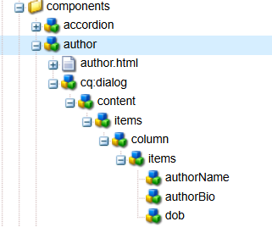

**2. Dialog Configuration in CRXDE**

The dialog consists of three mandatory field such as Author Name (Single-line text field), Author Bio( Multi-line text field), DOB ( Date picker)

* **/apps/myTraining/components/author/cq:dialog**

Dialog Structure in CRXDE:

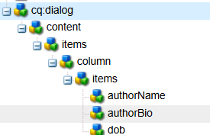

**3. Dialog Fields in AEM Touch UI**

The **dialog** appears in the **AEM Page Editor** when the component is added. The fields capture user input.

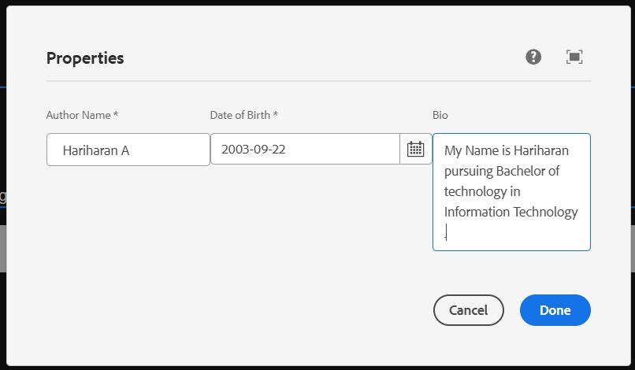

**4. Fetching Values in HTL**

The values are displayed using **HTL properties** in author.html:

<div class="author-container">

<h1>${properties.authorName}</h1>

<p>${properties.authorBio}</p>

<strong>${properties.dob}</strong>

</div>

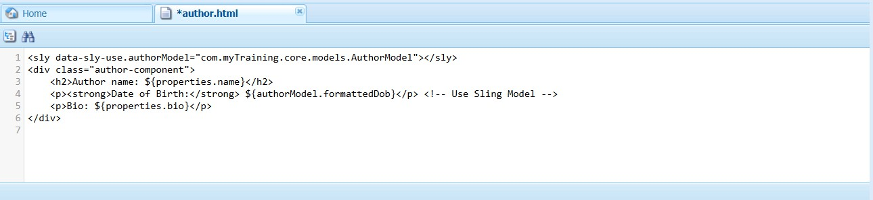

**5. Rendered Component on the AEM Page**

The component should display:

* **Author Name** - <h1>Hariharan A</h1>
* **Author Bio** - <p>My Name is Hariharan pursuing Bachelor of technology in Information Technology</p>
* **DOB** - <strong>2003-09-22<strong>

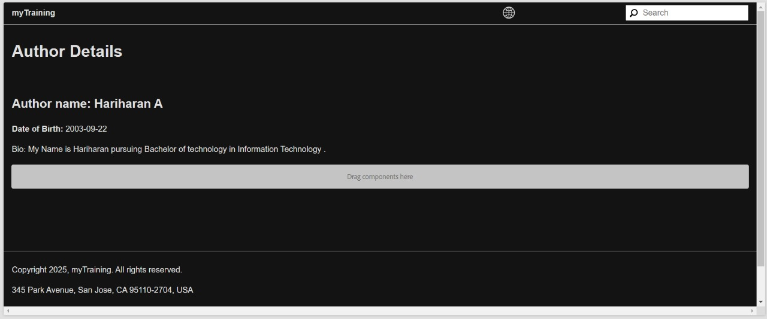

**6.What is ClientLib?**

Client Libraries (ClientLibs) manage CSS and JavaScript files in AEM. They improve performance and allow structured organization of front-end assets.

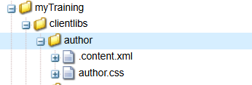

**8.What is Dialog Validation?**

Dialog validation ensures that fields are correctly filled before saving the component. It can be enforced using the required attribute and validation patterns.

**9.** **What is extraClientLib?**

Extra Client Libraries allow specific styling or scripts to be loaded only when necessary. They can be created similarly to ClientLibs but with the extraClientLibs attribute.

