1. **PREDICTING IMDB SCORES - ADS_Phase5**
2. **TEAM NUMBER : 01**
3. **– Hariharan.D (Team Member)**

# 3.1 Final Submission

[6]: *#importing necessary libraries* **import pandas as pd from sklearn.preprocessing import** StandardScaler, LabelEncoder **from sklearn.impute import** SimpleImputer **from sklearn.model_selection import** train_test_split **import warnings**

warnings.simplefilter(action='ignore', category=**FutureWarning**)

*#importing the netflix dataset*

file_path = r"C:\Users\Saranya\Desktop\IBM\NetflixOriginals.csv" encoding = "ISO-8859-1" df = pd.read_csv(file_path, encoding=encoding) df

|  |  |  |
| --- | --- | --- |
| [6]: | Title | Genre \ |
| 0 | Enter the Anime | Documentary |
| 1 | Dark Forces | Thriller |

2 The App Science fiction/Drama

|  |  |  |  |  |  |
| --- | --- | --- | --- | --- | --- |
| 3 The Open House | | | | Horror thriller | |
| 4 Kaali Khuhi | | | | Mystery | |
| .. … | | | | … | |
| 579 Taylor Swift: Reputation Stadium Tour | | | | Concert Film | |
| 580 Winter on Fire: Ukraine's Fight for Freedom | | | | Documentary | |
| 581 Springsteen on Broadway | | | | One-man show | |
| 582 Emicida: AmarElo - It's All For Yesterday | | | | Documentary | |
| 583 David Attenborough: A Life on Our Planet | | | | Documentary | |
| Premiere Runtime IMDB Score | | | | Language | |
| 0 August 5, 2019 58 2.5 | | | | English/Japanese | |
| 1 August 21, 2020 81 2.6 | | | | Spanish | |
| 2 December 26, 2019 | 79 |  | 2.6 Italian | |
| 3 January 19, 2018 | 94 |  | 3.2 English | |
| 4 October 30, 2020 | 90 |  | 3.4 Hindi | |
| .. … | … | … | … | |
| 579 December 31, 2018 | 125 |  | 8.4 English | |
| 580 October 9, 2015 | 91 |  | 8.4 English/Ukranian/Russian | |
| 581 December 16, 2018 | 153 |  | 8.5 English | |
| 582 December 8, 2020 | 89 |  | 8.6 Portuguese | |
| 583 October 4, 2020 | 83 |  | 9.0 English | |

[584 rows x 6 columns]

[7]:

df

.

info()

<class 'pandas.core.frame.DataFrame'> RangeIndex: 584 entries, 0 to 583 Data columns (total 6 columns):

# Column Non-Null Count Dtype

--- ------ -------------- ----0 Title 584 non-null object

1 Genre 584 non-null object 2 Premiere 584 non-null object

1. Runtime 584 non-null int64
2. IMDB Score 584 non-null float64
3. Language 584 non-null object dtypes: float64(1), int64(1), object(4) memory usage: 27.5+ KB

[8]:

df

.

head()

[8]: Title Genre Premiere Runtime \

|  |  |
| --- | --- |
| 0 Enter the Anime Documentary August 5, 2019 | 58 |
| 1 Dark Forces Thriller August 21, 2020 | 81 |
| 2 The App Science fiction/Drama December 26, 2019 | 79 |
| 3 The Open House Horror thriller January 19, 2018 | 94 |
| 4 Kaali Khuhi Mystery October 30, 2020 | 90 |

IMDB Score Language

1. 2.5 English/Japanese
2. 2.6 Spanish 2 2.6 Italian 3 3.2 English

4 3.4 Hindi

[9]:

*#to display null values*

df

.

isnull()

[9]: Title Genre Premiere Runtime IMDB Score Language

|  |  |  |  |  |
| --- | --- | --- | --- | --- |
| 0 False False | False | False | False | False |
| 1 False False | False | False | False | False |
| 2 False False | False | False | False | False |
| 3 False False | False | False | False | False |
| 4 False False | False | False | False | False |
| .. … … | … … | … | … |  |
| 579 False False | False | False | False | False |
| 580 False False | False | False | False | False |
| 581 False False | False | False | False | False |
| 582 False False | False | False | False | False |
| 583 False False | False | False | False | False |

]

[584

rows x 6 columns

[10]:

*#handling null values*

df

.

fillna(df

.

mean(), inplace

=

**True**

)

df

.

dropna(inplace

=

**True**

)

[11]:

*#Display distinct languages*

value_lang

=

df[

'

Language

'

]

.

value_counts()

print

(

"

**\n**

Distinct languages:

"

)

print

value_lang

)

(

|  |  |  |
| --- | --- | --- |
| Distinct languages: |  | |
| English | 401 | |
| Hindi | 33 | |
| Spanish | 31 | |
| French | 20 | |
| Italian | 14 | |
| Portuguese | 12 | |
| Indonesian | 9 | |
| Japanese | 6 | |
| Korean | 6 | |
| German | 5 | |
| Turkish | 5 | |
| English/Spanish | 5 | |
| Polish | 3 | |
| Dutch | 3 | |
| Marathi | 3 | |
| English/Hindi | 2 | |
| Thai | 2 | |
| English/Mandarin | 2 | |
| English/Japanese | 2 | |
| Filipino | 2 | |
| English/Russian | | 1 |
| Bengali | | 1 |
| English/Arabic | | 1 |
| English/Korean | | 1 |
| Spanish/English | | 1 |
| Tamil | | 1 |
| English/Akan | | 1 |
| Khmer/English/French | | 1 |
| Swedish | | 1 |
| Georgian | | 1 |
| Thia/English | | 1 |
| English/Taiwanese/Mandarin | | 1 |
| English/Swedish | | 1 |
| Spanish/Catalan | | 1 |
| Spanish/Basque | | 1 |
| Norwegian | | 1 |
| Malay | | 1 |
| English/Ukranian/Russian  Name: Language, dtype: int64 | | 1 |

[12]:

distinct_lang

=

df[

'

Language

'

]

.

unique()

print

(

distinct_lang

)

['English/Japanese' 'Spanish' 'Italian' 'English' 'Hindi' 'Turkish'

'Korean' 'Indonesian' 'Malay' 'Dutch' 'French' 'English/Spanish'

'Portuguese' 'Filipino' 'German' 'Polish' 'Norwegian' 'Marathi' 'Thai'

'Swedish' 'Japanese' 'Spanish/Basque' 'Spanish/Catalan' 'English/Swedish'

'English/Taiwanese/Mandarin' 'Thia/English' 'English/Mandarin' 'Georgian'

'Bengali' 'Khmer/English/French' 'English/Hindi' 'Tamil'

'Spanish/English' 'English/Korean' 'English/Arabic' 'English/Russian'

'English/Akan' 'English/Ukranian/Russian']

[13]:

*#label encoder for language column*

label_encoder

=

LabelEncoder()

df[

'

Language

'

]

=

label_encoder

.

fit_transform(df[

'

Language

'

])

df

[13]:

Title

Genre \

0 Enter the Anime Documentary 1 Dark Forces Thriller

2 The App Science fiction/Drama

|  |  |
| --- | --- |
| 3 The Open House | Horror thriller |
| 4 Kaali Khuhi | Mystery |
| .. … | … |
| 579 Taylor Swift: Reputation Stadium Tour | Concert Film |
| 580 Winter on Fire: Ukraine's Fight for Freedom | Documentary |

1. Springsteen on Broadway One-man show
2. Emicida: AmarElo - It's All For Yesterday Documentary
3. David Attenborough: A Life on Our Planet Documentary

Premiere Runtime IMDB Score Language

1. August 5, 2019 58 2.5 6
2. August 21, 2020 81 2.6 29
3. December 26, 2019 79 2.6 20
4. January 19, 2018 94 3.2 2
5. October 30, 2020 90 3.4 18

.. … … … …

1. December 31, 2018 125 8.4 2
2. October 9, 2015 91 8.4 13
3. December 16, 2018 153 8.5 2
4. December 8, 2020 89 8.6 28
5. October 4, 2020 83 9.0 2

[584

rows x 6 columns

]

[14]:

*#scaling*

scaler

=

StandardScaler()

df[

'

Runtime

'

]

=

scaler

.

fit_transform(df[

'

Runtime

'

]

.

values

.

reshape(

-

1

,

1

))

df

[14]:

Title

Genre \

0 Enter the Anime Documentary 1 Dark Forces Thriller

1. The App Science fiction/Drama
2. The Open House Horror thriller
3. Kaali Khuhi Mystery

.. … …

1. Taylor Swift: Reputation Stadium Tour Concert Film
2. Winter on Fire: Ukraine's Fight for Freedom Documentary
3. Springsteen on Broadway One-man show
4. Emicida: AmarElo - It's All For Yesterday Documentary
5. David Attenborough: A Life on Our Planet Documentary

Premiere Runtime IMDB Score Language

1. August 5, 2019 -1.282615 2.5 6
2. August 21, 2020 -0.453425 2.6 29
3. December 26, 2019 -0.525528 2.6 20
4. January 19, 2018 0.015248 3.2 2
5. October 30, 2020 -0.128959 3.4 18

.. … … … …

1. December 31, 2018 1.132852 8.4 2
2. October 9, 2015 -0.092907 8.4 13
3. December 16, 2018 2.142301 8.5 2
4. December 8, 2020 -0.165011 8.6 28
5. October 4, 2020 -0.381321 9.0 2

[584

]

rows x 6 columns

[15]:

*#train_test split*

*#X = df.drop('IMDB Score', axis=1)*

*#y = df['IMDB Score']*

*#X_train, X_test, y_train, y_test = train_test_split(X, y, test_size=0.2,*

␣

↪

*random_state=42)*

[16]:

*#print("\n X_test info")*

*#print(X_test.info())*

[17]:

*# Drop non-numeric columns*

X

=

df

.

drop([

"

IMDB Score

"

,

"

Title

"

,

"

Genre

"

,

"

Premiere

"

, axis

]

=

1

)

y

=

df[

"

IMDB Score

"

]

*# Import necessary libraries for model training and evaluation*

**from**

**sklearn**

**.**

**linear_model**

**import**

LinearRegression

**from**

**sklearn**

**.**

**metrics**

**import**

mean_absolute_error, mean_squared_error, r2_score

*# Split the dataset into training and testing sets*

X_train, X_test, y_train, y_test

=

train_test_split(X, y, test_size

=

0.2

,

␣

↪

random_state

=

42

)

*# Initialize the Linear Regression model*

model

=

LinearRegression()

*# Train the model on the training data*

model

.

fit(X_train, y_train)

*# Make predictions on the test data*

y_pred

=

model

.

predict(X_test)

*# Evaluate the model*

mae

=

mean_absolute_error(y_test, y_pred)

mse

=

mean_squared_error(y_test, y_pred)

rmse

=

mean_squared_error(y_test, y_pred, squared

=

**False**

)

r2

=

r2_score(y_test, y_pred)

print

(

f

"

Mean Absolute Error (MAE):

**{**

mae

**}**

"

)

print

(

f

"

Mean Squared Error (MSE):

**{**

mse

**}**

"

)

print

(

f

"

Root Mean Squared Error (RMSE):

**{**

rmse

**}**

"

)

print

(

f

"

R-squared (R2):

**{**

r2

**}**

"

)

Mean Absolute Error (MAE): 0.8066643972186746

Mean Squared Error (MSE): 0.9998118486476895

Root Mean Squared Error (RMSE): 0.999905919898312 R-squared (R2): 0.036735757620628084

[18]:

pip install matplotlib

Requirement already satisfied: matplotlib in c:\users\saranya\anaconda3\lib\site-packages (3.5.1) Requirement already satisfied: fonttools>=4.22.0 in

c:\users\saranya\anaconda3\lib\site-packages (from matplotlib) (4.25.0) Requirement already satisfied: python-dateutil>=2.7 in

c:\users\saranya\anaconda3\lib\site-packages (from matplotlib) (2.8.2) Requirement already satisfied: cycler>=0.10 in

c:\users\saranya\anaconda3\lib\site-packages (from matplotlib) (0.11.0) Requirement already satisfied: pyparsing>=2.2.1 in

c:\users\saranya\anaconda3\lib\site-packages (from matplotlib) (3.0.4) Requirement already satisfied: kiwisolver>=1.0.1 in

c:\users\saranya\anaconda3\lib\site-packages (from matplotlib) (1.3.2) Requirement already satisfied: pillow>=6.2.0 in

c:\users\saranya\anaconda3\lib\site-packages (from matplotlib) (9.0.1) Requirement already satisfied: packaging>=20.0 in

c:\users\saranya\anaconda3\lib\site-packages (from matplotlib) (21.3) Requirement already satisfied: numpy>=1.17 in c:\users\saranya\anaconda3\lib\site-packages (from matplotlib) (1.23.5) Requirement already satisfied: six>=1.5 in c:\users\saranya\anaconda3\lib\site-

packages (from python-dateutil>=2.7->matplotlib) (1.16.0)

Note: you may need to restart the kernel to use updated packages.

[19]: *# Import necessary libraries for model training and evaluation* **from sklearn.linear_model import** LinearRegression

**from sklearn.metrics import** mean_absolute_error, mean_squared_error, r2_score

[20]: *# Split the dataset into training and testing sets*

X_train, X_test, y_train, y_test = train_test_split(X, y, test_size=0.2,␣ ↪random_state=42)

[21]: *# Initialize the Linear Regression model* model = LinearRegression()

*# Train the model on the training data* model.fit(X_train, y_train)

*# Make predictions on the test data* y_pred = model.predict(X_test)

[22]: *# Evaluate the model* mae = mean_absolute_error(y_test, y_pred) mse = mean_squared_error(y_test, y_pred) rmse = mean_squared_error(y_test, y_pred, squared=**False**) r2 = r2_score(y_test, y_pred)

print(f"Mean Absolute Error (MAE): **{**mae**}**") print(f"Mean Squared Error (MSE): **{**mse**}**") print(f"Root Mean Squared Error (RMSE): **{**rmse**}**") print(f"R-squared (R2): **{**r2**}**")

Mean Absolute Error (MAE): 0.8066643972186746

Mean Squared Error (MSE): 0.9998118486476895

Root Mean Squared Error (RMSE): 0.999905919898312

R-squared (R2): 0.036735757620628084

[23]:

**import**

**matplotlib**

**.**

**pyplot**

**as**

**plt**

**import**

**seaborn**

**as**

**sns**

[24]:

*# Scatter plot of actual IMDb scores vs. predicted IMDb scores*

plt

.

figure(figsize

=

(

8

,

6

))

plt

.

scatter(y_test, y_pred, alpha

=

0.5

)

plt

.

xlabel(

"

Actual IMDb Scores

"

)

plt

.

ylabel(

"

Predicted IMDb Scores

"

)

plt

.

title(

"

Actual vs. Predicted IMDb Scores

"

)

plt

.

show()

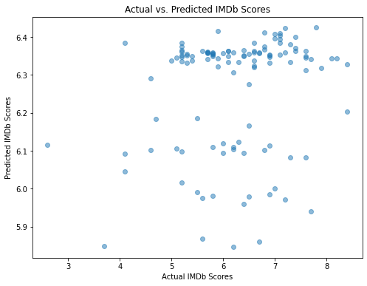

[25]: *# Distribution plot of the residuals (predicted - actual IMDb scores)* residuals = y_pred - y_test plt.figure(figsize=(8, 6)) sns.histplot(residuals, kde=**True**) plt.xlabel("Residuals (Predicted - Actual IMDb Scores)")

plt.ylabel("Frequency") plt.title("Residuals Distribution") plt.show()

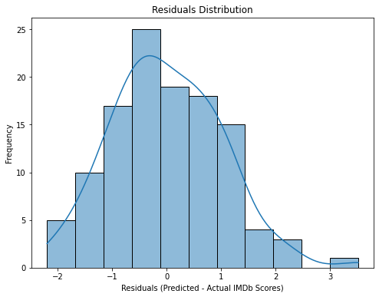

[26]: **from sklearn.ensemble import** RandomForestRegressor **from sklearn.model_selection import** train_test_split **from sklearn.metrics import** mean_absolute_error, mean_squared_error, r2_score **import matplotlib.pyplot as plt import seaborn as sns**

[27]: X = df.drop(["IMDB Score", "Title", "Genre", "Premiere"], axis=1) y = df["IMDB Score"]

X_train, X_test, y_train, y_test = train_test_split(X, y, test_size=0.2,␣ ↪random_state=42)

[28]: model = RandomForestRegressor(random_state=42) model.fit(X_train, y_train)

[28]: RandomForestRegressor(random_state=42)

[29]: **if** isinstance(model, RandomForestRegressor): feature_importance = model.feature_importances_ feature_names = X_train.columns

plt

.

figure(figsize

=

(

10

,

6

))

plt

.

barh(feature_names, feature_importance)

plt

.

xlabel(

"

Feature Importance

"

)

plt

.

ylabel(

"

Features

"

)

plt

.

title(

"

Feature Importance Plot

"

)

plt

.

show()

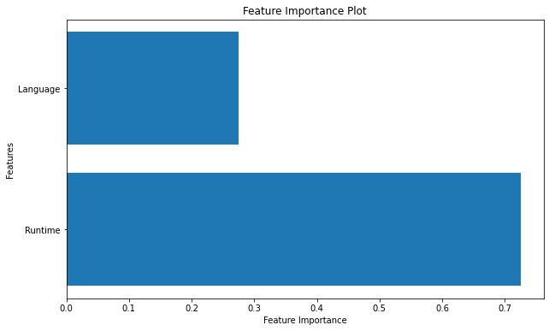

[30]:

**def**

predict_imdb_score

(

title, genre, premiere, runtime, language

):

*# Create input data for prediction*

input_data

=

pd

.

DataFrame({

'

Runtime

'

:[

runtime],

'

Language

'

:[

label_encoder

.

↪

transform([language])]})

*# Make a prediction*

predicted_imdb_score

=

model

.

predict(input_data)[

0

]

**return**

predicted_imdb_score

[34]:

*# Example usage:*

title

=

"

2023-01-01

"

genre

=

"

Action

"

premiere

=

"

2023-01-01

"

*# You can format the date accordingly*

runtime

=

400

language

=

"

English

"

predicted_score

=

predict_imdb_score(title, genre, premiere, runtime, language)

print(f"Predicted IMDb Score: **{**predicted_score**:**.2f**}**")

Predicted IMDb Score: 7.31

[ ]: *# User input* title = input("Enter the movie title: ") genre = input("Enter the movie genre: ") premiere = input("Enter the premiere date (YYYY-MM-DD): ") runtime = float(input("Enter the movie runtime (in minutes): ")) language = input("Enter the movie language: ")

predicted_score = predict_imdb_score(title, genre, premiere, runtime, language) print(f"Predicted IMDb Score: **{**predicted_score**:**.2f**}**")