

Name: Mobile Computing for Modern App Development Name: Hariharan E (192421337)

Course Code: ITA0306

20) Design a wireframe in Figma for a mobile application showcasing power management approaches.

Aim:
Design a wireframe in Figma for a mobile application showcasing power management approaches.

Procedure:

- Create a file
- Add The First Frame
- Add Shapes
- Add Text
- Create The Second Frame
- Add Prototyping Design:

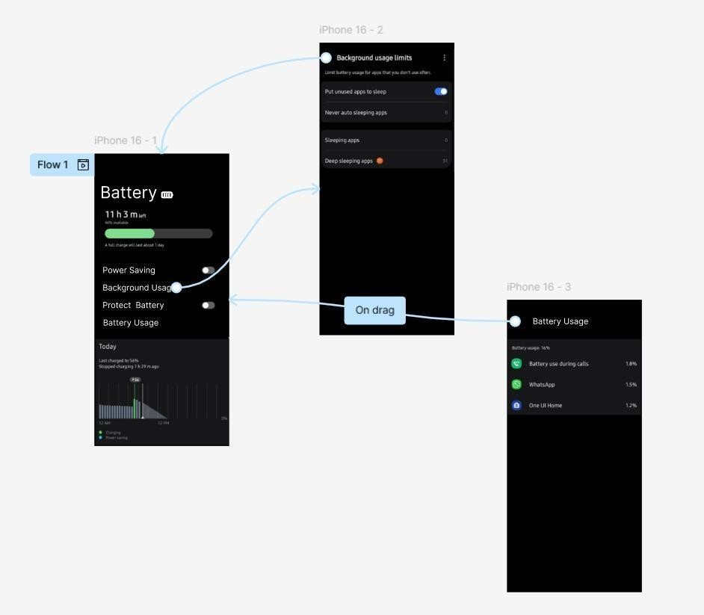

Result:
Hence the mobile application showcasing power management is created and executed successfully.

