

Name: Mobile Computing for Modern App Development Name: Hariharan E (192421337)

Course Code: ITA0306

Develop a user interface prototype in Figma showcasing security measures for a mobile app. Emphasize the intuitive design for user personalization.

Aim:
Developing a user interface prototype in Figma showcasing security measures for a mobile app.

Procedure:
  - Define Presentation Structure
  - Create a Figma Project
  - Design Visual Elements

  - Make it Interactive
  - Add Annotations and Explanations
  - Incorporate Multimedia
  - Storyboard Animation
  - Test the Prototype
  - Collaborate and Gather Feedback
  - Finalize and Share

Design:

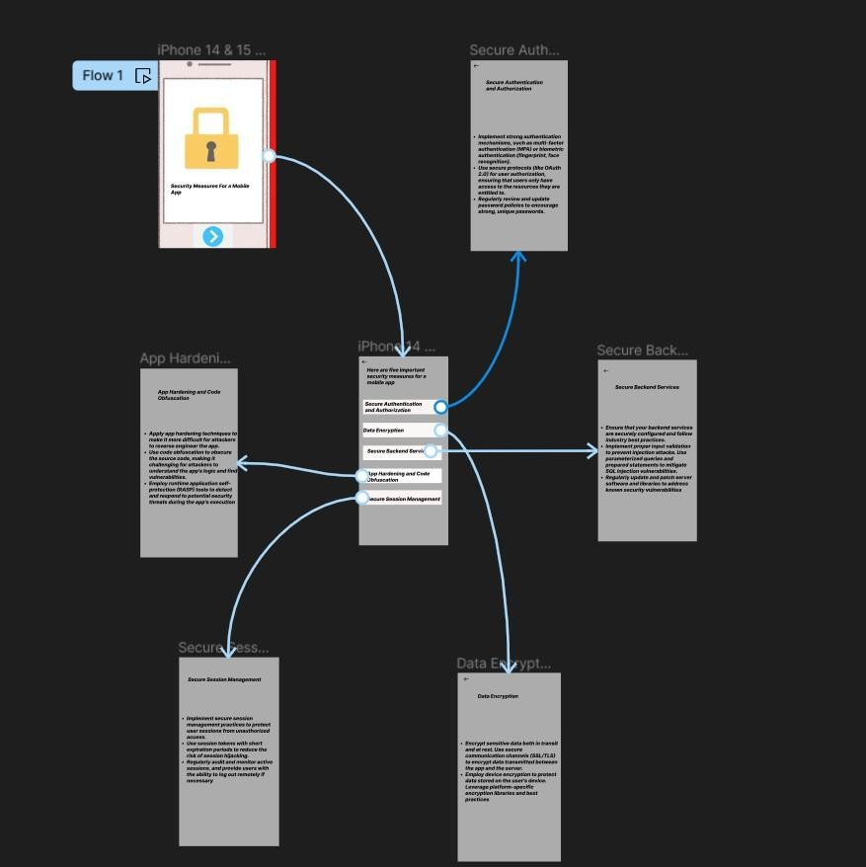
Result:
Hence an user interface prototype in Figma showcasing security measures for a mobile app have been created successfully

