A SHORT-TERM INTERNSHIP REPORT
ON GENERATIVE ARTIFICIAL INTELLIGENCE
A report submitted in partial fulfillment of the requirements for the award of degree of
BACHELOR OF TECHNOLOGY
IN
COMPUTER SCIENCE ENGINEERING (DATA SCIENCE)
By
NAME OF THE STUDENT
Reg. No: __________
Duration: __________ to __________
Department of Computer Science Engineering (Data Science)
ANNAMACHARYA INSTITUTE OF TECHNOLOGY & SCIENCES
(Autonomous)
Thallapaka Panchayath, New Boyanapalli, Rajampet, Annamayya Dist., A.P. – 516126
Academic Year: 2026–2027

INTERNSHIP REPORT
Title: Generative Artificial Intelligence – Concepts, Applications, Tools and Practical Learning
Particular | Details
Name of the Student | ____________________________
Registration Number | ____________________________
Program of Study | B.Tech – CSE (Data Science)
Department | Computer Science Engineering (Data Science)
Internship Topic | Generative Artificial Intelligence
Faculty Guide | ____________________________
Industry/Training Organization | Skill Dzire / __________________
Duration | 8 Weeks
Date of Submission | ____________________________

CERTIFICATE
This is to certify that the internship report entitled “Generative Artificial Intelligence – Concepts, Applications, Tools and Practical Learning” submitted by the student of B.Tech in Computer Science Engineering (Data Science) is a record of the learning and practical work carried out during the internship period.
The report is submitted in partial fulfillment of the requirements for the award of the degree of Bachelor of Technology in Computer Science Engineering (Data Science) during the academic year 2026–2027.
Mentor Signature Department Internship In-Charge
Head of the Department Industry Guide

ACKNOWLEDGEMENT
I express my sincere gratitude to my industry guide, faculty guide, Head of the Department, and the entire training team for providing guidance and support throughout my internship on Generative Artificial Intelligence.
I am thankful to the faculty members of the Department of Computer Science Engineering (Data Science), Annamacharya Institute of Technology & Sciences, for their encouragement and valuable suggestions while preparing this report.
I also thank the organization and trainers who provided practical exposure to modern Generative AI concepts, tools, prompting methods, language models, image generation, retrieval-augmented generation, and responsible AI practices.
Finally, I thank my family and friends for their continuous support and motivation during the internship.
Date: ____________
Place: ____________
Student Signature
Name: __________________

ABSTRACT
Generative Artificial Intelligence (Generative AI) is a branch of artificial intelligence that learns patterns from existing data and uses those patterns to create new content. The content may be text, images, audio, video, software code, presentations, or structured information. This internship focused on developing a clear and practical understanding of Generative AI, including foundation concepts, generative models, large language models, transformers, prompt engineering, retrieval-augmented generation, multimodal AI, and responsible use.
The internship connected theoretical concepts with practical examples. The learning process covered how a generative model receives an input prompt, processes information using learned representations, predicts or generates content, and produces an output. Special attention was given to the difference between traditional predictive AI and generative systems.
The report also explains major model families such as Generative Adversarial Networks (GANs), Variational Autoencoders (VAEs), diffusion models, and transformer-based language models. Practical topics include prompt design, embeddings, vector databases, RAG, model evaluation, hallucination reduction, privacy, bias, and human review.
Overall, the internship helped build a foundation for using Generative AI responsibly in education, business, software development, data science, customer support, research, and creative applications.

TABLE OF CONTENTS
S.No | Chapter / Topic | Page
1 | Executive Summary | 7
2 | Organization Overview | 8
3 | Introduction to Generative AI | 9
4 | Generative AI vs Traditional AI | 10
5 | Generative Models and Learning | 11
6 | Latent Space | 12
7 | GANs | 13
8 | VAEs | 14
9 | Diffusion Models | 15
10 | Transformers | 16
11 | Large Language Models | 17
12 | Prompt Engineering | 18
13 | Embeddings and Vector Search | 19
14 | Retrieval-Augmented Generation | 20
15 | Multimodal Generative AI | 21
16 | AI Tools and Workflow | 22
17 | Week 1–2 Activity Report | 23
18 | Week 3–4 Activity Report | 24
19 | Week 5–6 Activity Report | 25
20 | Week 7–8 Activity Report | 26
21 | Technical Skills Acquired | 27
22 | Managerial Skills | 28
23 | Communication Improvement | 29
24 | Conclusion and References | 30

CHAPTER 1: EXECUTIVE SUMMARY
This internship was designed to provide a practical and understandable introduction to Generative Artificial Intelligence. The training began with the meaning of AI and machine learning and then moved toward models that can create new content.
The first stage focused on the basic idea of generation. Instead of only classifying an input or predicting a label, a generative model learns a representation of data and produces a new sample that follows the learned patterns. Examples include generating a paragraph from a prompt, creating an image from a text description, summarizing a document, or generating program code.
The training then covered important model families. GANs use a generator and discriminator in a competitive learning process. VAEs learn a compact latent representation and generate new samples by decoding points from that space. Diffusion models generate content by learning how to reverse a controlled noise process.
Transformer architecture and large language models were studied as major foundations of modern text-based Generative AI. Prompt engineering, embeddings, RAG, multimodal systems, evaluation, and responsible AI were included to connect theory with practical usage.
- Understand fundamental Generative AI terminology.
- Explain the basic working of GAN, VAE, diffusion and transformer models.
- Write clearer prompts and evaluate generated responses.
- Understand RAG and why external knowledge can improve answers.
- Recognize limitations such as hallucinations, bias, privacy and incorrect outputs.

CHAPTER 2: OVERVIEW OF THE ORGANIZATION
The uploaded internship template describes Skill Dzire as a real-time learning platform that provides job-oriented courses, projects, internships, placement programs, faculty development programs and workshops. It follows a learner-centric approach and combines learning materials with practical activities. The revised report retains that organization-oriented structure while changing the technical subject from solar-energy training to Generative AI.
For this revised internship report, the organization/training environment is treated as the learning platform through which the student studies current AI technologies and practical workflows. The focus is on understanding concepts clearly, practicing with AI tools, documenting activities, and connecting classroom learning with industry expectations.
Area | Generative AI Internship Focus
Learning model | Concept explanation + demonstrations + practice
Core technology | Generative AI and foundation models
Practical skills | Prompting, RAG, embeddings, evaluation
Professional skills | Documentation, presentation, teamwork
Outcome | Ability to explain and apply GenAI concepts

CHAPTER 3: INTRODUCTION TO GENERATIVE AI
Generative AI is an AI technology that creates new content from patterns learned during training. A simple way to understand it is: traditional systems often answer “Which category does this input belong to?”, while generative systems can answer “What new content can be produced from this instruction?”
For example, a classification model may identify whether an email is spam. A generative model can draft a reply to an email. An image classifier can recognize a dog in a picture, while an image generation model can create a new dog image from a text prompt.
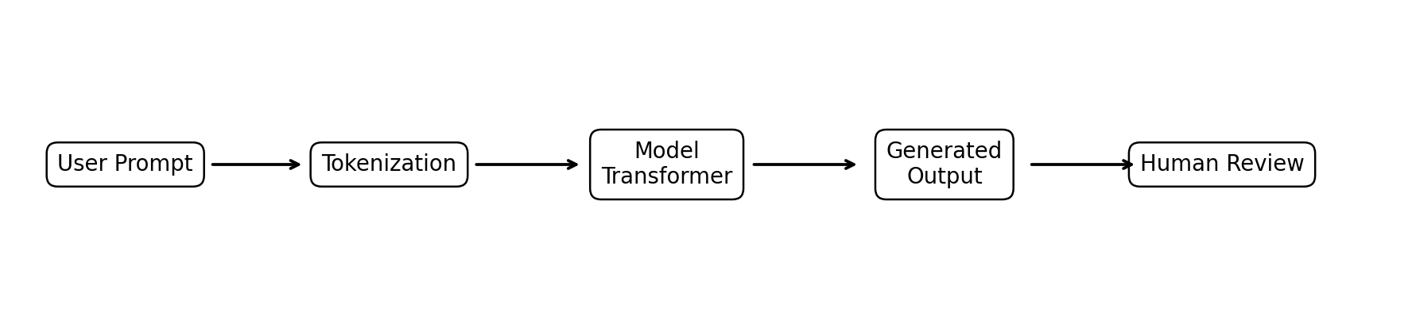
Figure 3.1: Simplified Generative AI workflow
- Input: prompt, text, image, audio or other context.
- Model processing: learned representations are used to predict/generate content.
- Output: newly generated content.
- Review: human verification remains important for high-impact use cases.

GENERATIVE AI VS TRADITIONAL / DISCRIMINATIVE AI
A discriminative model generally learns a relationship that helps distinguish classes or predict a target. A generative model learns how data can be represented or produced. The distinction is useful, but real systems can combine both approaches.
Feature | Discriminative / Predictive AI | Generative AI
Main purpose | Predict or classify | Create new content
Typical output | Label, score or prediction | Text, image, audio, code, etc.
Example | Spam/not spam classifier | Email draft generator
Question | What class is this? | What content can be generated?
Data use | Learns decision boundaries/predictive relationships | Learns patterns/distributions/representations
Evaluation | Accuracy, precision, recall | Quality, relevance, factuality, safety, human preference
Generative AI does not automatically mean the output is correct. A generated answer may be fluent but factually wrong. Therefore, evaluation, grounding, source checking, and human oversight are important parts of a useful Generative AI system.

GENERATIVE MODELS AND LEARNING
A generative model attempts to learn useful structure from data so that it can generate new examples. During training, the model adjusts parameters to reduce an objective or loss. The exact learning method differs between model families.
In language generation, a model may learn to predict the next token based on the preceding context. Repeating this process allows the model to generate a sequence. In image generation, a model may learn relationships between visual features and text descriptions, or learn how to reconstruct images from noisy versions.
- Training data: examples used to learn patterns.
- Parameters: numerical values learned by the model.
- Loss/objective: measures how well the model performs its training task.
- Inference: using a trained model to produce an output.
- Sampling/decoding: methods used to select generated tokens or content.
The quality of a generative system depends not only on the model but also on data quality, training method, context, prompt quality, evaluation and deployment design.

LATENT SPACE
Latent space is a learned representation in which complex data can be represented using a smaller or more meaningful set of numerical features. It is called “latent” because the representation is not directly observed in the original data; it is learned by the model.
A useful example is a face-image dataset. Instead of treating every pixel as an isolated value, a learned representation can capture factors related to shape, lighting, pose and other features. Moving through latent space can correspond to changing these underlying properties.
Concept | Simple Meaning
Latent vector | A numerical representation of an item
Encoder | Maps input data into a latent representation
Decoder | Maps a latent representation back into data
Interpolation | Moving between representations to create gradual changes
Importance | Provides a structured space for generation and manipulation
Latent representations are important in VAEs, image generation, representation learning and other generative systems. The quality and structure of the learned space affect how smoothly and meaningfully a model can generate new content.

GENERATIVE ADVERSARIAL NETWORKS (GANs)
A Generative Adversarial Network contains two neural networks: a Generator and a Discriminator. The Generator creates synthetic samples, while the Discriminator attempts to distinguish real samples from generated samples.
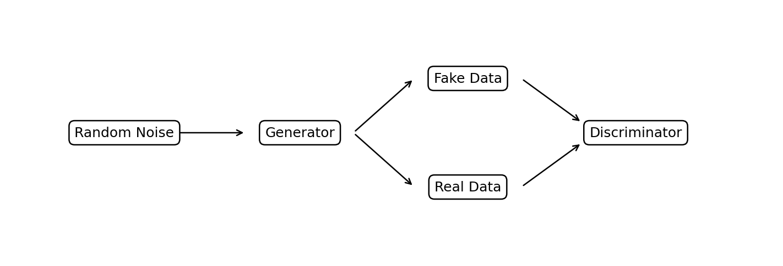
Figure 13.1: Simplified GAN architecture
During training, the Generator tries to produce increasingly realistic samples. The Discriminator tries to become better at detecting generated samples. This adversarial process can improve generation quality.
- Generator: creates synthetic data from random input or a latent representation.
- Discriminator: predicts whether a sample is real or generated.
- Adversarial training: both networks improve through competition.
- Applications: image synthesis, style transfer and data augmentation.
- Limitation: training can be unstable and may suffer from mode collapse.

VARIATIONAL AUTOENCODERS (VAEs)
A Variational Autoencoder is a generative model built around an encoder and decoder. The encoder maps an input into a probabilistic latent representation, and the decoder reconstructs or generates data from that representation.
The important idea is that the model learns a structured latent space rather than memorizing individual examples. A new latent point can be sampled and passed through the decoder to produce a new output.
Component | Function
Encoder | Converts input into parameters of a latent distribution
Latent sampling | Selects a latent representation from the learned distribution
Decoder | Reconstructs or generates the data
Reconstruction loss | Encourages output to resemble the input
KL-related regularization | Encourages a useful, smooth latent distribution
VAEs are useful for representation learning, controlled generation and exploring the structure of data. Compared with GANs, they often provide a more explicit latent representation, although generated outputs can sometimes appear less sharp.

DIFFUSION MODELS
Diffusion models are generative models that learn to create data by reversing a gradual noise process. During training, noise is progressively added to data. The model learns how to remove that noise step by step.
At generation time, the process starts from a noisy sample and repeatedly denoises it until a meaningful output appears. In text-to-image systems, a text prompt can condition the generation process so that the final image follows the requested description.
- Forward process: gradually add noise to training examples.
- Reverse process: learn to remove noise.
- Conditioning: use text or other information to guide generation.
- Sampling: perform multiple denoising steps to obtain a final sample.
- Applications: image synthesis, editing, inpainting and creative design.
Diffusion models have become important because they can produce high-quality images and support flexible editing. Their main practical considerations include computation cost, sampling time, prompt adherence and safety.

TRANSFORMERS AND ATTENTION
Transformers are neural network architectures that process sequences using attention mechanisms. Attention helps the model determine which parts of the input are important when processing each token.
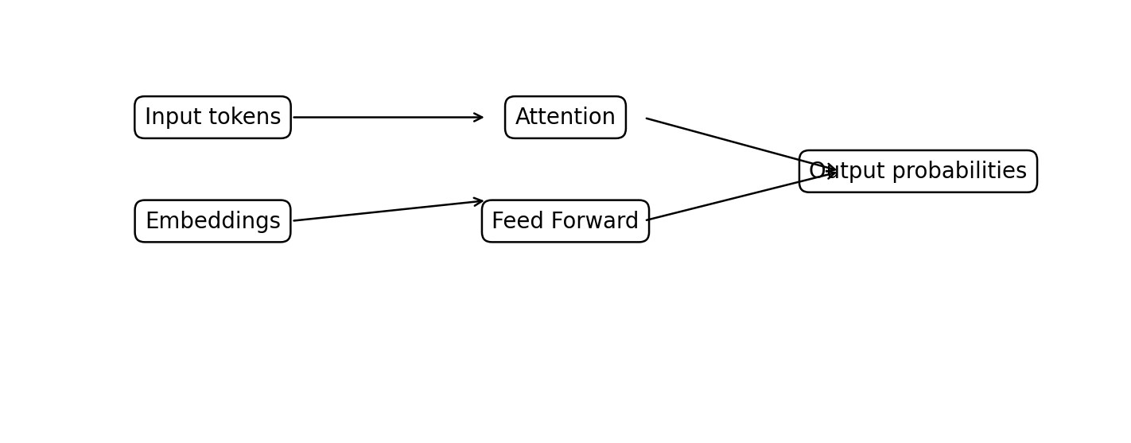
Figure 16.1: Simplified transformer-style flow
A transformer-based language system commonly uses tokenization, embeddings, attention layers, feed-forward layers, normalization and output prediction. Self-attention allows relationships between tokens to be modeled even when relevant words are far apart in the sequence.
- Tokenization: converts text into model-readable units.
- Embeddings: represent tokens as numerical vectors.
- Attention: weighs relationships between tokens.
- Feed-forward layers: transform learned representations.
- Output layer: produces probabilities for possible next tokens.

LARGE LANGUAGE MODELS (LLMs)
Large Language Models are neural models trained on large collections of text or related data. They learn statistical and semantic patterns that allow them to perform tasks such as question answering, summarization, translation, drafting, coding and information extraction.
A simplified generation process is: the prompt is tokenized, tokens are converted into representations, the transformer processes the context, probabilities are calculated for the next token, and a decoding method selects a token. The process continues until the response is completed.
Term | Meaning
Token | A unit of text processed by the model
Context | Information available to the model for the current response
Prompt | Instruction or input provided by the user/system
Inference | Running a trained model to obtain an output
Fine-tuning | Additional training for a specific behavior/task
Temperature | A decoding control affecting randomness/variety
LLMs can be highly capable but are not guaranteed to be truthful. Their outputs should be verified when accuracy, safety or current information is important.

PROMPT ENGINEERING
Prompt engineering means designing instructions and context so that a Generative AI model is more likely to produce a useful result. A good prompt is clear about the task, context, constraints and expected output.
Technique | Example Idea
Role | Act as a data analyst.
Task | Explain the concept of RAG.
Context | The audience is a first-year engineering student.
Constraints | Use simple language and a short example.
Format | Return the answer as a table with three columns.
Examples | Show one sample input and expected output.
A practical prompt template is: Role + Task + Context + Constraints + Output Format + Quality Check. Prompting should be iterative: write a first prompt, inspect the output, identify what is missing, and improve the instructions.
- Be specific instead of vague.
- Give relevant context.
- State the expected format.
- Break complex tasks into steps.
- Ask the model to identify assumptions or uncertainty.
- Verify important claims independently.

EMBEDDINGS AND VECTOR SEARCH
An embedding is a numerical vector representing the meaning or characteristics of an item such as text, an image, or another object. Similar items often have vectors that are close to one another under a suitable similarity measure.
In a document search system, a document can be split into chunks and converted into embeddings. A user question can also be converted into an embedding. Vector search then finds chunks that are semantically similar to the query.
Step | What Happens
Chunking | Long documents are divided into useful sections.
Embedding | Each chunk becomes a numerical vector.
Indexing | Vectors are stored for efficient retrieval.
Query embedding | The user's question is converted to a vector.
Similarity search | Relevant chunks are retrieved.
Generation | Retrieved context is given to a language model.
Embeddings form an important bridge between unstructured information and retrieval-based AI applications. They are widely used in semantic search, recommendation, clustering and RAG systems.

RETRIEVAL-AUGMENTED GENERATION (RAG)
Retrieval-Augmented Generation combines information retrieval with text generation. Instead of asking a language model to answer only from its internal learned parameters, a RAG system retrieves relevant information from a selected knowledge source and supplies it as context.
A typical RAG workflow is: collect documents → clean and chunk → create embeddings → store vectors → retrieve relevant chunks → build a grounded prompt → generate an answer → evaluate the answer and citations.
RAG Component | Purpose
Document store | Contains the organization's or project's knowledge
Chunker | Creates manageable retrieval units
Embedding model | Converts chunks and queries into vectors
Vector database | Stores and searches vectors
Retriever | Selects relevant evidence
LLM | Uses evidence to formulate an answer
Evaluation | Checks relevance, groundedness and usefulness
RAG is useful for company policies, academic documents, manuals, project reports and other knowledge bases. It can reduce unsupported answers when retrieval and prompting are designed well, but retrieved content must still be checked for quality and completeness.

MULTIMODAL GENERATIVE AI
Multimodal Generative AI works with more than one type of information, such as text, images, audio and video. A multimodal system can interpret an image and answer questions about it, combine text and visual context, or generate content in multiple formats.
Modality | Possible Generative Task
Text | Drafting, summarization, question answering
Image | Generation, editing, captioning
Audio | Speech generation, transcription, voice interaction
Video | Generation, editing, storyboarding
Text + Image | Visual question answering and document understanding
Multimodal systems are useful in education, accessibility, design, marketing, customer support, healthcare documentation and content production. The same responsible-AI principles apply: verify outputs, protect private information and avoid using generated content as unquestioned evidence.

GENERATIVE AI TOOLS AND PRACTICAL WORKFLOW
The internship introduced a tool-oriented way of thinking: first understand the problem, then choose the right model or AI application, provide suitable context, evaluate the result, and document the workflow.
Task | Suitable Tool/Approach
Text drafting | LLM-based assistant
Document Q&A | RAG + embeddings + vector search
Image generation | Text-to-image diffusion-style system
Code assistance | Code-capable language model
Data analysis | Python + AI-assisted reasoning + verification
Presentation preparation | LLM for structure + human editing
Knowledge organization | Embeddings + semantic search
A professional workflow should separate generation from verification. Generated content can accelerate drafting and exploration, but the final output should be reviewed for correctness, relevance, originality, privacy, security and compliance.

WEEK 1–2 ACTIVITY REPORT
Day | Activity | Learning Outcome
Day 1 | Introduction to AI, ML and Generative AI | Understand core terminology and differences
Day 2 | Generative AI applications | Identify real-world use cases
Day 3 | Generative vs discriminative models | Explain the purpose of each approach
Day 4 | Generative model families | Compare GANs, VAEs and diffusion
Day 5 | Latent space | Understand learned representations
Day 6 | GAN architecture | Explain generator/discriminator roles
Day 7 | VAE architecture | Understand encoder, latent space and decoder
Day 8 | Diffusion concept | Explain noise addition and denoising
Day 9 | Review and exercises | Apply concepts using simple examples
Day 10 | Documentation | Summarize learning clearly
Weekly objective: Build a strong conceptual foundation in Generative AI and understand how different model families create new content.

WEEK 3–4 ACTIVITY REPORT
Day | Activity | Learning Outcome
Day 11 | Transformer architecture | Understand attention and token processing
Day 12 | Self-attention | Explain contextual relationships
Day 13 | LLM workflow | Understand tokenization, inference and decoding
Day 14 | Prompt engineering | Write structured prompts
Day 15 | Prompt testing | Compare outputs and refine prompts
Day 16 | Embeddings | Understand semantic numerical representations
Day 17 | Vector search | Understand similarity-based retrieval
Day 18 | Chunking and indexing | Prepare knowledge for retrieval
Day 19 | RAG architecture | Connect retrieval with generation
Day 20 | RAG exercises | Create a simple conceptual RAG workflow
Weekly objective: Move from model theory to practical interaction with language models, embeddings and retrieval-based systems.

WEEK 5–6 ACTIVITY REPORT
Day | Activity | Learning Outcome
Day 21 | RAG prompt construction | Ground model responses using retrieved context
Day 22 | RAG evaluation | Check relevance and groundedness
Day 23 | Hallucination study | Recognize unsupported model claims
Day 24 | Multimodal AI | Understand text-image-audio use cases
Day 25 | Image generation concepts | Understand text-to-image workflow
Day 26 | AI-assisted coding | Use generated code with testing
Day 27 | AI in data science | Explore summarization and analysis assistance
Day 28 | Business applications | Map GenAI to organizational tasks
Day 29 | Responsible AI | Study privacy, bias and safety
Day 30 | Mini case study | Combine concepts into an application idea
Weekly objective: Understand how Generative AI becomes a practical system and how quality, safety and evaluation affect its usefulness.

WEEK 7–8 ACTIVITY REPORT
Day | Activity | Learning Outcome
Day 31 | Project requirement analysis | Define an AI use case and target users
Day 32 | Knowledge preparation | Organize documents and context
Day 33 | Prompt and retrieval design | Improve response quality
Day 34 | Output evaluation | Identify factual and relevance errors
Day 35 | Documentation | Prepare technical explanation
Day 36 | Presentation preparation | Communicate technical ideas simply
Day 37 | Responsible AI review | Check privacy, bias and misuse risks
Day 38 | Final project review | Consolidate technical learning
Day 39 | Report preparation | Document activities and outcomes
Day 40 | Final reflection | Assess skills and future learning goals
Weekly objective: Integrate technical and professional skills into a clear, responsible Generative AI workflow.

TECHNICAL SKILLS ACQUIRED
- Generative AI fundamentals: understood generation, prompts, inference and model limitations.
- Model architectures: learned the basic architecture and working principles of GANs, VAEs, diffusion models and transformers.
- LLM understanding: learned tokens, embeddings, attention, context, decoding and inference.
- Prompt engineering: practiced structured prompts with role, task, context, constraints and output format.
- Semantic search: understood embeddings, chunking, indexing and vector similarity.
- RAG: learned the complete conceptual pipeline from documents to retrieval to grounded generation.
- Multimodal AI: understood how text, image, audio and video can be combined in AI workflows.
- Evaluation: learned to consider relevance, factuality, groundedness, consistency and human review.
- Responsible AI: recognized privacy, bias, copyright, security, hallucination and misuse risks.
- Documentation: developed the ability to explain technical concepts using simple language and structured reports.
These skills provide a foundation for further study in AI engineering, data science, machine learning, NLP, LLM application development and intelligent information systems.

MANAGERIAL AND PROFESSIONAL SKILLS
Skill | Learning During Internship
Planning and time management | Organized weekly learning activities and report work.
Teamwork | Discussed concepts, exercises and project ideas with peers and mentors.
Problem solving | Analyzed why prompts, retrieval or generated outputs might fail.
Decision making | Selected suitable approaches based on task requirements.
Communication | Practiced explaining AI concepts to technical and non-technical audiences.
Adaptability | Learned new AI concepts and tools as the field changes quickly.
Documentation | Maintained structured notes, weekly reports and technical explanations.
Presentation | Prepared clear explanations of architectures and workflows.
Professionalism | Used review and verification before treating AI output as final.
Continuous learning | Identified new areas such as fine-tuning, agents and evaluation.
The internship also highlighted that AI skills are not limited to model knowledge. Professional success requires communication, critical thinking, teamwork, responsible decision making and the ability to learn continuously.

COMMUNICATION SKILL IMPROVEMENT & SELF-EVALUATION
The internship showed that technical knowledge is most useful when it can be communicated clearly. I can improve my communication by actively participating in discussions, asking well-prepared questions, and explaining complex AI topics using simple examples.
- Participate more actively in team discussions and technical reviews.
- Practice explaining one AI concept in simple language within two or three minutes.
- Use diagrams, tables and examples to make technical presentations easier to understand.
- Ask for constructive feedback on reports, presentations and project explanations.
- Improve written communication through concise technical documentation.
- Use professional communication tools and maintain clear, timely updates.
- Build confidence through short demonstrations and peer discussions.
Self-Evaluation Area | Rating (1–5)
Oral communication | ____
Written communication | ____
Initiative | ____
Team interaction | ____
Ability to learn | ____
Planning and organization | ____
Professionalism | ____
Creativity | ____
Quality of work | ____
Overall performance | ____
Supervisor Evaluation: The supervisor may independently assess the student using the institution's standard 1–5 rating scale.

CONCLUSION AND REFERENCES
Conclusion
The Generative AI internship provided a structured understanding of how modern AI systems can create text, images, code and other forms of content. The learning progressed from fundamental concepts to generative model families, transformers, large language models, prompt engineering, embeddings, RAG and multimodal AI.
The most important learning outcome was understanding that a useful Generative AI application is more than a model. It requires good inputs, relevant context, retrieval or grounding when necessary, careful evaluation, human review and responsible handling of data. The internship also strengthened professional skills such as documentation, presentation, teamwork and continuous learning.
Generative AI is developing rapidly, so continued learning is essential. Future areas of study include fine-tuning, parameter-efficient adaptation, AI agents, multimodal RAG, evaluation frameworks, model serving, security and responsible AI governance.
References / Suggested Learning Sources
- Goodfellow, I., Bengio, Y., and Courville, A., Deep Learning, MIT Press.
- Vaswani, A. et al., “Attention Is All You Need,” research paper introducing the Transformer architecture.
- Relevant documentation and learning materials for Python, machine learning, NLP, transformer models, embeddings and vector databases.
- Course and internship materials provided by the training organization.
- Official documentation of the Generative AI tools used during practical learning.
Student Signature: ____________________ Faculty Guide: ____________________
Note: This revised report is based on the uploaded internship document's academic/report structure, while replacing the original technical subject matter with clear Generative AI concepts and an eight-week Generative AI learning plan.

