**VIT-AP UNIVERSITY, ANDHRA PRADESH**

**CSE4027 – Data Analytics - Lab Sheet : 1**

**Academic year:** 2020-2021  **Branch/ Class:** B.Tech

**Semester:** Fall  **Date: 21.10.21**

**Faculty Name:** Dr.Hari Seetha  **School:** SCOPE

**Student name: Hari Krishna P Reg. no.: 19BCE7675**

**LAB 1 Exercises**

1. Create a variable named carName and assign the value Volvo to it.



1. Create a variable named maxSpeed and assign the value 120 to it.



1. Use the correct function to combine the text "Hello" with the txt variable, to output "Hello World!".

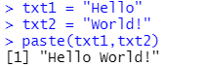

1. Display the sum of 5 + 10, using two variables: x and y.

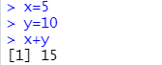

1. Assign the value "Orange" to multiple variables **in one line.**

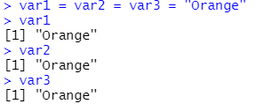

1. **myvar<30,** What data type is myVar?



1. x<-10.5,Which function can be used to check the data type of variable x?



1. Use the correct function to find the lowest number in a set(10,20,30,40,60)



1. Find the square root of 256



1. Create a str variable with the value "Hello”



1. find the number of characters in the str variable,where str<-“Hello World”

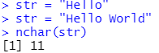

1. check if the character "H" is present in the str variable:



1. combine (concatenate) the two strings::VIT-AP”, “University”?

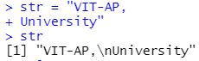

1. What is the output of the following code?



1. 9>8



1. Compare two variables and show the Boolean output

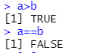

1. Assign any value to a and b .

i)Print "Hello World" if a is greater than b.

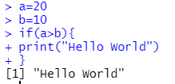

ii) p rint "Yes" if a is equal to b, otherwise print "No".

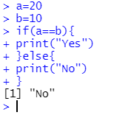

1. Print i as long as i is less than 6.

i)In the above problem, exit the loop if i is equal to 4.

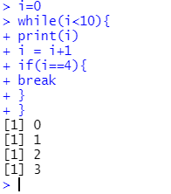

ii) skip the value of 3 in a loop.

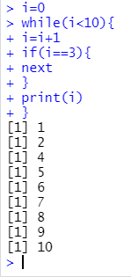

1. iterate over a sequence of numbers 1to 100 and print each number

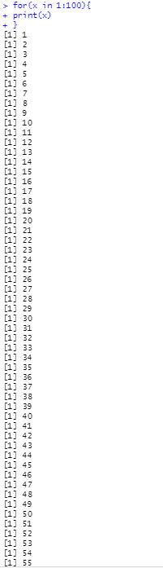 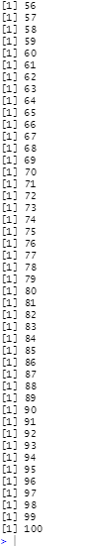

1. Write a function to find mn

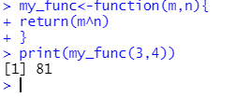

1. Write a recursive function to print the factorial of a given number.

