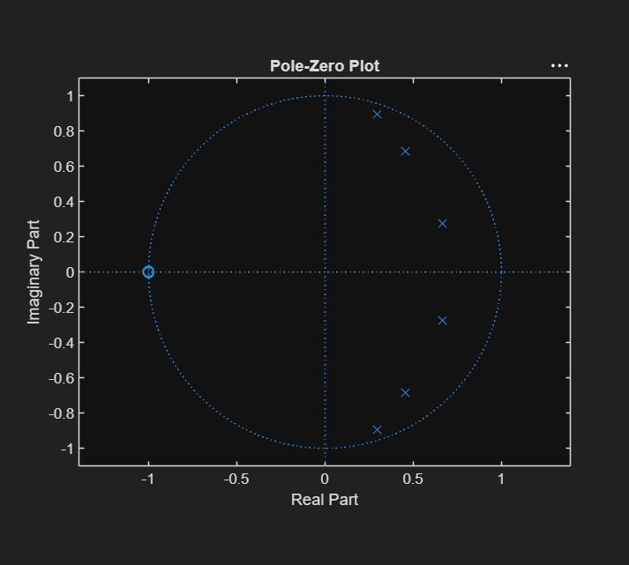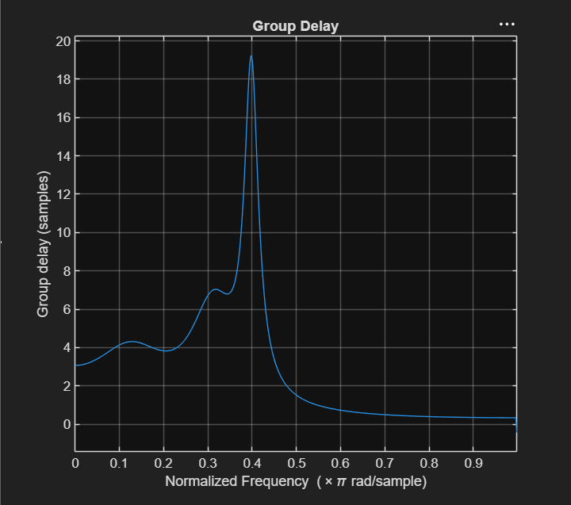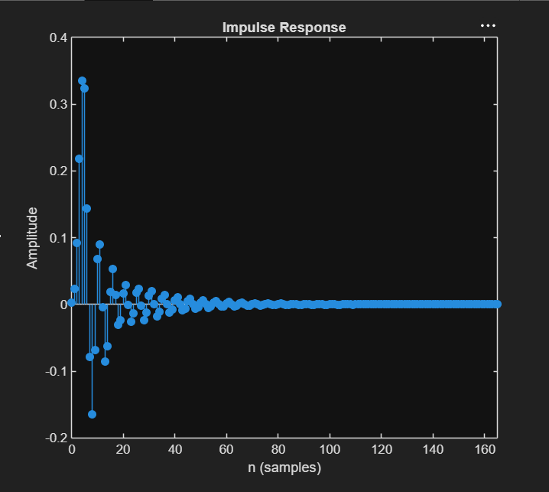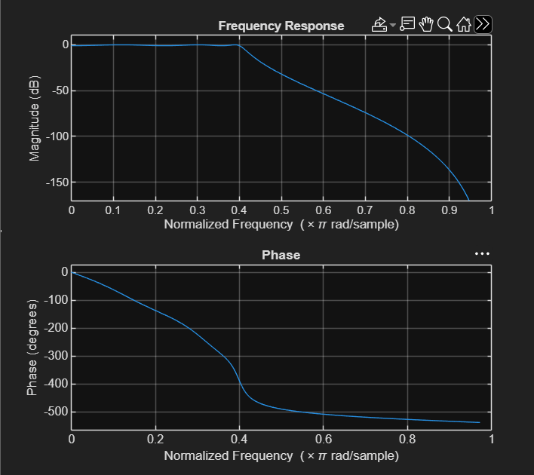

PROGRAM
clc;
clear;
close all;

% EX NO: 2
% Chebyshev IIR Filter
% DATE:
% 2.1 Design and Performance Evaluation of a
% Chebyshev Type-I IIR Low-Pass Filter using MATLAB

% Filter Specifications
Wp = 0.4; % Passband Edge (Normalized)
Ws = 0.55; % Stopband Edge (Normalized)
Rp = 1; % Passband Ripple (dB)
As = 40; % Stopband Attenuation (dB)

% Calculate Minimum Filter Order
[N, Wn] = cheb1ord(Wp, Ws, Rp, As);

% Design Chebyshev Type-I Low-Pass Filter
[b, a] = cheby1(N, Rp, Wn, 'low');

% Display Filter Details
fprintf('Filter Order = %d\n', N);
fprintf('Normalized Cutoff Frequency = %.4f\n', Wn);

% Stability Check
if all(abs(roots(a)) < 1)
disp('System is STABLE');
else
disp('System is UNSTABLE');
end

% ----------------------------
% Frequency Response
% ----------------------------
figure;
freqz(b, a);
title('Frequency Response');

% ----------------------------
% Impulse Response
% ----------------------------
figure;
impz(b, a);
title('Impulse Response');

% ----------------------------
% Group Delay
% ----------------------------
figure;
grpdelay(b, a);
title('Group Delay');

% ----------------------------
% Pole-Zero Plot
% ----------------------------
figure;
zplane(b, a);
title('Pole-Zero Plot');

