1. more
Description: Displays a text file one screen at a time, allowing you to read long files page by page.
more /etc/passwd
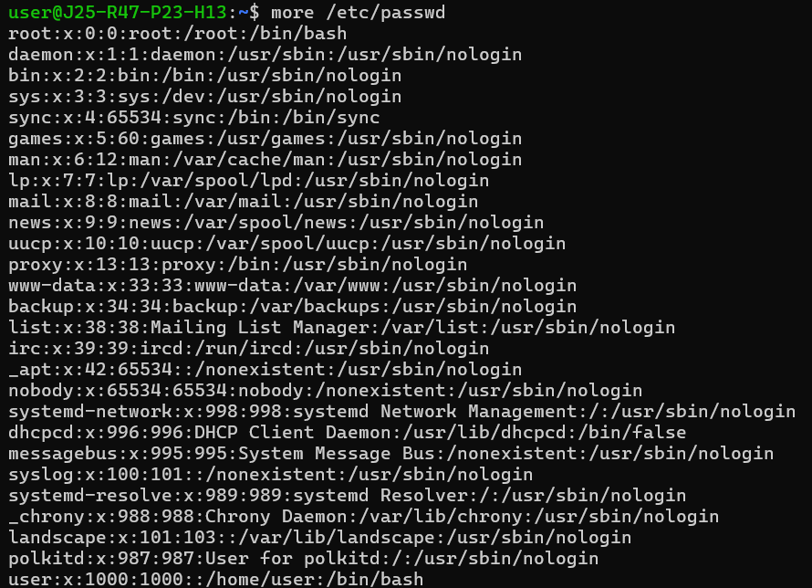
2. od
Description: Displays the contents of a file in octal, hexadecimal, decimal, or other formats, useful for inspecting raw data.
echo "Linux" > sample.txt
od -c sample.txt
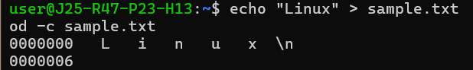
3. expand
Description: Converts tab characters in a file into spaces.
printf 'Hello\tLinux\n' > sample.txt
expand sample.txt
4. file
Description: Identifies the type of a file based on its contents.
file sample.txt
5. fold
Description: Wraps long lines of text into shorter lines of a specified width.
echo "Linux commands are useful for system administration" | fold -w 15
6. join
Description: Combines two sorted files based on a common field.
printf '1 Harini\n2 Arun\n' > file1.txt
printf '1 Chennai\n2 Dindigul\n' > file2.txt
join file1.txt file2.txt
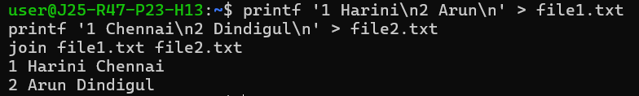
7. less
Description: Displays a file one screen at a time, allowing you to scroll through its contents.
less sample.txt
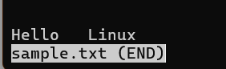
8. ln
Description: Creates a hard link or symbolic link to a file.
ln -s sample.txt sample_link.txt
ls -l sample_link.txt
9. readlink
Description: Displays the target path of a symbolic link.
Command to run:
ln -s /etc/hostname hostname_link
readlink hostname_link
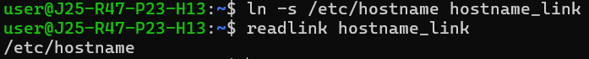10. rev
Description: Reverses the characters in each line of a file or input text.
Command to run:
echo "Linux Commands" | rev

