21-10-2026
1. chage
Description: Changes password expiry information, including the maximum password age and account expiry date.
Command:
sudo chage -l "$USER"
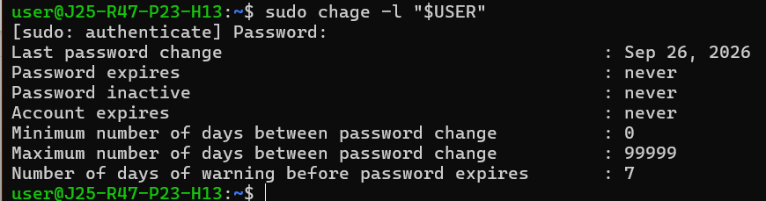
2. chfn
Description: Changes a user's descriptive information, such as full name, office number, and contact details.
Command:
sudo chfn "$USER"
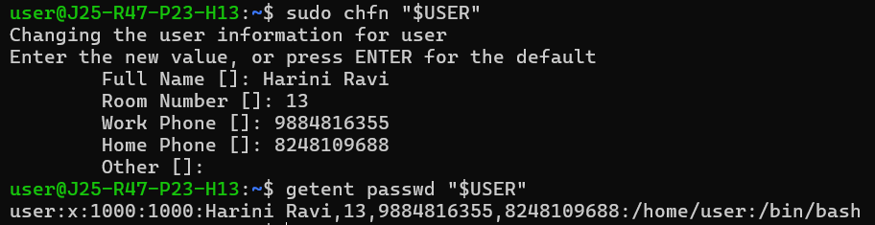3. chsh
Description: Changes the login shell associated with a user account.
Command:
chsh -s /bin/bash
This changes own login shell to Bash, if permitted and /bin/bash is an allowed shell.
Check the current shell:
getent passwd "$USER"
The last field in the output shows the configured login shell.
4. chpasswd
Description: Changes passwords for one or more user accounts using username-and-password pairs supplied through standard input.
Command:
printf '%s\n' 'testuser:TempPass123!' | sudo chpasswd
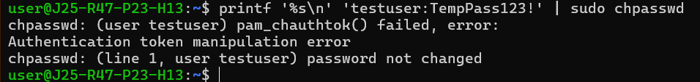
This sets the password for testuser, which must already exist.
5. finger
Description: Displays information about user accounts, such as login name, real name, terminal, and login activity. It may require installing the finger package.
Command:
finger "$USER"
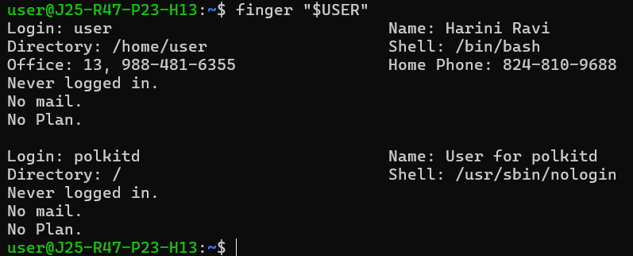6. id
Description: Displays the user ID (UID), primary group ID (GID), and supplementary group memberships.
Command:
id "$USER"
Sample output:
7. passwd
Description: Sets or changes a user's password. Without a username, it changes the current user's password.
Command:
passwd
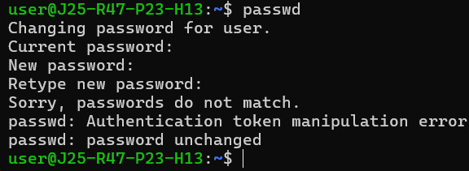
8. pinky
Description: Displays basic information about users, including login names and, where available, login activity.
Command:
pinky
The output depends on which users are logged in and what information is available.
9. username
Description: There is no standard Linux command named username on typical SUSE systems. To display your current username, use whoami.
Command:
whoami
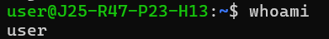
10. useradd
Description: Creates a new user account. Options can specify the home directory, login shell, and other account properties.
Command:
sudo useradd -m -s /bin/bash testuser
This creates testuser, creates a home directory, and sets Bash as the login shell.
Set a password:
sudo passwd testuser
Verify the account:
id testuser
