1. lsof — Find what is using port 8080
sudo lsof -i :8080
Use case: Your Spring Boot application fails to start because port 8080 is already occupied. This command can help identify the process using it.
2. fuser — Identify processes using a port
sudo fuser -v 8080/tcp
Shows process IDs associated with TCP port 8080. Unlike lsof, it provides a concise way to identify processes using a specified resource.
3. ss — Inspect listening ports
ss -tuln
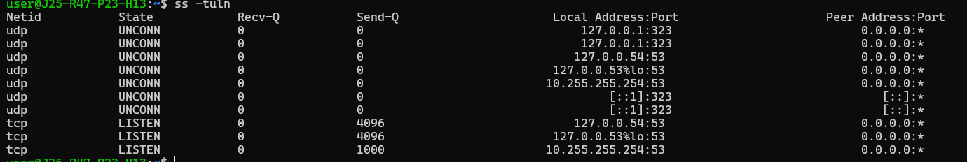
- -t: TCP sockets
- -u: UDP sockets
- -l: Listening sockets
- -n: Numeric addresses and ports
Useful for checking whether a service is listening on the expected port.
4. journalctl — Investigate system errors
journalctl -p err -b
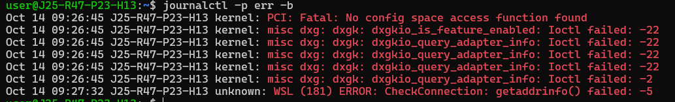
Displays error-level journal messages from the current boot. This is useful when investigating Linux service failures.
5. systemctl — Check a service
systemctl status ssh
Displays the status of the SSH service. On some distributions, the service may be named sshd instead.
6. timedatectl — Check time configuration
timedatectl status
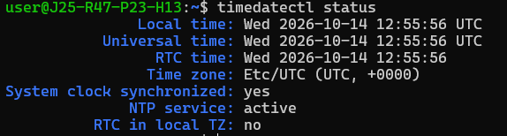
Shows the system clock, time zone, and NTP synchronization status.
7. lsblk — Understand disk devices
lsblk -f
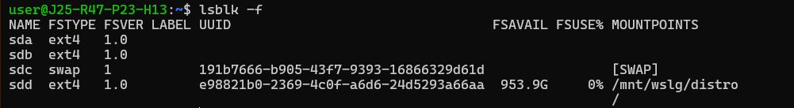
Lists disks, partitions, filesystem types, labels, and mount points. Useful when working with additional storage on AWS EC2.
8. blkid — Identify filesystems
sudo blkid
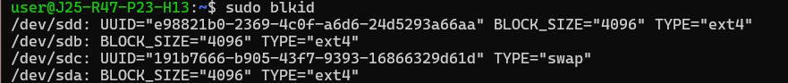
Displays filesystem UUIDs and types, which can help when configuring persistent mounts.
9. getent — Query system information
getent passwd root
getent hosts localhost
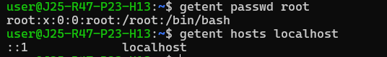
Retrieves account or host information using the system's configured lookup mechanisms.
10. namei — Trace directory permissions
namei -l /var/log/syslog
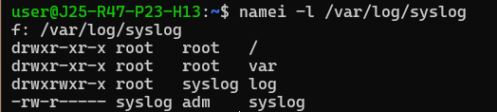
Shows permissions and ownership for every component of the path. This is particularly useful when a user cannot access a file even though the file itself appears readable.

