1. access
Command:
test -r ~/.bashrc && echo "Readable" || echo "Not readable"
Description: Checks whether the current user has permission to read the .bashrc file. This is useful when checking file permissions in Linux scripts.
Output:
2. basename
Command:
basename /var/log/syslog
Description: Extracts the filename from a complete file path. It is useful in shell scripts when only the filename is required.
Output:
3. cat
Command:
cat /etc/os-release
Description: Displays the contents of a file in the terminal. It can be used to inspect Linux configuration files and operating system information.
Output:
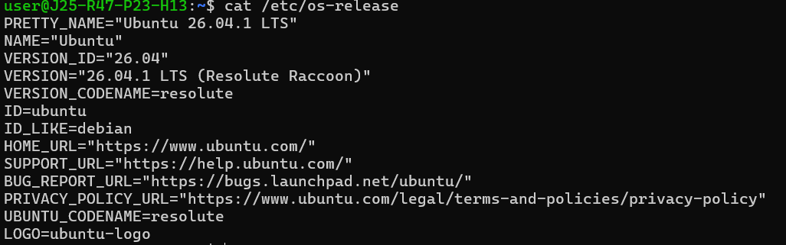4. cksum
Command:
cksum /etc/hosts
Description: Calculates a checksum and the size of a file in bytes. It helps detect accidental changes when comparing files.
Output:
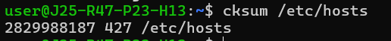
5. cmp
Command:
cmp file1.txt file2.txt
Description: Compares two files byte by byte to identify differences. If the files are identical, it produces no output; otherwise, it reports the first difference.
Output when files differ:
6. compress
Command:
compress file1.txt
Description: Compresses a file using the traditional Unix compression format and usually creates a .Z file. The command may need to be installed separately on Ubuntu.
Output:
7. cp
Command:
cp ~/.bashrc ~/.bashrc.backup
Description: Copies a file from one location to another. This command creates a backup of the .bashrc configuration file before making changes.
Output:
8. cpio
Command:
find . -maxdepth 1 -type f -print | cpio -ov > backup.cpio
Description: Creates an archive containing files from the current directory, excluding files in subdirectories. It is useful for basic file archiving and backup tasks.
Output:
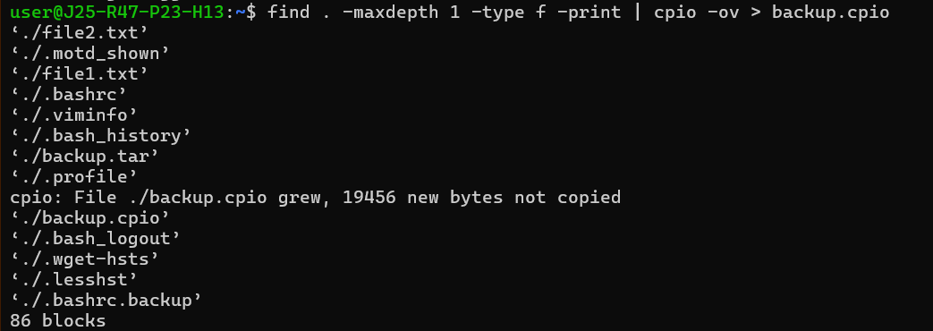9. csplit
Command:
csplit sample.txt 5
Description: Splits a text file into two parts at the specified line number. This example creates one file containing the first four lines and another containing the remaining lines.
Output:
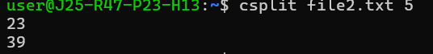
10. cut
Command:
cut -d: -f1 /etc/passwd
Description: Extracts selected fields from text using a specified delimiter. This command displays the usernames listed in the Linux /etc/passwd file.
Output:
