Amrita Vishwa Vidyapeetham
Nagercoil Campus, Amritagiri, Erachakulam, Nagercoil - 629 901
Internal Assessment – Case Study / Automata Design Activity
Hostel Gate-Pass Turnstile Protocol Verification using a DFA
Degree / Branch / Section | B.Tech. / CSE / Section: ________
Course Code / Name | 23CSE303 – Theory of Computation
Year / Semester | III / S5
Group number | ________
Date of submission | ________
Total marks | 20

Sl. No. | Group member | Register number
1 | Nandhan J S | nc.sc.u4cse24118
2 | Adithyan A | nc.sc.u4cse24141
3 | Harini P | nc.sc.u4cse24142

a) Real-World Problem Description

Problem statement
A hostel gate is controlled by an RFID turnstile and a warden's approval console. A student who wants to leave taps their card, the warden approves or denies the request, and only an approved request unlocks the turnstile. When the student returns, they tap in at the gate. The system logs every gate event in order. The problem is to decide whether a logged sequence of events is a legal run of the protocol, rejecting any log that shows unauthorised exit, tailgating, a return without a prior exit, or a return after curfew.
This is a protocol-verification problem: the input is a sequence of events over time, not a string checked for its format.

Input
A finite string over the event alphabet Σ = {t, a, d, x, r, c}:
Symbol | Event
t | Student taps card to request an exit
a | Warden approves the request
d | Warden denies the request
x | Turnstile rotation detected (one physical passage out)
r | Student taps card on return
c | Curfew signal from the gate clock

Output / decision
A binary decision: ACCEPT if the event log is a legal, complete protocol run (the gate ends idle with the student inside the hostel), and REJECT otherwise.

Constraints and rules
- No exit without approval. A rotation x is legal only immediately after an approval a.
- One approval, one rotation. An approval authorises exactly one passage. A second x (tailgating) is a violation.
- A denial ends the request. After d the gate returns to idle, and an x without a fresh t a is a violation.
- No return without exit. A return tap r is legal only when the student is currently outside.
- Curfew. If the curfew signal c arrives while the student is outside, the run is a violation, even if the student returns later.
- No overlapping requests. A new tap t while a request is pending or authorised is a violation.

Assumptions
- The gate serves one student session at a time. Multiple students are outside the model.
- Curfew is a single discrete event `c`, not elapsed time. The model records that curfew occurred while the student was out and does not measure duration.
- Sensors are reliable, so every physical rotation and card tap produces exactly one event.
- The signal c arriving while the student is inside is harmless and ignored.

Valid and invalid cases
Input | Verdict | Reason
ε (empty log) | Valid | No activity; the gate stays idle
t d | Valid | Request denied; the gate returns to idle
t a x r | Valid | Approved, exited, returned
t d t a x r | Valid | Denied once, then a full legal trip
t a x r t a x r | Valid | Two complete trips
t x | Invalid | Passage without approval (rule 1)
a x | Invalid | Approval with no request; protocol never started
t a x x | Invalid | Tailgating on a single approval (rule 2)
t d x | Invalid | Passage after denial (rule 3)
r | Invalid | Return without a prior exit (rule 4)
t a x c r | Invalid | Curfew occurred while outside (rule 5)
t t | Invalid | Overlapping requests (rule 6)
t a x | Invalid | Student still outside; run is incomplete

The valid runs form the language **L = { w ∈ Σ* : w is a sequence of complete trips and denied requests }**, which is essentially (td | taxr)* with the harmless inside-curfew symbol allowed. This language is regular.

b) Decidability Analysis

Verdict
The problem is decidable. Given any event log w ∈ Σ*, there is an algorithm that always halts and correctly answers whether w is a legal run of the gate protocol.

Formal statement
Let **L_gate = { w ∈ Σ* : w is a legal run of the gate protocol }**. The decision problem is membership: given w, is w ∈ L_gate?

Justification
- L_gate is regular. Every rule in (a) depends only on which of a fixed, finite number of situations the gate is in: idle, request pending, approval granted, student outside, or violation. No rule needs an unbounded count or memory beyond the current situation. The language is therefore accepted by the DFA designed in (d).
- Membership in a regular language is decidable. A Turing machine M decides L_gate as follows: on input w, simulate the DFA on w, reading one symbol per step and updating the state with the transition function. After the last symbol, accept if the DFA is in an accepting state, otherwise reject.
- M always halts. The input is finite with |w| = n symbols. Each step consumes one symbol and never moves backwards. The transition function is total, so every (state, symbol) pair has a defined next state, and illegal moves go to a violation state. M halts after exactly n steps on every input, so it is a decider and not merely a recogniser.
- Complexity. Time is O(n) and extra working space is O(1), since only the current state is stored.
In the language hierarchy, Regular ⊂ Context-free ⊂ Decidable ⊂ Turing-recognisable, and L_gate sits at the innermost level.

Related questions are also decidable
Question | Problem | Decidable?
Is a given log valid under the policy? | Membership (A_DFA) | Yes: simulate the DFA
Does the policy accept any legal run at all? | Emptiness (E_DFA) | Yes: graph reachability
Are two versions of the policy equivalent? | Equivalence (EQ_DFA) | Yes: check the symmetric difference is empty

Contrast: where undecidability begins
Decidability here depends on the policy being a finite automaton. If the policy could be an arbitrary program, verification becomes undecidable.
Claim: "Given an arbitrary program P controlling the gate, does P ever release the turnstile without an approval?" is undecidable.
Reduction sketch from the halting problem. Given a Turing machine M and input w, build a controller P that, on any event, first simulates M on w. If and only if that simulation halts, P releases the turnstile without approval; otherwise P behaves correctly. Then P violates the safety rule exactly when M halts on w. A decider for the safety question would therefore decide the halting problem, which is impossible. This is an instance of Rice's theorem: any non-trivial semantic property of a program's behaviour is undecidable.

Conclusion
The gate-pass protocol verification problem is decidable, with a linear-time, constant-space decider obtained directly from its DFA. Restricting the policy to a finite-state model is what makes it decidable.

c) Selection and Formal Definition of the Computational Model

Selected model: Deterministic Finite Automaton (DFA)
A DFA is a 5-tuple M = (Q, Σ, δ, q0, F), where:
- Q is a finite, non-empty set of states
- Σ is a finite input alphabet
- δ : Q × Σ → Q is the total transition function
- q0 ∈ Q is the start state
- F ⊆ Q is the set of accepting states
For this problem: Q = {q0, q1, q2, q3, q4}, Σ = {t, a, d, x, r, c}, start state q0, and F = {q0}. The full δ is given in (d).

Why a DFA is suitable
- The rules need only finite memory. Every rule depends on which situation the gate is in. Nothing needs an unbounded count or a nested structure.
- The language is regular (Myhill–Nerode). The five states are pairwise distinguishable, so the language has exactly five equivalence classes. For example, q1 and q2 are separated by the suffix axr, q1 and q3 by d, and q2 and q3 by xr. Every live state can reach acceptance and q4 cannot, so the DFA is minimal.
- Determinism matches the physical system. Each event in a given situation has exactly one legal outcome. An NFA would add no power and only ambiguity.
- A PDA or Turing machine would be overkill. There is no stack (no nesting) and no unbounded counter or tape (no arithmetic), so the extra power would go unused.
- It is cheap to implement. The controller is a lookup table with O(1) work per event and constant memory, which suits a gate microcontroller.

d) Automaton / Model Design

Set of states
State | Meaning
q0 | Idle, student inside (start and accepting state)
q1 | Request pending (card tapped, awaiting warden)
q2 | Authorised (approval granted, not yet passed)
q3 | Outside (student has exited)
q4 | Violation (trap state)

Input alphabet, initial state and final states
- Input alphabet: Σ = {t, a, d, x, r, c}
- Initial state: q0
- Final (accepting) states: F = {q0}

Transition function
The legal moves are:
δ(q0, t) = q1, δ(q1, a) = q2, δ(q1, d) = q0, δ(q2, x) = q3, δ(q3, r) = q0.
The curfew signal is ignored while the student is inside:
δ(q0, c) = q0, δ(q1, c) = q1, δ(q2, c) = q2.
Every other pair, including δ(q3, c), maps to q4, and δ(q4, σ) = q4 for every σ ∈ Σ.

Transition table
δ | t | a | d | x | r | c
→ \*q0 | q1 | q4 | q4 | q4 | q4 | q0
q1 | q4 | q2 | q0 | q4 | q4 | q1
q2 | q4 | q4 | q4 | q3 | q4 | q2
q3 | q4 | q4 | q4 | q4 | q0 | q4
q4 | q4 | q4 | q4 | q4 | q4 | q4
The arrow marks the start state and the asterisk marks the accepting state.

State diagram
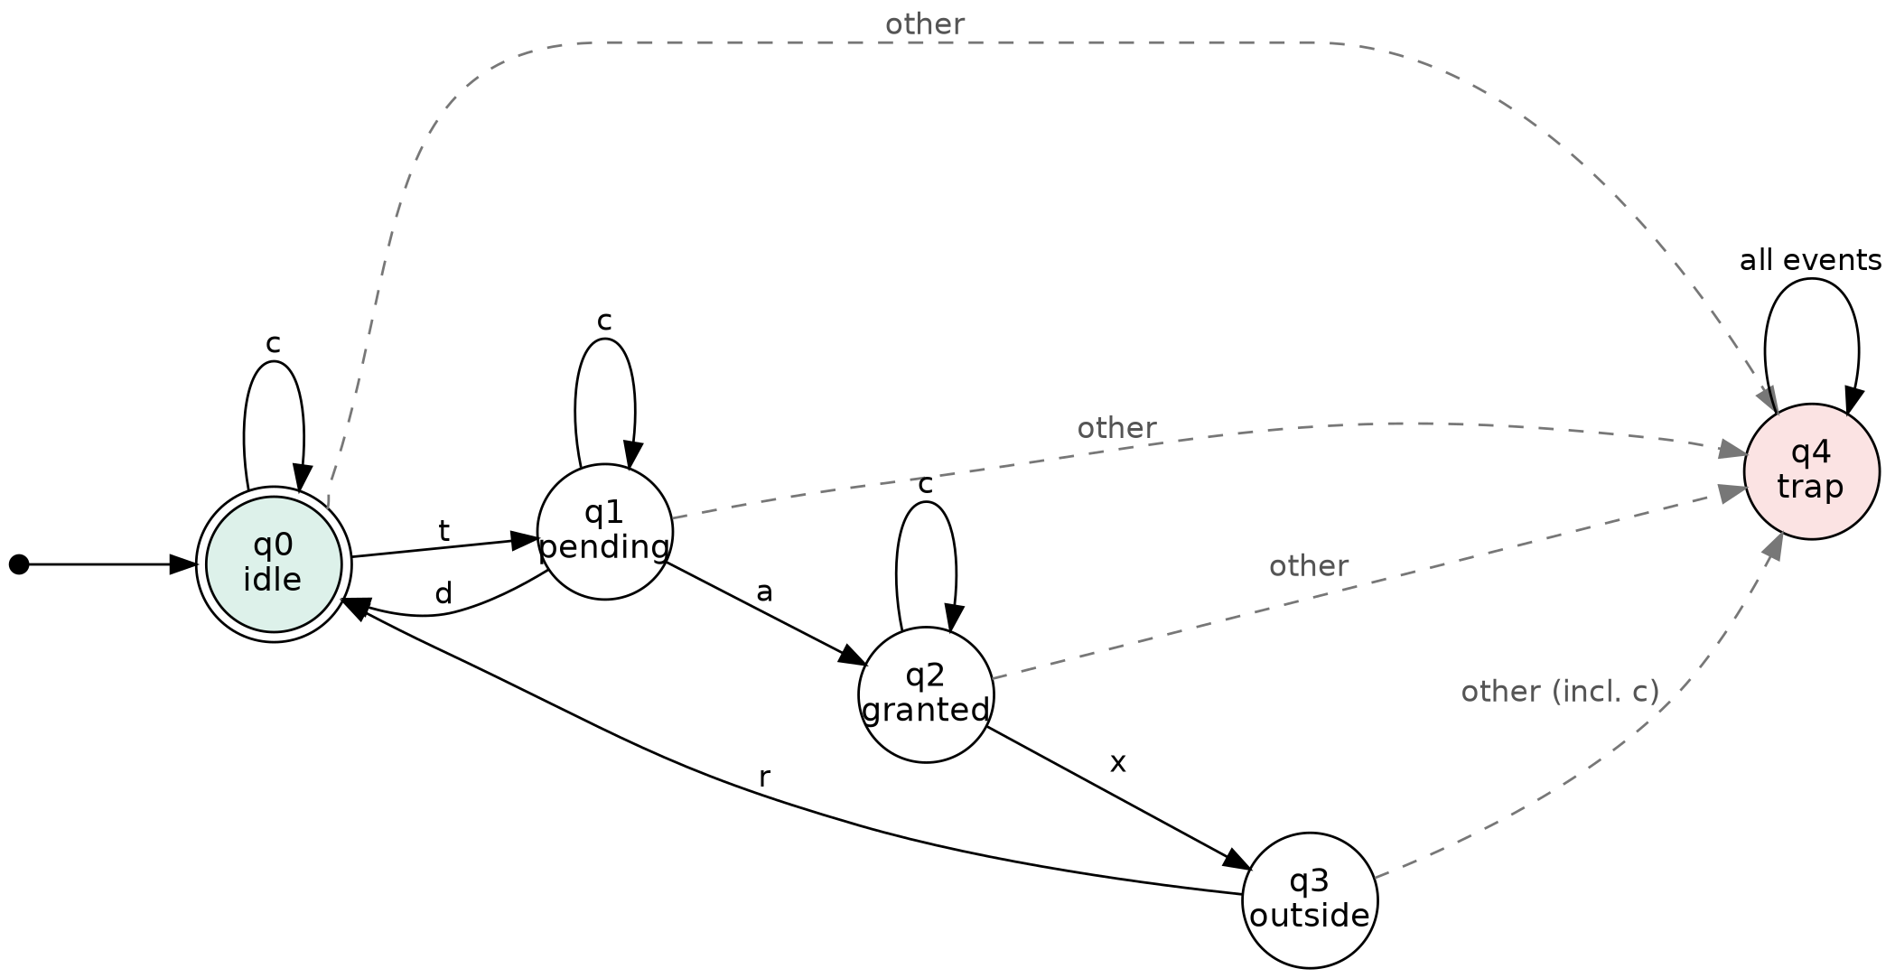
Figure 1. State diagram of the gate-pass DFA. The double circle is the accepting state, the solid arrows are the legal transitions, and the dashed arrows show every other event leading to the trap state q4.

e) Working and Test Cases
# | Input | Verdict | Final state | Reason
1 | t a x r | Accept | q0 | Complete legal trip
2 | t d t a x r | Accept | q0 | Denial, then a legal trip
3 | t a x r t a x r | Accept | q0 | Two consecutive trips
4 | t x | Reject | q4 | Passage without approval
5 | t a x x | Reject | q4 | Tailgating on one approval
6 | t a x c r | Reject | q4 | Curfew while outside
7 | t a x | Reject | q3 | Incomplete: student never returned
8 | r | Reject | q4 | Return without a prior exit

State-transition sequence: accepted input `t a x r`
(q0, taxr) ⊢ (q1, axr) ⊢ (q2, xr) ⊢ (q3, r) ⊢ (q0, ε)
The final state q0 ∈ F, so the input is accepted.

State-transition sequence: rejected input `t a x c r`
(q0, taxcr) ⊢ (q1, axcr) ⊢ (q2, xcr) ⊢ (q3, cr) ⊢ (q4, r) ⊢ (q4, ε)
The final state q4 ∉ F, so the input is rejected. The violation is detected at c and stays latched, so the later r cannot repair it.
Test case 7 never enters q4 but is still rejected because it ends in a non-accepting state. The DFA therefore catches both illegal events and incomplete runs.

f) Practical Significance and Limitations

How the model represents the real system
Each state is a situation the gate can be in. Each input symbol is a sensor or console event. The transitions encode the protocol rules, q4 represents an alarm condition, and acceptance means the log is a compliant run.

Practical significance and applications
- Log auditing: gate logs can be checked for violations in one linear pass.
- Runtime monitoring: the same automaton can run inside the gate controller as a table lookup with constant memory.
- Policy change checking: two versions of the hostel rules can be compared automatically, since DFA equivalence is decidable (see b).
- Similar systems: metro gates, office badge doors, library exit gates and exam-hall entry.
- Wider context: this is the same idea as protocol verification and model checking, applied at small scale.

Assumptions made in the model
- The gate serves one student session at a time.
- Curfew is a single discrete event c, not a measured duration.
- Sensors are reliable, so every tap and rotation produces exactly one event.
- The warden's decision is atomic (a or d), and c is harmless while the student is inside.

Limitations
- No student identity. The DFA cannot tell which student is outside. Tracking N students needs a state for every combination, which grows exponentially.
- No unbounded counting. Occupancy with no fixed limit is not a regular language. A fixed capacity K would need K+1 states.
- No real time. Curfew is abstracted to one event. Modelling elapsed time needs a timed automaton.
- No fault handling. Missed sensor reads, forced entry, or a card tap with no rotation are outside the model.
- Accept/reject only. The model checks event order but does not drive the turnstile. A real controller would be a Moore or Mealy machine with outputs.
- No recovery. q4 is absorbing, so in practice the warden would need a reset override.

Individual Contribution of Group Members
Group member | Register number | Contribution
Nandhan J S | nc.sc.u4cse24118 | Task (a) Real-World Problem Description and Task (b) Decidability Analysis
Adithyan A | nc.sc.u4cse24141 | Task (c) Selection and Formal Definition of the Computational Model and Task (f) Practical Significance and Limitations
Harini P | nc.sc.u4cse24142 | Task (d) Automaton / Model Design and Task (e) Working and Test Cases

