M.HARINI

21ADR015

KONGU ENGINEERING COLLEGE, Perudurai

**Table of content:**

|  |  |
| --- | --- |
| **Content** | **Page no** |
| **Python code** | **1-6** |
| **C Code** | **6-7** |

**Figure Tabel:**

|  |  |
| --- | --- |
| **Figure name** | **Page number** |
| Fig 1: Peaks signal 1 output | 2 |
| Fig 2: Peaks signal 2output | 3 |
| Fig 3: Indices for peak signal 1 | 3 |
| Fig 4: Indices for peak signal 2 | 4 |
| Fig 5 : C programme output | 6 |

**PYTHON CODE :**

import numpy as np

import matplotlib.pyplot as plt

from scipy.signal import find_peaks

signal_1 = np.loadtxt('Data_1.txt')

signal_2 = np.loadtxt('Data_2.txt')

peaks_max_1, _ = find_peaks(signal_1)

peaks_max_2, _ = find_peaks(signal_2)

peaks_min_1, _ = find_peaks(-signal_1)

peaks_min_2, _ = find_peaks(-signal_2)

plt.figure(figsize=(10, 6))

plt.plot(signal_1, label='Signal 1', color='black')

plt.plot(peaks_max_1, signal_1[peaks_max_1], 'ro', label='Maxima (Red)')

plt.plot(peaks_min_1, signal_1[peaks_min_1], 'bo', label='Minima (Blue)')

plt.title('Peaks in Signal 1')

plt.xlabel('Index')

plt.ylabel('Signal Amplitude')

plt.legend()

plt.grid(True)

plt.show()

**1**

**OUTPUT 1:**

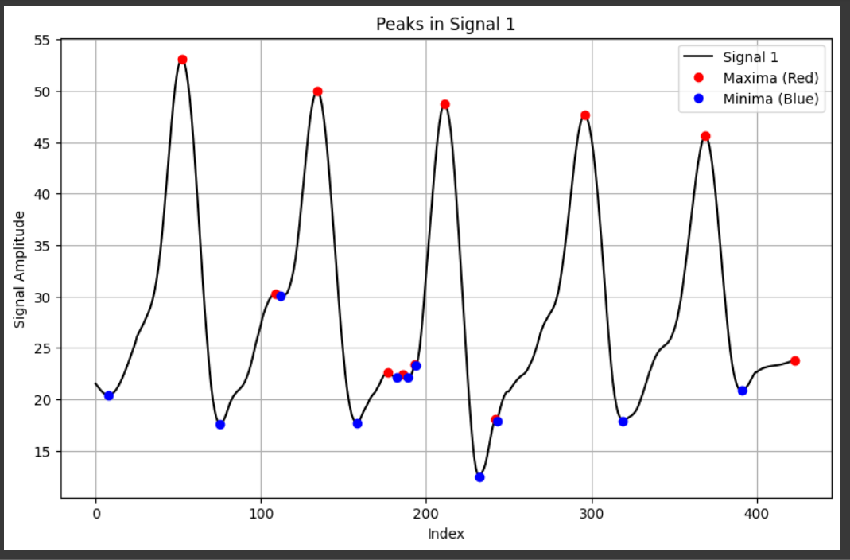

**Fig 1: Peaks signal 1 output**

plt.figure(figsize=(10, 6))

plt.plot(signal_2, label='Signal 2', color='black')

plt.plot(peaks_max_2, signal_2[peaks_max_2], 'ro', label='Maxima (Red)')

plt.plot(peaks_min_2, signal_2[peaks_min_2], 'bo', label='Minima (Blue)')

plt.title('Peaks in Signal 2')

plt.xlabel('Index')

plt.ylabel('Signal Amplitude')

plt.legend()

plt.grid(True)

plt.show()

**2**

**OUTPUT 2:**

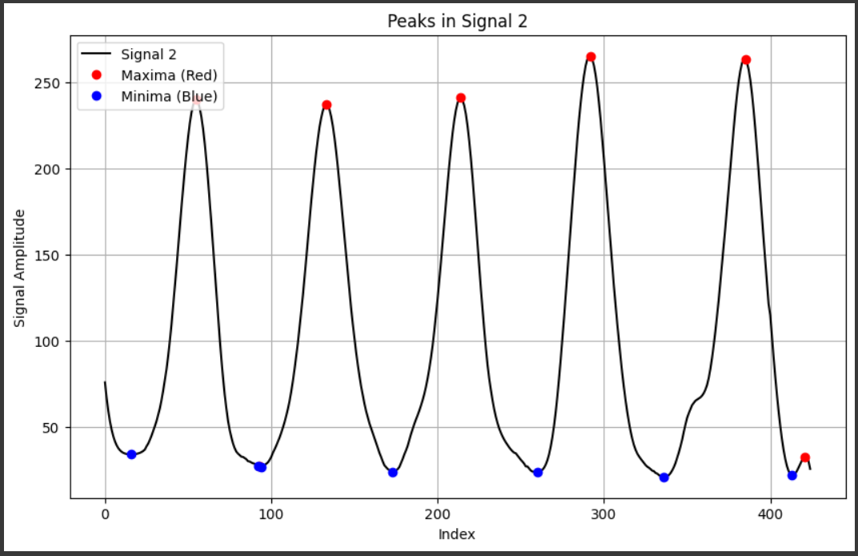

**Fig 2: Peaks signal 2output**

print("Maxima indices for Signal 1:", peaks_max_1)

print("Minima indices for Signal 1:", peaks_min_1)

**OUTPUT 3:**



**Fig 3: Indices for peak signal 1**

print("Maxima indices for Signal 2:", peaks_max_2)

print("Minima indices for Signal 2:", peaks_min_2)

**3**

**OUTPUT 4:**



**Fig 4: Indices for peak signal 2**

**C code :**

#include <stdio.h>

#include <stdlib.h>

#define MAX_LENGTH 10000

int load_data(const char *filename, double data[], int max_length) {

FILE *file = fopen(filename, "r");

if (file == NULL) {

perror("Error opening file");

return -1;

}

int count = 0;

while (count < max_length && fscanf(file, "%lf", &data[count]) == 1) {

count++;

}

fclose(file);

return count;

}

void print_maxima(double data[], int n, const char *dataset_name) {

printf("Maxima in %s:\n", dataset_name);

for (int i = 1; i < n - 1; i++) {

if (data[i] > data[i - 1] && data[i] > data[i + 1]) {

printf("Maxima at index %d, value: %f\n", i, data[i]);

}

**4**

}

void print_minima(double data[], int n, const char *dataset_name) {

printf("Minima in %s:\n", dataset_name);

for (int i = 1; i < n - 1; i++) {

if (data[i] < data[i - 1] && data[i] < data[i + 1]) {

printf("Minima at index %d, value: %f\n", i, data[i]);

}

}

}

void find_peaks(double data[], int n, const char *dataset_name) {

print_maxima(data, n, dataset_name);

print_minima(data, n, dataset_name);

}

int main() {

double data1[MAX_LENGTH], data2[MAX_LENGTH];

int count1 = load_data("Data_1.txt", data1, MAX_LENGTH);

if (count1 == -1) return 1;

int count2 = load_data("Data_2.txt", data2, MAX_LENGTH);

if (count2 == -1) return 1;

find_peaks(data1, count1, "Data_1");

find_peaks(data2, count2, "Data_2");

return 0}

**5**

**OUTPUT 5:**

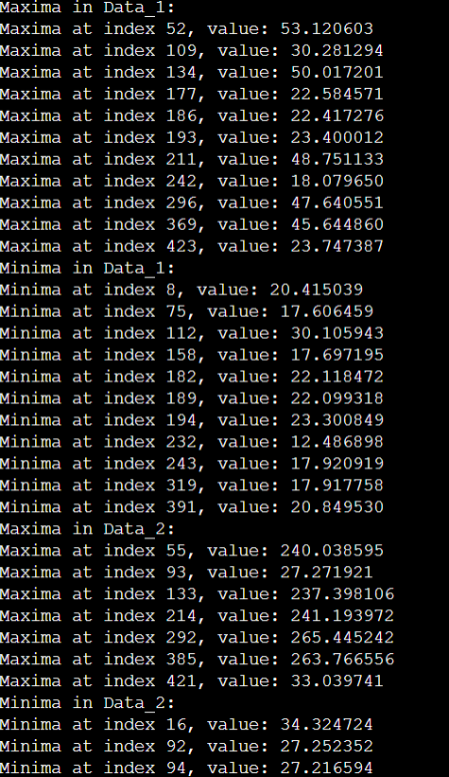

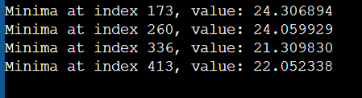

**Fig 5 : C programme output**

**6**