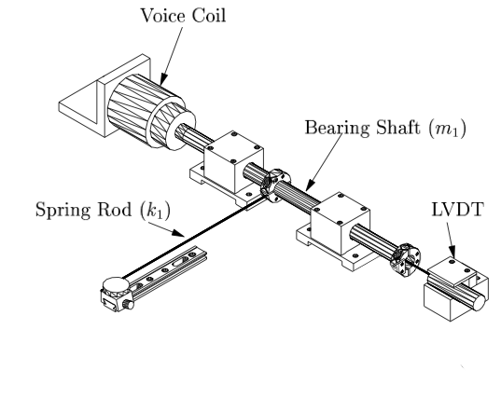

To conclude this analysis of the Mascot, let us now be a little more careful about the model. We've already made the point that the system response is actually the voltage step across the LVDT sensor, rather than the position of the shaft. If we are more realistic about the input signal, it is also a voltage, the voltage applied to the voice coil actuator. The voice coil actually has its own dynamics, and provides most of the damping in the primary spring system.

When we account for the input signal as a voltage, we end up with a system function with a degree 5 polynomial in the denominator, and with a degree 2 polynomial in the numerator, as before.

As a result, when ω is large, the gain becomes proportional to ω−3. This power law is visible in right side of the log-log Bode plot where the graph straightens out into a straight line for large ω.

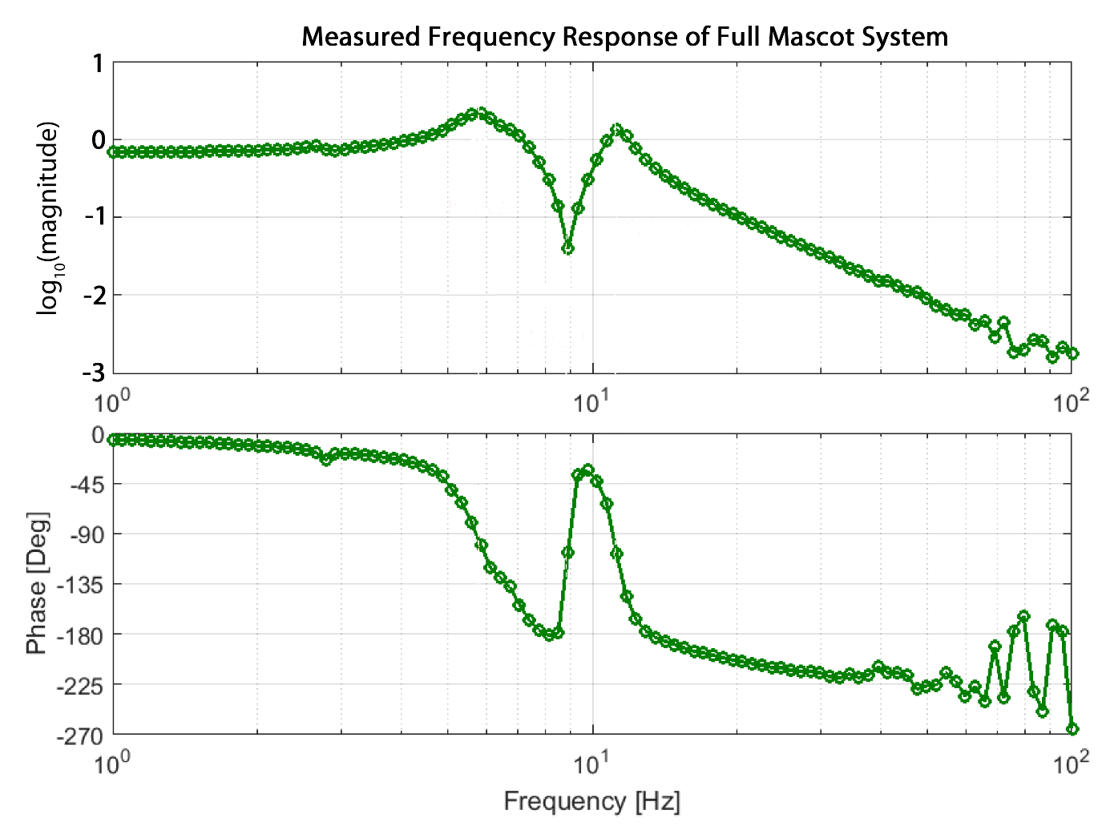

In the plots below, the green circles indicate recorded data from our frequency sweep with the mascot. The red line labeled Model (Mech+Elec) shows the gain from a model that models the voice coil actuator as an order 1 subsystem used to transform an input voltage to a mechanical force. The black line labeled Model (Mech) shows the gain from a model that considers the mechanical force as the input to the system.

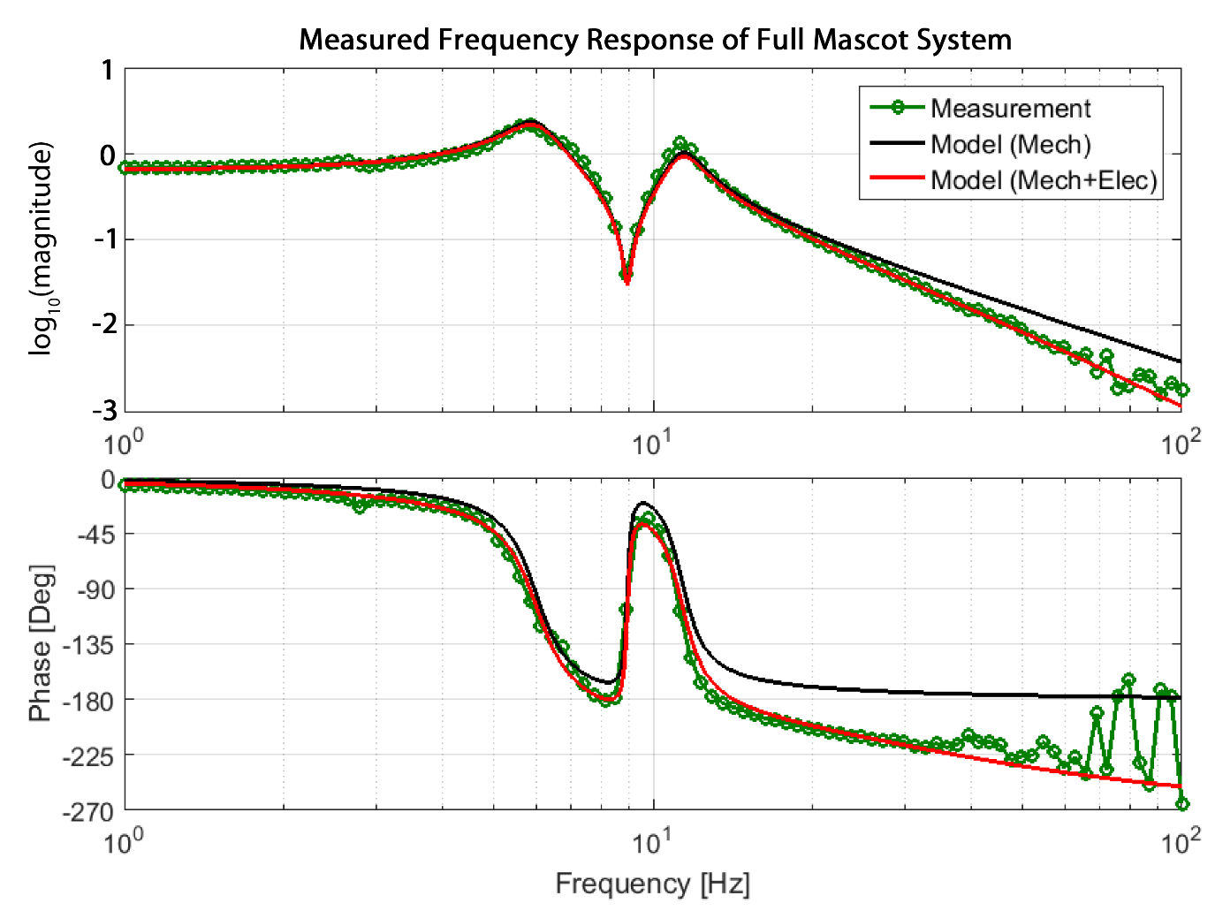  
Measured frequency: response of the Mascot system