Dept of Electronics Engineering

From:  HARI PRASATH S  2023504030@student.annauniv.edu  8610753818 | 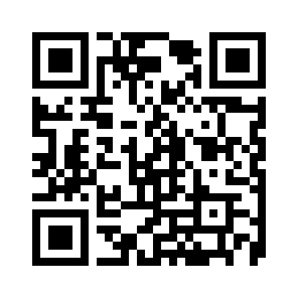

13 August 2026

To,
The Head of the Department
Dept of Electronics Engineering
MIT Campus
Anna University
Chennai

Respected Sir/Mam,
Sub : OD - reg - Reg.
IITM Workshop on 31st July

Yours sincerely,

HARI PRASATH S
✓ Digitally verified by the HoD

