Dept of Electronics Engineering

From:  Hari Prasath S  2023504030@student.annauniv.edu  8610753818 | 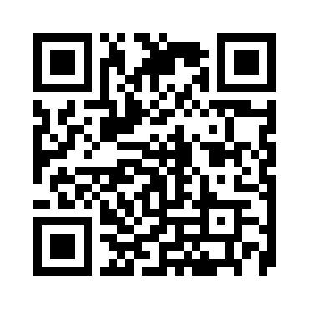

24 April 2026

To,
The Head of the Department
Dept of Electronics Engineering
MIT Campus
Anna University
Chennai

Respected Sir/Mam,
Sub : Medical Certificate acknowledgement - Reg.
I wish to bring to your kind notice that I was absent for the regular classes from 16 March 2026 to 28 March 2026, as I was unwell and under medical care. I regret the inconvenience caused due to my absence and assure you that I will make up for the missed classes/work at the earliest. I request your approval and consideration for the Medical Certificate submitted. Thanking you in anticipation.

Yours sincerely,

Hari Prasath S

