Dept of Electronics Engineering

From:  A Student  student@example.edu  9876543210 | 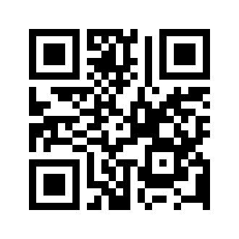

25 April 2026

To,
The Head of the Department
Dept of Electronics Engineering
MIT Campus
Anna University
Chennai

Respected Sir/Mam,
Sub : Leave Request - Reg.
I request permission to attend a family function on 26 April 2026.

Yours sincerely,

A Student

