Secure DMS – Capstone Project Submission
Secure Digital Document Management Portal
1. Architecture Diagram
The deployed Azure architecture shows the VNet, three subnets, Application Gateway/WAF, App Service, Private Endpoint, Private DNS, Cosmos DB, Blob Storage and monitoring flow. It represents the actual Secure DMS traffic path.
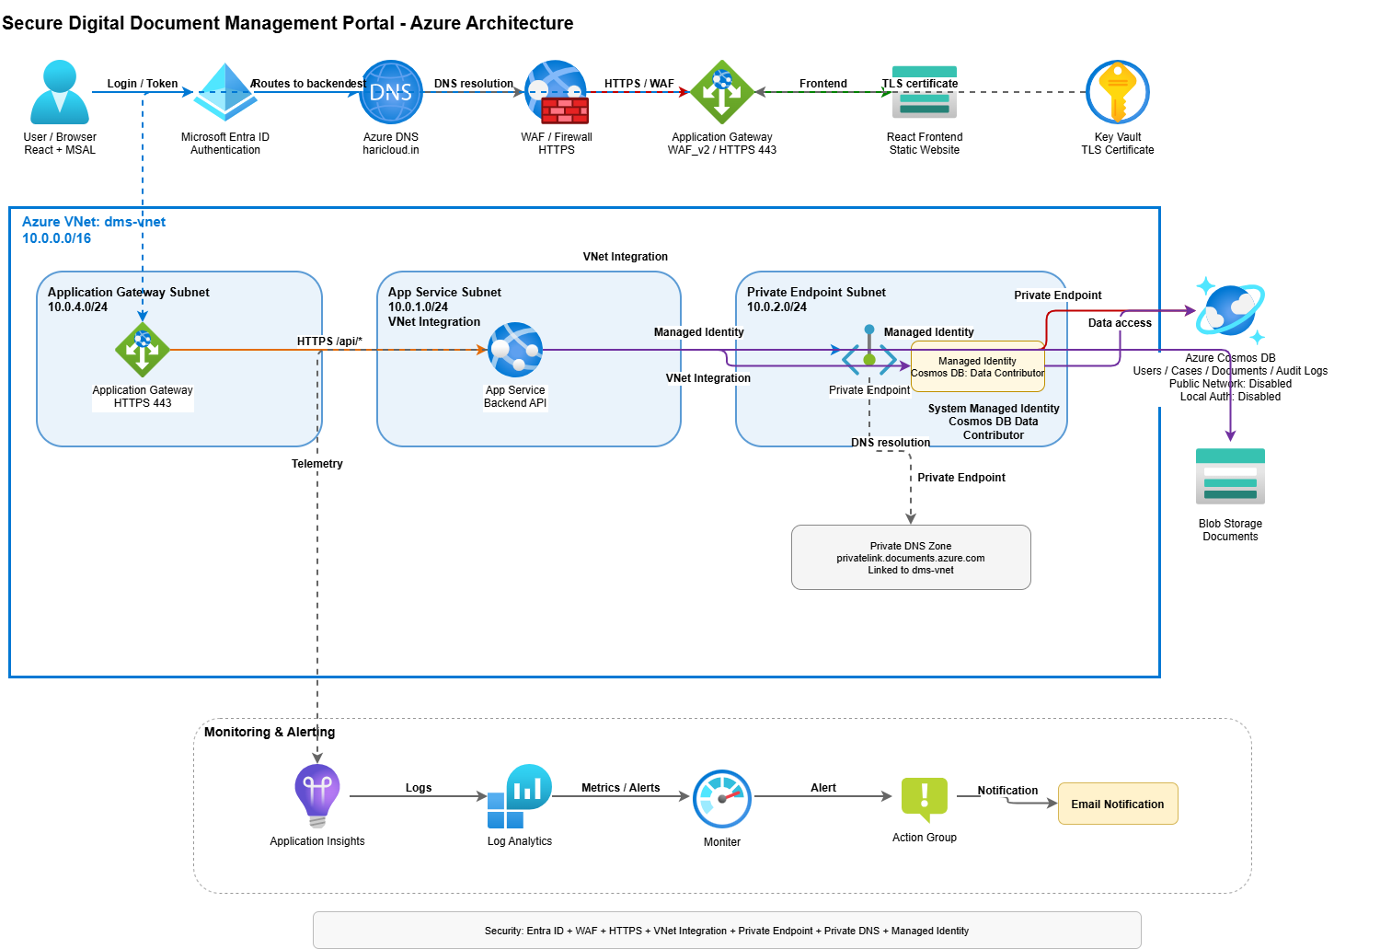
Figure 1 – Deployed Secure DMS Azure Architecture
2. Git Repository
The repository contains the frontend, backend, infrastructure files and deployment configuration used for the Secure DMS project. The project structure screenshot provides the repository evidence.
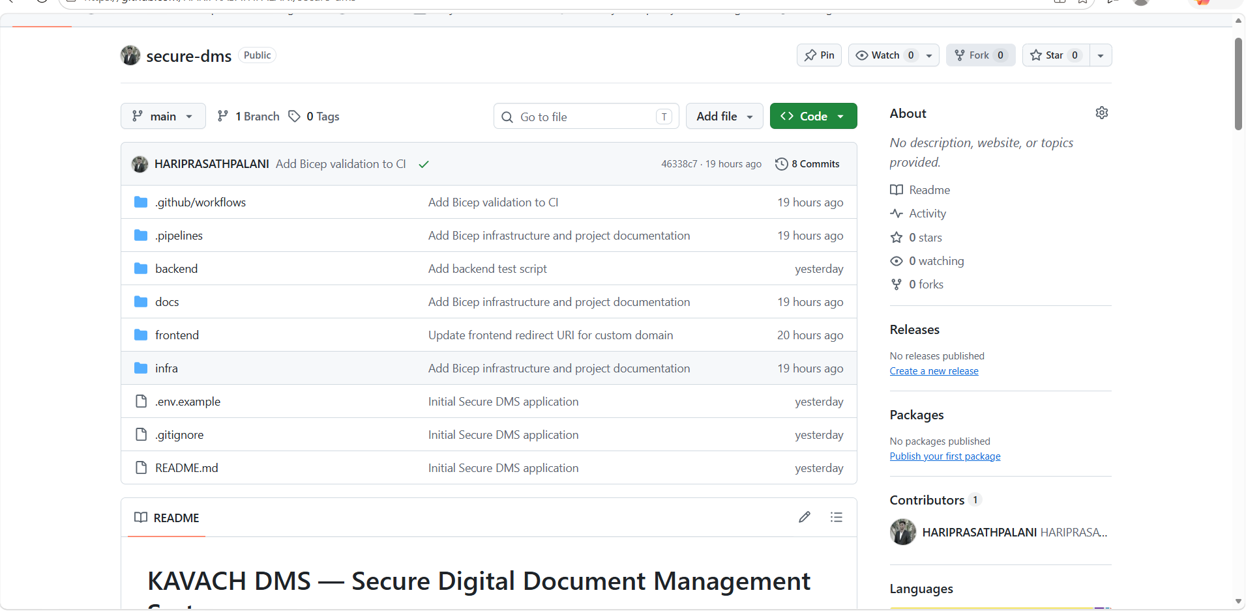
Figure 2 – GitHub Project Structure
3. Pipeline Evidence
GitHub Actions is used for CI/CD. The evidence shows the workflow execution and the separate backend and frontend deployment workflows used for the deployed application.
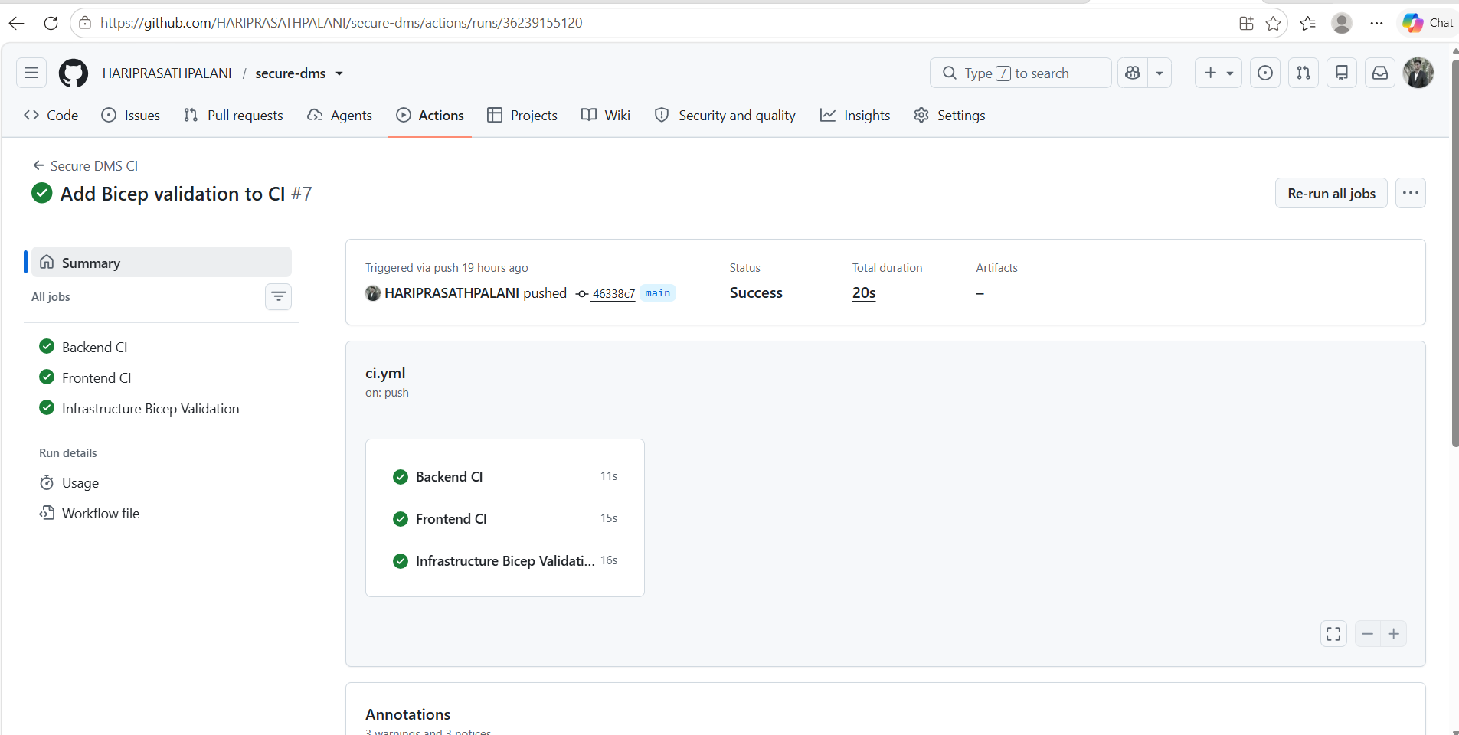
Figure 3 – GitHub Actions Workflow
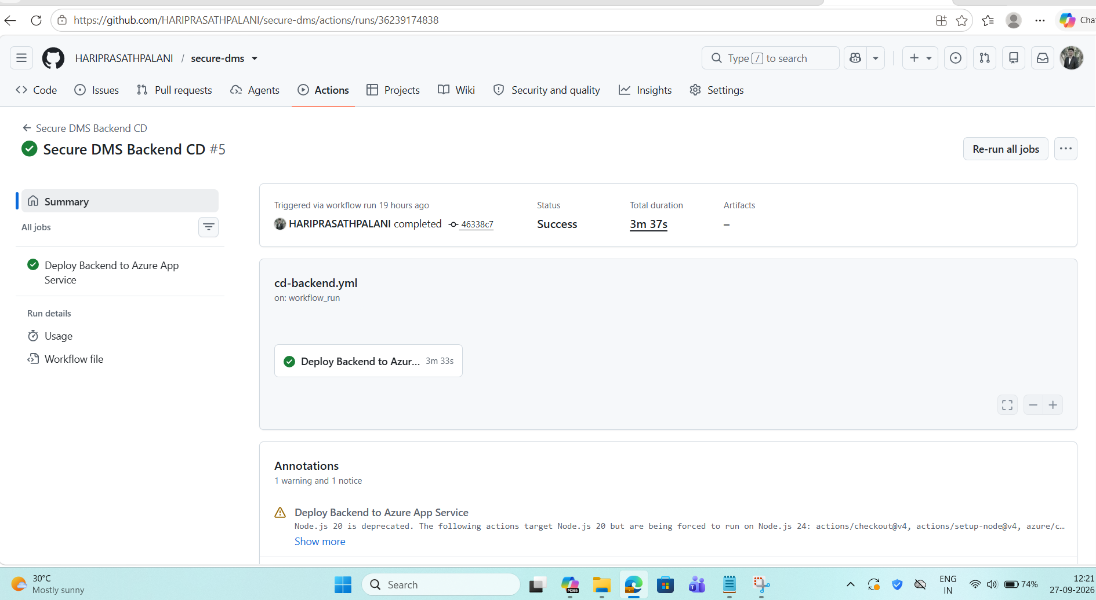
Figure 4 – Backend CD
Figure 5 – Frontend CD
4. Live Demo URL
The deployed Secure DMS frontend is available at https://dms.haricloud.in. The login and production API health screenshots show the live application and backend endpoint running successfully.
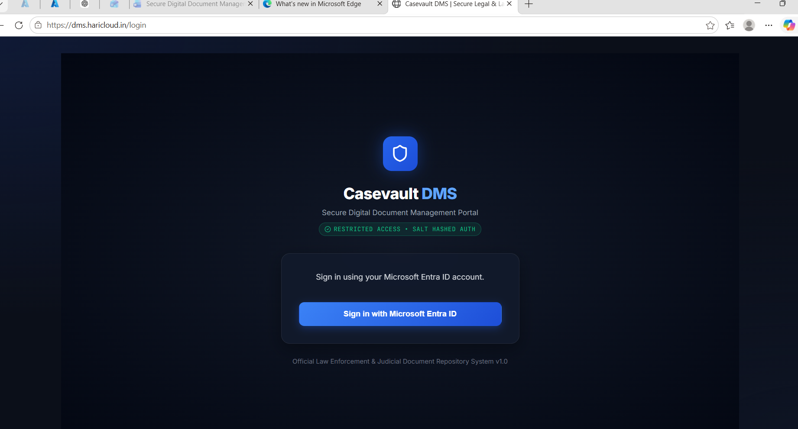
Figure 6 – Secure DMS Login Page
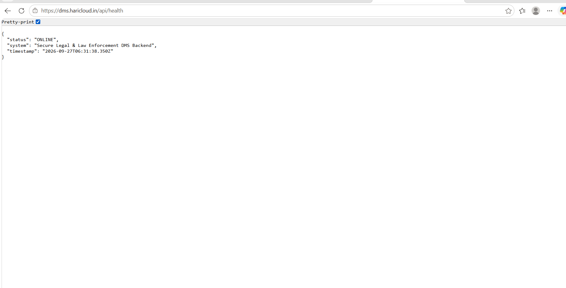
Figure 7 – Production API Health
5. Security Evidence
Cosmos DB public access is disabled, App Service access restrictions are configured, and the backend uses System Managed Identity for Azure resource access instead of connection strings.
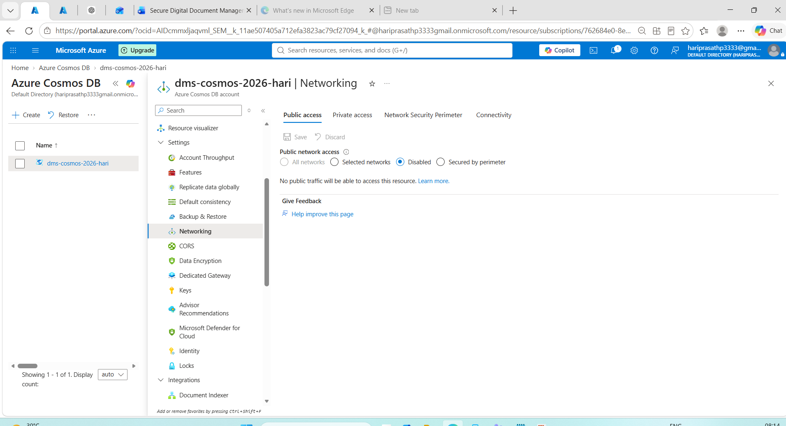
Figure 8 – Cosmos DB Public Access Disabled
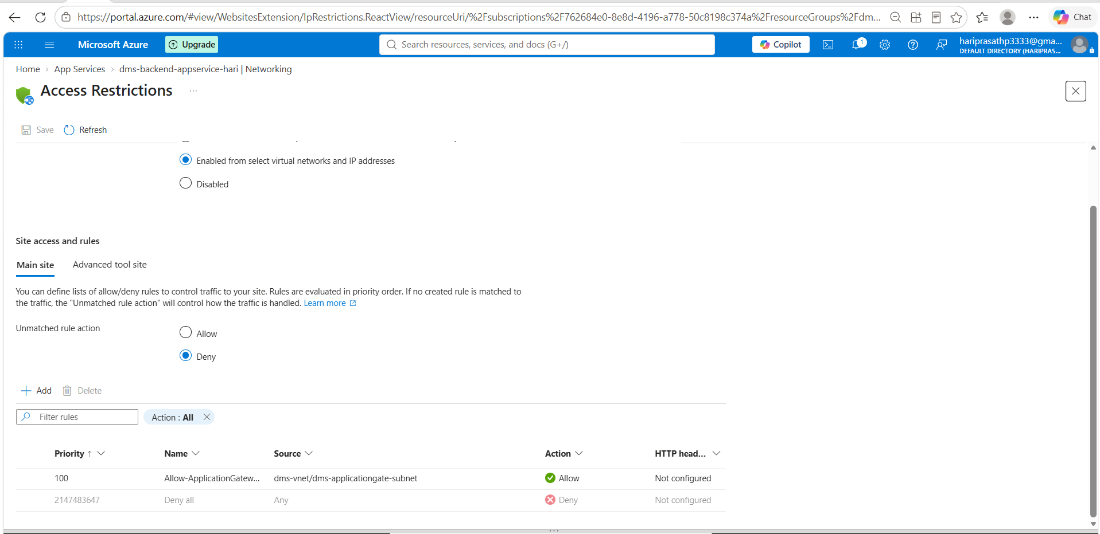
Figure 9 – App Service Access Restrictions
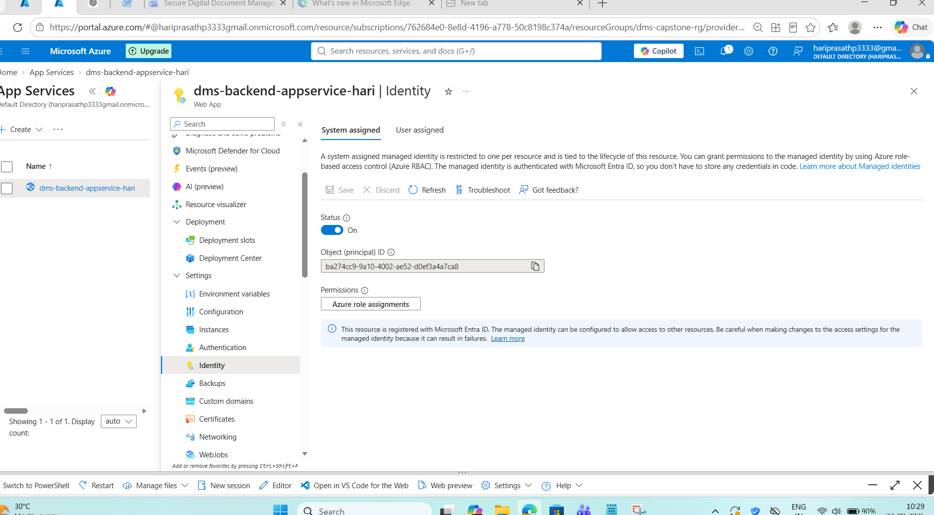
Figure 10 – System Managed Identity
6. Monitoring Dashboard
Application Insights provides application monitoring, while Azure Monitor alert rules are configured for backend and Cosmos DB conditions. The screenshots provide evidence of live monitoring and configured alerts.
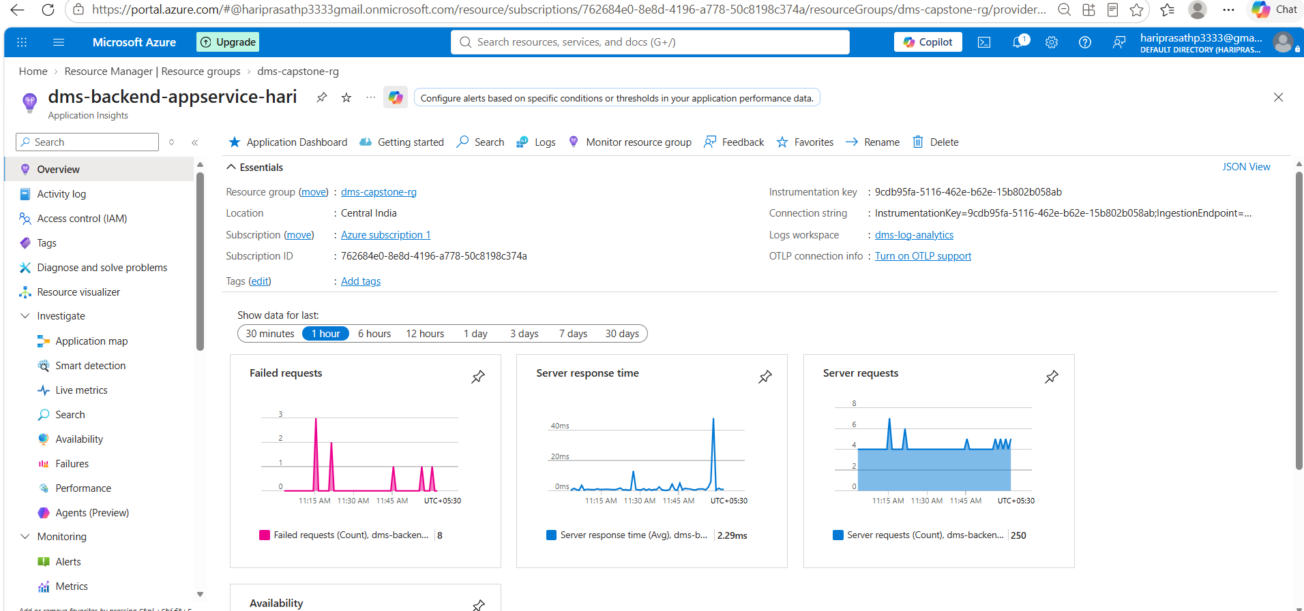
Figure 11 – Application Insights
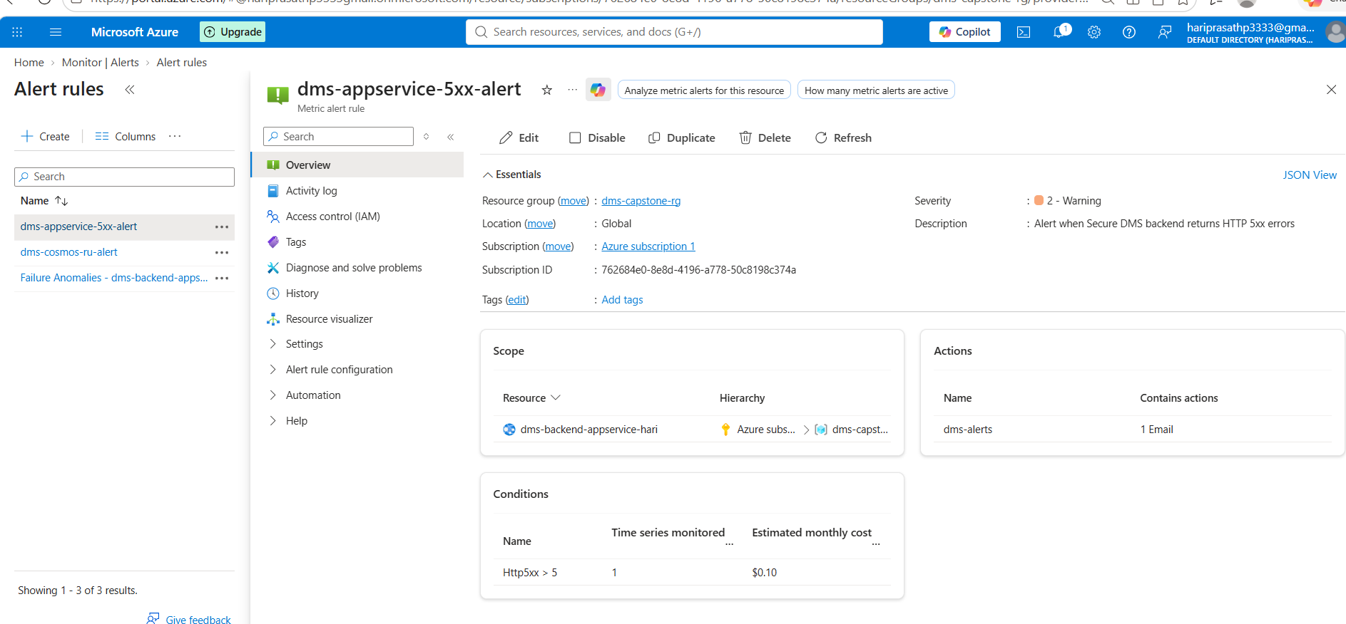
Figure 12 – App Service Alert
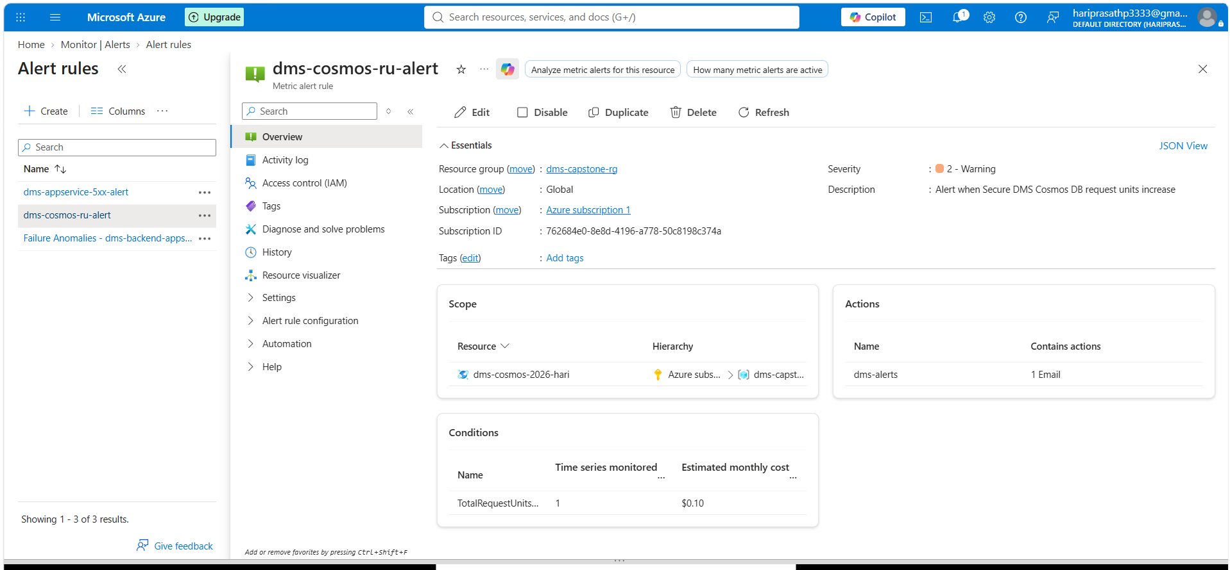
Figure 13 – Cosmos DB Alert
Prepared for Capstone Project Submission

