Instructions

1. Download and install anaconda3 from given link

- link : <https://www.filehorse.com/download-anaconda-64/download/>

- At the stage given in the image below check both checkboxes

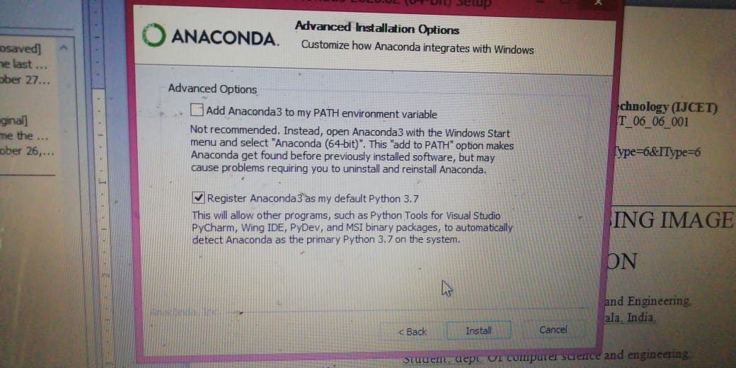

1. Open anaconda prompt
2. In prompt(cd) Navigate to project folder
3. Run command : pip install opencv-python
4. Run command : pip install numpy
5. Run command : python data.py